**Inter-Club Council Agenda 2/5/25**

1. Attendance & club updates (what are they up to, upcoming events or past activities)

22 attendees

|  |  |
| --- | --- |
| Club Name | *Update* |
| Art |  |
| Astronomy | Gaby - Partnering with local high school on project |
| Black Student Union | Shale & Mark – Root beer float & orange dream sale, feeding homeless on Saturday |
| Chess Club | Julio – first meeting this Friday or next 2-3PM in library |
| Community Connections Club | Anthony - |
| Computer Science Club |  |
| Early Childhood Education Club |  |
| Future Business Leaders of America |  |
| Film Club |  |
| F.I.R.M.E |  |
| Games |  |
| HEAL | Diana – helping at Living Color event 5/3 11am-4pm in Williamson Ranch Park, health fair 4/8, SUMMA conference workshop for those who couldn’t attend |
| Honors | Sean – Cookie decorating at Galentine’s 3/13  Multicultural festival 4/9 – planning committee 2:30 on Wednesdays |
| Hope & Home | Brianna Luna - |
| International Student Club |  |
| Kapwa | Patrick & Aki - |
| LatAm |  |
| LMCAS | Chiamaka – no update |
| LVN Class of 2025 | Ashley – working on pinning ceremony |
| MSA |  |
| Philosophy Club | Maddie, Jace & Agelo – UC Berkeley Philosophy Club field trip, Michael Sutton speaking on Ethics of AI discussion |
| Pride Alliance |  |
| Puente | Guadalupe, |
| RN Class of 2025 |  |
| Rotaract | Jeremiah – CCC science fair at LMC, Rotaract volunteering and creating a sign up sheet: 3/13 10AM-7PM, 3/14 12-4:30, clean up & awards Sat 3/15 7:30-10:30 – free food for volunteers |
| Shenanigans |  |
| STREAM |  |
| Turning Point USA |  |
| WINS | D’Anna & Jetsi - free hands on STEM activities |
| Writer's Guild | Julio – Blind Date with a book went well |
|  |  |
|  |  |
|  |  |
|  |  |
|  |  |
|  |  |

1. Club Carnival Planning:
   1. Time: 11AM-1PM
   2. **Vote:** select date: **March 4th** or 6th
      1. March 4 is the preference, vote was 12 to 1 for March 6
   3. **Vote:** select theme: County Fair Carnival or Spring in Bloom
      1. **Unanimous Spring in Bloom**
   4. **Vote:** select location:
      1. CC 3rd floor & patio: 0 votes
         1. Crowded
      2. outdoor quad by library & science with pedal karts: 2
         1. some preferred this, but less accessible to others in cc, feels more fun
      3. **outdoor quad by Student Services steps (like Mustang Day): 8**
         1. 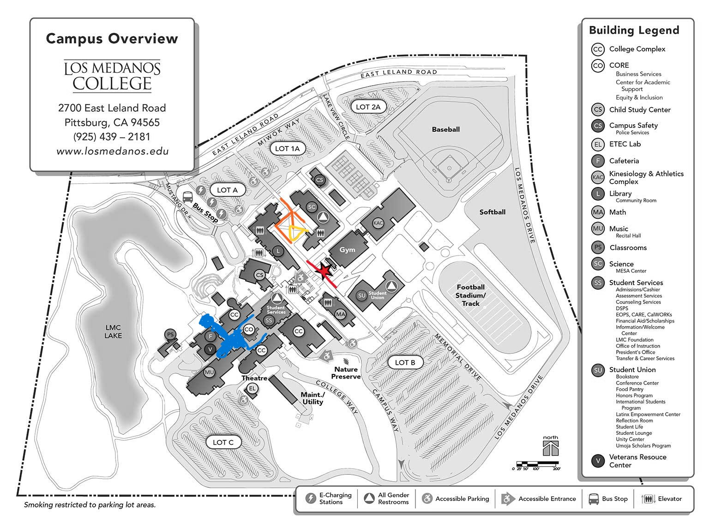considered a safe bet
   5. **Decide:** Would clubs like to fundraise?
      1. If so, should we also provide something?
      2. **serve popcorn and cotton candy, and clubs can sell drinks/snacks/real food**
      3. serve water and clubs can sell anything
      4. serve pizza or simple sandwiches, and sell drinks/snacks/dessert
   6. **Vote:** Approve Club Carnival Budget

**ICC request up to $2400** for light refreshments, decorations, and activities

* + 1. $700 for food (about $2/person for 300 people)
    2. $500 for Pedal karts: **decided not to do this 🡪 leave $500 for extra activities**
    3. $200 for decorations
    4. $200 for posters
    5. $800 for prizes/games/joint activity

Motion: Jitsi of WINS – Motion to spend $2400 on club carnival

Second: Briana of Hope & Home

Vote: 11 – 0 - 0

* 1. **Next Club Carnival committee meeting: 2/29 from 3:30-4:30**
     1. **HEAL Pot painting & seeds**
     2. **Each club have a flower – bulk flowers in Oakland and Martinez**
     3. **2-4 tables of filler flowers**
  2. **2 stations of bouquet making**
  3. **Origami flowers**
  4. **Spring festival**

1. ICC Finance Chair: responsible for managing ICC funds by receiving and tracking fund requests, supporting clubs through the fund request process and presentation, provide a brief finance report at ICC meetings.
   1. Must be available for all upcoming ICC meetings
   2. Nominations: Is anyone interested in this position?
      1. Share briefly their club and their interest in the position

Ashley of LVN Class of 2025 is interested

Vote: 12 – 0 - 0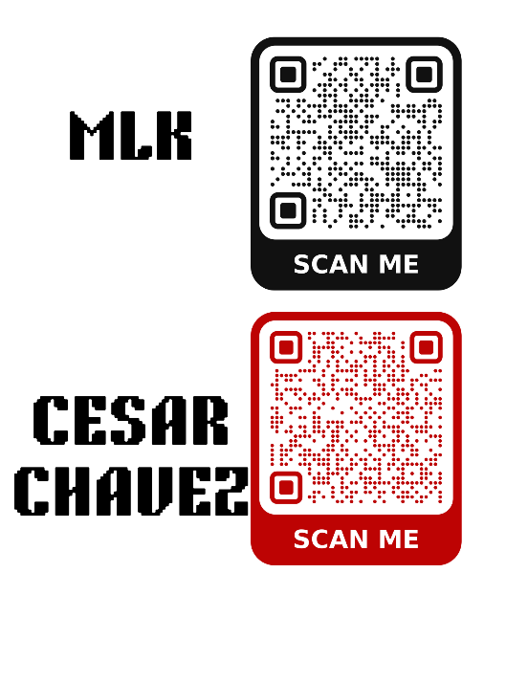

1. Volunteer at the Crab Feed (21+) on 3/8 - 3-11pm
   1. tips for clubs
2. Announcements
   1. sign up for MLK luncheon
   2. sign up for Cesar Chavez luncheon
   3. Volunteer at Graduation 11:30-5 on 5/23:

email Melissa Stender at [mstender@losmedanos.edu](mailto:mstender@losmedanos.edu)

**Robert's Rules of Order Reference**

* 1. Clubs discuss, chair calls on each member to speak
  2. Chair calls for a motion
     1. Student says "I move to approve **amount** for **Club Name** for their **event name**"
     2. David says "I move to approve up to $700 for Honors Club's Multicultural Festival"
  3. chair asks for a second
     1. student says "I second"
  4. chair calls for a vote: raise your hand if you approve, raise your hand if you disagree, anyone abstain?
  5. Motions and seconds cannot be made by the club who is requesting the funds

**Fund Requests**

Fund Requests due Sunday at midnight the Sunday before ICC

* 1. ICC Balance: $19,371.15

Mustang Madness / Spring Showdown

Spring Clubs in Bloom

Club Spring Festival

Spring