Inter-Club Council Agenda 9.4.24

- What is ICC?
- Attendance & Club Updates

- Chair

- LMCAS opportunity – Mondays 1-3PM, ensure the student voice is heard in committees, scholarships available

- Club Carnival Committee – who’s in?

- Complete charter packets asap – digital questions?

- Funds

  - Ice cream social $50 for ice cream

  - Impact conference attendance competition

  - Blood drive donor competition

- Open Comments/questions

- Next ICC Meeting

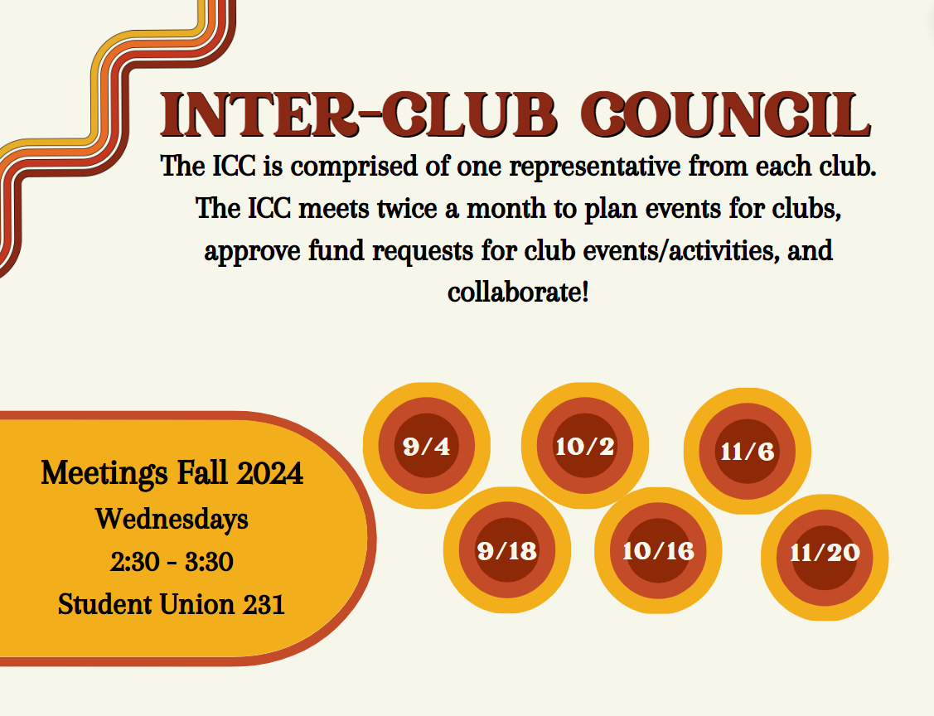

Upcoming Events
- 9/10 @11-2: pet rock in SU courtyard
- 9/17 @11-1: National Voter Registration Day in quad
- 10/4 @4-9pm Homecoming Dance

