**Inter-Club Council Agenda 2/5/25**

1. Attendance & club updates (what are they up to, upcoming events or past activities)

|  |  |
| --- | --- |
| Club Name | *Update* |
| Art |  |
| Astronomy |  |
| Black Student Union |  |
| Chess Club |  |
| Community Connections Club |  |
| Computer Science Club |  |
| Early Childhood Education Club |  |
| Future Business Leaders of America |  |
| Film Club |  |
| F.I.R.M.E |  |
| Games |  |
| HEAL |  |
| Honors |  |
| Hope & Home |  |
| International Student Club |  |
| Kapwa |  |
| LatAm |  |
| LMCAS |  |
| LVN Class of 2025 |  |
| MSA |  |
| Philosophy Club |  |
| Pride Alliance |  |
| Puente |  |
| RN Class of 2025 |  |
| Rotaract |  |
| Shenanigans |  |
| STREAM |  |
| Turning Point USA |  |
| WINS |  |
| Writer's Guild |  |
|  |  |
|  |  |
|  |  |
|  |  |
|  |  |
|  |  |

1. Club Carnival Planning:
   1. Time: 11AM-1PM
   2. **Vote:** select date: March 4th or 6th
   3. **Vote:** select theme: County Fair Carnvial or Spring in Bloom
   4. **Vote:** select location:
      1. CC 3rd floor & patio
      2. outdoor quad by library & science with pedal karts
      3. 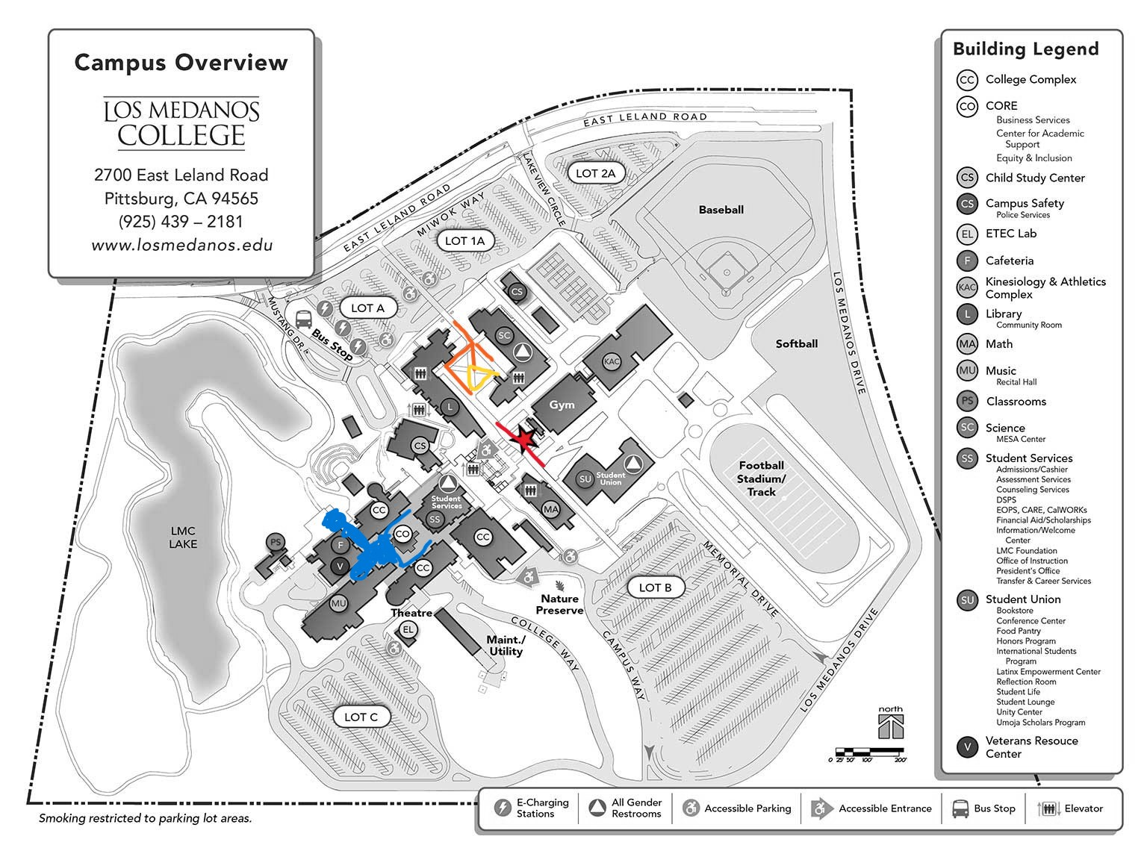outdoor quad by Student Services steps (like Mustang Day)
   5. **Decide:** Would clubs like to fundraise?
      1. If so, should we also provide something?
      2. serve popcorn and clubs can sell drinks/snacks/real food?
      3. serve water and clubs can sell anything
      4. serve pizza or simple sandwiches, and sell drinks/snacks/dessert
   6. **Vote:** Approve Club Carnival Budget

**ICC request up to $2400** for light refreshments, decorations, and activities

* + 1. $700 for food (about $2/person for 300 people)
    2. $500 for Pedal karts
    3. $200 for decorations
    4. $200 for posters
    5. $800 for prizes/games/joint activity
  1. **Next Club Carnival committee meeting: 2/29 from 3:30-4:30**

1. ICC Finance Chair: responsible for managing ICC funds by receiving and tracking fund requests, supporting clubs through the fund request process and presentation, provide a brief finance report at ICC meetings.
   1. Must be available for all upcoming ICC meetings
   2. Nominations: Is anyone interested in this position?
      1. Share briefly their club and their interest in the position

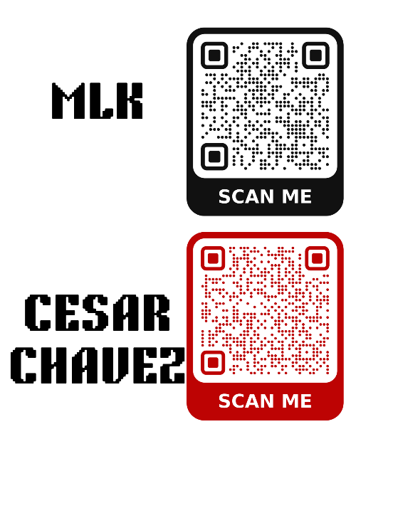

1. Volunteer at the Crab Feed (21+) on 3/8 - 3-11pm
   1. tips for clubs
2. Announcements
   1. sign up for MLK luncheon
   2. sign up for Cesar Chavez luncheon
   3. Volunteer at Graduation 11:30-5 on 5/23:

email Melissa Stender at [mstender@losmedanos.edu](mailto:mstender@losmedanos.edu)

**Robert's Rules of Order Reference**

* 1. Clubs discuss, chair calls on each member to speak
  2. Chair calls for a motion
     1. Student says "I move to approve **amount** for **Club Name** for their **event name**"
     2. David says "I move to approve up to $700 for Honors Club's Multicultural Festival"
  3. chair asks for a second
     1. student says "I second"
  4. chair calls for a vote: raise your hand if you approve, raise your hand if you disagree, anyone abstain?
  5. Motions and seconds cannot be made by the club who is requesting the funds

**Fund Requests**

Fund Requests due Sunday at midnight the Sunday before ICC

* 1. ICC Balance: $19,371.15