- Go to the InSite Website and click on “Reports-Districtwide”
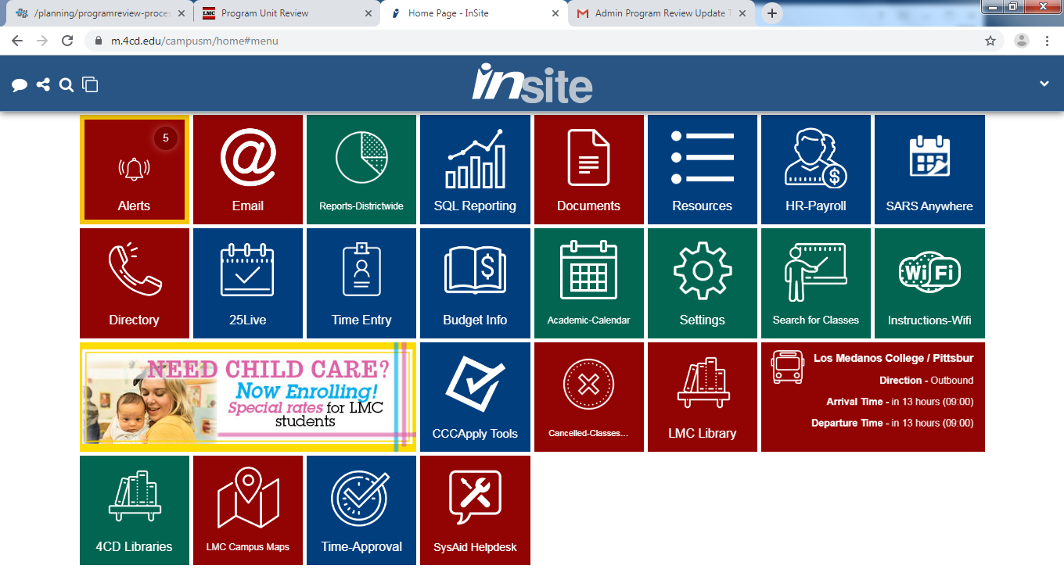

- Click on “Graduation Reporting”
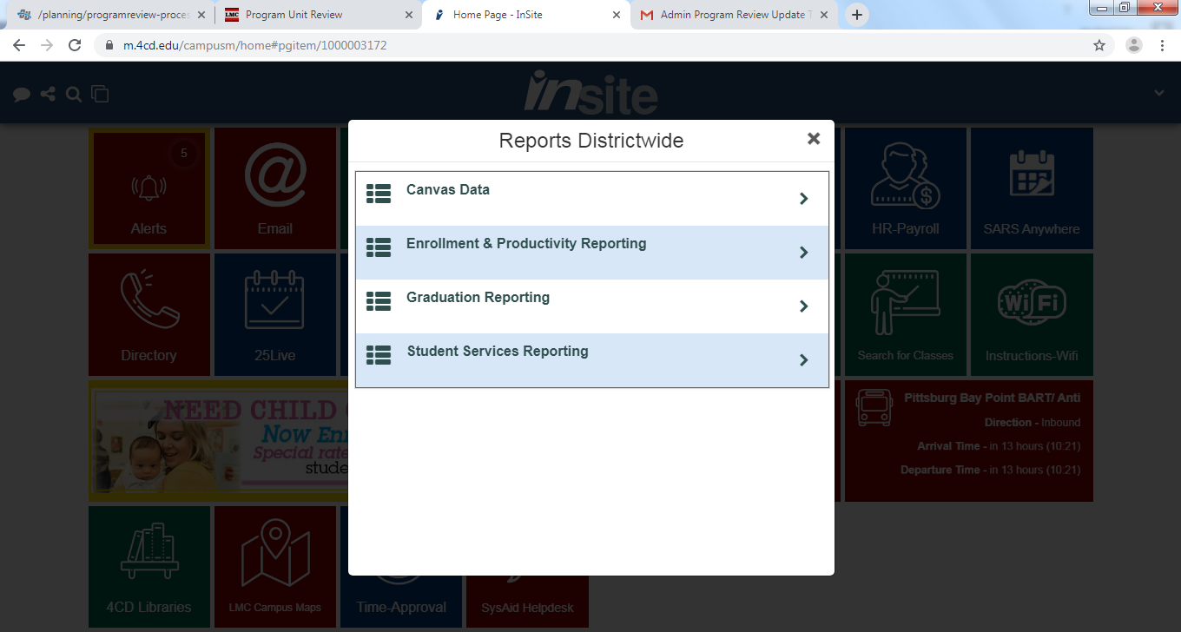

- Click on “Degrees and Certificates View”
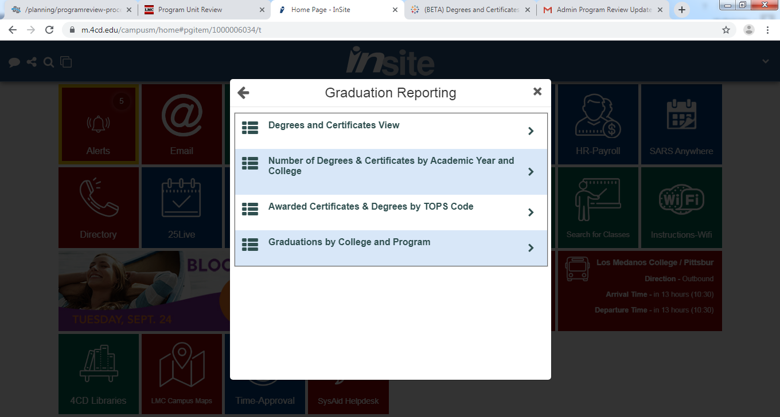

- It will take you to this new webpage.
