DIALOGUE ON GE ASSESSMENT
Feb 4, 2013
4-5 pm
room L-109

Agenda:

- Background: big changes in GE
  - New 5-year cycle
  - New 18-unit GE package for Standard Path AA/AS
  - Getting input from faculty over the last few months
  - GE’s charge from the senate to assess the new model

- Discussions in TLC and the GE committee so far, and what decisions we need to make.

- Discuss options at tables, then as a whole group.

Key questions for discussion:

- What is our research question? Roughly, it is this: How well will students do under the new 18-unit requirement?
However, to get at this big question, we’ll need to select one or more specific questions. For example:
How well will students do in achieving the GE learning outcomes (all or selected) with the new 18-unit requirement?
How are grades, success rates, or graduation rates affected by the new model?
On a standardized or semi-standardized assessment instrument, how well do students do in Spr ’18 compared with Fall ’13?

- What kind of assessment method(s) or instrument(s) should we use? (See examples attached of course-embedded, not course-embedded, or partly embedded assessments.)

- Which GE SLOs will we assess? (all 5 may not be feasible—see SLOs below)

- Your thoughts: what else do we need to consider to make this go well?

New 18-unit General Education Requirement for AA or AS Degree

3 units each (except 6 units for D):

- Biological or Physical Science

- Social and Behavioral Science

- Creative Arts / Humanities

D. Language and Rationality
1. English Composition (Eng 100)
2. Communications and Analytical Thinking (math)

E. Ethnic and multicultural studies (our new local option)

GE Student Learning Outcomes (SLOs)

At the completion of the LMC general education program, a student will:

- Read critically and communicate effectively as a writer and speaker.

- Understand connections among disciplines and apply interdisciplinary approaches to problem solving.

- Think critically and creatively. Discussions in tlc and the ge committee so far

- Consider the ethical implications inherent in knowledge, decision-making and action.

- Possess a worldview informed by diverse social, multicultural and global perspectives.

GE Committee meetings Spr 2013 (all Thursdays at 3:30 pm in L-106). Please come as guest or new member! (GE chair: Alex Sterling, ext 3212, office CC2-294)
- January 17
- February 7, 21
- March 7
- April 4, 18
- May 2, 16
1. Possible template for creating a course-embedded assessment prompt—that is, each class would have a different topic/prompt, but the directions and assessment circumstances would otherwise be identical, as much as possible, to create some uniformity. The sample could be used to assess SLOs 1 and 3.

Student ID #: _______________________

Course name and section #: ______________________________________________

Writing prompt: _________________________________________________________
______________________________________________________________________
______________________________________________________________________
______________________________________________________________________
______________________________________________________________________
______________________________________________________________________

Directions: You have 50 minutes to write an essay responding to the prompt. Your essay will be graded, so do your best work. Your essay should have a short introduction and conclusion, and should have at least two body paragraphs. Make sure to answer everything asked for in the prompt and nothing more. You will be graded on:
- How well you show you understand the topic and your ability to articulate key concepts in your own words. (Quoting some sources is allowed, but don’t rely on it.)
- Your ability to think critically and creatively about the topic, to do your own thinking about it.
- Focus, organization, clarity.
- Your writing skill in general.

- Sample of non-course-embedded assessment: every student does exactly the same thing. The sample could be used to assess SLOs 1,3,4, and 5.

Student ID #: _______________________

Course name and section #: ______________________________________________

Writing prompt: In an essay, critically examine the gender wage gap issue as described by the short article and graph below. Accurately summarize the main idea(s) and explain the meaning of key statistics. Then analyze the issue: What are some likely causes of the wage gap between men and women? What ethical issue(s) is/are suggested by the information? What further information would help us understand this issue better? Finally, provide one possible solution to the problem.

Directions: You have 50 minutes to write an essay responding to the prompt. Your essay will be graded, so do your best work. Your essay should have a short introduction and conclusion, and should have at least two body paragraphs. Make sure to answer everything asked for in the prompt and nothing more. You will be graded on:
- How well you show you understand the topic and your ability to articulate key concepts in your own words. (Quoting some sources is allowed, but don’t rely on it.)
- Your ability to think critically and creatively about the topic, to do your own thinking about it.
- Focus, organization, clarity.
- Your writing skill in general.

America's gender wage gap
Apr 17th 2012, 17:52 by The Economist online
FULL-TIME working women in America earned only 82.2% of men's median weekly earnings last year, according to a new report by the Institute for Women's Policy Research, a think-tank in Washington, DC. Women earned less than men in almost all occupations. Only in the fields of "stock clerks and order fillers" and "bookkeeping, accounting and auditing clerks" did women make slightly more than their male counterparts. The gender wage gap (women's earnings as a percentage of men's) was most pronounced amongst CEOs and financial managers. Female chief executives earned only 69% as much as male bosses, resulting in $658 less in median weekly earnings.
(see graph on the next page)
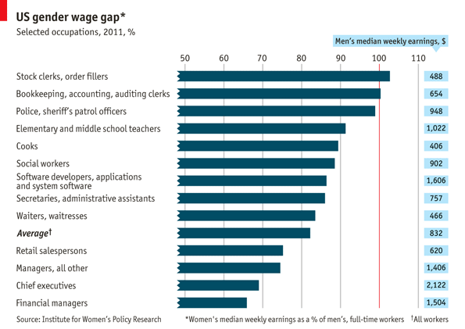

- Draft/sample of partly course-embedded assessment: every student would get exactly the same prompt, but what exactly they write would vary according to course. The sample could be used to assess SLOs 1, 2, and 3.

You will have fifty minutes to write a short reflective essay about this GE course based on the questions below. Please write your responses to ALL of the questions.
What concept was the most difficult for you to learn in this course? Describe the concept, and explain why you think this concept was hard for you to understand.

Describe a concept presented in this course that seems relevant to your life. How could you apply this concept to your life?

Describe a concept presented in this course that you could relate to a concept you learned in a different college course. Describe the relationship you see between these two concepts.

