Summary of GE assessment 2013-2014
In 2013-14 the GE Committee led a General Education assessment designed answer the following question:
How will students do on a course-embedded assessment that measures GE SLO 1 (writing/reading), GE SLO 3 (critical thinking), and GE SLO 4 (ethics) relative to number of GE units taken?
During the school year 2012-2013, the GE assessment was planned during multiple meetings: all-faculty-invited GE events, Teaching and Learning Committee meetings, and many GE committee meetings.
During the Fall 2013 semester, we collected over 300 student papers from GE courses in journalism, biology, philosophy, and political science. Each student handed in a 2-page paper based on a short article about an ethical issue. Using the student ID numbers of all the students who did the assessment, the district research office made us a weighted random sample of 90 students with varying numbers of GE units successfully completed:
- 30 students with a low number of GE units (0-9)
- 30 students with a medium number of GE units (12-18)
- 30 students with a high number of GE units (21+)

In January 2014 twelve LMC faculty met and scored the 90 papers. Faculty were from biology, physical sciences, art & humanities, political science, journalism, English, math, plus one dean. Using a rubric, each student paper was scored as high proficient (HP), proficient (P), or not proficient (NP) in ethical thinking, critical thinking, writing, and reading. Proficient was defined as, “meets our expectations for a student at or near completion of the AA/AS degree.”
What were the results? Our major finding was that as students take and pass more GE courses, their proficiency in ethical thinking, critical thinking, and writing increases. (See PowerPoint slide pasted in below.)
However, only in the 21+ unit range did the majority of students score as proficient or high proficient in ethical thinking and critical thinking. In the 12-18 unit range, which is the GE requirement for a non-transfer associates degree (12 units GE + English and math), less than 50% of students are proficient in ethical and critical thinking, and only 63% are proficient in writing.

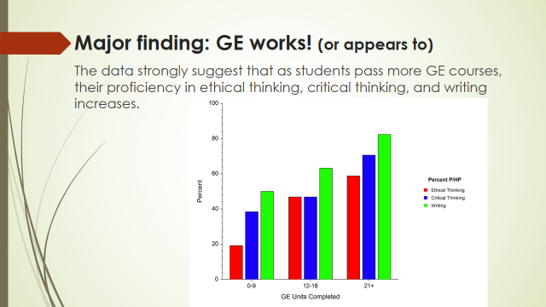

Alex’s thoughts about what it means (as of April 9, 2014):
- The study could be redone better, but still the results are meaningful.

- Ideas for more research:
  - same focus on ethics with more non-GE faculty participating + other improvements
  - similar study with focus on GE SLO 5 (diversity) instead of ethics

- Renew professional development efforts around ethics, critical thinking, and writing.
  - In GE, bump up our ethics teaching a notch. Ask more of our students when it comes to them demonstrating their ability to think through an ethical issue.
  - Work with new Professional Learning Facilitator.

- Regarding the new requirements for the local AA/AS, eliminating the ethical inquiry requirement and the communication & critical thinking box was not justified by this study.

- Learn more about the population that does the local associates degree, and design our program for them.

- Visit the GE Committee to share your ideas! Apr 18, May 2, May 16. All 2:30-4 in room L-105. asterling@losmedanos.edu.

