Present: Sara Toruno-Conley (English Faculty); Interim Chair; Voting Members: Jeffery Bui (LMC Associated Student), Tess Caldwell (English); Cindy McGrath (Journalism), Robert (Bob) Moore (Science Faculty); Diwa Ramos (Math Faculty); Ryan Tripp (Social Sciences Faculty); Non-Voting Members: Rikki Hall (Director of Admissions & Records); Natalie Hannum (VP of Instruction), Ryan Pedersen (Dean of Instruction: Math & Sciences), and Shondra West (note taker)
Absent: Christina Goff (Librarian); Morgan Lynn (English Faculty, Curriculum Chair); Adrianna Simone (GE Chair)
Guest:

Meeting called to order: 1:03 pm Location: Online – Zoom Meeting

CURRENT ITEMS
- Welcome, Public Comment and Announcements:
- S. Toruno-Conley shared an upcoming webinar series focused on Cal IGETC and AB928 will be offered by ASCCC scheduled on various dates: Sept-October.
- N. Hannum share a roadshow is underway regarding Cal IGETC to update the community college constituents. The new Cal IGETC goes into effect 2024-2025 school year.

- Approval of the Agenda - Action: Approved (M/S: B. Moore/D. Ramos); unanimous

- Approve Meeting Minutes Aug 24, 2022
Action: Approved with name correction from R. B. Moore to B. Moore. (M/S: D. Ramos/R. Tripp); unanimous

- GE Catalog Update
The committee discussed making changes to the LR2 a and b statements noted in the catalog. The discussion included why the changes were needed, which was to correct the ordering of the a and b statements and match the GE document. The committee reached a conclusion to make the following edits:

- The LR completion is for students to complete LR1 English and LR2 Communication and Analytical thinking. However, the LR2 has an (a) and (b) that students are required to complete one. With the exception that students can satisfy the analytical section with high school math or transfer math equivalency.
- Revise the statement “satisfy one of the following” students are required to meet the requirement.
- Switch LR2a communication and LR2b analytical thinking to LR2a analytical thinking and LR2b communication
- Remove the information below from under communication and add it to the analytical thinking section:
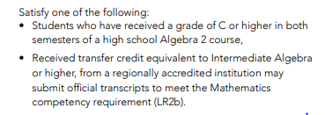
- Add an “and” after spch 120
- Revise the “satisfy one of the following” statement
- Add “critical thinking” wording after communication
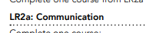
- Revise the statement underneath LR2 to read “complete LR2a or LR2b
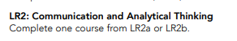
- Remove the wording “students who have” and change it to “Received a grade of C….” as a requirement instead of a selection.
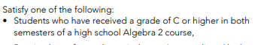
- Readjust the text and relocate it to the top or bold section so students know the requirement.
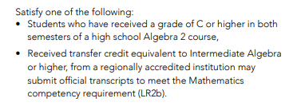
- Change the LR2b reference after the Mathematics competency requirement to LR2a
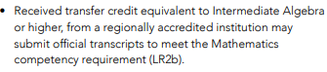
- Remove or revise the statement “complete two course”
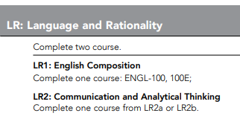

The changes will be brought to the next meeting for review and editing.

- Incoming GE COORs: Review any COORs needing GE Review
The committee members were assigned to break out rooms to complete the respective GE COOR review.

- GE COORs Quality Check: Rubric and Course Cohort Document - Tabled

Meeting adjourned at 2:36 pm

