Revising a Course in eLumen

Login
lmc.elumenapp.com Login using your portal login
- Click on the Curriculum tab at the top of the page.
- Click on the Curriculum Library
- Type in the course you would like to revise in the Subject Code and Number box (no dashes)
- Click the box next to your course name and select “New Revision”
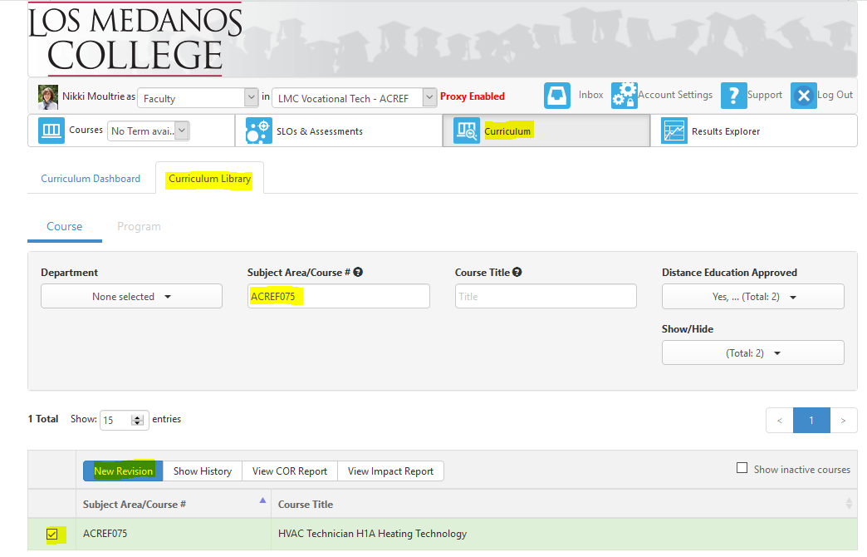
There will be a pop up for you to select an option – Select “Course Revision for All Courses”
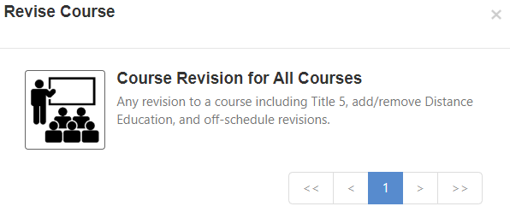

  - There are eight tabs (steps) for revising a course. You will automatically be put in the “Step View” with tabs.

Tab #1 - Cover Info

General Information
Subject Code/Number, Course Title, TOP/CIP/SAM, your department, and course description will all be prefilled. Update your course description here. Most other areas should not be edited.

Faculty Requirements (previously Courses to Disciplines)
Drop down menus – at this time the drop down menus do not separate options into masters/non-masters. Here is the most recent edition of Minimum Qualificators for Faculty https://asccc.org/sites/default/files/Minimum_Qualifications2018.pdf

Proposal Details
Initiator – “Add Additional Contributors” if more than one person initiating the course revision
Effective date – always choose the next catalog, summer. Currently, Summer 2021
Submission Rationale – Dropdown choices. For a Title 5 revision (5 year review) use “Mandatory Revision”
Notes for submission – Include what items you will be updating, formerly on the “Cover Sheet to Changes to an Existing Course Outline of Record” form. Sample “Title 5 review, updated description, SLOs/content, added updated assignments, and Prerequisite/Co-Requisite, etc.” Please note that whatever is typed in this box will be on the course outline of record.

Attachments

Upload Online Addendum Form and/or Prerequisite/Co-requisite Validation Form for review and approval. Please note only the most recent approved documents will be attached to the Course Outline of Record.

Cohort
Cohort Number – Dropdown choices. Indicate the cohort year as it relates to the Program Review Process.

Tab #2 - Course Development Options

More Options
Most items will not be changed in this screen unless you are adding Credit by Exam.
Grading Code = Dropdown choices. Select all that apply.
Course Support Status (CB26) – Select either (S) Course is a support course or (N) Course is not a support course. Most courses outside of MATH/ENGL will be (N).
Section Size – Class Maximum – This is a new field in eLumen and will most likely be empty. The Tech Review Committee will fill in this information for you if it is blank.

Transferability & Gen. Ed Options
Course General Education Status (CB25) – Dropdown choices - select appropriate option.
Coding A = Course meets any of the following:
- CSU General Education Breadth Area A2: Written Communication
- CSU General Education Breadth Area A3: Critical Thinking
- UC IGETC Area 1A: English Composition
- UC IGETC Area 1B: Critical Thinking-English Composition OR
- Course has a general education certification or articulation agreement that ensures the course fulfills English composition requirements at an accredited four-year institution OR
- Course fulfills local general education requirements for English Composition as outlined in Title 5 Section 55063
Coding B = Course meets any of the following:
- CSU General Education Breadth Area B4: Mathematics/Quantitative Reasoning
- UC IGETC Area 2: Mathematical Concepts and Quantitative Reasoning OR
- Course has a general education certification or articulation agreement that ensures the course fulfills mathematics or quantitative reasoning requirements at an accredited four-year institution
Coding C = Course is not transferrable to fulfill general education mathematics or quantitative reasoning at a four-year institution, but fulfills local general education requirements for Analytical Thinking or Mathematics Competency as outlined in Title 5 section 55063.
Coding Y = Not Applicable (Not a General Education Course)

Request for Transferability (CB05)
You may add requests for transferability or GE patterns in this area. Additionally, request for C-ID should be entered here.

Tab #3 - Units and Hours
Credit/Non-Credit Options
Most courses are credit so the first box should be correct and no additional boxes should be checked. For non-credit courses, information in this box should pre-fill. Funding Agency Category (CB23) should always be “Not Applicable”
If the course has variable units, make sure that box is checked.
Hours and Units in eLumen are very different than they were in our paper process. At this time, we ask that if you want to make a change to hour and/or units, you indicate such change in the “0 Comment” box at the bottom of the page. The change will be completed by the Curriculum Specialist at the Tech Review level.

Tab #4 - Pre-requisites and Entrance Skills
Pre-requisites, Co-requisites, Anti-requisites and Advisories
If you need to add a pre/co-req or advisory click “Add Group” and then “Add Requisite”
Choose your requisite type and chose your requisite course. If it is an “Advisory” type information in the text box to the right. We will confirm everything in tech review.

Entrance Skills (also Course Note)
You can edit/add/remove a course note here.

Limitations on Enrollment
You can edit/add/remove a limitation here. Mainly used for auditions, tryouts, etc.

Tab #5 - Specifications

Methods of Instruction
Choose all that apply from the drop down menu. At this time a rationale is not required.

Assignments
The textbox should be in the assignment box from the initial import. Please do not edit the first column, add/edit your assignments in the Description column.
Two college-level reading and writing assignments are required. If your course has laboratory, the “lab or field activity, product, and/or report” is required. If the course is 100% laboratory, no additional assignments are needed. If your course has HBA, the “specific example for Hours by Arrangement” is required. Referencing a CSLO increases the flow and contiguity of the outline.
These assignments should read like actual in class assignments. Reading assignments should reference comprehension after reading college-level material: “Read the chapter on….and be prepared to discuss…” Writing assignments should include a page length and incorporate college-level writing skills “In a three-page paper…”
Assignments should be linked to CSLOs, similar to our previous COR. Just put the CSLO (or more than one CSLO if necessary) in parentheses at the end of the assignment description.
Reading #1 Example: Read Jonathan Kozol’s text, “Savage Inequalities,” Jeannie Suk Gersen's article, "The Uncomfortable Truth About Affirmative Action," and the series of articles exploring affirmative action decisions in the Supreme Court. Be prepared to make an informal presentation regarding the kinds of support each side uses as well as a critique of the effectiveness of that kind of support. (CSLO 1, 2, and 4)

Methods of Evaluation
Provide representative assessments for measuring CSLOs (typically example test, homework or laboratory questions or exercises). The evaluation of higher critical thinking skills should be emphasized, therefore only one true/false or multiple-choice question will be accepted. You are required to give two examples. Choose all that apply from the drop down menu.

Major Essays | 75%
Smaller Assignments (journals, quizzes, etc.) | 10%
Completion assignments (rough drafts, class  participation, etc.) | 10%
Final | 5%

Equipment
Items such as calculators, graphing paper, swimsuit, yoga mat, etc. should be included in this box.

Textbooks
Follow formatting listed on page, textbooks should be college-level and published within the past five years. Classics accepted on a course-by-course basis. Indicate (Classic) after title. If the text has an edition, place after the title. Science courses that include a laboratory component must include a laboratory manual. Laboratory manuals should be clearly noted as such. Publisher and ISBN are not required. If possible, two textbooks are required.
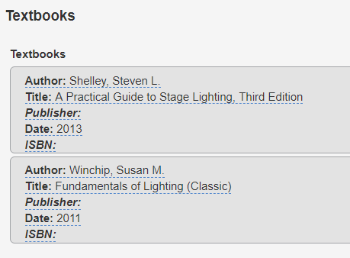

Other Instructional Materials
Additional items suggested for the course, i.e. novels, readers, articles, online resources, etc.

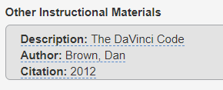

Material Fee
If required, format as follows: $... for…

Tab #6 - Learning Outcomes
Course Objectives – DO NOT USE
Course Objectives = Course Student Learning Outcomes (CSLOs)
CSLOs should finish the sentence “Students will be able to…” and begin with a Bloom’s Taxonomy verb. The standards to use when revising/evaluating CSLOs is that if you gave the CSLOs and course content (next tab) to a new adjunct instructor, could they teach the course using the listed CSLOs/course content.
Each CSLO will have their own box and the Expected CSLO Performance should be 70. You can edit, delete, and add CSLOs in this screen. If the course contains both lecture and laboratory you must designate the laboratory SLOs with (Laboratory).
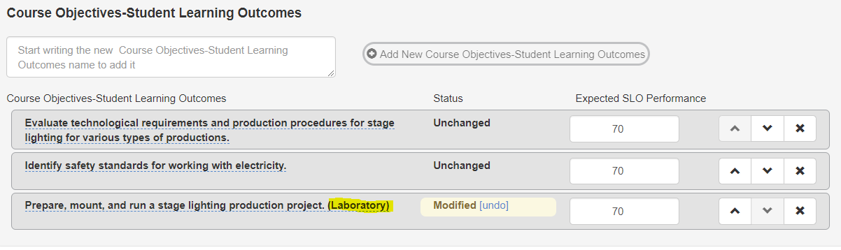

Tab #7 - Outline (Course Outline/Course Content)
eLumen does not have the capability to format an outline beyond numbers. You can select the number option to create levels. If your course has laboratory, click the laboratory content box and put your laboratory content in that box. 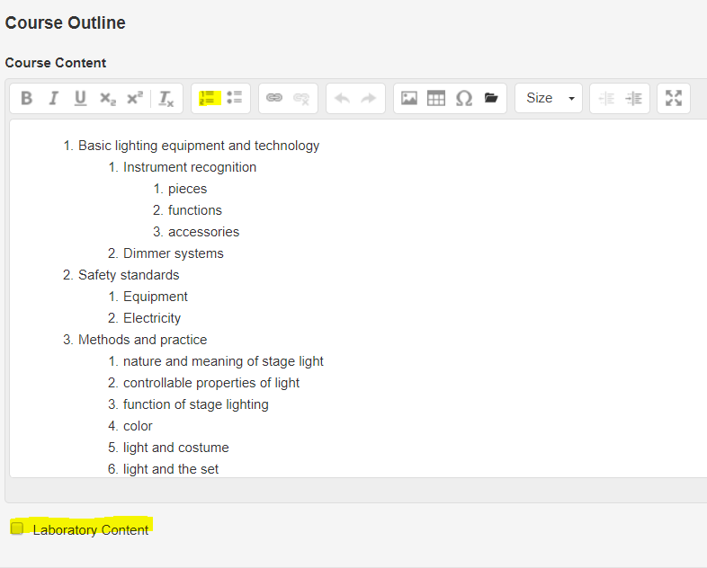

Tab #8 – Curriculum Technician
Information in this area is not editable and is used only by the Curriculum Specialist once your course is approved by the Curriculum Committee.

Submitting Your Course
You can click “Save as Draft” if you are not ready to submit the course. You can always access it in your Inbox. If you would like to review your entire outline again, click Continue Workflow and “Outline View” – this will allow you to see the entire outline on one page.
When you are ready, click “Submit” and a pop up will ask you to confirm and will tell you where the course outline is going next.
eLumen will email the next person in the approval process at the end of the day.
You can check on the status of your course by click on the Curriculum Button and Curriculum Dashboard. The Workflow Status will tell you who is the current reviewer/approver.

