The Next Step in Diversifying the Faculty
By Rafael Walker October 23, 2016
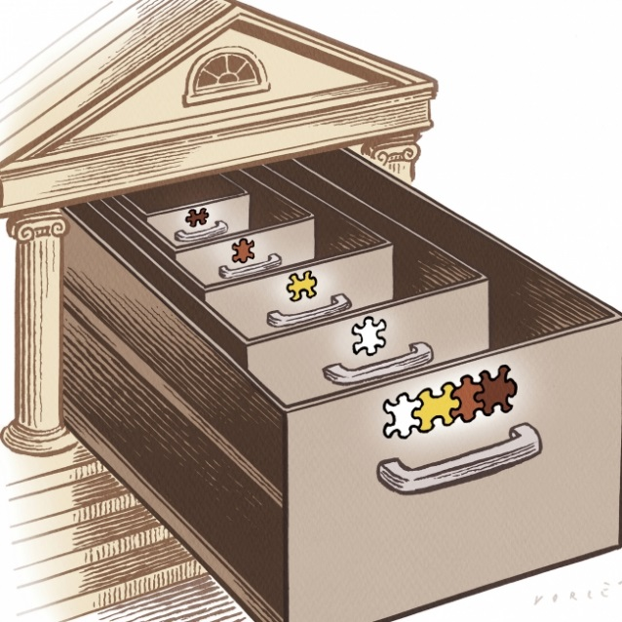
Christophe Vorlet for The Chronicle

These days there’s no escaping discussions about the need to diversify academe. So it should be. A recent addition to this brimming conversation was a widely discussed essay in The Hechinger Report from Marybeth Gasman, a professor of higher education at the University of Pennsylvania, in which she argued that there aren’t more people of color on faculties for a simple reason: Colleges and universities don’t want them.
Gasman’s essay certainly sheds light on the more deplorable side of the problem, but, at this late date, I do not believe it fair to conclude that all or even most institutions flatly do not want faculty members of color. The benefits of diversity are too familiar to us today to hold such a position.
If we cannot attribute all of the hindrances to faculty diversity to discrimination, to what do we attribute the rest? I suspect that there may be a more unconscious and less damnable, if no less serious, side to the dilemma — one that has to do both with how we measure diversity and with how we mentor minority students.
When we measure an institution’s diversity, we typically calculate the proportion of that institution’s faculty coming from historically underrepresented groups. Such calculations are also performed at the departmental level since, of course, if each of the departmental units constituting the university has proportionate numbers of minority faculty members in their ranks, the institution as a whole will, too.
Simple math, right? Not quite. While these measurements successfully capture the diversity within a department, they fail to capture the diversity within that department’s subfields. For example, if Diversity U.’s history department has 30 faculty members, and five of them are black, we would, following standard practice, report the department as having fulfilled its racial-diversity goal for black faculty, since its proportion roughly mirrors the black proportion of the nation at large. It wouldn’t matter one mite to this metric that all five of those black faculty members specialize in African-American history.
But it should matter. For one, advocates regularly cite diversity’s capacity to enrich learning through increasing the number of perspectives. Since the majority of conversations occur among people in the same subfield, can a department or discipline that increases the proportion of minority faculty members by concentrating hiring in one particular subfield, like at Diversity U., justly be understood as diverse?
Sadly, this scenario is not merely a thought experiment, for subfields in the humanities are anything but diverse. I examined the faculties of the nation’s top 20 English and history departments (as ranked by U.S. News & World Report), focusing on three subfields — medieval, early-modern Europe (also known as Renaissance in English), and 19th-century British (or Victorian). For English, I inspected a total of 21 departments and found that only one department had a black faculty member working in any of those three well-established subfields. History departments performed slightly better on this diversity measure, but only slightly: Of the 22 departments examined, only three had one black faculty member — and, in each case, only one — specializing in any one of the three subfields.
Why is there such a glaring paucity of black faculty specializing in these subfields? Why are they gravitating instead to subfields relating to African or African-American culture? Part of the reason is surely self-selection: People like doing work that they can identify with. But self-selection alone cannot explain asymmetries of this magnitude. My own experience as a black academic has shown me that much more than student choice is at work here. While a number of aspiring black academics self-select into African-American subfields, countless others are pushed into such subfields by well-meaning mentors and by the profession’s larger socializing effects.
As many can attest, the decision to go to graduate school for a Ph.D. is rarely reached independently. Applicants to doctoral programs are usually high-performing students in a particular major who impressed their teachers enough for these teachers to recommend graduate school — a ritual resembling a laying on of hands. What is true for the standard applicant to graduate school is doubly true for minority applicants, who are likelier than their majority peers to be first-generation graduates and who therefore tend to be less knowledgeable about the arcane inner workings of academe.
Mentoring relationships usually form along lines of mutual identification, with the result that minority students commonly end up being mentored by faculty members who share their demographics. If personal demographics inform scholars’ choice of subfield in the humanities, and if it’s customary for apprentices to follow their mentors, the homogenization of subfields can be understood as part of a hard-to-break cycle.
But what happens to the minority aspirant who considers breaking that cycle? One would think, in light of the profession’s enthusiasm about diversity, that such a maverick would be encouraged. But in my experience, this has seldom been the case.
I entered graduate school with plans to study white women in 19th- and 20th-century American literature (and I did). In the early months of my first year, the black faculty members in the department were quite nice to me, offering valuable unsolicited advice and even inviting me places. These easy relations came to a halt once it became clear that I wasn’t going to convert to a full-fledged African-Americanist.
Over the years, I’ve lent an ear — and shoulder — to a number of other guilt-ridden minority graduate students who had hopes of specializing in one of the many white-dominated subfields but who were fearful of upsetting advisers past or present. Without exception, these folks all opted to appease their mentors and pursue subfields consistent with their demographics. Well, I suppose there is one exception: the young woman who abandoned the profession altogether.
I am not suggesting that there is anything wrong with people choosing fields of inquiry based on their identities; indeed, some of the best work results from passionate identification. However, identity should enrich, not restrict, one’s interests, and, besides, identity certainly encompasses much more than what we check on the census boxes.
Beyond its personal effects on aspiring minority scholars, failing to attend to the diversity of subfields also has profound institutional implications. By neglecting the diversity within subfields, we unwittingly limit our ability to diversify academe by any measure — even by the crude metric that I’ve mentioned. The superficial kind of diversity that Diversity U. boasts would be nigh impossible, since it’s improbable that a history department of 30 could comfortably support five tenure lines in African-American history. In any department, there are only so many slots that can be allotted to any given subfield. If minority graduate students are being trained to fill slots in only a few of those subfields, once those subfields reach saturation, departments won’t be able to continue adding minority faculty members, since there won’t be any such candidates in the pool to fill the other vacancies.
Perhaps the reason that the diversity of subfields remains under-examined is that the consideration strikes people as premature. At this stage of the fight, skeptics might reason, let’s just concentrate on getting minorities into the institution one way or another and worry about subfields later.
However, because of the cyclical nature of this problem, not worrying about it now will make it all the more difficult to fix later. There are steps that could be taken immediately to address these disparities. At the individual level, faculty members in homogenous subfields could begin reaching out to their talented minority students, and at the institutional level, colleges could encourage their departments to identify and create target searches for their homogenous subfields. The problem will sooner or later become ineluctable. Why let it get to that point?
Rafael Walker is a critical-writing instructor at the University of Pennsylvania.

