Tenure-Track Wisdom: Emily Van Duyne
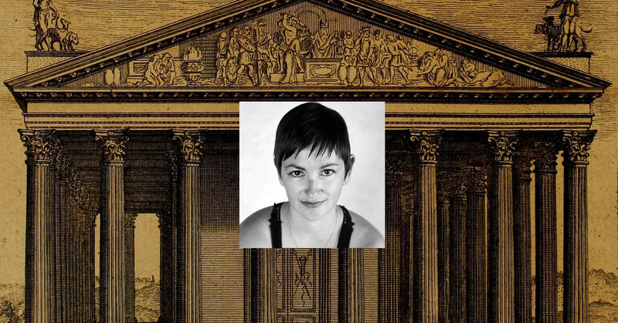
October 12, 2016
Image: Emily Van Duyne and the Temple of Diana
Here is the latest in a series of interviews with new assistant professors on their first year on the tenure track. This month, I spoke with Emily Van Duyne, an assistant professor of writing and first-year studies at Stockton University, in New Jersey. She has recently written for The Chronicle about the policing of women’s bodies in academia. Check out her blog, or catch up with her on Twitter at @EmilyVanDuyne.
Dan: Tell us about yourself. How do you see yourself as a scholar, and what do you research?
Emily: In my Vitae profile, I describe myself as “a mongrel scholar,” and that feels entirely accurate in content and tone. In the critical-thesis semester of my MFA, during which I had to write a 50-page essay about Plath, I realized, “Oh, wait, I wanna get a doctoral degree and do this like, forever.” For various personal reasons (love/love disasters/pregnancy/single motherhood) that didn’t happen. Adjuncting, though, ended up being a giant (and often painful) blessing in disguise, because it forced me to think critically about the interconnectedness of systems I had benefitted from my entire life — education, economics, race, and gender, to name just a few. At that point, before I realized it, the academy itself became, and remains, my area of research: chiefly, the role of contingency within it, but also how that intersects with feminism and motherhood.
That said, I am also a poet, essayist, and critic. I’m at work on a manuscript about Plath as a cultural icon and on a memoir of a reading life. I have a manuscript of poems that I need to send out, and a manuscript called Laminations, which was a blog that turned into a serial romance about dating as a feminist single mother; it’s under consideration at several presses. I’m working on a memoir called None Of That: Loving A Psychopath, about, well, loving a psychopath. And most recently, and excitingly, I’m editing with Jillian Powers a collection of essays on contingency in higher education, to be called The Precariat & The Professor.
Dan: Tell us about your current position. Where do you teach, what’s your teaching load, and do you have service responsibilities?
Emily: I teach at Stockton University, which is a regional public university, kind of like a public Antioch College, in the New Jersey pine barrens. Until 2014, it was Stockton College, and the change definitely feels like more than just in name. Since I was a student at Stockton for a year back in 1999, it has acquired several satellite campuses, numerous graduate programs, and more than doubled its student population.
I teach a 3-3 load of four-credit courses, like all my colleagues — although this past year I had a course release in the fall and spring semesters, for various reasons. I also teach in a four-week intensive summer program for entering freshmen.
I have a lot of service responsibilities, like every faculty member at Stockton, and especially faculty in first-year studies, which is a service-heavy program. This past year, I wrote the five-year review for the minor we offer in women’s, gender, and sexuality studies. I organized and moderated a panel for Stockton’s International Writer-in-Residence program, sat on the assessment and advising committees, wrote a long internal report for my home program based on a survey we gave to faculty, staff, and administrators — the list goes on and on.
This fall, I’m taking over as coordinator of first-year writing — which is a big job — mostly because it involves scheduling the largest group of adjuncts at Stockton. But I’m more than happy to do that, as it’s in line with my scholarship, and my heart.
Dan: What was your path from the M.F.A. to Stockton like?
Emily: In a word, weird. I had no intention of becoming a professor. I taught a class at a community college in fall 2009, after finishing my M.F.A. I figured, what the hell, it can’t hurt. But I fell in love with it. Teaching centered and grounded me, and made me a better thinker, writer, and human being. I had a preternatural sense that if I just stuck with it, I’d get a full-time job, and luckily, that happened — but not without basically everyone in my life (and out of it on the Internet) telling me I was crazy to stay, that being an adjunct is like being in an abusive relationship. But the thought of leaving college teaching left me feeling bereft, like I was bailing on the thing that had given my life shape and meaning. So I stayed. I just kept picking up classes, and by fall 2013, I was teaching 24 credits a semester.
I began writing about that in 2013, and published several columns on contingent faculty at Adjunct Nation. That led to a long open letter titled “Why Buy the Cow?” which I posted to my personal blog on January 22, 2014, (the night before my birthday). I linked it to my Facebook page, and went to sleep. When I woke up, the post had almost 500 unique visitors in less than 12 hours, and another 500-plus by the end of the day. ... My dean emailed me to say he had admired the piece, and that “everyone” was reading it. That coincided with an opening for a one-year full-time position in my program. The same day I interviewed for that job, I had a phone interview with The Atlantic about working as an adjunct. I said to the reporter, “Well, I wrote this open letter,” and she said “I know! I read it, I loved it.”
And I just thought: “How is this my life?” For so long, it felt like I was shouting into a void, and then suddenly, people were listening and responding. In any case, I got the job, and then the following year, I was hired on the tenure track, the job I currently have.
Dan: What was it like to go from adjunct, to visiting faculty, to tenure-track faculty at the same institution?
Emily: Lovely and disturbing. Lovely in that I got what I so badly desired — I became a real boy! I no longer felt like a fraud when I called myself a professor. That alone was pretty damn great. But disturbing in that it illustrated more sharply, and in many ways proved, the feelings and theories I had about the relationship adjuncts have to their workplaces.
All of the sudden, people saw me. That was the hardest part. People I had seen and nodded at on the campus 1,000 times were like, “Oh, did you just finish your degree? What institution were you at before?” More than that, they listened to me. They asked me questions. They believed me to have an authority they had previously disregarded, if they noticed me at all. I do want to be clear that members of my home program are exempt from this; I had quite a few champions in my time as an adjunct at Stockton. But the difference between being adjunct and full-time can’t really be overstated, I think.
Beyond that, I have institutional support now, in addition to a salary and health benefits for myself and my son. So I am able to travel to conferences, and write in the summers — in fact, I’m encouraged to. That is an extraordinary difference that, again, cannot be overstated.
I hate the idea of being a token — “the little adjunct that could.” It’s ludicrous to imagine that my being hired changed anything for adjuncts at Stockton. It did not. It changed my life, certainly, but my desire to further interrogate contingency in higher education did not change. In fact, it increased.
Dan: What did you learn about teaching and scholarship during the past year?
Emily: That I am not as good a teacher as I thought I was, and that I want to write 20 books about everything under the sun. That I wish I had a Ph.D., and not just because of imposter syndrome, but because I wanted the opportunity to have that kind of sustained, concentrated study about one thing, and the ways that that one thing relates to the world around it. I think I would have loved that.
But scholarship happens in many ways, and for me it has sort of happened, and continues to happen, on the job.
Dan: What do you wish you had known going into your first year on the tenure track?
Emily: That if you can say no to things, the earth isn’t going to swallow you up whole. I mean, I could write a million things about how gendered service is, but the truth is, while that’s entirely real, we also have to make choices to combat that stereotype and that reality.
I have often felt, in this past year, like I was being asked to perform superhuman feats of work, on multiple levels — teaching, scholarship, creative work, service, being a sympathetic ear to my students — and then go home and be a mom and a partner, and attempt to have some kind of social life.
And there’s this sense (possibly magnified for me, since I was an adjunct) that we should all be really, really grateful for the opportunity to kill ourselves with labor since the jobs are so rare, and since so many of us just love to teach and write and stay in college forever. It is probably a cliché, but I think I could have said no to several things, and my tenure file would have been none the worse. And I would have had more time for … food? Sex? Reading to Hank (my son) & Stella (my stepdaughter)? Jogging? My cats? All of that.
Dan: What are you looking forward to next year?
Emily: Attempting to make the previous paragraph part of my lived existence! Also, finishing my memoir, and the Plath manuscript. I just did a panel on her with Karen V. Kukil, who curates the Plath and Woolf collections at Smith College, and I’m going there in the fall to do research. Becoming a better teacher. Continuing to love and be loved by Vincent, my wonderful partner, who makes my life possible. Working on the adjunct symposium I’m helping to facilitate at Stockton in spring 2017. Taking the kids to Harry Potter World. Hank starting kindergarten. Continuing to work at my dream job, with a host of insanely smart, kind, fascinating people. And not electing Donald Trump president of the United States.

