September 6, 2016

To The President Of The Academic Senate Of Los Medanos College

I am writing to let you know that I am interested in serving on the Safety Committee at Los Medanos College. I have no prior experience in this field, and I would like to contribute and learn what is being done at our college in terms of safety and prevention.

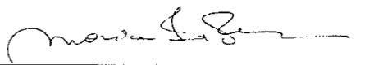
Respectfully,

Maria G Perrone
Mathematics Assistant Professor

