College Presidents Say Race Relations Are Just Fine (Students, Not So Much)
By Hayley Munguia
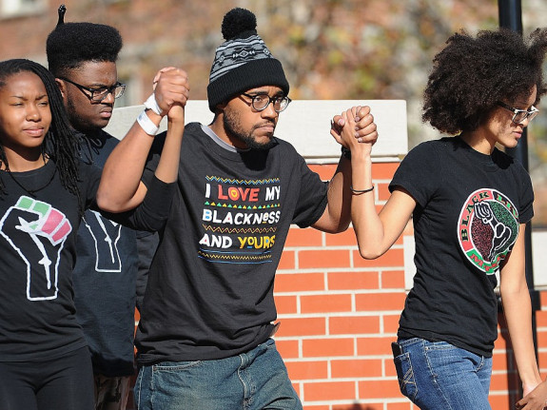
University of Missouri students celebrate the resignation of University of Missouri System President Tim Wolfe amid allegations of racism.
Michael B. Thomas / Getty Images
Despite the recent wave of campus protests over racism, a vast majority of college presidents believe race relations on their campuses are good — and the share of presidents who believe it is even higher this year than it was last year.
Students aren’t nearly so optimistic, as the protests at campuses such as Yale and the University of Missouri have demonstrated, and as separate survey data shows. My colleague Leah Libresco has written about student demands to address race relations on campuses nationwide; the most common request is a more diverse faculty.
The data on college leaders’ attitudes comes from the sixth annual Survey of College and University Presidents from Inside Higher Ed and Gallup, which covers 727 presidents at public, private and for-profit institutions.
The survey also asked the presidents about things like the financial health of their institutions and their views of President Obama’s performance on higher education, but the questions on race relations give the first comprehensive look since the fall protests at how administrators are thinking about these issues.
Eighty-four percent of the presidents surveyed said race relations on their campuses were good or excellent — a 3-point increase from last year. When asked how they thought race relations on campus today compare to five years ago, 69 percent said they’re about the same or better. Notably, presidents believe their own campus is doing better on the issue than others across the country, but the overwhelming majority still believe that race relations are “fair” or “good” on campuses nationwide.
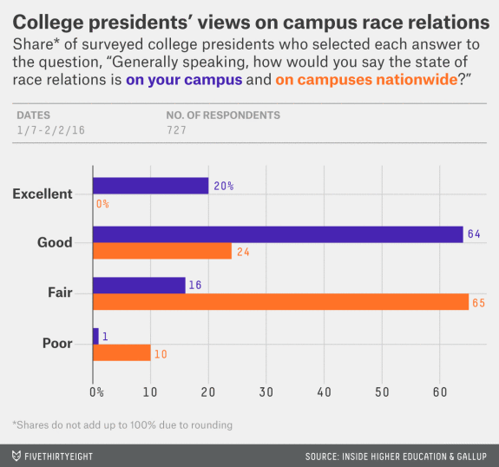
College students don’t feel quite the same way. A survey of 19,580 students at a mix of 26 colleges and universities found that 57.5 percent said they had witnessed discrimination on campus, and 41 percent of those who had experienced discrimination said it was based on race. (The survey, from UCLA’s Higher Education Research Institute, focused on questions of diversity on campus; it was conducted between October 2014 and June 2015 — before widespread campus protests began in the fall.)
A five-year study, also from UCLA’s HERI, found that discrimination was pervasive on the least diverse campuses, those with less than 20 percent minority representation.¹ At least half of African-American and Latino students at these schools said they had experienced discrimination in the form of verbal comments.
According to the National Center for Education Statistics, colleges across the U.S. are becoming more and more diverse. From 1976 to 2012, the share of white students fell from 84 percent to 60 percent, while the share grew for all racial minorities.
But things haven’t changed as much at the administrative level. The American Council on Education conducts a study of college presidents every few years, and in 2011 (the last year available), the council found that only 13 percent of college presidents were racial minorities — a 5-point increase from 1986.
“In 1986, the first year of ACE’s college president study, the demographic profile of the typical campus leader was a white male in his 50s,” the study’s author, Bryan Cook, wrote. “He was married with children, Protestant, held a doctorate in education, and had served in his current position for six years. Twenty-five years later, with few exceptions, the profile has not changed.”

