Calif. Community College System Gets First Latino Boss

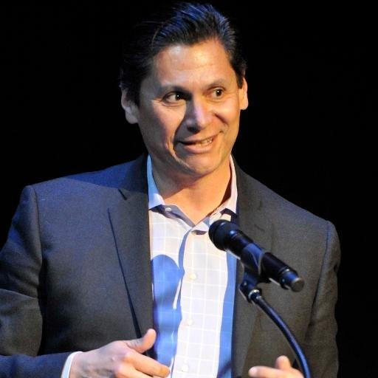
Eloy Ortiz Oakley was named the California Community Colleges' first Latino chancellor this week. Source: Twitter @EloyOakley
July 21, 2016 Natalie Gross
The California Community Colleges Board of Governors voted unanimously this week to appoint Eloy Ortiz Oakley as the system’s next chancellor. This decision marks the first time a Latino has been at the helm of the 113-college system, where Hispanic students make up 42 percent of the student population and represented nearly half of all new students last fall.
Oakley told the board Monday that “we must pay particular attention to African Americans and Latinos in this state,” calling them “the backbone of our workforce,” the Los Angeles Times reports. “We need to redouble our efforts as a system to ensure that every student in California has the opportunity to obtain a college credential.”
As a former first-generation college student, Oakley, 51, shares in common a background with 40 percent of California Community Colleges students — 61 percent of whom are also Latino, according to a 2014 analysis.
After serving in the U.S. Army, Oakley attended community college and later went on to receive bachelor’s and master’s degrees from the University of California, Irvine and is currently the president-superintendent of Long Beach City College.
While at Long Beach, Oakley helped establish the Long Beach College Promise, a program that guarantees students can attend the college for one year tuition free and received preferred admission status if they transfer to a California State University, writes Ashley A. Smith of Inside Higher Ed. (President Obama’s 2015 plan America’s College Promise was modeled after the Long Beach initiative.)
Oakley said he plans to promote a similar statewide version, a California College Promise, when he is chancellor and would also like to lobby for an increase in the state’s per-pupil funding of $6,000 for community college students.

With questions or comments about Latino Ed Beat, contact Natalie Gross. You can also follow her on Twitter @NGross_EWA.

