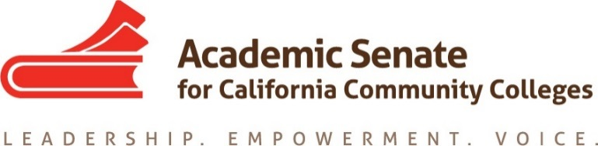

​

Good morning CTE Liaisons,

It was great to see so many of you at plenary and I am happy to report that almost all of our colleges now have active CTE liaisons. I hope that this listserv will provide some guidance and support to you as you communicate to your local senates on issues of importance pertaining to CTE. Perhaps the most pressing issue for CTE faculty right now is that of the design and implementation of the Strong Workforce Program local share plan.

The plans being developed locally are to center around two main principles—providing more CTE courses/programs and improving the quality of existing CTE programs/courses. The over-arching goal is to provide opportunities for innovation in CTE programming. In order for any plan to meet these two needs involvement of the academic senate on academic and professional matters as outlined in our 10+1 is essential.

The ASCCC has been consistently promoting the need for CTE faculty and senate involvement in this planning through dialog with senate leaders, Chief Instructional Officers, and others. One way colleges are responding to this is need is by creating a sub-committee of the senate to look at local data around CTE programming and develop the plan there.

While it is discouraging to know some colleges have begun planning without faculty input, it is not too late to engage in collegial discussions and assert faculty primacy over the 10+1 items associated with these plans. All plans are due to the Chancellor’s office no later than January 31, 2017. Currently, there is no requirement of senate approval. It is up to faculty on each campus to engage in the leadership of this planning and collegially consult with administration. Additionally, there is no requirement of local Board approval for the plan, which can save time locally.

I want to encourage all local senates to focus on putting processes in place for the development of the Strong Workforce Program local share plan and how that fund will be expended. The funding allocation model for districts was designed by the state Chancellor’s Office. If you do not know your allocation you can find it [here](http://www.doingwhatmatters.cccco.edu/portals/6/docs/sw/Strong%20Workforce%20Program%20Allocation%20for%202016-17.pdf). The Strong Workforce Program website has a plethora of resources to help with planning and is worth bookmarking on your computer. The [FAQ](http://www.doingwhatmatters.cccco.edu/StrongWorkforce/FAQ200MRollout.aspx#localshare) section can save some time and energy!

During our opening session at fall plenary one of our panelists had a great line which stuck with me and may help with messaging on this locally. He said administrators need to be reminded that “faculty are not the problem; faculty will help solve the problem.”

Please don’t hesitate to connect with me if you need further guidance.

Best,

Lorraine Slattery-Farrell

CTE Leadership Committee Chair