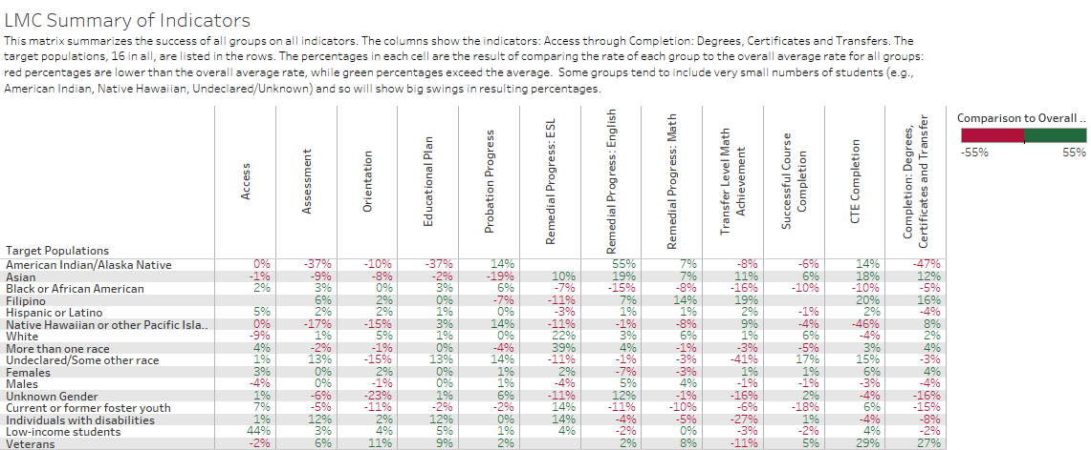

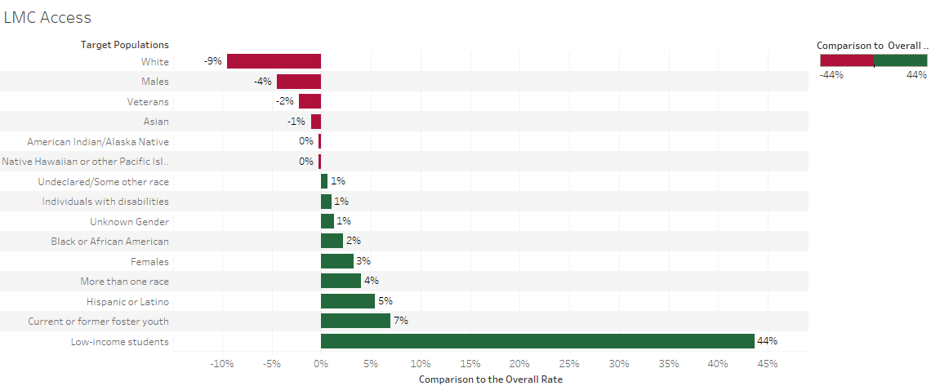

Access Definition: Compares the percentage of each group that is enrolled (2015-2016) to the percentage of each group in the adult population within the community.

Access: Three Greatest Disproportionately Impacted Groups
Whites -9%
Males -9%
Vets -2%

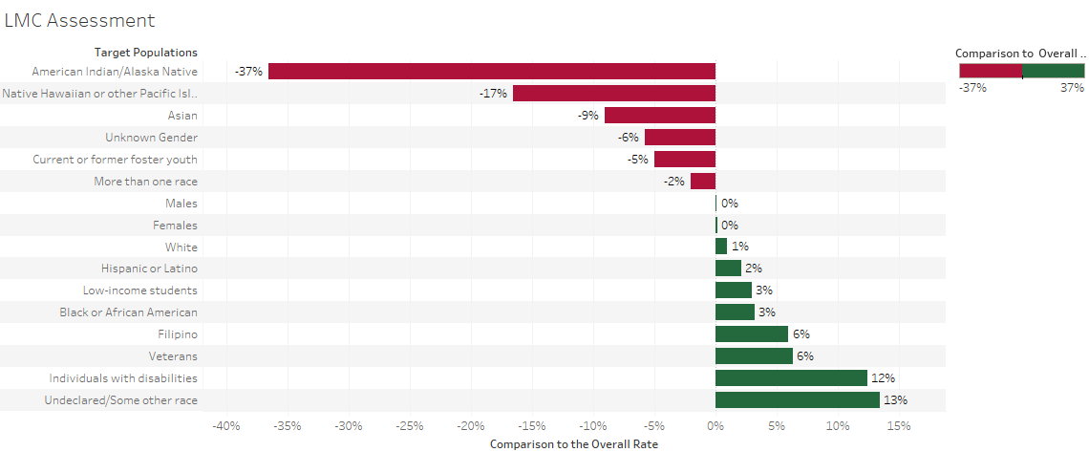

Assessment Definition: Assessment compares the percentage of each group receiving the service within one year to all FA 2016 first-time students by group. Services are: 1) orientation, 2) assessment, 3) educational plan. Percentages are also shown for students receiving all services.

Assessment: Three Greatest Disproportionately Impacted Groups
American Indian/Native Alaskan -37%
Native or Hawaiian or other Pacific Islander -17%
Asian -9%

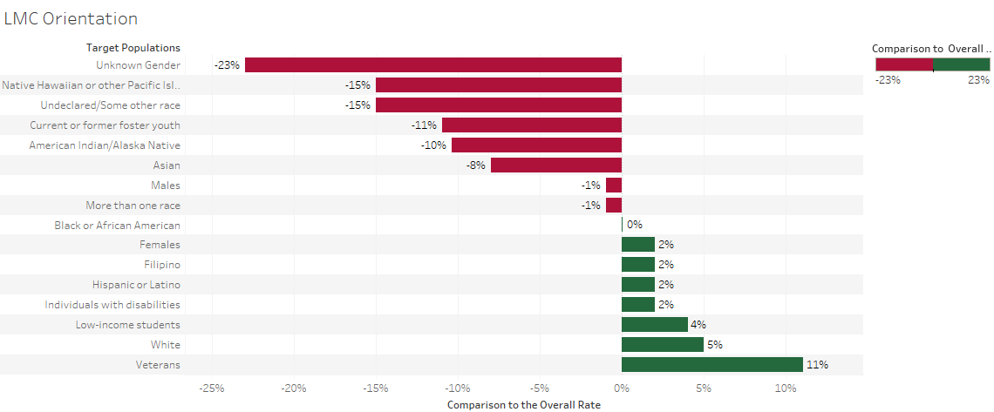

Orientation Definition: Orientation compares the percentage of each group receiving the service within one year to all FA 2016 first-time students by group. Services are: 1) orientation, 2) assessment, 3) educational plan. Percentages are also shown for students receiving all services.

Orientation: Three Greatest Disproportionately Impacted Groups
Unknown gender -23%
Native or Hawaiian or other Pacific Islander -15%
Undeclared/Some other race -15%
Foster Youth -11%
American Indian/Alaskan Native -10%
Asian -8%
Males -1%
More than one race -5%

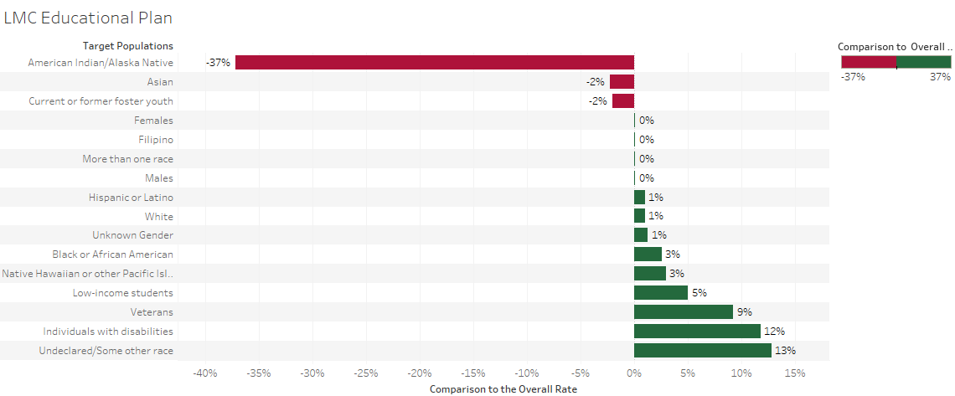

Educational Plan Definition: Educational Plan compares the percentage of each group receiving the service within one year to all FA 2016 first-time students by group. Services are: 1) orientation, 2) assessment, 3) educational plan. Percentages are also shown for students receiving all services.

Educational Plan: Three Greatest Disproportionately Impacted Groups
American Indian/Native Alaskan -8%
Unknown gender -2%
Asian -2%

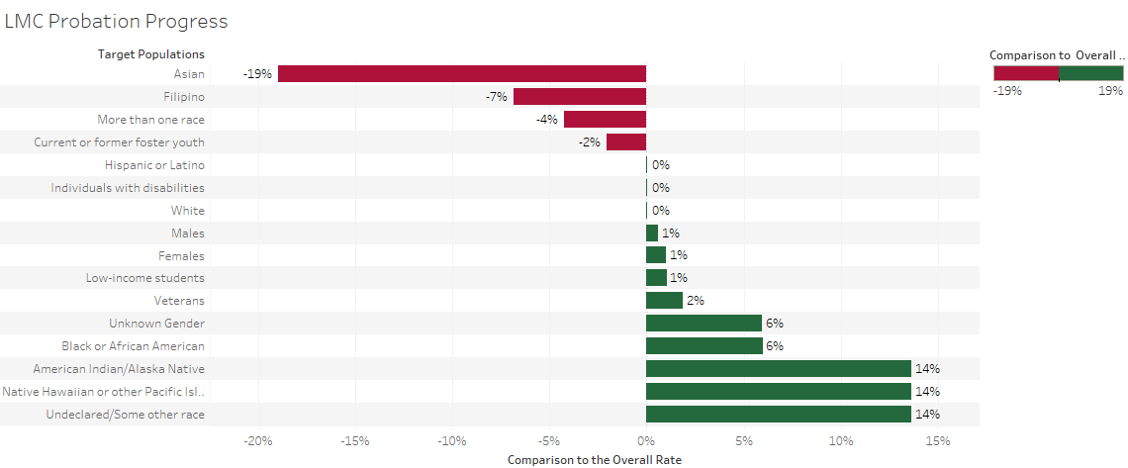

Probation Progress Definition: The percentage of students who achieved good academic standing (clear of probation) with 3 primary terms after academic probation, Fall 2016 to Spring 2017.

Educational Plan: Three Greatest Disproportionately Impacted Groups
Asian -19%
Filipino -7%
More than one race -4%
Foster Youth -2%

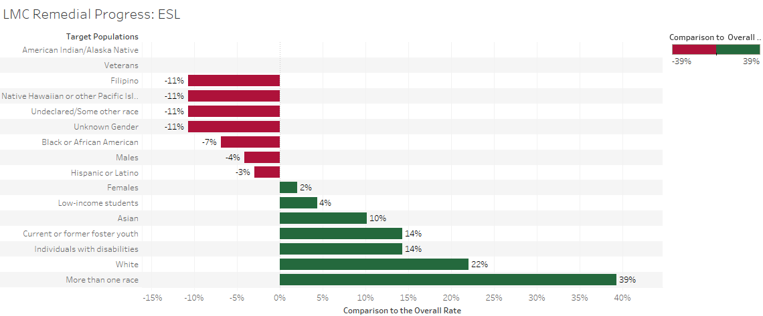

ESL Definition: Compares the percentage of credit students in each group who first enrolled in a course below transfer level in ESL and completed a college-level course in the same discipline, 2010-11 to 2015-16.

ESL: Three Greatest Disproportionately Impacted Groups
Filipino -11%
Native or Hawaiian/Pacific Islander -11 %
Undeclared/Some other race -11%
Unknown Gender -11%
Black or African American -7%
Males -4%
Hispanic/Latino -3%

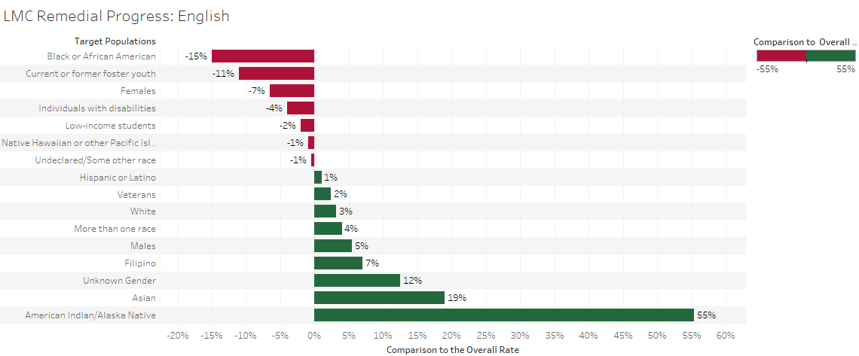

Remedial Progress English Definition: Compares the percentage of credit students in each group who first enrolled in a course below transfer level in English and completed a college-level course in the same discipline, 2010-11 to 2015-16.

ESL: Greatest Disproportionately Impacted Groups
Black or African American -15%
Current/Former Foster Youth -11%
Females -7%
Individuals with disabilities -4%
Low-income students -2%
Native or Hawaiian/Pacific Islander -1 %
Undeclared/Some other race -1%

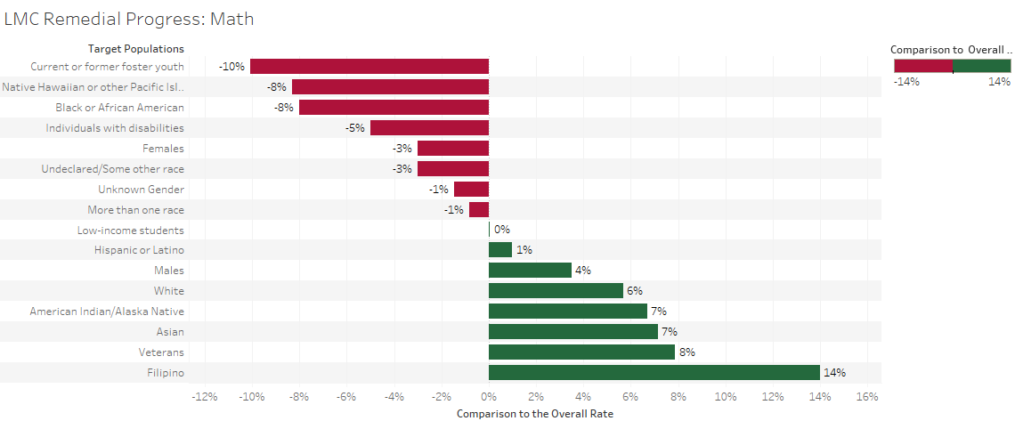

Remedial Progress Math Definition: Compares the percentage of credit students in each group who first enrolled in a course below transfer level in mathematics, and/or ESL and completed a college-level course in the same discipline, 2010-11 to 2015-16

Remedial Progress Math: Greatest Disproportionately Impacted Groups
Foster Youth -10%
Native or Hawaiian or other Pacific Islander -8 %
Black or African American -8%
Individuals with disabilities -5%

Transfer Level Math Achievement Definition: Compares the percentage of first-time students completion-oriented in each group who attempt Math their first-year and complete transfer-level Math in the first or second year, 2014-15 to 2015-16

Transfer Level Math Achievement: Three Greatest Disproportionately Impacted Groups
Current or former Foster Youth -10%
Pacific Islander -8%
Black or African American -8%

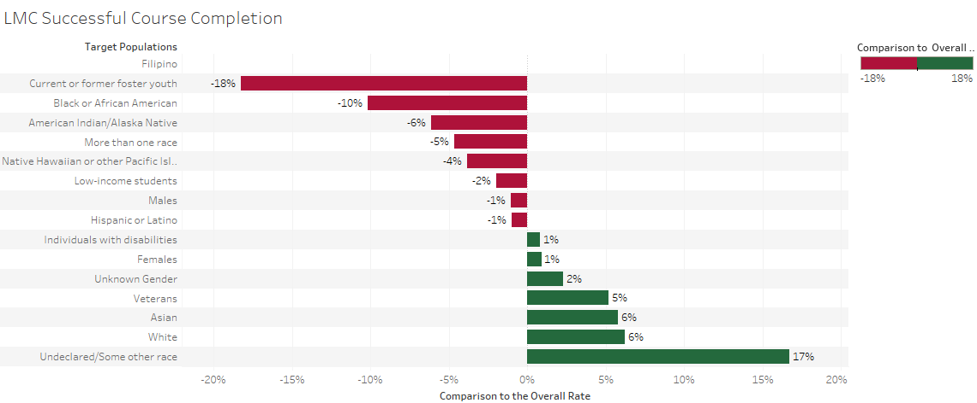
Course Completion Definition: Shows the percentage of successful credit course completions to all credit course enrollments at census.
Course Completion: Greatest Disproportionately Impacted Groups
Foster Youth -18%
Black or African American -10%
American Indian / Alaskan Native -6%

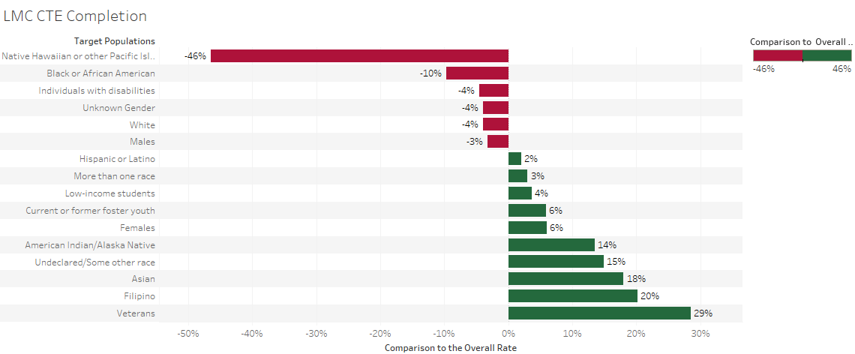
CTE Completion Definition: Compares the percentage of students completing more than eight CTE units in 2010-11 who completed a degree, certificate, apprenticeship or transfer-related outcomes within 6 years (2015-16).

CTE Completion: Greatest Disproportionately Impacted Groups
American Indian / Alaskan Native -46%
Black or African American -10%
Individuals with disabilities -4%
White -4%

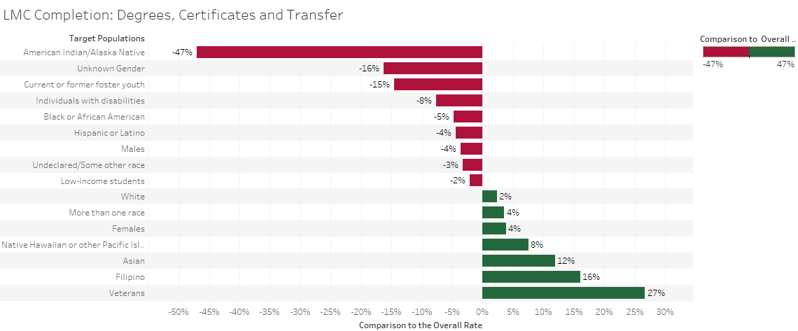

Completion: Degree, Certificate and Transfer Definition: Compares the percentage of first-time completion-oriented students who completed a degree, certificate or transfer-related outcomes within six years, 2011-2016.

Completion: Degree, Certificate and Transfer: Greatest Disproportionately Impacted Groups
American Indian / Alaskan Native -47%
Unknown gender -16%
Foster youth -15%

