An Activist Defends His Dissertation in Rap
By Fernanda Zamudio-Suaréz February 27, 2017
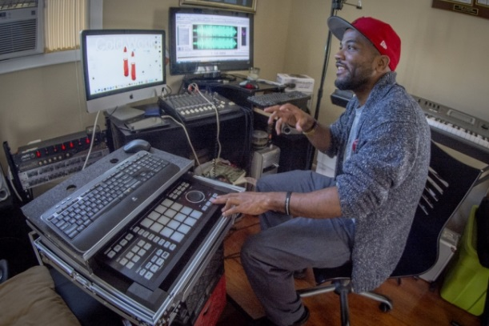
Ken Scar, Clemson U.

A.D. Carson in his studio. A doctoral student in rhetorics, communication, and information design at Clemson U., Mr. Carson successfully defended his unusual dissertation project on Friday.
"And If I’m scaring you brothers, if I’m scaring you. Just tell ’em I came to do the talking. You just came to listen."
That’s an opening line in A.D. Carson’s Ph.D. dissertation at Clemson University. Mr. Carson, a doctoral student in rhetorics, communication, and information design, successfully defended his dissertation on Friday.
In lieu of the typical paper or project, Mr. Carson created a 34-track rap album, "Owning My Masters: The Rhetorics of Rhymes & Revolutions," for the dissertation committee. His dissertation was more than just an album. His work included a timeline of social movements on campus, a blog, music videos, transcribed lyrics, and a peek into his compositional process. At his defense, he performed a four of his songs and showed one music video.
His master’s and undergraduate theses were also about music, but for his final project, Mr. Carson wanted to do something that pushed the boundaries. Drawing samples from several artists like Aretha Franklin and Buddy Rich, his album explores racism, problems in the rap community, and different facets of black lives. It also draws on his experience as a campus activist.
“My committee was careful that the work actually does the work that it claims to do.”
In April 2016, Mr. Carson was one of five students arrested on trespassing charges after they briefly occupied Sikes Hall, Clemson’s main administration building, during a nine-day sit-in on the steps of the building. The protests were organized by a student group called "See the Stripes," which called attention to the racial climate on the campus and issued a statement of grievances and demands.
Throughout the sit-in, Mr. Carson says he was working on his dissertation, and hoping that it would not only satisfy the committee but also spark a larger discussion about race, hip-hop culture, and activism.
Mr. Carson spoke with The Chronicle on Friday after defending his dissertation. The following transcript of that conversation has been edited for length and clarity.

Tell me about the different components of your dissertation.
There’s a 34-track album, a video channel, a photo gallery, and lyrics that are also transcribed on Rap Genius. There’s also a blog that has some video content. And then there’s a timeline that has multimedia links as well as bibliographical information.
What was defending the dissertation like?
There’s no way that I could perform all 34 tracks, or present all of the videos for the interactive timeline, or any of the other components that exist as part of the project. It’s really a matter of trying to explain where I’m coming from by way of different examples and rooting what’s going on in some of the literature that I’ve been engaging with over the past couple years.
How what was it like when you presented this idea to your adviser?
The program is known for pushing the boundaries and really thinking about the ways that we engage with language and in language. He [Victor J. Vitanza, a professor of English and founding director of the program in rhetorics, communication, and information design] was pretty receptive.
The challenge was really for me to find a place for myself to do the kind of work that I would like to do. And then to be responsible about presenting that work in a manner that is going to be respectful to all of the multiple genres and disciplines that are being engaged.
How involved was your adviser?
I’ve had many, many different advisers. My committee members all offered different perspectives in different ways to really make me think long and hard about the ways that my work is going to take in the digital form.
How did you get the idea to not just do an album, but a whole multimedia project?
It would be one thing to just do the album, but I think that it would be better representative of the kinds of engagement that might be happening in rap to have many of these different components. It’s not simply a matter of rap, but a kind of cultural production.
Was there one particular moment when you thought, This isn’t just an album, but a cultural production?
With the See the Stripes campaign, you realize it’s not just music and poetry, but it’s also engaging in a community. These are things that led up to the nine-day sit-in that occurred last semester and my being one of the five people who were arrested.
It’s not just a matter of music, but it’s a matter of engaging with the community in such a way that the issues that exist within the community are dealt with head-on. With hopes also to change the way that we engage with one another, but also the ways that we challenge the university and the administration to engage with us as members to this community, as students and community members here at Clemson.

When you were defending your dissertation, what did people say about this activism role your music takes on?
I realized that there were lots of people who were in attendance at the defense who were moved by the messages, the music, and the engagement in ways that I hadn’t considered.
Like what?
The fact that people left encouraged, people felt empowered. It’s not a thing that I take a whole lot of time to sit back and consider. This is a thing that we’ve all been engaged in for a really long time, that we’ve been engaging in as a community here at Clemson for the past few years.
Did you write any of these songs or blog posts after the sit-in? How did your experience with the sit-in affect the way the dissertation turned out?
I’ve been writing and posting the entire time I’ve been here, during and after the sit-in. I don’t think that anything changed as much as continued engagement as it existed before, from the beginning of the See the Stripes campaign all the way through this past October and November.
What was the makeup of the committee? How did people receive and react to the rap album and multimedia project?
My committee was careful that the work actually does the work that it claims to do. They were really receptive to taking on the challenge of working with me through it and helping me to think of some of those challenges and challenging me in those places where I needed to be. Again, I believe they did that today and they will continue to do that in the future.
One of the songs that struck me was "Grand Wizard." It pushed the boundaries a bit. How did you talk to your adviser about that song?
Obviously what comes up is the question of whether this song reproduces some of the things that the project is aiming to critique. That was a question that was even raised in a Q&A today. One of the ways of responding to that question is that that is an interpretation and hopefully while engaging that question continues to be raised. Maybe in not as provocative terms, but it is a thing that continues to come up because there is a reality of doing the project like this and then asking whether it is engaging in the reproduction of what the project aims to push back against.
"Grand Wizard" belabors that question. This thing that some people might want to call black-on black-crime, that we know to be not the thing that people want it to be when they’re deploying that term — it’s the thing that we would want to challenge when someone brings that question up of what is going on in black neighborhoods, as opposed to crime at large, or white-on-white crime.
There is that response of, "Well, this seems to be an odd choice." That choice is deliberate. And hopefully people are engaging with that question rather than just dismissing it as a misstep or being apathetical or being hypocritical.
Fernanda Zamudio-Suaréz is a web writer. Follow her on Twitter @FernandaZamudio, or email her at fzamudiosuarez@chronicle.com.

