Los Medanos College
New Instructional Program Proposal – Phase 2

Criteria A. Appropriateness to Mission
- Statement of Program Goals and Objectives:

Transit agencies across the nation are facing issues of retirement, lack of trained personnel and an increase in technical requirements as the industry seeks to enhance efficiencies, modernize, and accommodate a growing population of riders. This new program is focusing on the technical trades of Electrical and Electronic specialization for entry level transit maintenance worker classifications with an annual starting pay from $59,475 to $77,745.

The goal of the Certificate of Achievement in Transit Electrical Technology is to train students for the skills required by the technical positions which include: diagnosing operational problems in heavy industrial electrical equipment and systems and determining parts and labor required for repairs; performing preventive maintenance on electrical systems and equipment; assessing and troubleshooting electronic, electrical and mechanical yard and train control equipment problems down to the component level; installing, repairing and maintaining yard and train control equipment.

- Catalog Description

CERTIFICATE OF ACHIEVEMENT
TRANSIT ELECTRICAL TECHNOLOGY
The Certificate of Achievement in Transit Electrical Technology trains students for the skills required by the technical positions which include: diagnosing operational problems in heavy industrial electrical equipment and systems and determining parts and labor required for repairs; performing preventive maintenance on electrical systems and equipment; assessing and troubleshooting electronic, electrical and mechanical yard and train control equipment problems down to the component level; installing, repairing and maintaining yard and train control equipment.

REQUIRED COURSES:
ETEC-010 Direct Current Circuits 4
ETEC-012 Alternating Current Circuits 4
ETEC-020 Electric Motor Control 3
ETEC-022 Semiconductor Devices 2
ETEC-024 Digital Devices 2
ETEC-040 National Electrical Code 3
ETEC-042 Wiring Methods and Code Application 1
ETEC-044 Power Distribution & Transformers 3
ETEC-046 DC & AC Motors & Generators 3
TOTAL UNITS FOR THIS CERTIFICATE 25

Program Student Learning Outcomes
- Gain entry-level or mid-level employment in the transit electrical field.
- Troubleshoot, analyze, operate, repair, and install electrical & electronics equipment.
- Communicate the technical status of equipment in writing and verbally; be able to work and communicate with teams.
- Safely use electrical and electronics test equipment.
- Demonstrate the operational concepts of equipment and technology used in the electrical or electronics field.
- Demonstrate the skills and knowledge necessary to take and pass certification exams for career advancement in transit electrical fields.

- Program Requirements

ETEC 10, Direct Current Circuits, 4
This is a first semester course in the fundamentals of electricity and electronics. It will provide a good background in direct current circuits including Ohm's law, component identification, and electrical terminology commonly used in the industry. Students will learn how electricity interacts with passive components.

ETEC 12, Alternating Current Circuits, 4
This course will address calculation, construction, measurement and analysis of single phase alternating current RCL circuits. Magnetism, transformer theory, passive filters, vectorial analysis and power in alternating current circuits will be extensively covered.

ETEC 20, Electric Motor Control, 3
This course is a study of electrical control circuits as they apply to industrial control systems. This course covers control components and their use in control systems as well as the use and development of electrical schematic and wiring diagrams.

ETEC 22, Semiconductor Devices, 2
This course is a study of active electronic semiconductor devices commonly used in analog and industrial control circuits. The analysis of the operational characteristics, biasing, power dissipation and application of each device will be explored.

ETEC 24, Digital Devices, 2
This course of study will provide the student with the concepts of digital devices and circuitry commonly used in modern electronic circuits. The student will understand sequential logic circuits binary and hexadecimal numbering systems, binary math and the application of these subjects in industrial control systems.

ETEC 40, National Electrical Code, 3
A study of electrical wiring methods as they apply to residential, commercial, and industrial wiring. This course stresses the application of the regulations of the National Electrical Code. Students learn the theory behind the design and safe installation of complex electrical systems.

ETEC 42, Wiring Methods and Code Application, 1
This course provides hands on skill development in the use of tools, materials, and methods demanded by employers in the electrical industry to install electrical wiring systems to code specifications in residential, commercial, and industrial settings.

ETEC 44, Power Distribution Systems, 3
This course is a comprehensive study of poly-phase systems and how they are used today for power distribution. The understanding of polyphase systems and the effects of loading and neutral current calculation will be stressed. A thorough coverage of the principles of operation, application and construction of transformer connections will be emphasized to enable the student to understand single and polyphase system voltages and currents.

ETEC 46, DC & AC Motors & Generators, 3
A comprehensive study of Direct Current and Alternating Current Rotating electrical machinery. This course will include the identification, construction, connection, operation, and application of single and poly-phase motors and generators commonly found in today's automated systems

- Background and Rationale

LMC’s flagship Career Technical Education (CTE) program, Electrical and Instrumentation Technology (ETEC), was designed primarily to serve the workforce needs of local advanced manufacturing and in particular the petrochemical industry as well as steel manufacturing and water/wastewater treatment and supply. Embedded in the program are electrical and electronics courses that suit the needs of mass transit agencies such as Bay Area Rapid Transit, Golden Gate Transit, AC Transit, SAM Trans, SFMTA, and VTA. After a detailed review by transit electrical maintenance officials from BART, 25 of the 42 units that make up the ETEC Certificate of Achievement were selected that would meet the needs of the transit industry.

There are three key workforce recruitment issues faced by Bay Area transit agencies in these electrical classifications: high vacancy rates, gaps in technical knowledge and recognized limitations on promotions of current workers into the Electronic and Electrical areas. (See Figure 1 for data for BART).

Based on evaluation of the existing workforce and the existing recruitment/selection process, the data shows the following:

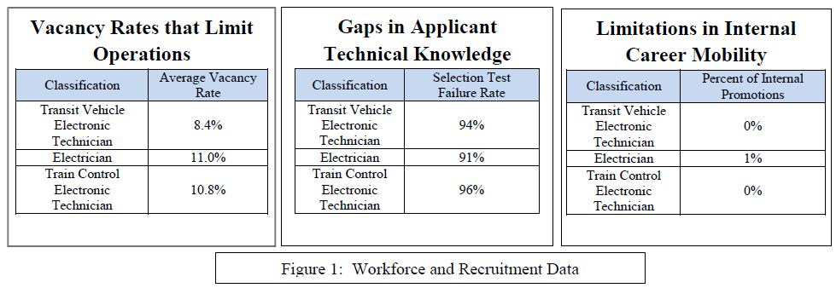

Criteria B. Need
- Enrollment and Completer Projections
Fall-Year 1: 66 Spring – Year 1: 99 Fall-Year 2: 132
Annual Completions: 40

- Place of Program in Curriculum/Similar Programs

The Certificate of Achievement in Transit Electrical Technology becomes the fourth certificate in the Industrial Technology Program joining Electrical Technology, Instrumentation Technology and Process Technology. Each program is designed by and for local advanced manufacturing and transit officials, many of whom serve as adjunct faculty in the ETEC and PTEC programs.

- Similar Programs at Other Colleges in Service Area
East Bay community colleges with electrical/electronics programs (including their 3-year average annual completions) are Chabot (12), Contra Costa (9), Diablo Valley (14), Laney (28). Up until closure in 2014-15 ITT Technical Institute added another 42 annual completions on average per year.

It’s important to note that the electrical programs at these colleges do not strongly emphasize the application of knowledge, skills and abilities in an industrial setting. Most are designed around residential and commercial applications. LMC’s strong industrial focus benefits students seeking careers in the field of mass transit.

- Labor Market Information & Analysis (CTE only)

Occupations
Code | Description
49-2094 | Electrical and Electronics Repairers, Commercial and Industrial Equipment
Regions
Code | Description
6001 | Alameda County, CA
6013 | Contra Costa County, CA
6095 | Solano County, CA
Timeframe
2016 - 2020
Occupation Summary for Electrical and Electronics Repairers, Commercial and Industrial Equipment
735 |  |  |  |  | 2.2% |  |  |  |  |  |  |  |  | $36.45/hr
Jobs (2016) |  |  |  |  | % Change (2016-2020) |  |  |  |  |  |  |  |  | Median Hourly Earnings
18% above National average |  |  |  |  | Nation: 2.7% |  |  |  |  |  |  |  |  | Nation: $27.04/hr
Growth for Electrical and Electronics Repairers, Commercial and Industrial Equipment (49-2094)
735 |  |  |  | 751 |  |  |  | 16 |  |  |  |  |  |  |  |  |  |  | 2.2%
2016 Jobs |  |  |  | 2020 Jobs |  |  |  | Change (2016-2020) |  |  |  |  |  |  |  |  |  |  | % Change (2016-2020)
Percentile Earnings for Electrical and Electronics Repairers, Commercial and Industrial Equipment (49-2094)
$29.44/hr |  |  |  |  | $36.45/hr |  |  |  |  |  |  |  |  | $43.54/hr
25th Percentile Earnings |  |  |  |  | Median Earnings |  |  |  |  |  |  |  |  | 75th Percentile Earnings
Regional Trends
 |  | Region |  |  |  |  | 2016 Jobs |  |  |  | 2020 Jobs |  |  |  |  | Change |  |  |  |  |  | % Change
● | Region |  |  |  |  | 735 |  |  | 751 |  |  |  |  |  | 16 |  |  |  |  |  | 2.2%
● |  | East County |  |  |  |  | 30 |  |  |  | 32 |  |  |  |  | 2 |  |  |  |  |  | 6.7%
● |  | California |  |  |  |  | 6,973 |  |  |  | 7,176 |  |  |  |  | 203 |  |  |  |  |  | 2.9%
● |  | United States |  |  |  |  | 69,546 |  |  |  | 71,416 |  |  |  |  | 1,870 |  |  |  |  |  | 2.7%
Regional Breakdown
County |  |  |  |  |  |  |  | 2020 Jobs
Alameda County, CA |  |  |  |  |  |  |  | 436
Contra Costa County, CA |  |  |  |  |  |  |  | 169
Solano County, CA |  |  |  |  |  |  |  | 147
Job Postings vs. Hires
11 |  |  |  |  |  |  |  | 28
Avg. Monthly Postings (Jan 2016 - Aug 2017) |  |  |  |  |  |  |  | Avg. Monthly Hires (Jan 2016 - Aug 2017)
Occupation Age Breakdown
 |  | Age |  |  |  |  |  |  |  |  |  | 2016 Jobs |  |  |  |  | 2016 Percent
● | 14-18 |  |  |  |  |  |  |  |  |  | 0 |  |  |  |  | 0.0%
● | 19-24 |  |  |  |  |  |  |  |  |  | 59 |  |  |  |  | 8.0%
● | 25-34 |  |  |  |  |  |  |  |  |  | 166 |  |  |  |  | 22.6%
● | 35-44 |  |  |  |  |  |  |  |  |  | 142 |  |  |  |  | 19.3%
● | 45-54 |  |  |  |  |  |  |  |  |  | 188 |  |  |  |  | 25.6%
● | 55-64 |  |  |  |  |  |  |  |  |  | 155 |  |  |  |  | 21.0%
● | 65+ |  |  |  |  |  |  |  |  |  | 26 |  |  |  |  | 3.5%
Occupation Race/Ethnicity Breakdown
 |  | Race/Ethnicity |  |  |  |  |  |  |  |  |  | 2016 Jobs |  |  |  |  | 2016 Percent
● | White |  |  |  |  |  |  |  |  |  | 479 |  |  |  |  | 65.1%
● | Hispanic or Latino |  |  |  |  |  |  |  |  |  | 96 |  |  |  |  | 13.1%
● | Asian |  |  |  |  |  |  |  |  |  | 58 |  |  |  |  | 7.8%
● | Black or African American |  |  |  |  |  |  |  |  |  | 55 |  |  |  |  | 7.5%
● | Two or More Races |  |  |  |  |  |  |  |  |  | 38 |  |  |  |  | 5.2%
● | American Indian or Alaska Native |  |  |  |  |  |  |  |  |  | 5 |  |  |  |  | 0.7%
● | Native Hawaiian or Other Pacific Islander |  |  |  |  |  |  |  |  |  | 4 |  |  |  |  | 0.5%
National Educational Attainment
 |  |  | Education Level |  |  |  |  |  |  |  |  |  | 2016 Percent
● | Less than high school diploma |  |  |  |  |  |  |  |  | 1.6%
● | High school diploma or equivalent |  |  |  |  |  |  |  |  | 32.0%
● | Some college, no degree |  |  |  |  |  |  |  |  | 35.1%
● | Associate's degree |  |  |  |  |  |  |  |  | 21.7%
● | Bachelor's degree |  |  |  |  |  |  |  |  | 9.0%
● | Master's degree |  |  |  |  |  |  |  |  | 0.6%
● | Doctoral or professional degree |  |  |  |  |  |  |  |  | 0.0%
Industries Employing Electrical and Electronics Repairers, Commercial and Industrial Equipment
Industry |  |  |  |  |  |  |  |  |  |  | Occupation Jobs in Industry (2016) |  |  |  |  | % of Occupation in Industry (2016) |  |  |  |  |  | % of Total Jobs in Industry (2016)
Federal Government, Civilian, Excluding Postal Service |  |  |  |  |  |  |  |  |  |  | 61 |  |  |  |  | 8.3% |  |  |  |  |  | 0.5%
Electrical Contractors and Other Wiring Installation Contractors |  |  |  |  |  |  |  |  |  |  | 48 |  |  |  |  | 6.5% |  |  |  |  |  | 0.5%
Local Government, Excluding Education and Hospitals |  |  |  |  |  |  |  |  |  |  | 38 |  |  |  |  | 5.2% |  |  |  |  |  | 0.1%
Electrical Apparatus and Equipment, Wiring Supplies, and Related Equipment Merchant Wholesalers |  |  |  |  |  |  |  |  |  |  | 34 |  |  |  |  | 4.6% |  |  |  |  |  | 1.1%
Commercial and Industrial Machinery and Equipment (except Automotive and Electronic) Repair and Maintenance |  |  |  |  |  |  |  |  |  |  | 29 |  |  |  |  | 3.9% |  |  |  |  |  | 1.5%

Also include the results of discussions with key local employers/potential advisory committee members.

- Employer Survey (CTE only)

BART has been an active partner of the LMC ETEC program for many years. Representatives from their HR department participate in LMC’s annual Industrial Technology Career Fair and have conducted on-site testing of the college’s Automotive Technology students in the past. The transit agencies mentioned previously are now invited to participate in the Advisory Committee and will also be invited to participate in the annual career fair.

The Bay Area transit agencies (including Los Angles Transit) listed in Section 4 visited the college in spring 2016 for discussions with college faculty, staff and administrators. Details around program content were discussed as transit representatives shared challenges to fill anticipated workforce needs of all agencies. Officials toured the ETEC lab and spoke with students while they conducted lab exercises.

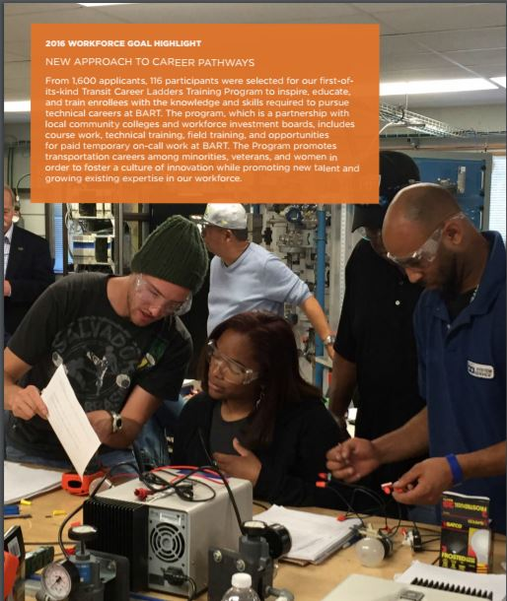

BART Annual Report January 2017

10. Explanation of Employer Relationship (CTE only)

Demand for graduates of the ETEC program will continue and likely increase as “baby boomers” continue to leave the workforce. Recruitment of qualified instructors will continue to be a challenge as it is for community colleges system-wide. This is evidenced by recommendations 13 through 16 by the Strong Workforce Task Force:

13. Increase the pool of qualified CTE instructors by addressing CTE faculty recruitment and hiring practices.
14. Consider options for meeting minimum qualifications to better integrate industry professionals who possess significant experience into CTE instructional programs.
15. Enhance professional development opportunities for CTE faculty to maintain industry and program relevance.
16. Explore solutions to attract industry professionals in high-salaried occupations to become CTE faculty in community colleges.

- List of Members of Advisory Committee (CTE only)

AGENCY | LAST | FIRST
Anheiser-Busch People Department | Hernandez | Alejandro
Anheiser-Busch People Department | Wagner | Matthew
BART | Bajaj | Prem
Brinderson | Jones | Marlowe
C&H Sugar | Purvis | Randall
Delta Diablo Sanitation District | Dominguez | Steven
Delta Diablo Sanitation District | Lowrey | Angela
Dow Chemical Company | Russo | George
Dow Chemical Company | Burmann | Fred
Dow Chemical Company | Russo | George
Dow Chemical Company | Fiori | Jason
EBMUD | Lamb | Ted
Greysam Industrial Services | Foxworth | Mark
Greysam Industrial Services | Foxworth | MaryBeth
Kone Cranes | Magnotta | Mike
Phillips 66 | Babot | Jorge
Phillips 66 | Finklestein | Terri
SFPUC/SFWATER | Ardrey | Steve
Shell Oil | Peters | Robert
Shell Oil | Robert | Muller
Shell Oil | Plurkowski | Nick
Shell Oil | Mahoney | Bill
Tesoro | Kruger | Jon
Tesoro | Britz | Eric
USS Posco | Martucci | Pat
USS Posco | Cox | Jason
USS Posco | Rowney | Joann
USS Posco | Smith | Marianne

- Recommendations of Advisory Committee (CTE only)
The ETEC Advisory Committee voted unanimously on December 16, 2016 to create the Certificate of Achievement in Transit Electrical Technology.

Attachment: Labor / Job Market Data (CTE only)
Attachment: Employer Survey (CTE only)
Attachment: Minutes of Key Meetings

Criteria C. Curriculum Standards

- Display of Proposed Sequence
Fall-Year 1

ETEC 10 Direct Current Circuits 4 units
ETEC 12 Alternating Current Circuits 4 units

Spring-Year 1

ETEC 20 Electric Motor Control 3 units
ETEC 22 Semiconductor Devices 2 units
ETEC 24 Digital Devices 2 units

Fall-Year 2

ETEC 40 National Electrical Code 3 units
ETEC 42 Wiring Methods and Codes 1 units
ETEC 44 Power Distribution Systems 3 units
ETEC 46 DC & AC Motors & Generators 3 units

- Transfer Documentation (if applicable)
Not Applicable

Attachment: Outlines of Record for Required Courses should be separately attached to each course
Attachment: Transfer Documentation (if applicable)

Criteria D. Adequate Resources
- Library and/or Learning Resources Plan
No library and/or learning resources are needed

- Facilities and Equipment Plan
Existing facilities and equipment are adequate for the program.

- Financial Support Plan
No additional financial support is needed

- Faculty Qualifications and Availability
Existing faculty qualifications and availability are adequate.

Criteria E. Compliance
- Based on model curriculum (if applicable)
Not applicable

- Licensing or Accreditation Standards
No impact

- Student Selection and Fees
Standard selection process and student fees

