How Teacher-Scholars Prepare Students for an Evolving World
By Michael Gettings August 07, 2017
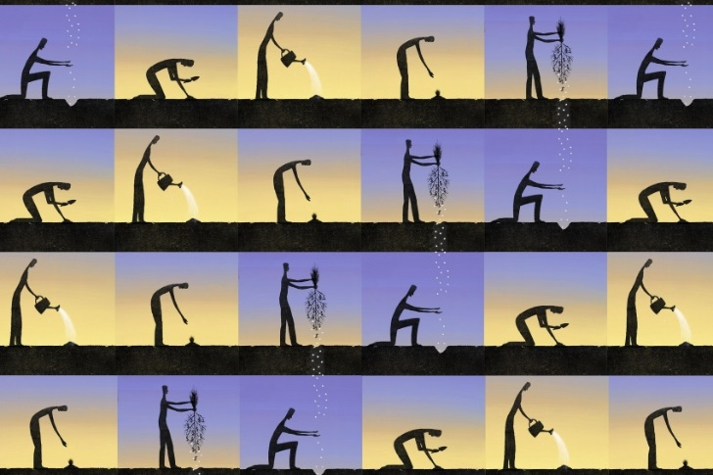
Jon Krause for The Chronicle
You’ve probably heard "ivory tower" jokes or other ways of lampooning academic researchers and scholars. Here’s one: How many college professors does it take to change a light bulb? Answer: Eight. One to secure funding for the light bulb, one to observe and record the changing of the bulb, one to consider the theoretical implications of the change, one to write the research paper, two to edit the journal to which the research paper is submitted, and two more to serve as blind peer-reviewers for the manuscript. (The actual changing of the bulb will be done by a graduate student.)
Jokes aside, parents’ and students’ continuing concerns about the value of a college education are only exacerbated by the perception that college provides poor career preparation. Part of this perception is fueled by an attitude that professional scholars obsess over inconsequential arcana with no relevance to the rest of the world and use phrases like "obsess over inconsequential arcana" while doing it.
My own field, philosophy, regularly faces this accusation. Research papers with titles like "Hegemonic Stability Theory: An Empirical Assessment" and "The Dynamics of Interbeing and Monological Imperatives in Dick and Jane: A Study in Psychic Transrelational Gender Modes,"* only confirm this suspicion in the minds of those already disposed to think of the liberal arts as out of touch or useless. I suspect that part of the perception is due to the data points available to most observers — we see only the published research paper title or a few sentences describing academic research, written in the language of that discipline. These sources are often only legible to other professional academics in that narrow field. We don’t see what has led to that output, nor what skills are developed along the way.
The fact is that professional academic work connects with the rest of our lives, and when academics do this kind of work, it informs their teaching. At many liberal-arts colleges and universities, the faculty embody what is called a teacher-scholar model. Kenneth Ruscio, former president of Washington and Lee University, points out that the dash between "teacher" and "scholar" is significant. It’s a link joining the two endeavors, not a slash dividing them.
As faculty, our research informs our teaching and benefits our students. One is not a teacher and a scholar, one is a teacher-scholar. Through scholarship, teachers model good learning and offer special opportunities to students. These opportunities are not merely confined to increased knowledge of inconsequential arcana. The benefits of this model for both teacher and student are maximized in the liberal-arts setting where students can build strong relationships with faculty.
One of the recent sources of anxiety for future job-seekers is the prediction that automation and artificial intelligence will eliminate a great number of present-day jobs. A May 2017 report from the Pew Research Center ("The Future of Jobs and Job Training") puts it plainly: "Multiple studies have documented that massive numbers of jobs are at risk as programmed devices — many of them smart, autonomous systems — continue their march into workplaces." The report says that one outcome will likely be that "workers of the future will learn to deeply cultivate and exploit creativity, collaborative activity, abstract and systems thinking, complex communication and the ability to thrive in diverse environments." In their 2016 book Becoming Brilliant (American Psychological Association), the developmental psychologists Roberta Michnick Golinkoff and Kathryn Hirsh-Pasek compile some of these future-work skills into a list called "the Six C’s": collaboration, communication, content, critical thinking, creativity, and confidence. These skills not only allow us to tackle today’s challenges in the workplace, they will allow us to tackle problems we can’t even envision yet.
Though it may not be apparent on the surface, the teacher-scholar helps students develop these skills. When someone asks me about the relevance of what looks like highly specialized, narrow academic research in my field, I often share with them what I tell our philosophy majors as they begin their senior theses.
In writing a highly specialized thesis, you do more than learn deeply about a topic in your field of interest. You also learn how to undertake a large-scale, long-term project on your own, at times encountering obstacles that require you to dig deep and be resilient (confidence). You become a local expert in that field and will very likely know more about your subject than anyone in your region (content). You will have to find a way to make an original contribution to the field, introducing ideas that no one has produced before (creativity). You will have to exercise judgment in the face of complexity (critical thinking). You will have to discuss your work to your peers, listen to their feedback, and revise your work after reflecting on their ideas (collaboration). Once the final draft is complete, you will present it publicly to an audience, answering questions (communication). All of this prepares you for life and a professional career. You will use all these skills again.
So when someone makes ivory tower jokes or questions the value of a liberal-arts education in which the culminating work of the student is a paper titled "South Asian Influence in Schopenhauer’s The World as Will and Idea: an East/West Dialogue," remember that it was a community of teacher-scholars who made this possible, and the student leaves with valuable skills that will serve her well into the future.
Michael Gettings is an associate professor of philosophy and dean of academic services at Hollins University.
* The title of the second paper is a trick — it’s not a real academic paper, but was taken from Bill Watterson’s Calvin and Hobbes comic strip. See what you learn when you read the scholarly footnotes?

