Half of bachelor’s degree earners enroll in community college
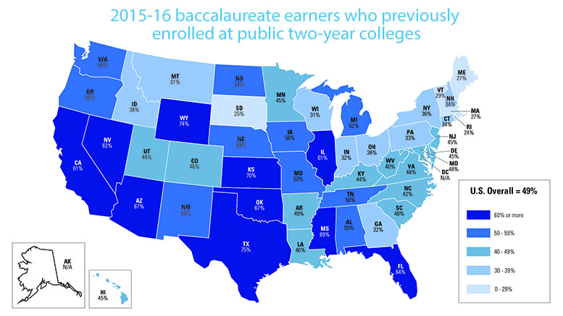
Source: National Student Clearinghouse Research Center, "Snapshot 26: Two-Year Institutions’ Contributions to Four-Year Degrees," March 2017.
By Daily Staff March 29, 2017
Nearly half of students receiving bachelor’s degrees last year had previously attended a public two-year college, according to the National Student Clearinghouse Research Center.
Of the 1.8 million baccalaureate earners in the 2015-16 academic year, 860,263 of them — or 49 percent — had a two-year public enrollment at some point in the previous 10 years, according to the center’s new report, “Snapshot 26: Two-Year Institutions’ Contributions to Four-Year Degrees.“
The national rate is three percentage points higher than it was for students who graduated with four-year degrees in 2013-14, as previously reported by the center.
In 20 states — among them Arizona, California, Florida, Illinois, Michigan and Mississippi — more than half of the 2015-16 bachelor’s degree earners had enrolled at a two-year public institution over the previous decade. In Kansas, Texas and Wyoming it was about 70 percent.
“This snapshot report shows that community colleges are greatly impacting educational attainment for hundreds of thousands of students,” said Doug Shapiro, the center’s executive director. “Even when not awarding their own degrees, these institutions are adding great value to their communities and states.”
The report examined the 10-year period prior to the bachelor’s degree award date to see how many of the 2015-16 bachelor’s degree recipients had previously enrolled at two-year public institutions. The prior enrollment at a two-year public institution may have occurred in any state, may have been brief, and may or may not have been the first institution the student attended. It may also have occurred as part of a high school dual-enrollment program.
The report also looked at how quickly the baccalaureate earners who previously enrolled at a public two-year college attained their bachelor’s degrees. About half (49 percent) did so within three years of leaving the two-year college. Most of them (37 percent) did so in two to three years. Thirty-one percent completed their baccalaureate in four to five years.
Almost two-thirds (63 percent) of the prior enrollments in two-year public institutions lasted for three or more terms.

