Morehouse professor retires after nearly 60 years at college
by thegrio | March 10, 2017 at 3:44 PM Filed in: Education, News

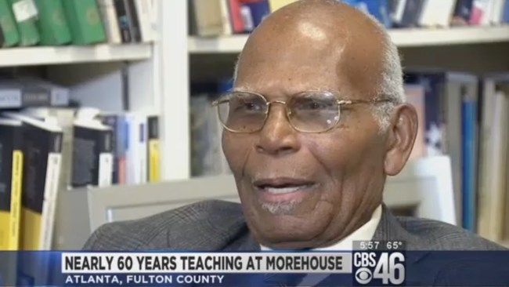

After 59 years of serving the Morehouse College academic community, Dr. Tobe Johnson is hanging up his syllabus for retirement.
Johnson attended Morehouse at just 16, and that was the beginning of a nearly 60-year-long relationship with the school.
After graduating in 1954, he left Morehouse and joined the military and served for four years in Japan before he came back to finish out his schooling and get his bachelor’s degree there. Because of segregation, it was hard for him to pursue a higher education than that, but he was able to get a stipend from the state of Alabama to attend Columbia University before returning to Morehouse, where it all began.
CBS46 News
One of Dr. Johnson’s most famous students was the first black mayor of Atlanta, the late Maynard Jackson. Now, after spending his career teaching political science at Morehouse, Johnson is ready for retirement.
He plans to fish and vacation in either Alaska or Europe, though the draw of Morehouse must just be too much to keep away, because he would also consider teaching political science part-time even after retirement!

