Proposal to the Los Medanos College Academic Senate
Revisions to Term Order in Academic Year and Definition of Continuous Enrollment for Catalog Rights
This is a combined proposal to align Los Medanos College’s academic term order and definition of continuous enrollment to Diablo Valley College and Contra Costa College.

Rationale for Revision:
- AB 1111 (Common course numbering) and AB 928 (Combined transfer general education) will require districtwide alignment to develop new ed planning and degree audit systems that are clear to students.
  - Current disconnect causes confusion among students, counselors, staff, and faculty. Current definition make misinterpretation extremely easy and occur too often.
- Revision would align current order of academic terms with financial aid offices and other colleges in district.

Term Order in Academic Year
Quick Summary of Current Academic Year Order:
Los Medanos College | Diablo Valley College and Contra Costa College
An academic year begins with the summer session:  - Summer  - Fall  - Spring  Summer 2023 example: a student who takes their first class in Summer 2023 will be tied to the 2023-2024 academic year | An academic year begins with the fall term:  - Fall  - Spring  - Summer  Summer 2023 example: a student who takes their first class in Summer 2023 will be tied to the 2022-2023 academic year

Proposed New Order of Los Medanos College Academic Year:

An academic year begins with the Fall session:

- Fall
- Spring
- Summer

Summer 2023 example: a student who takes their first class in Summer 2023 will be tied to the 2022-2024 academic year

Definition of Catalog Rights and Continuous Enrollment
Quick Summary of Current Definition Differences:
Los Medanos College | Diablo Valley College and Contra Costa College
A student is considered “continuing” if they complete (receive A, B, C, D) at least one course in academic year at LMC only  Catalog Rights language does not include IGETC and CSU-GE | A student is considered “continuing” if they receive A, B, C, D, F, P, NP, IP, W, EW, MW or I at any college in district  Catalog Rights includes CSU GE and IGETC, and do not apply to IGETC of CSU-GE

Proposed New Language for Los Medanos College Catalog Rights and Continuous Enrollment:

LMC publishes a new catalog every year, and the requirements for the degree/certificate programs may change from one catalog to the next. The requirements in a specific academic year’s catalog are the student’s contract (catalog rights) with the college and that catalog defines what the student must complete to earn a degree or certificate. Catalog rights do not pertain to prerequisites. Students have the right to graduate under the terms and regulations of any of the catalogs that are published while in continuous enrollment at LMC, prior to eligibility for graduation.

Continuous enrollment is defined as enrollment in at least one course at Contra Costa College, Diablo Valley College or Los Medanos College in an academic year (fall, spring, summer). The student must receive a grade or notation on their transcript of A, B, C, D, F, P, NP, I, MW, EW, or W for the course. This continuous enrollment policy applies to students who are new, returning, or continuing. If students break continuous enrollment, they will be granted catalog rights to the catalog in effect when they return or petition for the degree or certificate.

The college reserves the right to change catalog rights or program requirements based upon legal mandate and accreditation standards at any time. Catalog rights do not apply to IGETC certification. Students must follow the IGETC pattern in effect when they petition for certification. Courses used for CSU GE or IGETC certification must be on the approved list at the time they are completed.

Catalog Referral, Academic Term Order:
Current Contra Costa College definition (found on page 4 of the 2022-2023 Contra Costa College Catalog of Classes)
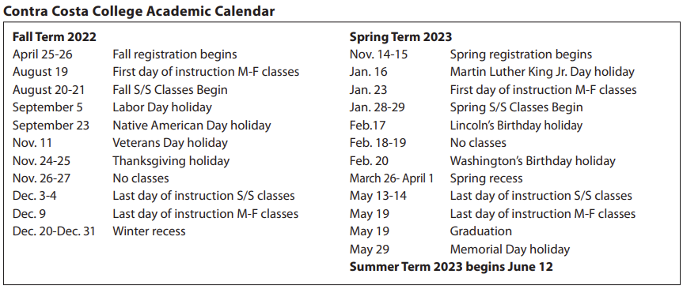
Current Diablo Valley College Academic Year (found on page 9 of the 2022-2023 Diablo Valley College Catalog of Classes)
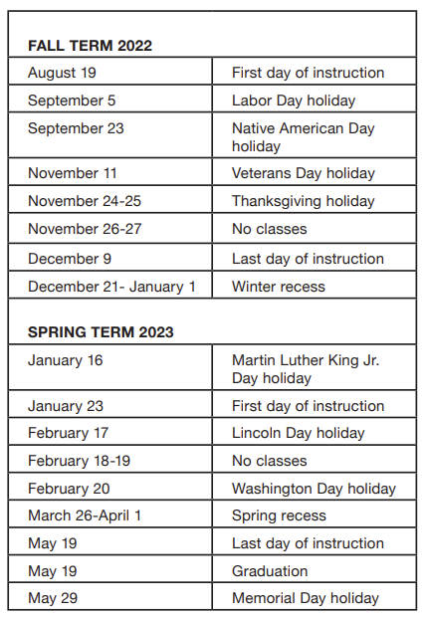

Current Los Medanos Academic Year (found on page 9 of the 2022-2023 Los Medanos Catalog of Classes)
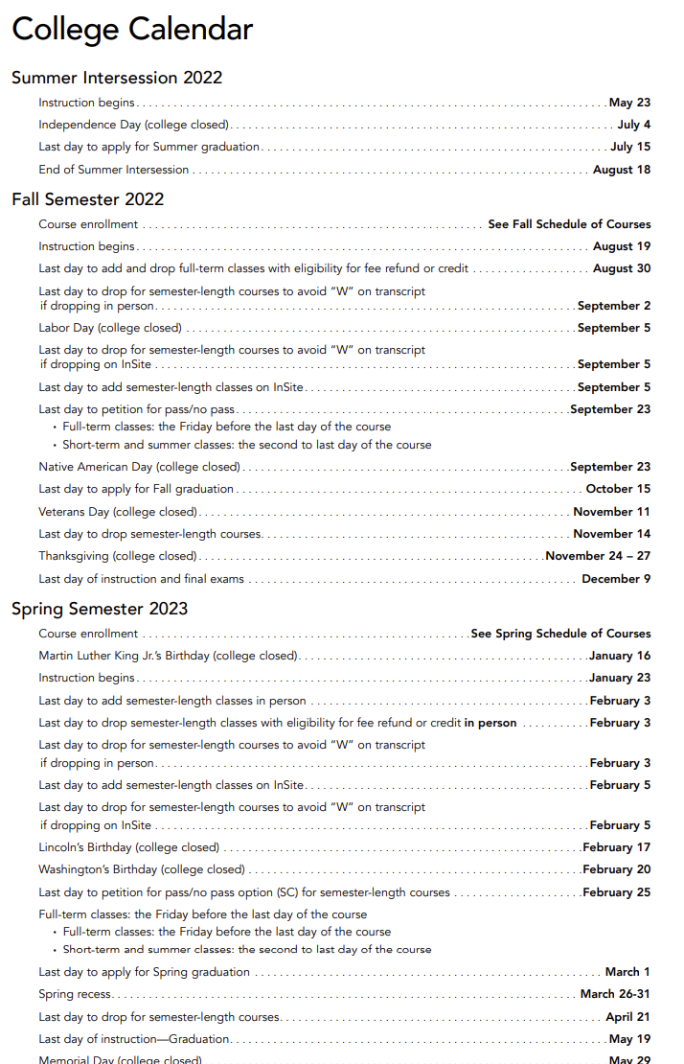

Catalog Referral, Catalog Rights and Continuous Enrollment:
Current Los Medanos definition (found on page 62 of the 2022-2023 Los Medanos Catalog of Classes)
LMC publishes a new catalog every year, and the requirements for the degree/certificate programs may change from one catalog to the next. Catalog rights do not pertain to prerequisites. Students have the right to graduate under the terms and regulations of any of the catalogs that are published while in continuous enrollment at LMC, prior to eligibility for graduation. Continuous enrollment at LMC is defined as the period of time in which a student’s record reflects completion of at least one course, for one semester or term, during a given catalog (academic) year, from the time of original enrollment. A student who has a break in attendance for more than a year must use the catalog that is in effect at the time of readmission or a subsequent catalog for the period of continuing enrollment.

Current Diablo Valley College definition (found on page 62 of the 2022-2023 Diablo Valley College Catalog of Classes)
The college catalog specifies the requirements to earn a degree or certificate. The requirements in a specific academic year’s catalog are the student’s contract (catalog rights) with the college and that catalog defines what the student must complete to earn a degree or certificate. Students may follow the catalog requirements that were in effect for the academic year when their attendance began at Diablo Valley College or follow the catalog requirements in effect during subsequent years of attendance provided that continuous enrollment has been maintained. Effective fall 2009, continuous enrollment is defined as enrollment in at least one course at Diablo Valley College, Los Medanos College or Contra Costa College in an academic year (fall, spring, summer). The student must receive a grade or notation on their transcript of “A,” “B,” “C,” “D,” “F,” “P,” “NP,” “I” or “W” for the course. This continuous enrollment policy applies to students who are new, returning or continuing. Students completing a degree may choose a general education pattern under one academic year and major program requirements from a different academic year. The academic year(s) chosen must be declared on the application for the degree. Former students who completed their requirements prior to leaving but failed to petition for degree or certificate may petition and choose the catalog requirements in effect at the time of petition or those in effect at the time of their last enrollment. Under special circumstances, exceptions to this catalog rights policy may be considered through a petition process initiated through the Admissions and Records Office. The college reserves the right to change catalog rights or program requirements based upon legal mandate and accreditation standards at any time. Catalog rights do not apply to IGETC certification. Students must follow the IGETC pattern in effect when they petition for certification. Courses used for CSU GE or IGETC certification must be on the approved list at the time they are completed.

Current Contra Costa College definition (found on page 56 of the 2022-2023 Contra Costa College Catalog of Classes)
Graduation requirements are determined according to the college catalog in effect at the time of first enrollment in any college within the Contra Costa Community College District. Students may follow the catalog requirements that were in effect for the academic year when they began their attendance at Contra Costa College or follow the catalog requirements in effect during any new catalog year that follows their initial enrollment, provided that continuous enrollment has been maintained. Continuous enrollment is defined as enrollment in at least one course at Contra Costa College, Diablo Valley College or Los Medanos College in an academic year (fall, spring, summer). The student must receive a grade or notation on their transcript of A, B, C, D, F, P, NP, I, MW, EW, or W for the course. This continuous enrollment policy applies to students who are new, returning or continuing. If students break continuous enrollment, they will be granted catalog rights to the catalog in effect when they enroll or apply for the degree or certificate. Catalog rights do not apply to CSU GE or IGETC certification. Students must follow the CSU GE or IGETC pattern in effect when they petition for certification. Courses used for certification must be on the approved list at the time they are completed.
*Simplified Language on page 59 Graduation Checklist: “If continuous enrollment is maintained by enrolling in at least ONE course at CCC, DVC, or LMC in Academic Year (Summer, Fall, Spring), students are guaranteed rights to the catalog requirements in effect during their initial term of enrollment. Should catalog requirements change while continuous enrollment is maintained, students may utilize any subsequent catalog in effect to graduate.”

