DRAFT 4CD

DISTANCE EDUCATION STRATEGIC PLAN
  - 2022 – 2027
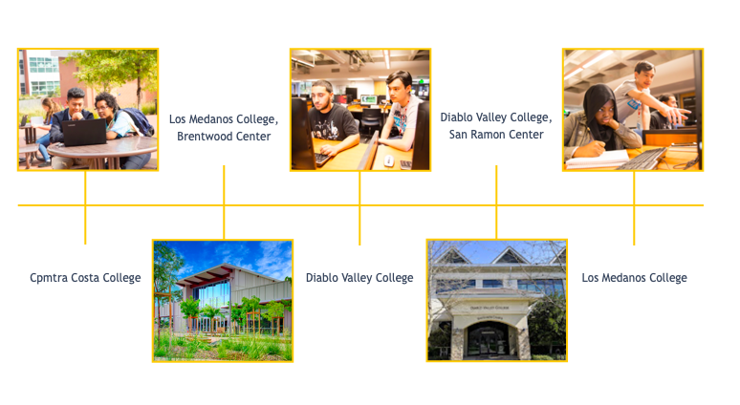

Table of Contents
IntroductioN 1
PLAN DEVELOPMENT CHRONOLOGY 1
In Appreciation 2
Plan Participants and Contributors 2
Town Hall Participants 2
Districtwide Distance Education Council 3
4CD Core Beliefs and Strategic Goals 4
Vision 4
Mission 4
Values 4
Strategic Directions 6
Distance Education Mission 7
Background Summary 7
Current Trends 10
Then and Now 10
Response to COVID-19 Transition to 100% Online Classes 11
Additional and ongoing improvements to Professional Development 11
Enrollment Trends 11
Review of Distance Education Statistics 22
Distance Education Strategic Plan Goals 24
Goal 1: Develop Principles of Excellence in Alignment with Diversity, Equity, Anti-racism, Inclusion, Accessibility and Student Success. 24
Goal 2: Enhance Professional Development 24
Goal 3: Provide Comprehensive Online Student Support Services 25
Goal 4: Improve Technology Infrastructure and Support 26
Proposed Five-Year Action Plan for Implementation 28
Appendix 32
Appendix a: Definitions 32
Appendix B: References and Sources of Authority 32
U.S. Department of Education Definition of Distance Education 32
California Code of Regulations, Title 5, Sections 55200 - 55210 32
Contra Costa Community College District Distance Education Policy 35
Appendix C: Student Survey Instruction Modality Preferences 38

IntroductioN
The current Contra Costa Community College District Strategic Plan establishes as its first Strategic Direction the intention to “Improve Student Learning and Completion Across all District Campuses.” The value of Distance Education as a means to help achieve that goal is demonstrated in the objective that states the need to “Foster high-quality distance education across the District as a vehicle for achieving Vision for Success goals and promoting all forms of student success.”
In alignment with that objective and Strategic Direction, the 4CD Districtwide Distance Education Council (DDEC) created the Distance Education Strategic Plan 2022-2027. The plan’s purpose is to guide distance education development from 2022 to 2027 through districtwide goals and broad strategic recommendations to support the colleges with their distance education programs. The plan additionally outlines clear objectives to facilitate achieving adopted strategic and Distance Education goals.

PLAN DEVELOPMENT CHRONOLOGY
DATE | EVENT/ACTION
Oct. 15, 2021 | DDEC Strategic Planning Retreat and drafting broad goals
Nov. 18, 2021 | Districtwide Town Hall meeting, goals presentation and break-out groups with captured feedback
Nov. 18, 2021 and ongoing | Continuous opportunities for feedback through Canvas discussions and SharePoint documents
Jan. 26, 2022 Feb. 9, 2022 | Presentation to DDEC for discussion and feedback  Development of Action Steps
Spring 2022 | Draft presented to campus Academic Senates
March 2022 | Revisions to draft based on campus feedback
April, 13 2022 | Final Draft presented to DDEC
May 11, 2022 | Presentation of final DE Strategic Plan to 4CD Governing Board

In Appreciation
We thank all who were directly involved in the preparation of this plan, as well as all who invested their time to participate in the Districtwide Town Hall and campus meetings, and/or contributed through asynchronous comments. Your contributions improved and deepened the breadth of our plan.

Plan Participants and Contributors

Town Hall Participants
Allison Albright  Nicole Almassey  Rachel Anicetti  Maritez Apigo  Lindsay Arentz  Dora Argueta-Rico  William (Bill) Bankhead  Jeffrey Benford  Jason Berner  Emma Blackthorne  Sarah Boland Drain  Liesl Boswell  Crystala Button  Arminda Calagui  Phyllis Carter  Eloine Chapman  Carl Chiu  Rayshell Clapper  Rain Dougan  Drew Douglass  Abigai Duldulao  Roseann Erwin  Robert Estrada  James Eyestone  Nicholas Falasco  Angela Fantuzzi | Catherine Franco  Dennis Franco  John Freytag  Louie Giambattista  Brandy Gibson  Lisa Smiley-Ratchford  Irena Stefanova  Bethann Stone  Christina Goff  Concha Gomez  Letta Greene  Marisa Greenberg  Paula Gunder  David Hagerty  Joy Hakola-Dardin  Kathleen Halaszynski  Steven Hales  Rikki Hall  Robert Hawkins  Scott Hubbard  Katrina Keating  Kathleen King  Anne Kingsley  Bob Kratochvil  Sabrina Kwist  Allan Lacayo  Susan Lamb | Timothy Leong  Lynda Letona -Rodriguez  Vicki Ferguson  Mercedes Lezama  Ken Lira  Lan Lo  Brandon Marshall  Carla Matute  Tanisha Maxwell  Michele McCabe  Cindy McGrath  Mojdeh Mehdizadeh  Joanna Miller  Carrie Million  Mario Tejada  Elizabeth Vega  Grace Villegas  Sandra Moore  Emily Moss  Yasser Moten  Nikki Moultrie  Kristy Myers  James Noel  Aprill Nogarr  Janith Norman  George Olgin | Mayra Padilla  Jeanette Peavler  Marcia Perata  Anne Petersen  Lizette Ponthier  Matthew Powell  Arek Puzia  Michael Quinn  Charles Ramos  Kelly Ramos  Amy Raymond  Win Rein  Cesar Reyes  Virginia Richards  Tia Robinson-Cooper  Richard Robison  Sonia Robles  Emma Rogers  Eric Sanchez  Tara Sanders  Kim Schenk  Gabriela Segade  Chase Wheeler  Maya Yamato

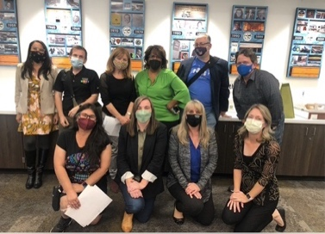

Districtwide Distance Education Council
Nicole Almassey
Maritez Apigo – Co-chair
Jason Berner
Crystala Button
Courtney Diputado
James Eyestone
Scott Hubbard
Kathleen King
Anne Kingsley
Monica Landeros
Brandon Marshall
Carrie Million
April Nogarr
Janith Norman
Jeanette Peavler
Richard Robison
Joanna Miller – Co-chair
Mojdeh Mehdizadeh

(Oct. 15, 2021 DE Strategic Planning Retreat, DO: Pictured from left, back row, Maritez Apigo, Scott Hubbard, Joanna Miller, Janith Norman, Jason Berner, Richard Robison, and from left, front row, Mónica Landeros, Anne Kingsley and Carrie Million. Not pictured, Mojdeh Medizadeh.)

4CD Core Beliefs and Strategic Goals

Vision
To provide educational excellence, support social justice, and contribute to the economic vitality for all our students and the surrounding community

Mission
To empower all students to fulfill their educational and career aspirations and thrive in the modern world

Values
Student-Centered  We know that keeping the student experience central in all policy, program, process, and practice decisions is vital to advancing students’ success. We recognize that every member of the District community has a part to play in strengthening students’ learning and achievement and are dedicated to actively carrying out this role. | Access  We provide a bridge to opportunity that connects all students to excellent educational experiences and supports in alignment with their goals, including new and returning students, skill builders, career changers, and lifelong learners. This foundational commitment is vital to ensuring all members of the Contra Costa County community—particularly those historically underrepresented— know they have an educational home in our District.
Equity  We are committed to social justice and relentlessly work to ensure student’s social and economic mobility. We believe all students can succeed and have high expectations for their potential, performance and achievement. We act to identify student groups experiencing disproportionate impact, recognize unintended consequences of our beliefs and behaviors, disrupt inequitable systems and practices, and close achievement gaps. | Innovation and Excellence  We hold ourselves to the highest standards, engaging students in excellent programs, practices, experiences, and supports. We know that while often challenging, adapting to change and embracing improvement is essential to addressing longstanding student success issues. We take strategic, data-driven action to increase outcomes for all our students, enhance our institutions’ wellbeing and sustainability, and assess our effectiveness.
Academic Freedom  We value the freedom of faculty and students to pursue knowledge without constraint and to explore the life of the mind and express observations in an open, responsible, and respectful academic environment. We know that in this environment, imaginations thrive, and intellectual skills develop. | Safety  We are uncompromising in our commitment to the physical, emotional, and intellectual well-being of every member of our District. We strive for students, faculty, staff, administrators, and community members alike to view the District and our colleges as secure spaces and trust that a threat to their security will be taken seriously and immediately addressed
Diversity and Inclusivity  We embrace and celebrate the remarkable diversity of all members of the District. We are committed to promoting an environment where all people can thrive and contribute by practicing mutual respect and cultural competency. We honor the experiences and perspectives of all individuals and practice inclusive decision-making. | Community Engagement  We regard connection with our surrounding community as essential to our District’s success and are dedicated to being a good neighbor, collaborator, and partner. We know that when we work in concert with the Contra Costa County community, we are best able to share its values and more effectively respond to its needs.
Communication  We know communication throughout the District, driven by our common interests and goals, and free of restrictions, is key to serving our students with increasing success. Open channels among leaders Districtwide enable us to make strategic decisions based on our long-term objectives. | Accountability  We show our deep gratitude for Contra Costa County’s faith and investment in our District and our colleges through the prudent stewarding of our financial, human, and environmental resources and through transparency with all stakeholders
Collaboration  We promote unguarded cooperation across the District, our colleges, programs, and departments to facilitate a student learning experience that is cohesive and meaningful. We foster strong partnerships between the District, other educational segments, employers, and community organizations to ensure students can move seamlessly through their postsecondary journey and effectively into the workforce. | Integrity  We are steadfast in promoting a culture where all people are intentional in their action, considerate of their impact, and dedicated to carrying out our collective values. Through regular reflection and use of evidence, we ensure our actions align with the District’s goals and the best interests of students and hold each other responsible for fulfilling these commitments.

Strategic Directions
Strategic Direction 1: Improve Student Learning and Completion across District Colleges
Support all college faculty, staff, and administrators in advancing student learning and completion. Strengthen college efforts to implement high-quality academic programs and champion the provision of proactive student support, including the adoption and scaling of effective practices.

Strategic Direction 2: Decrease Equity Gaps for All Students
Support college efforts to eliminate inequities in student access and outcomes. Help colleges identify which student groups are less likely to arrive prepared for college-level work and achieve their goals; understand the specific factors impacting the success of these learners; and explore what these student groups need to succeed and feel a sense of belonging. Promote the adoption of evidence-based strategies for rapidly improving their outcomes.

Strategic Direction 3: Advance Existing Community Partnerships and Create New Collaborations to Strengthen Student Pathways
Support college efforts to align with key K-12, university, community, and workforce partners to facilitate students’ movement into and through their institutions and transition to additional education and living-wage employment.

Strategic Direction 4: Cultivate a Culture of Engagement throughout the District
Ensure all members of the District community feel safe, connected, engaged, and valued. Support the professional learning and continuous improvement of all District faculty, staff, and administrators. Foster effective communication between the District and colleges and encourage active participation in decision-making.

Strategic Direction 5: Responsibly, Effectively, and Sustainably Steward District Resources
Prudently and judiciously steward Contra Costa County’s investment in the District by leveraging all District resources. Ensure fiscal responsibility and environmental sustainability are key considerations in all decision-making and understood as essential to a student-centered environment. In the new state funding paradigm, maintain financial stability. Maintain strong alignment and coordination among the District and its three colleges, leveraging the distinct assets of each institution as well as the unique power of their combined efforts to strategically tackle challenges, increase resource efficiency, and better serve our students.

Distance Education Mission
Empower students to achieve their educational goals through a commitment to providing access to innovative, equitable and high-quality online learning opportunities and student support services.

Background Summary
Contra Costa Community College District is a leader in statewide distance education, with its three colleges among the first 15 to become fully integrated teaching institutions on the California Virtual Campus Course Exchange. In addition, the faculty union and district successfully negotiated a requirement for training in order to teach online. (The requirement was temporarily suspended during the pandemic, but is expected to be reinstated for Fall 2022. The 4CD recognizes online education as a valuable and important delivery option for its diverse student body, many of whom are working, parenting or caregiving, or facing other challenges with transportation or accessibility.
It’s been a 20-year journey to arrive at the current state, and the journey continues still. The focus of this path is on continuous improvement to provide quality distance education classes and programs, with equitable outcomes to narrow achievement gaps and ensure opportunities and support for all learners to achieve their goals.

A Unifying Learning Management System
In 2011, Distance Education at 4CD was an individual college experience. Each college had its own learning management platform with little continuity across campuses. In an effort to improve student experiences, the district and colleges formed a Learning Management System Taskforce to investigate and choose a common learning management system that would allow students at one college to adapt more easily to classes they took at sister campuses and provide a seamless experience across the district. By summer of 2013, all classes across the district had been migrated to one system. The taskforce became the Learning Management System Workgroup and included campus Distance Ed Coordinators and IT representatives, under the direction of the district Director of IT.
By fall, it was clear that the LMS was an important technological aspect, but only one of a complex mode of delivery. DE campus committee chairs and coordinators soon came together to informally create the District Distance Education Council, now the Districtwide Distance Education Council (DDEC.)
With Distance Education growing within the district and across the state, leaders recognized the need for a broader view for the council that would encompass online pedagogy, professional development, student services, student support, evaluation, state and federal requirements, accreditation and more. DDEC was formally charged by the 4CD Chancellor’s Cabinet with work that included developing strategic direction for Distance Education, drawing on the campus Distance Education Committees and working with the LMS workgroup. The DDEC reports directly to the District’s Consultation Council.

A new statewide entity, the California Virtual Campus
Meanwhile, in 2013, a new entity was created through a grant from the California Community Colleges Chancellor’s Office to provide leadership in developing high-quality online instruction across the state and in helping students complete their degrees more quickly. The Online Education Initiative (OEI), now the California Virtual Campus-OEI (CVC-OEI or just CVC) launched a program to bring all the then 112 California’s community colleges onto a single learning management platform. After months of vetting and student focus group sampling, the CVC-OEI chose the innovative Canvas platform, and used $13 million of its annual budget to offer Canvas to all community colleges free of charge. In late 2015, 4CD adopted Canvas, and offered its first courses on that platform by summer 2016, with all courses migrated by summer 2017. Along with Canvas, the CVC also provided 24-7 online help for students and faculty at no charge at that time. In 2018, with the support of their Academic Senates, Diablo Valley College and Contra Costa College joined the California Virtual Campus Consortium to take advantage of free student support services and agreed to work towards aligning 20% of their online offerings with the CVC rubric for quality online course design. Los Medanos joined the Consortium in 2020.
As of August 2021, through ongoing support and technical expertise provided by District IT and with support from campus Admissions and Records and Financial Aid teams, all three colleges are among the 15 ‘Teaching Colleges’ within the CVC network. Through that work students from 49 eligible California Community Colleges can enroll directly into 4CD college courses without additional college applications otherwise needed for each school, and with coordinated transcripts and financial aid.

The Strategic Plan Development Process
Under DDEC’s charge to provide strategic direction, the Council drafted a plan that would create goals, objectives and steps to strengthen and guide distance education within the colleges and across the district. The plan took shape over six months, through districtwide presentations, feedback, revisions, and review. The plan was adopted by the 4CD Governing Board on Dec. 14, 2016. The 4CD Distance Education Strategic Plan, 2017-2022, included five goals, each with its own set of objectives and action steps.
The new DE Strategic Plan 2022-2027, to guide growth and development over the next five years was similarly created with input from diverse groups across campuses. The plan development began in earnest in October 2021 with the DDEC coming together for several hours of brainstorming and drafting goals. After a DDEC review of Goals and creation of objectives with some possible action steps, a districtwide Town Hall was held virtually on Nov. 18. More than 100 participants, including all three college presidents, deans, managers, faculty and classified staff joined the forum to help shape the new plan.
The new draft plan was reviewed again by DDEC in January, and after more revisions, was taken to campus Academic Senates, Distance Education Committees, and other college-wide committees for additional review and feedback in Spring 2022. Based on that feedback, a final draft plan was created and approved by DDEC in April. The approved and finalized plan was to be presented to the 4CD Governing Board at their meeting on May 11, 2022.

Current Trends

Then and Now
Distance Education at 4CD was slowly but steadily advancing over time, with new disciplines and additional classes coming online to enhance distance offerings to students. By Fall 2015, enrollments in online classes across the district were approaching about 9% of total enrollments, with 22% of students districtwide taking at least one online class. That number continued to gradually grow. By Fall 2019, online offerings districtwide accounted for about _% of total enrollments, with __% of students taking at least one online class. That trend continued through early Spring 2020, when suddenly, explosively, everything in education and in life in general radically changed with a declaration of a global COVID-19 pandemic. By April 2020, 100% of classes offered at 4CD and 100% of students were learning online.

Response to COVID-19 Transition to 100% Online Classes
When the COVID pandemic struck in earnest in early spring 2020, and all physical presence was restricted on all 4CD campuses, the district was well situated to massively scale its Professional Development to teach online. Over the previous two years, DDEC had created the 4CD Institute for Online Teaching and established the Becoming an Effective Online Instructor (BEOI) as its signature and foundational class to teach instructors online technological and pedagogical skills. In addition, in 2019, the District and faculty union negotiated an agreement to require online training to teach online in the 4CD, with the BEOI class or its equivalent set as the standard training requirement.
In fall 2019, the districtwide professional development team was offering two classes per semester with about 30 faculty participants per class. Offerings began to ramp up in spring 2020, and by summer 2020, a new section of BEOI with 150 faculty participants and six facilitators began every week for six weeks throughout the summer. More than 1,200 faculty of the district’s estimated 1,700 at any given time have been trained, and course offerings are ongoing. A new hybrid class was piloted in Summer 2021 and was added to the schedule for Winter 2022 and Spring 2022.

Additional and ongoing improvements to Professional Development
The courses include equity and inclusivity, but will undergo revisions to ensure focus on these important aspects in online instruction as Distance Education redoubles efforts to narrow persistent equity gaps in online instruction.
Enrollment Trends
Growth in online education throughout the state of California has been constant over the past years, well before the jarring transfer of all instruction to online in Spring of 2020. Well into early 2020, online enrollments were the only areas of growth at most California Community Colleges statewide. While there was a full system move from in-person learning to online learning beginning in March 2020, system coding for tracking online enrollment did not fully change until the spring 2021, a year later, as it was not anticipated that the transition to distance education would be in effect for more than a year. What is seen in the online enrollment trends in the following chart truly accounts for a half year (spring 2021) with corrected coding and tracking mechanisms fully in place. A more thorough accounting of sections, enrollment, and success will be available at the conclusion of 2021-22 academic year. Although the data post-March 2020 should be considered preliminary, an upward trend in success and closing the achievement gap between modalities predates the transition.

Table 1 below demonstrates that growth in distance education has been continuous through the last several years. Clearly the most significant gains in distance education enrollment were experienced during the 2020-21 academic year.

Table 1: Multiyear trend in 100% Online course enrollment
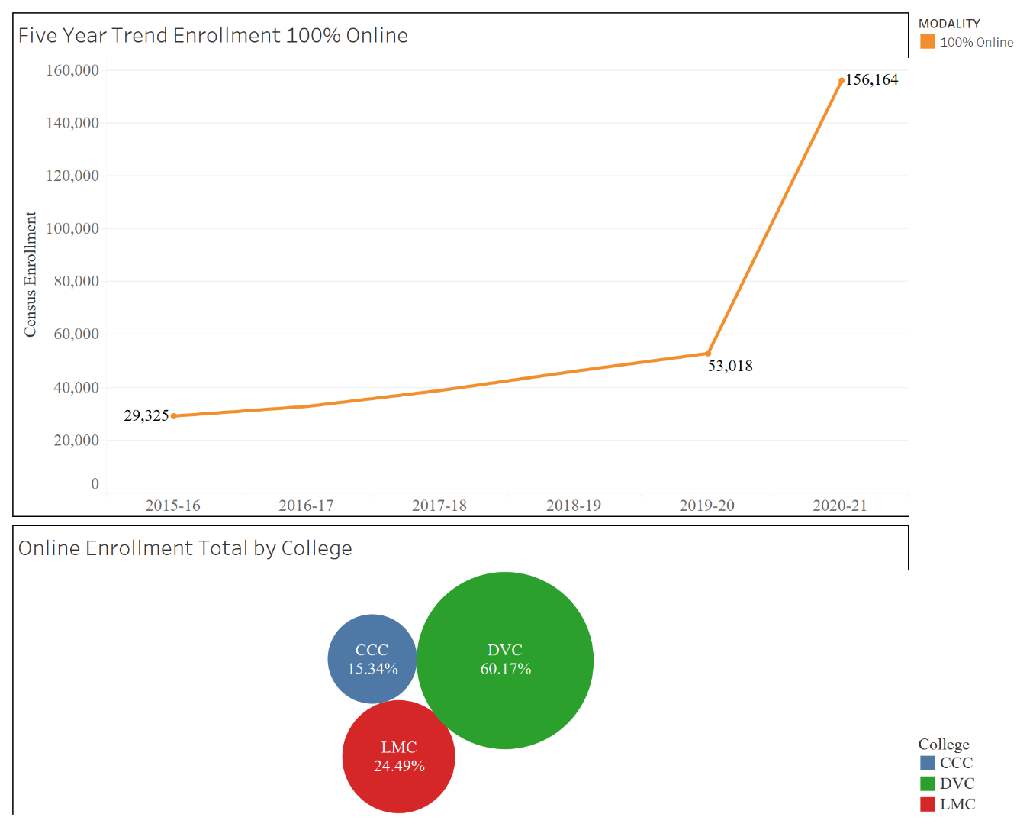

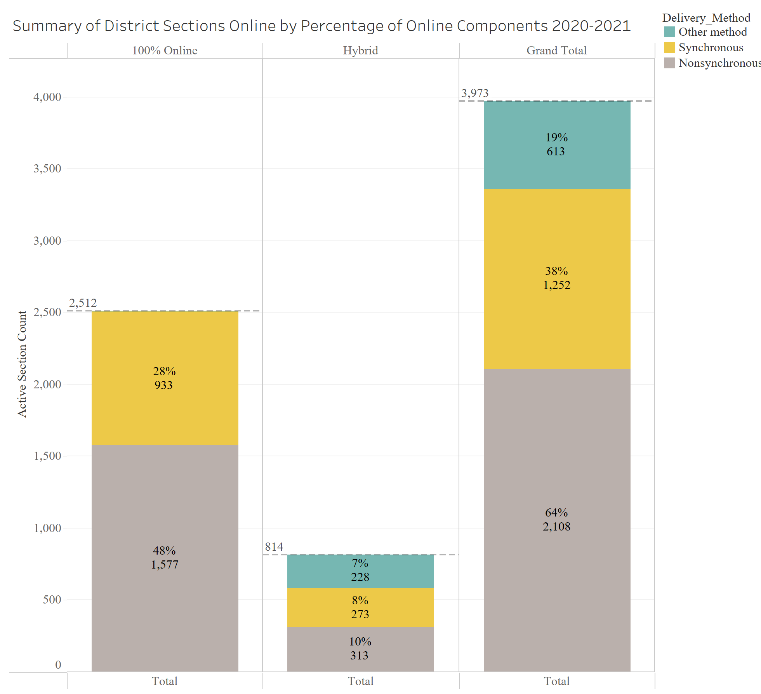
Table 2: District Sections Online Percentage 2020-21

Table 2 is a summary of the number of total sections districtwide and the associated modalities and instructional delivery methods for both 100% online sections and hybrid. The grand total column includes all modalities for comparison (in person, combination, hybrid and 100% online). Fully in-person sections only account for 647 sections in total districtwide during the 2020-21 academic year, whereas the vast majority were delivered either synchronously or asynchronously in an online learning environment. Tables 3 and 4 provide further drill in detail by examining the section delivery modalities at each college.
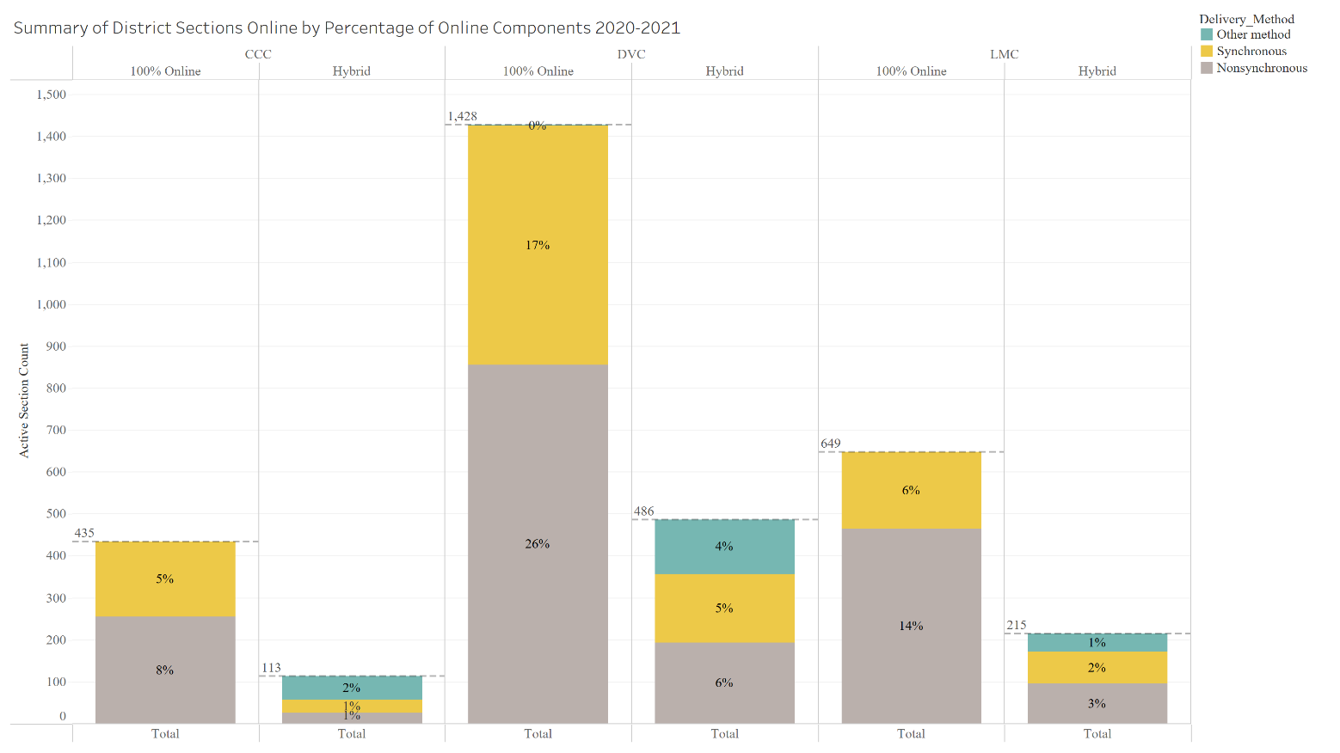
Table 3: District Sections Online Summary by College

The following tables examine enrollment trends; first by academic division, then by ethnicity/race, gender, and age for the 2020-21 academic year. Keeping in mind that the academic year was the first full academic year during the pandemic, overall increases in 100% online enrollment naturally increased among all categories, with corresponding decreases in the in-person face-to-face instructional modalities.

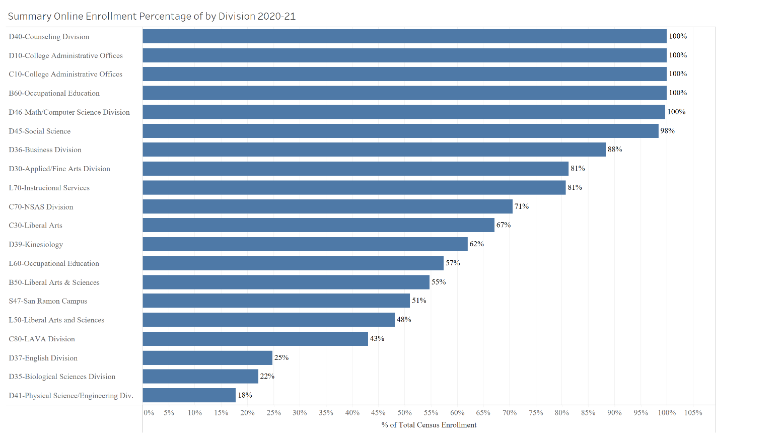
Table 4: Enrollment Summary for 100% online by Division 2020-21

Table 5: Enrollment trend in 100% online by student race/ethnicity
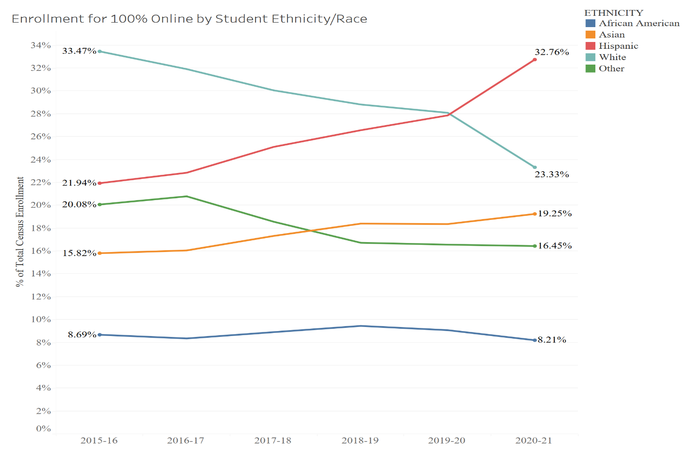

Table 6: Enrollment trend in 100% online by student gender
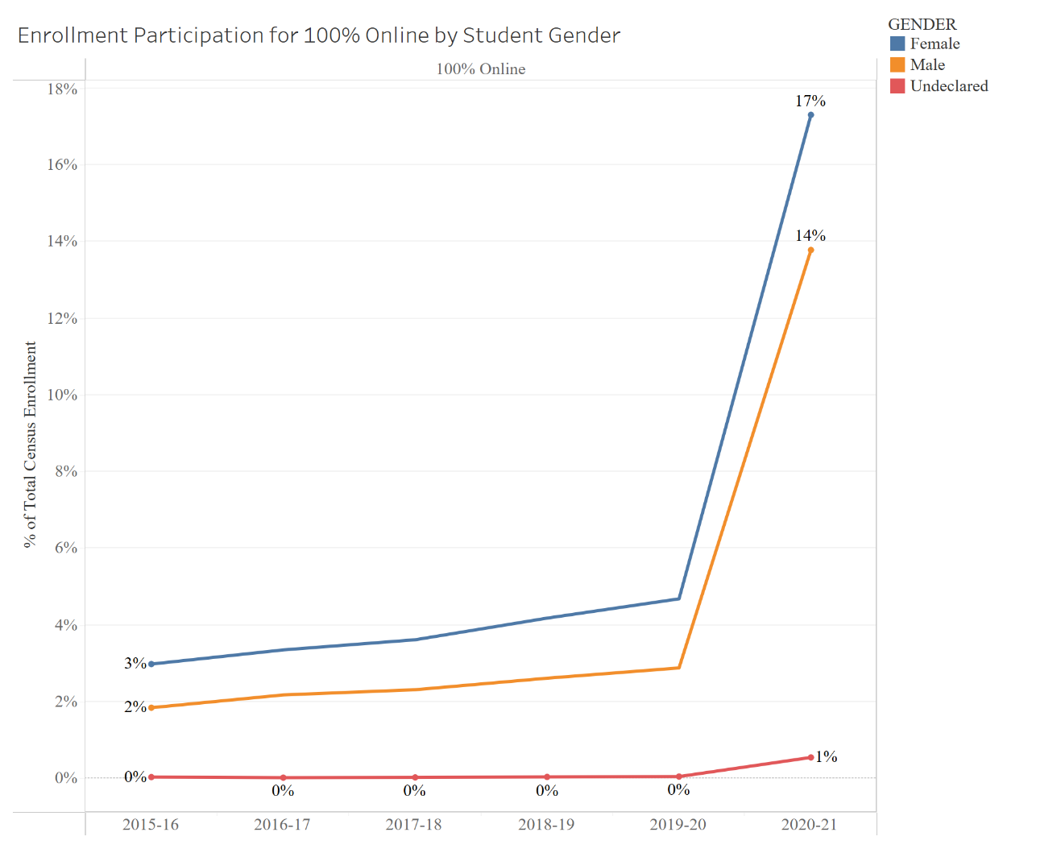

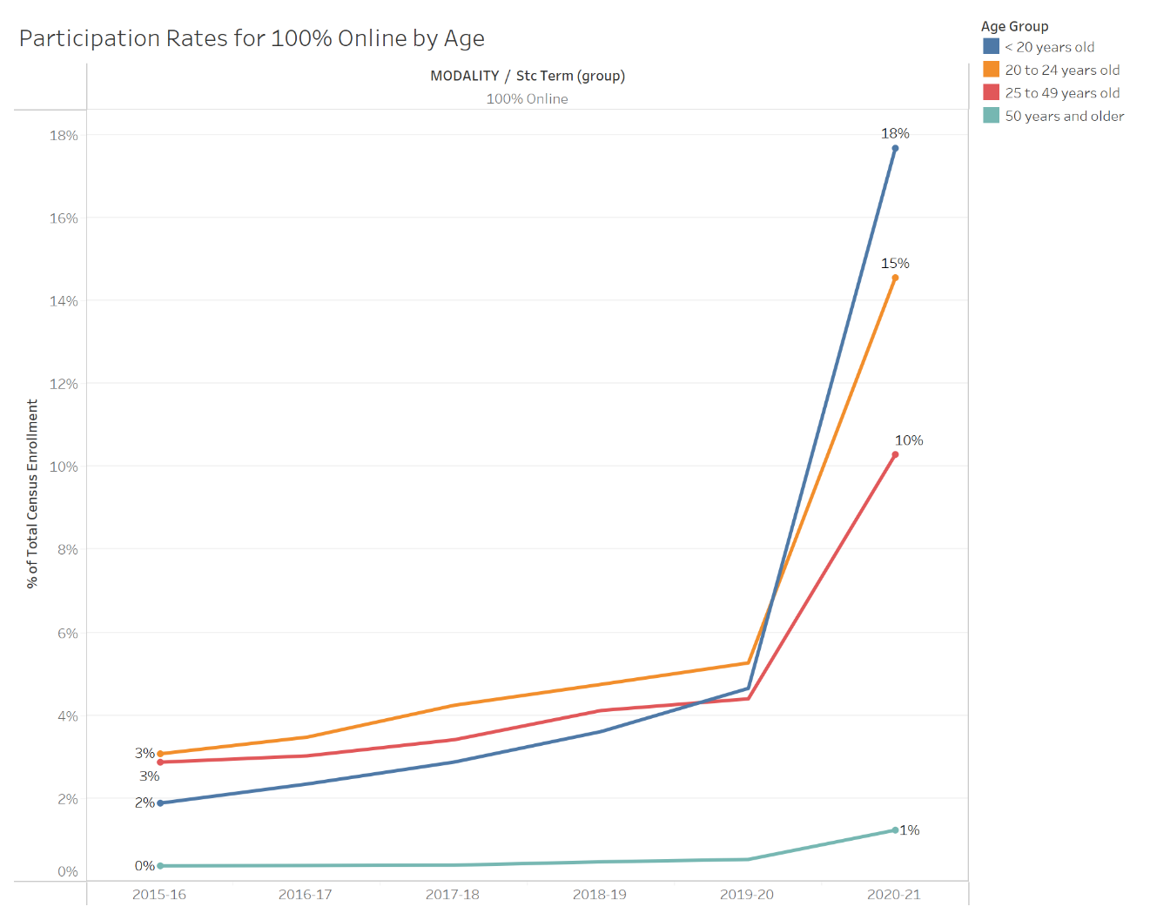
Table 7: Enrollments 100% online by student age

Along with the pandemic and transition to primarily distance education modalities, opportunities emerged for closing the performance gap between in-person and online modalities. Significant efforts and investments were made to improve the distance education learning environments, resulting in closure of the performance gap across all student characteristics. DDEC had already developed districtwide training for online instructors when classes moved online in Spring 2020. That training was immediately ramped up, with a team of experienced online instructors immediately agreeing to facilitate multiple sections of the 4-week course in online pedagogy and practice. Those efforts, together with informal volunteer and paid mentoring, on the campuses resulted in online instruction training for more than 1,200 part- and full-time faculty.
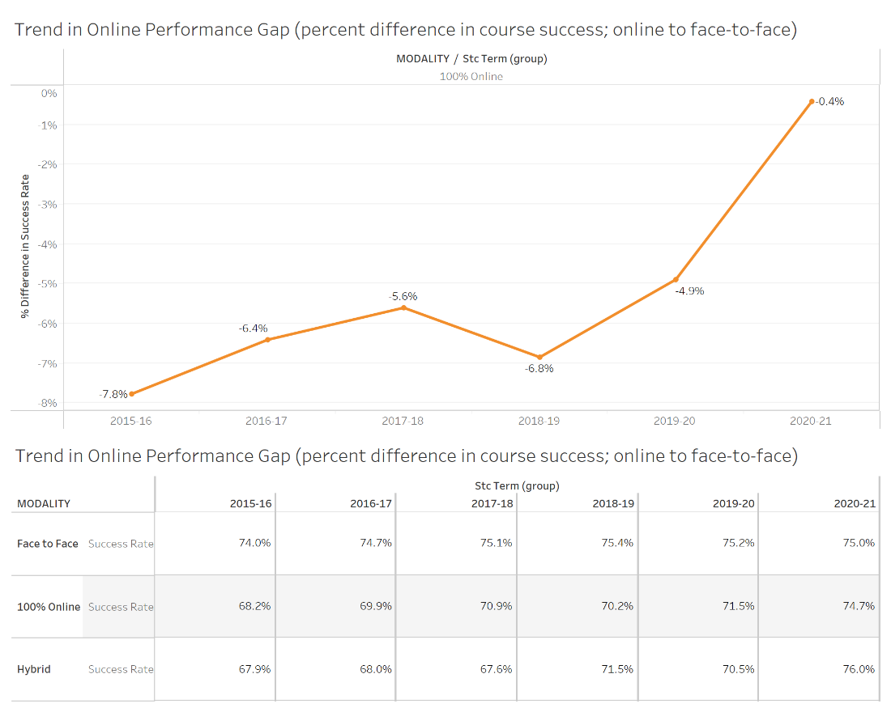
Table 8: 100% online performance gap

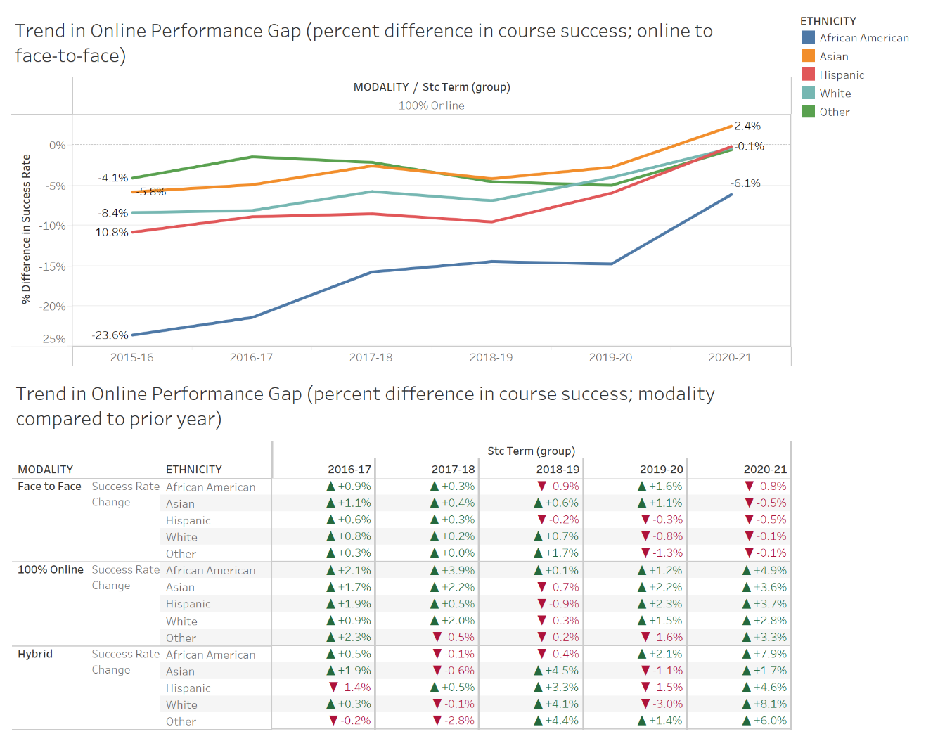
Table 9: Performance gap by student race/ethnicity

Review of Distance Education Statistics
- Success and course retention rates with DE courses are strong. ​
- Clear theme that the rates are increasing across all groups and all modalities.​
- Equity considerations among the Hispanic and African American groups; particularly with success rates; however, gains are being made. ​
- Reviewing Spring term data, the pandemic effects are more visible (last slides); the good news is that in Spring 2021 a full recovery with growth are apparent in retention and success.

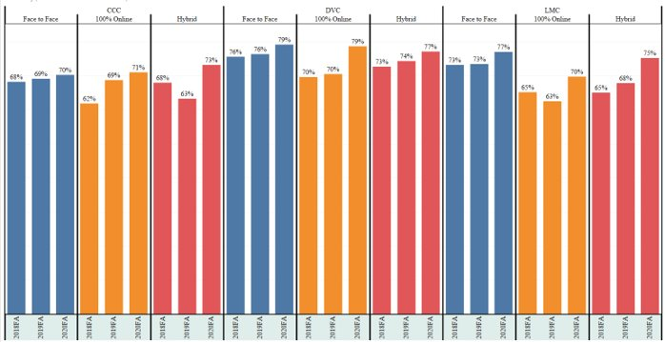

Success rates fall terms: Rates in all modalities in all locations have increased over time.
Success Rates Fall Terms, by Ethnicity and Modality: Success rates in all modalities have increased over time.
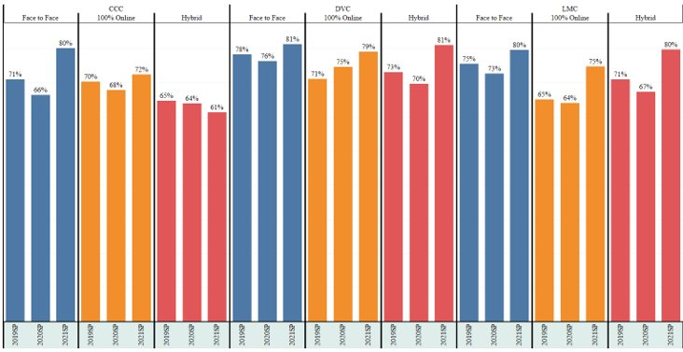
Course Success Rates Spring Terms by Modality: Clearly see the dip in success in Spring 2020 and generally a full recovery with growth Spring 2021.

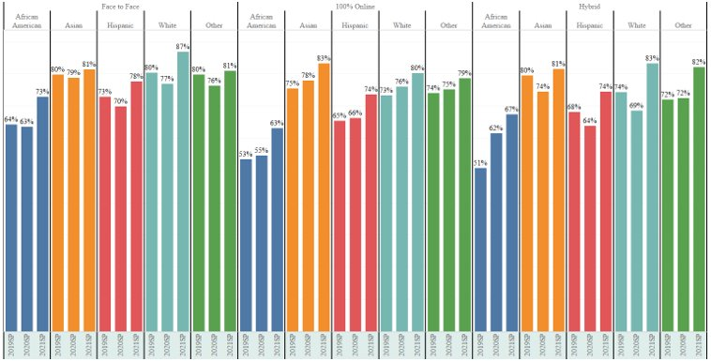
Course success rate Spring term by Ethnicity and Modality: Clearly see the dip in success in Spring 2020 and generally a full recovery with growth Spring 2021.

Distance Education Strategic Plan Goals

Goal 1: Develop Principles of Excellence in Alignment with Diversity, Equity, Anti-racism, Inclusion, Accessibility and Student Success.

Objectives:
- Align courses with the CVC Course Design Rubric and equity rubrics.
- Institutionalize campus Distance Education programs.
- Evaluate and strengthen processes in Guided Pathways, Curriculum development, Scheduling, Student Learning Outcomes, and Open Educational Resources to reflect and include equity, inclusivity and accessibility online.
- Improve online faculty evaluations to ensure that faculty provide regular and substantive interaction and other practices in high-quality online instruction.
- Ensure continuity of negotiated requirement that all 4CD faculty have completed training to teach online to facilitate adherence to principles of excellence for diversity, anti-racism, inclusion, accessibility and success.

Possible Action Steps:
- Define ‘Excellence,’ by identifying benchmarks for student achievement and support, faculty training levels.
- Establish ongoing funding for campus programs to support high-quality online education.
- Collaborate with librarians districtwide to facilitate professional development in technical skills and information on Open Educational Resources and Zero Textbook Cost courses and degrees.
- Continue dialog with management and United Faculty regarding online evaluations and training requirements.
- Continuously improve and expand as needed the current districtwide professional development program to train/mentor online faculty to support high quality interaction with students.

Goal 2: Enhance Professional Development

Objectives:
- Provide districtwide professional development in equitable, accessible online pedagogy and practice that is regularly updated to ensure relevance and currency.
- Integrate Diversity, Equity and Inclusion, and Social Justice in districtwide training courses in online teaching.
- Establish districtwide training for accessibility in compliance with state and federal law.
- Establish mechanisms for districtwide training as new technologies emerge.

Possible Action Steps:
- Secure ongoing funding for faculty training and facilitation in professional development.
- Secure funding and support for continuation of Peer Online Mentoring and Review program.
- Establish regular DDEC annual review processes for online training courses.
- Establish one or more DDEC workgroups, as appropriate to address emerging technologies.
- Ensure access to accessibility training through districtwide, state or CVC resources.

Goal 3: Provide Comprehensive Online Student Support Services

Objectives
- Develop and implement best practices for delivering online student support services, and evaluate effectiveness.
- Establish a single-stop resource for information on best practices in online student services.
- Assess opportunities for professional development in delivery of online student support services.
- Assess opportunities for training in onboarding online tutors, instructional aides and providers of other student-facing services.

Possible Action Steps
- Regularly analyze budget through program review and other processes to ensure adequate support for program effectiveness in Distance Education student services.
- Establish districtwide dialog to collaborate with Student Services to create best practices and professional development for online student services delivery.
- Provide connection to resources in professional development for the delivery of online student services.
- Survey online tutoring, instructional aides, and other student facing services to determine needs in professional development.
- Evaluate student needs for individual technology and internet access.

Goal 4: Improve Technology Infrastructure and Support

Objectives
- Develop districtwide instructional technology procurement process that ensures equity, accessibility, and student privacy, and promotes equitable outcomes and student success.
- Evaluate and adopt instructional technology to facilitate innovative online teaching that supports a variety of teaching modalities.
- Explore emerging technologies, including Artificial Intelligence and Virtual Reality, that may lead to enhanced online learning.
- Promote easy, reliable and secure student access to campus WiFi in collaboration with campus and district staff.

Possible Action Steps
- Analyze current campus, district, and DDEC processes for procuring instructional technology.
- Collect and analyze best practices for technology procurement at other CCC districts, which could rubrics for desirability, equity, and accessibility.
- Explore and establish best practices for supporting student technology needs.
- Explore best practices for supporting innovative online instruction.

Goal 5: Strengthen District Support for Coordination and Continuous Improvement

Objectives
- Institutionalize DE program-level support across all campuses to facilitate online student success with full-time DE Coordinators, trainers, and accessibility specialists.
- Provide necessary infrastructure and technology to enable data-driven decisions districtwide.
- Strengthen collaboration between DE and Equity with district support for diversity, equity, inclusion and anti-racism.
- Develop districtwide collaboration to clarify, increase and promote online degrees and pathways.
- Establish districtwide collaboration with the California Virtual Campus in development of regional certificates, degrees and pathways.

Possible Action Steps
- Establish (Explore opportunities for?) ongoing funding for campus DE Programs and technology.
- Ensure program review process includes disaggregated data for Distance Education delivery of courses and programs.
- Establish regular districtwide student survey to assess student demand and needs online.
- Establish a districtwide collaborative group to explore, create and promote online pathways, certificates and degrees.
- Establish a districtwide collaborative group to examine and create intentional opportunities for integration of diversity equity, inclusion and anti-racism in online classrooms.
- Explore and access possibilities with the California Virtual Campus to develop regional or statewide certificates, degrees or pathways.

Proposed Five-Year Action Plan for Implementation
Possible Action Item | Strategic Goal | Proposed Timeline
Establish a districtwide collaborative group to explore, create and promote online pathways, certificates and degrees. | 5.4 Develop districtwide collaboration to clarify, increase and promote online degrees and pathways. | Fall 2022
Establish regular districtwide student survey to assess student demand and needs online. | 5.2 Provide necessary infrastructure and technology to enable data-driven decisions districtwide. | Fall 2022
Secure ongoing funding for faculty training and facilitation in professional development.  Establish regular DDEC annual review processes for online training courses. | 2.1 Provide districtwide professional development in equitable, accessible online pedagogy and practice that is regularly updated to ensure relevance and currency. | Fall 2022
Establish (Explore opportunities for???) ongoing funding for campus DE Programs and technology. | 5.1 Institutionalize DE program-level support across all campuses to facilitate online student success with full-time DE Coordinators, trainers, and accessibility specialists. | Spring 2022
Collect and analyze best practices for technology procurement at other CCC districts, which could rubrics for desirability, equity, and accessibility. | 4.1 Develop districtwide technology procurement process that ensures equity, accessibility, and student privacy, and promotes equitable outcomes and student success. | Fall 2022
Provide connection to resources in professional development for the delivery of online student services. | 3.3 Assess opportunities for professional development in delivery of online student support services. | Fall 2022
Provide connection to resources in professional development for the delivery of online student services. | 3.4 Assess opportunities for training in onboarding online tutors, instructional aides and providers of other student-facing services. | Fall 2022
Establish ongoing funding for campus programs to support high-quality online education. | 1.1 Align courses with the CVC Course Design Rubric and equity rubrics. | Fall 2022 ongoing
Continue dialog with management and United Faculty regarding online evaluations and training requirements.  Define ‘Excellence,’ by identifying benchmarks for student achievement and support, faculty training levels. | 1.5 Ensure continuity of negotiated requirement that all 4CD faculty have completed training to teach online to facilitate adherence to principles of excellence for diversity, anti-racism, inclusion, accessibility and success. | Fall 2022
Establish one or more DDEC workgroups, as appropriate to address emerging technologies. | 2.4 Establish mechanisms for districtwide training as new technologies emerge. | Spring 2023
Establish districtwide dialog to collaborate with Student Services to create best practices and professional development for online student services delivery. | 3.1 Develop and implement best practices for delivering online student support services, and evaluate effectiveness. | 2022-2023
Analyze current campus, district, and DDEC processes for procuring instructional technology. | 4.3 Explore emerging technologies, including Artificial Intelligence and Virtual Reality, that may lead to enhanced online learning. | 2022-2023
Explore best practices for supporting innovative online instruction. | 4.2 Evaluate and adopt technology to facilitate innovative online teaching that supports a variety of teaching modalities. | 2022-2023
Explore and access possibilities with the California Virtual Campus to develop regional or statewide certificates, degrees or pathways. | 5.5 Establish districtwide collaboration with the California Virtual Campus in development of regional certificates, degrees and pathways. | 2023-2024
Establish a districtwide collaborative group to examine and create intentional opportunities for integration of diversity equity, inclusion and anti-racism in online classrooms. | 5.3 Strengthen collaboration between DE and Equity with district support for diversity, equity, inclusion and anti-racism. | 2023-2024
Establish ongoing funding for campus programs to support high-quality online education. | 1.2 Institutionalize campus Distance Education programs. | 2023 - 2024
Continuously improve and expand as needed the current districtwide professional development program to train/mentor online faculty to support high quality interaction with students.  Collaborate with librarians districtwide to facilitate professional development in technical skills and information on Open Educational Resources and Zero Textbook Cost courses and degrees. | 1.3 Evaluate and strengthen processes in Guided Pathways, Curriculum development, Scheduling, Student Learning Outcomes, and Open Educational Resources to reflect and include equity, inclusivity and accessibility online. | 2023 - 2024
Continue dialog with management and United Faculty regarding online evaluations and training requirements. | 1.4 Improve online faculty evaluations to ensure that faculty provide regular and substantive interaction and other practices in high-quality online instruction. | 2023 - 2025
Establish districtwide accessibility training or ensure access to accessibility training through state or CVC resources. | 2.3 Establish districtwide training for accessibility in compliance with state and federal law. | 2023 - 2025
Establish regular DDEC annual review processes for online training courses. | 2.2 Integrate Diversity, Equity and Inclusion, and Social Justice in districtwide training courses in online teaching. | 2023 - 2025
Establish one or more DDEC workgroups, as appropriate to address emerging technologies. | 2.4 Establish mechanisms for districtwide training as new technologies emerge. | 2024 - 2025
Establish districtwide dialog to collaborate with Student Services to create best practices and professional development for online student services delivery | 3.2 Establish a single-stop resource for information on best practices in online student services. | 2025 - 2026
Explore and establish best practices for supporting student technology needs. | 4.4 Promote easy, reliable and secure student access to campus WiFi in collaboration with campus and district staff. | 2026 - 2027

Appendix

Appendix a: Definitions

Appendix B: References and Sources of Authority

U.S. Department of Education Definition of Distance Education
Retrieved from U.S. Federal Register on 01.25.2022
Distance education: Education that uses one or more of the technologies listed in paragraphs (1)(i) through (1)(iv) of this definition to deliver instruction to students who are separated from the instructor or instructors, and to support regular and substantive interaction between the students and the instructor or instructors, either synchronously or asynchronously.

California Code of Regulations, Title 5, Sections 55200 - 55210
Retrieved on 01.25.2022 from Barclays Official California Code of Regulations Currentness
Title 5. Education
Division 6. California Community Colleges
Chapter 6. Curriculum and Instruction
Subchapter 3. Alternative Instructional Methodologies
Article 1. Distance Education

5 CCR § 55200
§ 55200 Definition and Application
Distance education means instruction in which the instructor and student are separated by time and/or distance and interact through the assistance of technology. All distance education is subject to the general requirements of this chapter as well as the specific requirements of this article. In addition, instruction provided as distance education is subject to the requirements of the Americans with Disabilities Act (42 U.S.C. § 12100 et seq.) and section 508 of the Rehabilitation Act of 1973, as amended (29 U.S.C. § 794d).
Note: Authority cited: Sections 66700 and 70901, Education Code. Reference: Sections 70901 and 70902, Education Code; title 29 United States Code section 794d; and title 42 United States Code sections 12100, 12101, 12102, 12103, 12131, 12132, 12133 and 12134.

5 CCR § 55202
§ 55202 Course Quality Standards
The same standards of course quality shall be applied to any portion of a class conducted through distance education as are applied to in-person classes, in regard to the course quality judgment made pursuant to the requirements of section 55002, and in regard to any local course quality determination or review process. Determinations and judgments about the quality of distance education under the course quality standards shall be made with the full involvement of faculty in accordance with the provisions of subchapter 2 (commencing with section 53200) of chapter 2.
Note: Authority cited: Sections 66700 and 70901, Education Code. Reference: Section 70901, Education Code.

5 CCR § 55204
§ 55204 Instructor Contact
In addition to the requirements of section 55002 and any locally established requirements applicable to all courses, district governing boards shall ensure that:
(a) Any portion of a course conducted through distance education includes regular effective contact between instructor and students, and among students, either synchronously or asynchronously, through group or individual meetings, orientation and review sessions, supplemental seminar or study sessions, field trips, library workshops, telephone contact, voice mail, e-mail, or other activities. Regular effective contact is an academic and professional matter pursuant to sections 53200 et seq.
(b) Any portion of a course provided through distance education is conducted consistent with guidelines issued by the Chancellor pursuant to section 409 of the Procedures and Standing Orders of the Board of Governors.
Note: Authority cited: Sections 66700 and 70901, Education Code. Reference: Sections 70901 and 70902, Education Code.

5 CCR § 55206
§ 55206 Separate Course Approval
If any portion of the instruction in a new or existing course is to be provided through distance education, an addendum to the official course outline of record shall be required. In addition to addressing how course outcomes will be achieved in a distance education mode, the addendum shall at a minimum specify how the portion of instruction delivered via distance education meets:
(a) Regular and effective contact between instructors and students and among students as referenced in title 5, section 55204(a), and
(b) Requirements of the Americans with Disabilities Act (42 U.S.C. § 12100 et seq.) and section 508 of the Rehabilitation Act of 1973, as amended, (29 U.S.C. § 749d)
The addendum shall be separately approved according to the district's adopted curriculum approval procedures.
Note: Authority cited: Sections 66700 and 70901, Education Code. Reference: Sections 70901 and 70902, Education Code.

5 CCR § 55208
§ 55208 Faculty Selection and Workload
(a) Instructors of course sections delivered via distance education technology shall be selected by the same procedures used to determine all instructional assignments. Instructors shall possess the minimum qualifications for the discipline into which the course's subject matter most appropriately falls, in accordance with article 2 (commencing with section 53410) of subchapter 4 of chapter 4, and with the list of discipline definitions and requirements adopted by the Board of Governors to implement that article, as such list may be amended from time to time.
(b) Instructors of distance education shall be prepared to teach in a distance education delivery method consistent with local district policies and negotiated agreements.
(c) The number of students assigned to any one course section offered by distance education shall be determined by and be consistent with other district procedures related to faculty assignment. Procedures for determining the number of students assigned to a course section offered in whole or in part by distance education may include a review by the curriculum committee established pursuant to section 55002(a)(1).
(d) Nothing in this section shall be construed to impinge upon or detract from any negotiations or negotiated agreements between exclusive representatives and district governing boards.
Note: Authority cited: Sections 66700 and 70901, Education Code. Reference: Sections 70901 and 70902, Education Code.

5 CCR § 55210
§ 55210 Ongoing Responsibility of Districts
If a district offers one or more courses or course sections in which instruction is provided through distance education for at least 51 percent of the hours of instruction in the course or course section, the district shall:
(a) maintain records and report data through the Chancellor's Office Management Information System on the number of students and faculty participating in new courses or sections of established courses offered through distance education ;
(b) provide to the local governing board, no later than August 31st of each year, a report on all distance education activity;
(c) provide other information consistent with reporting guidelines developed by the Chancellor pursuant to section 409 of the Procedures and Standing Orders of the Board of Governors.
Note: Authority cited: Sections 66700 and 70901, Education Code. Reference: Sections 70901 and 70902, Education Code.

Contra Costa Community College District Distance Education Policy
Contra Costa Community College District Board Policy 4014

DISTANCE AND CORRESPONDENCE EDUCATION
To ensure the integrity of the Distance and Correspondence Education offerings and comply with federal regulations (34 CFR Section 602.17g) and ACCJC policies, each college will ensure student authentication to
Distance and Correspondence Education classes using the unique student ID and password issued by the Contra Costa Community College District as part of the enrollment process. Required use of the student ID and password serves as a means to validate that the student who is registered for a course is the same student doing the work and receiving the grades/credits. The District and the colleges will, at all times, work to ensure that each student’s password is protected against public disclosure. Students shall be notified about steps to take in order to request the issuance of a new password should they believe that their existing password has been compromised.
The District will make available to each student, at the time of registration, a statement of the process in place to ensure student privacy.
Definitions per Federal Regulations
Distance Education means [34 CFR Section 602.3]:
Education that uses one or more of the technologies listed in paragraphs (1) through (4) to deliver instruction to students who are separated from the instructor and to support regular and substantive interaction between the students and the instructor either synchronously or asynchronously. The technologies may include:
1. the internet;
2. one-way and two-way transmissions through open broadcast, closed circuit, cable, microwave, broadband lines, fiber optics, satellite, or wireless communications devices;
3. audio conferencing; or
4. video cassettes, DVDs, and CD-ROMs, if the cassettes, DVDs, or CD-ROMs are used in a course in conjunction with any of the technologies listed in paragraphs (1) through (3).
Correspondence education means [34 CFR Section 602.3]:
1. education provided through one or more courses by an institution under which the institution provides instructional materials, by mail or electronic transmission, including examinations on the materials, to students who are separated from the instructor;
2. interaction between the instructor and the student is limited, is not regular and substantive, and is primarily initiated by the student;
3. correspondence courses are typically self-paced; and
4. correspondence education is not distance education.
Course Review and Approval
Each proposed or existing course offered by distance education shall be reviewed and approved separately.
Separate approval is mandatory if any portion of the instruction in a course or a course section is designed to be provided through distance education. The occasional online assignment does not necessitate separate Approval. The review and approval of new and existing distance education courses shall follow the curriculum approval procedures outlined in Curriculum and Instruction Procedure 4008, Review, Establishment, Modification and Discontinuance of Courses and Programs. Distance education courses shall be approved under the same conditions and criteria as all other courses and must be in compliance with the Americans with Disabilities Act and Section 508 of the Rehabilitation Act of 1973.
Instructor Preparation to Teach Distance Education. Instructors of distance education shall be prepared to teach in a distance education delivery method consistent with district policies and negotiated agreements.
Certification
When approving distance education courses, the college curriculum/instruction committee will certify the following:
- Course Quality Standards – The same standards of course quality are applied to the distance education courses as are applied to traditional classroom courses.
- Course Quality Determinations – Determinations and judgments about the quality of the distance education course were made with the full involvement of the college curriculum/instruction committee and followed the adopted course approval procedures.
- Instructor and Student Contact – Each section of the course that is delivered through distance education will include regular effective contact between instructor and students, as well as among students, either synchronously or asynchronously.
- Addendum to Course Outline - An addendum to the official course outline of record shall be made if any portion of the instruction of a new or existing course is provided through distance education.
The addendum must be approved according to the District’s curriculum approval procedure (Curriculum and Instruction Procedure 4008) and must address the following:
- How course outcomes will be achieved in a distance education mode;
- How the portion of instruction delivered via distance education provides regular and effective contact between instructor and students and among students; and
- How the portion of the instruction delivered via distance education meets the requirements of the Americans with Disabilities Act (ADA) and Section 508 of the Rehabilitation Act of 1973.
- Duration of Approval – All distance education courses approved under this procedure will continue to be in effect unless there are substantive changes to the course outline.
- Student Learning Outcomes - All distance education courses must demonstrate how they will achieve the student learning outcomes in an online learning environment
Code of Federal Regulations, Title 34, Sections 602.17g and 602.3
Title 5 Sections 55200 et seq.
Historical Annotation:
Adopted 11/14/12
First Revision 10/14/20

Appendix C: Student Survey Instruction Modality Preferences
Since the start of the pandemic, March 2020, 4CD has actively been engaging students to provide feedback and preferences for instructional modalities.

Initially students were surveyed in June 2020 through the California Community Colleges Chancellor’s office (CCCCO) and internally through 4CD internal survey methods. Students were asked to respond to numerous questions about their prior and current experiences with online learning, responses were provided by 483 students to the CCCCO survey and 126 responses to the internal 4CD survey. Most students did not have any significant experience with online learning, 21.8% regularly enrolled in online courses and 72.2% planned to enroll in courses for fall 2020 despite the significant changes to their lives and high degree of stress. Asked about their preferences for course delivery, 51% wanted a combination of synchronous and asynchronous courses, and 13.8% wanted only in person courses.

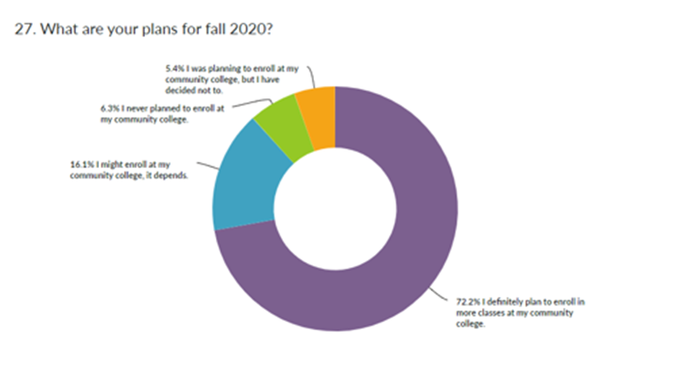

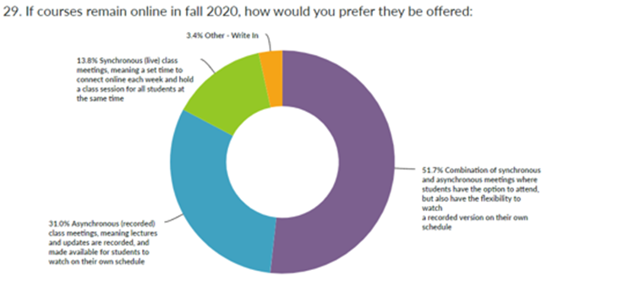
Similarly, students responding to the internal survey 41% of students responded they did not like or did not feel comfortable with distance learning.
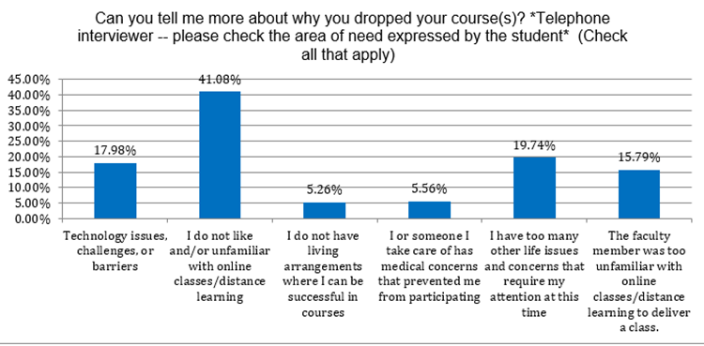

This survey was followed by another conducted in Spring 2021, a year after the beginning of the pandemic. This survey focused on what course modalities students preferred to enroll in for Fall 2021. A total of 4206 students responded. A total of 89% of students responded that they plan to enroll in Fall 2021.
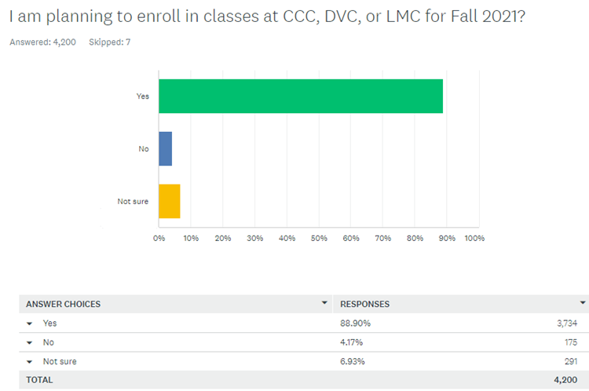

Of those students that planned to enroll we asked them about modality preferences; 47% preferred only online courses, and 37% wanted a combination of online and in person instruction.
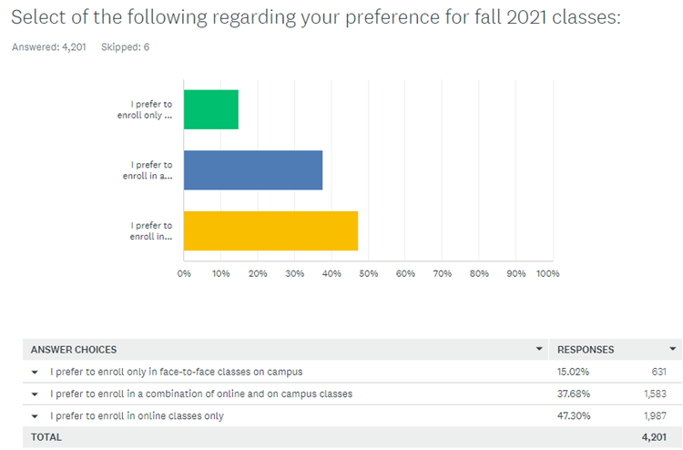

There was strong college interest in duplicating this survey for Spring 2022, to ensure that a scheduling mix of courses would meet student preferences. This survey was distributed in September 2021, and 5170 students responded.

Of those students that responded, 92.5% planned to enroll for Spring 2022.
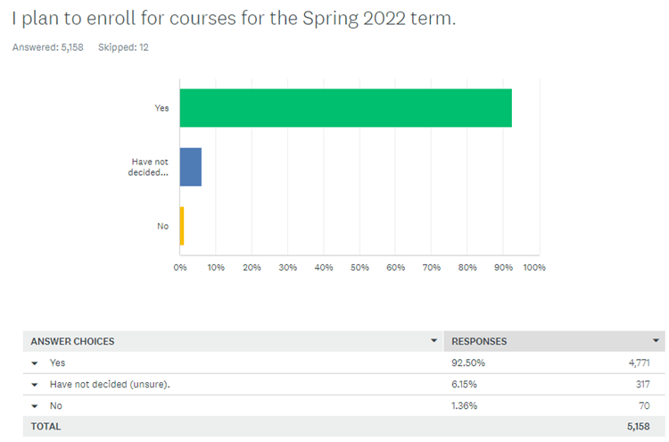
Of those that planned to enroll, 54% planned to enroll in only online courses.
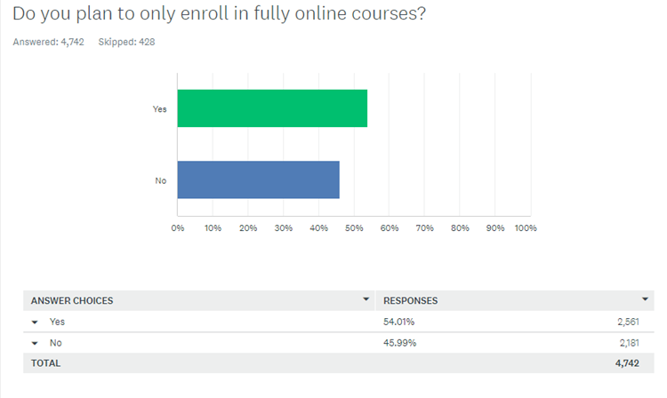
When asked about online delivery method preferences for different types of class activities 65% preferred a 100% online delivery format (synchronous or asynchronous) for lecture activities, and 45% preferred a fully online delivery method for lab activities.
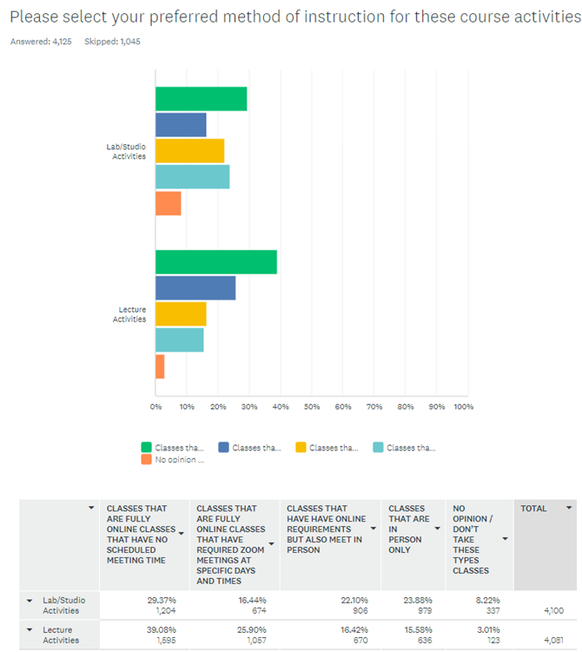
Over the two-year period students' preferences for 100% online instructional delivery has grown as students become more comfortable with the formats. Additionally, students have increasingly responded that they plan to continue attending even when courses are primarily offered online.

