On Leave: College Wellness, Mental Health And Not Returning To Campus46:58
November 27, 2018
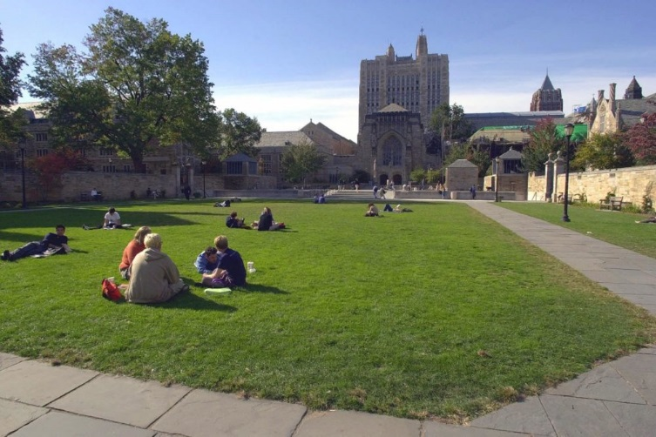
Yale University students and others spend a fall afternoon on Yale University's Cross Campus in New Haven, Conn., in an Oct. 11, 2000 file photo. (AP Photo/Bob Child/file)
With Jane Clayson
Your college student came home for Thanksgiving and didn’t go back to campus. We’ll look at when college students come home to stay.

Guests
William Stixrud, clinical neuropsychologist. Professor of Psychiatry and Pediatrics at the George Washington University School of Medicine. Author of "The Self-Driven Child: The Science and Sense of Giving Your Kids More Control Over Their Lives."
Rainesford Stauffer, dropped out of the University of Evansville after her freshman year. Returned to Kentucky and spent two years working before transferring to the New School. Currently getting a Master’s Degree in journalism at New York University. (@Rainesford)
Dr. Marcia Morris, psychiatrist at the University of Florida. Writes the Psychology Today blog, "College Wellness: Promoting Happiness and Health in the College Years." Author of "The Campus Cure: A Parent's Guide to Mental Health and Wellness for College Students." (@marciamorrismd)

From The Reading List
New York Times: "When a College Student Comes Home to Stay" — "Parents tend to think of getting in to college as the finish line of a race. They may worry about their high schooler’s grades, or tech usage, or friend group, but tell themselves, “As long as my kid gets off to college, it will be fine.”
"Unfortunately, that’s not always so. Thirty percent of freshmen won’t return for their sophomore year, and the wheels can start to fall off as early as Thanksgiving. We don’t talk about it much, but many teenagers go away to college only to recognize — either because of their grades, their habits, their mental health or all of the above — that they’re not ready for college life.
"When the new batch of freshmen arrived on campus this fall, many of them were greeted as members of the class of 2022, based on the old assumption that college is a four-year program. In fact, according to data from the nonprofit Complete College America, only 20 percent of students complete a bachelor’s degree in four years.
"And only 57 percent of students who enroll in college will graduate in six years. It’s not only the underachievers. Burnout is common among high-achieving high school students who sacrificed sleep and relaxation for four years to get into their college of choice, only to find once they get there that they can’t imagine another four years of grind."
New York Times: "Opinion: Dropping Out of College Into Life" — "'I never pegged you for a dropout,' a family friend said when I moved back home to sleepy Owensboro, Ky., after my freshman year of college.
"In high school I had been a stereotypical overachiever. Because my grades were good, I had little doubt that I’d excel in college. Instead, I did the opposite. I froze.
"There has been a lot of media coverage about students who fear failure so much that it affects everything from their grades to their mental health, but there seem to be misconceptions about where this fear comes from. It’s easy to dismiss young people as 'soft' or desperate for participation trophies, but fear of failure is far more complex.
"I never thought I would be the best student on campus and never expected to be treated as if I were outstanding. I was prepared for a bad grade or rejection letter here or there. I was not prepared for feeling like I didn’t fit in, that there was no place for me on a campus where everyone told me I should be having the time of my life. I wasn’t afraid of failing as a student; I was afraid of failing as a person."
Psychology Today: "The College Student Mental Health Crisis (Update)" — "What, exactly, is the 'college student mental health crisis?' It refers to the fact that (a) significant numbers of college students experience mental health problems (between a quarter and a third at any given time), and (b) over the past 15 to 20 years, we have seen a dramatic increase in the demand for mental health services on college campuses.
"To give one example of the numbers we are talking about, last month a research report came out that found rates of “past year treatment" had risen from 19% in 2007 to 34% in 2017. In addition, students with lifetime diagnoses increased from 22% in 2007 to 36% in 2017. The trend lines in these categories had been moving up steadily through the 1990s. Here, then, is the nutshell summary of the crisis:
"In the 1980s, at any given point, perhaps 1 in 10 college students could be readily characterized as needing/wanting/using some form of mental health treatment. Now that number is 1 in 3, with trend lines rising.
"Here is the $64,000 question about these numbers: What is really going on? Are we seeing an “epidemic” of mental illness racing through the country? Or are we seeing a shift in attitudes, definitions, and the expectation of, availability of, and willingness to seek mental health treatment? My opinion is that the primary cause is a change in attitudes and use, with an important secondary cause being an actual increase in emotional fragility and distress (and thus an increase in anxiety and depressive conditions).
"The first point is certainly true. That is, there have been major changes how people think about mental health and major increases in folks’ willingness to use mental health services. This attitude change is clearly one major reason for the difference. Some scholars argue that attitude change and a willingness to seek treatment is the only reason for the shift. In this interpretation of the crisis, people were suffering with mental illness in the 1980s and '90s at similar rates as they are now, but they were much less likely to talk about their problems openly and much more reluctant to seek treatment (perhaps because of stigma) or had less knowledge or access to do so."
This program aired on November 27, 2018.

