H. Quality Focus Essay

Introduction of Projects
In the spring of 2019, the Strategic Enrollment Management (SEM) committee was formed and endorsed as a sub-committee of the Shared Governance Council. SEM is charged with:
- Developing comprehensive student enrollment goals aligned with the College’s mission and Educational Master Plan;
- Utilizing Guided Pathways principles, ensuring strategies that improve equitable access, success, engagement, persistence, and completion outcomes for all students;
- Providing excellent and pertinent programs of study with clear pathways, course offerings and alignment, and student support;
- Creating decision-making and measurement strategies that are data-based;
- Recommending internal and external communication and marketing approaches to support enrollment management goals;
- Enhancing coordinated campus-wide efforts to ensure student success;
- Assessing existing studies and resources to better inform College practices and the student success factors;
- Optimizing student enrollments and completion, while ensuring financial viability – particularly in conjunction with the Student-Centered Funding Formula.
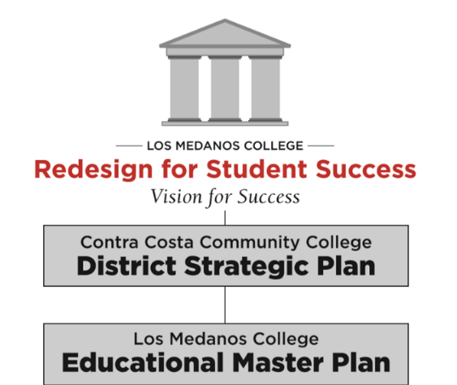
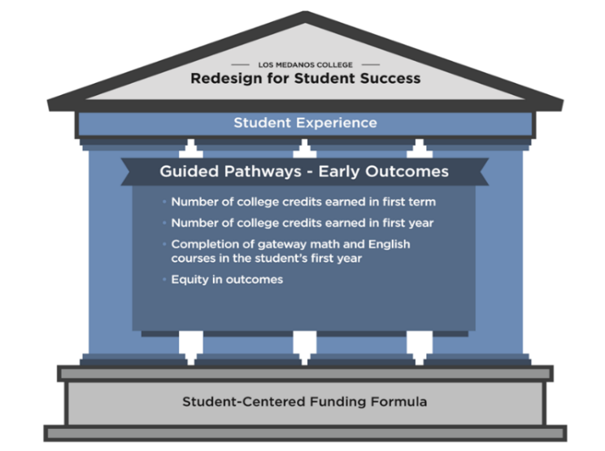
In the fall of 2019, the Strategic Enrollment Management committee led the conversation on completion of transfer level math and English courses in a student’s first year of enrollment. Several research studies and presentations were shared and discussed at the October and November SEM meetings. One research study focused on new first time, full time students with degree/transfer as their goal. The SEM committee suggested expanding this cohort to both full time and part time students. A second research study then focused on all new first time students, full and part time, with a goal of degree completion or transfer. The findings were:
- 51% of the fall 2018 cohort successfully completed gateway English in the first academic year.
- 46% of the fall 2018 cohort successfully completed gateway math in the first academic year.
However, about 1/3 of the first time students in the Fall 2018 cohort did not enroll in transfer level English or math at all. The findings were:
- 71% of the fall 2018 cohort enrolled in transfer level English in their first academic year. This means that almost 30% of them did not.
- 70% of the fall 2018 cohort enrolled in transfer level math in the first academic year; 30% did not.

Goals

Based on this data, the following goals were formulated:

1. Increase successful completion of transfer level English and math in the first year of a student’s enrollment at the college through a focus on practices that will directly address the needs of our disproportionately impacted student populations as identified in our Equity Plan.

2. Increase first-time students enrolled in their first year in transfer level English and math to 80% of all Fall cohorts by Fall 2022.

3. Research and evaluate how many sections of transfer level English and math would be needed each semester, including online courses, to meet students’ needs.

Anticipated Impact on Student Learning and Achievement
- We anticipate greater focus on equity centered practices will increase enrollment, retention, and successful completion of transfer level English and math courses for first-time students with degree/transfer goals in their first year at the college.
- Through effective recruitment, orientation and onboarding of first-time students, and by offering sufficient numbers of transfer level English and math sections, we anticipate an increase in first year enrollments, thus increasing equitable access to the transfer pathway.

Project #1: Intentional Outreach
We will continue long standing efforts to work collaboratively with our local feeder high schools, adult education schools, and community partners, including those in industry and local businesses, to inform prospective students about academic and career pathways at LMC. Our work in Guided Pathways will help to inform this effort and align our programs with the needs of our community. We will research and implement new tools to assist students in developing educational plans and use more streamlined technologies and support to facilitate actual registration as an integral part of orientation and counseling, with special emphasis on the need to enroll in transfer level English and math in the first year. Part of this effort will involve identifying the characteristics and needs of the 30% of students who matriculate but do not enroll in transfer level English and math in their first year. We will also explore new marketing strategies that effectively “get the word out” about the opportunities available, and highlight the welcoming and inclusive community students can expect to join. These efforts will be informed by student surveys and focus groups, for which we will enlist the help of our student government and student life organizations. In addition, a renewed emphasis on initiatives like Full Time, First Time, Free Tuition and other financial supports available to students will help our efforts to increase enrollments in key gateway courses, with targeted outreach to low income students.
Responsible Parties: Outreach, Counseling, other Student Services and Student Organizations
Timeline: Fall 2020- Fall 2022

Project #2: Strategic Scheduling
In collaboration with our Strategic Enrollment Management committee, we will explore innovative approaches to scheduling, e.g. scheduling for one or more years rather than semester by semester, creating priority time blocks for transfer level English and math courses, and researching ways to ensure enrollment in transfer level English and math for all students who have degree/transfer goals noted in their educational plans. Additionally, we will increase our use of data with regards to informing the scheduling of our transfer level English and math courses in particular. This will include a more in-depth analysis of historic student enrollment patterns in these courses, student educational plans to predict and manage future enrollment needs, and student feedback on how schedules impact their ability to enroll.
Responsible Parties: Strategic Enrollment Management committee and working groups that include representation from English, math and Counseling
Timeline: Fall 2020- Fall 2022

Project #3 Focused Retention Efforts
These efforts will be focused on disproportionately impacted student populations identified in our Student Equity Plan. In order to achieve Goal #1, we will increase professional development opportunities that focus on equity centered practices, and areas that need additional resources. Actions will particularly address students impacted by the “invisible costs” of being a student, e.g. food and housing insecurity, wellness, mental health needs, textbook and materials costs, et

One specific intervention already in place is “LMC Connect”, a software also known as Starfish, which provides an infrastructure to support retention and increase collaboration among faculty, counselors, and other staff. For this project, we intend to research the effectiveness of these initial efforts, identify what is and is not working, and implement modifications that would increase its effectiveness, including its ability to offer insight into the primary reasons that students drop out of first transfer level math and English courses and provide a safety net to help students at risk of doing so.
In addition, we would like to further support the efforts of our distance education committee to improve equitable access and success in distance education classes. This will include professional learning opportunities for faculty, and facilitating the integration of student support services such as Net Tutor, Cranium Café and other online platforms for our distance education students.

Responsible Parties: Student Retention and Support, Equity and Inclusion, Professional Development, in collaboration with faculty across disciplines, and committees such as our Distance Education and Teaching and Learning committees.
Timeline: Fall 2020- Fall 2022

Outcome Measures
- Increase successful completion in transfer level English and math in the first year for disproportionately impacted students as identified in Student Equity Plan.
- Increase first-time students enrolled in transfer level English and math to 80% of first time cohort by Fall 2022.
- Reduce wait lists for transfer level English and math courses while maintaining fill rates.

Evaluation of Progress
The specific actions planned for this Quality Focused Essay align with our Program Reviews, Strategic Enrollment Management (SEM) work plan, Educational Master Plan, and Vision for Success.
The progress will be included in the Program Review Reports, and discussed regularly in the Strategic Enrollment Management Committee (SEM) and Shared Governance Council (SGC). Any resources needed will be requested through the College’s resource allocation process.

