Contra Costa Community College District
2018 Educational Planning Annual Report

College

Program Review Narrative
Los Medanos College (LMC) conducts a comprehensive program review of all its instructional, student services, and administrative programs/units every five years. A five-year cycle was selected to align with the Title V requirement of updating all Course Outlines of Records (COORs) at least once in five years, and our course and program level assessment cycles. Year 1 of each cycle is designated as a Comprehensive Program Review year; our last Comprehensive Program Review was in 2012-2013 with our most recent Comprehensive Program Review ending in 2017-2018. This review will include Program Level Student Learning Outcomes for Cycle 1: 2012-2017. (Annual updates throughout Cycle 1 included only course level assessments.)
Progress Since 2017
Changes to Program Review (Please include current status and what was done)
The Planning Committee is leading the College in making significant changes to our Program Review process. The feedback gathered from the college community, during an intensive Flex workshop and subsequent survey, validated changes that were initially proposed by the Planning Committee. One significant change was to the frequency of our updates to the program review cycle. Rather than annual updates, we have modified the updates to occur in years three and year five of our five-year cycle. This will give programs and units additional time to achieve their goals and objectives set forth in their Comprehensive Program Review before being required to report on them; it will also allow a greater focus on implementing activities designed to achieve the objectives. The cycle summary will now occur in year one for Comprehensive Program Review, year three for an update, year five for an update, and then to year one again for Comprehensive Program Review.
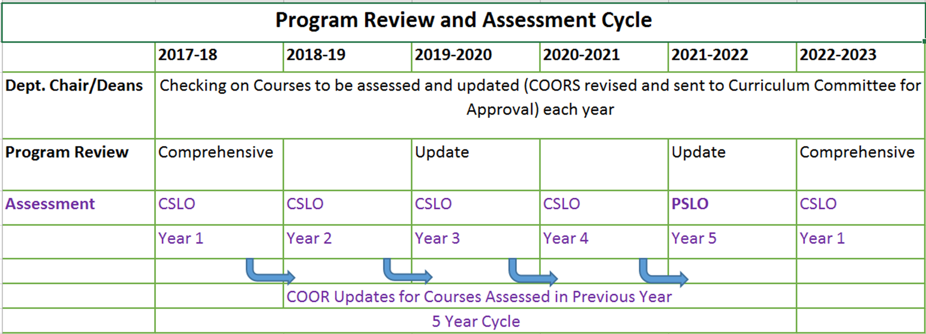
In addition, the Comprehensive Program Review template has been substantially revised with the input of our deans, department chairs and the Vice President of Instruction and Student Services. The current template was designed to be a practical, meaningful, data driven tool that provided programs with a clear representation on the status of their programs, their outcomes, and any work that needs to be completed to keep their programs current and thriving.
A total of 75 Comprehensive Program Reviews were conducted:
- 12 administrative units
- 43 instructional units
- 6 learning community units
- 14 student services units
Relevant data was gathered, with the assistance of the District Research Office, on an expanded set of data elements, and a new format was developed that made all data easily accessible to each program.
Aggregating the data provided by individual programs and units will be a rich source of data for the Planning Committee and the Shared Governance Council in the assessment of overall institutional effectiveness and needs for the next five years. Programs and units were asked to align their goals with our Strategic Planning and/or Integrated Planning Goals. Looking at how institutional goals are being addressed across multiple programs and units will allow us to develop a clearer vision of how those goals can be achieved, and what resources will be needed to attain them.
The Resource Allocation Process (RAP) is a budget augmentation methodology that incorporates shared governance into the core of its decision-making model. This methodology creates opportunities for college constituents to explicitly document their budgetary needs in a uniform format. It provides a structured, consistent criterion for the evaluation and approval of budget requests; utilizing a predictable and consistent schedule for budget development. Previously, a program/unit would develop their objectives in their annual program review and link any request for a budget augmentation(s) to their objective(s). Through a separate process the program/unit would need to complete and submit additional documentation and verification through a separate resource allocation process.
Based on input received from the campus to improve efficiency and effectiveness, the Vice President of Business and Administrative Services (VPB&AS) in collaboration with President’s Cabinet and the Shared Governance Council, developed recommended changes to the Resource Allocation Process (RAP). The recommended revisions were presented to the Academic Senate, Classified Senate and Planning Committee for input and to further establish modifications to the Resource Allocation Process (RAP). The modifications will not replace the process however, these changes will improve its efficiency and effectiveness.
The improvements to RAP included simplification and standardization of the forms for submitting a budget augmentation request. The revised forms were divided into three (3) separate funding categories – operating supplies/equipment/services, personnel (non-full time faculty or classified staff), and professional development – and then incorporated into the Comprehensive Program Review templates. Additionally, the Business Office has created a centralized budget request database to “house” all budget requests for review and evaluation by the Shared Governance Council, President’s Cabinet, Office of Instruction and Categorical Funding Agents.

Process Evaluation
The College integrated program review and resource allocation into a comprehensive process that led to accomplishment of its mission and improvement of institutional effectiveness and academic quality. In an effort to assess the effectiveness of this integration, a process evaluation was conducted following completion of the Comprehensive Program Review period (between April and May 2018). This evaluation will assist the College in determining if the “activities”— including timeline, tasks, responsible parties, reports, etc. were implemented as intended and resulted in certain outputs. Results of this process evaluation will strengthen our ability to report on our activities and provide us with information to improve our next program review process.

Cross Section Reports
- The Office of Planning & Planning & Institutional Effectiveness generated the following nine reports from the submitted Comprehensive Program Reviews by March 26, 2018:
- Degree and Certificate Requirements Report (Section 2)
- Course Offerings Report (Section 3)
- Curriculum Report—Existing and New Curriculum Analysis, and Program Changes (Section 1, 4, and 5)
- CTE Advisory Board Report (Section 6)
- Assessment Report (Section 7)
- Course Completion and Success Outcome Report (Section 8)
- Goal Report (Section 9)
- Resource Requests Report
- Professional Development Report

- The following Committee/Office received reports to evaluate the College’s accomplishments and improvement of its institutional effectiveness and academic quality:
- Academic Senate and Office of Instruction will receive:
- Degree and Certificate Requirements Report (Section 2)
- Course Offerings Report. (Sections 3)
- The Curriculum Committee received the Curriculum Report. (Sections 1, 4 and 5)
- The CTE Committee and Workforce Development received the CTE Advisory Board Report (Section 6)
- The Teaching & Learning Committee received the Assessment Report and will incorporate it to their annual report to the Shared Governance Council in fall 2018. (Section 7)
- The Planning Committee, Integrated Planning Leadership Group, Office of Equity and Inclusion, and Academic Senate received the Course Completion and Success Outcome Report. (Section 8)
- The Planning Committee and the Integrated Planning Leadership Group received the Goals Report and the Planning Committee incorporated it into its annual report to the Shared Governance Council on May 9, 2018. (Section 9)
- The Office of Business & Administrative Services received the Resource Request Report and reported to the Shared Governance Council on May 9, 2018. (Resource Requests Sections)
- The Office of Equity and Inclusion and the Professional Development Advisory Committee (PDAC) received the Professional Development Report and PDAC will incorporate it into its annual report to the Shared Governance Council in fall 2018.

Programs on Watch/In Trouble (Include reason)
N/A
Most Improved Programs (Please use your own elements when choosing the programs for this section. Ideas could be the top 5 improved programs due to increase in resources or the most improved over a three year period. Please include the reason for Improvement including productivity)
Early College Credit
Building on the recent increased success in early college credit programs, LMC has continued making strides in enhancing articulation and dual enrollment efforts in partnership with high schools in East County. This expansion has led to increased program offerings for students and a significant increase in the number of students annually earning early college credit.

The following tables demonstrate increased offerings and enrollment in these efforts:
Dual Enrollment | 2016-17 | 2017-18
Number of High Schools Served | 5 | 9
Number of Sections Offered | 19 | 23
Number Students Enrolled in Dual Enrollment Courses | 266 | 528
Success Rate (Overall) | 91% | 87%
FTES | 24.55 | 46.34

Articulation | 2016-17 | 2017-18
Number of Courses Articulated | 20 | 40
Number of Students Enrolled in Articulated Courses | 421 | 2,008
Number Students Receiving Credit | 350 | 1,628
% of Students Receiving Credit | 83% | 81%

In particular, significant increase in articulation was primarily the result of a collaboration with Antioch Unified School District (AUSD) and the implementation of the Get Focused Stay Focused (GFSF) curriculum that is aligned with COUNS-032 (Career Exploration) and COUNS-034 (College Success) courses. Most 9th graders in AUSD now participate in the GFSF curriculum and are eligible to receive 3-units of articulated credit with LMC upon successful completion of the class.
Moving forward, in 2018-19, LMC is launching the College Connect program in collaboration with Pittsburg High School (PHS). In this program, 60 PHS 12th graders are bused to LMC four days per week to take college classes in a cohort setting. By the end of the academic year, these students will have had the opportunity to complete 9-units with LMC, including two IGETC transfer courses. Furthermore, the college is already exploring increasing the number of students served by this program through partnering with additional high schools in 2019-2020.
English as a Second Language (ESL)
Under the leadership of Dr. Paula Gunder, our ESL program continues to be transformed. Enrollment remains high at a seat count of 198, up from a low of 114 in 2015. Productivity rose to 11.68 in 2017-2018, a significant increase from 7.64 in 2015-2016. Curriculum has been completely redesigned for both credit and noncredit offerings. Credit courses now lead to two local skills certificates: Intermediate English for College and Career Success and Advanced English for Academic and Professional Advancement. Noncredit courses will be offered for the first time in Spring 2019 and currently lead to 3 state approved CDCP certificates, with a 4th certificate in progress at this time. Dr. Gunder has been a leader and innovator in professional development within and beyond her department, implementing substantive training in Appreciative Advising, Habits of Mind, Reading Apprenticeship and Growth Mindset. In addition, she has championed the ESL PALS program, which is a peer mentorship program for ESL students in addition to supervising ESL peer tutors. She works closely with our full time counselor, Trinidad Zavala, who focuses on counseling ESL and Puente students, including teaching counseling courses for each of these learning communities. Transitional work continues with AEBG under the leadership of our Transition Specialist, Catherine Fonseca, who has designed and implemented bridge programs from Adult Education to LMC, encouraging a seamless transition. Given data provided by our district research office, we know that East County is home to a large non-native English speaking community, and we are committed to better serving that community and welcoming the diversity and strengths they bring to our college and our county.
Chemistry:
Over the past year, the chemistry program demonstrated the impact that focused departmental conversations and initiatives surrounding equity can have for the success of our students. This program has consistently outperformed state averages in terms of success rates for a number of years. Specifically, over the past 3 years the program has boasted success rates in the 75 – 78% range compared to a state average for chemistry of 65 – 70% in comparable courses according to data from the CCCCO DataMart. However, like many chemistry programs in the state, the program observed significant gaps in the success rates for African American students. In particular, from Fall 2015 to Spring 2017, the program saw success rates for African American students range from 56 – 68% consistently 10% or more below the course average success rate as a whole.
Led by faculty Dr. Melinda Capes and Dr. Dennis Gravert, the department engaged in meaningful conversations surrounding their data both with each other and the part-time members of their department, including dialog about various interventions that could address this gap specifically. Simultaneously, led by Senior Science Lab Coordinator Paul West together with a student worker, Sonia Bustos, the department utilized Student Equity funding to support a scientist portraiture project in which the biographies and photographs of prominent scientists from traditionally underrepresented groups in the field of chemistry were displayed throughout the program’s laboratories. Through the combined efforts of its faculty, staff, and students, the program saw a nearly 10% increase in the success rates for the African American student population for Fall 2017 – Spring 2018. This improvement was achieved while maintaining their strong success rates overall. Simultaneously, the program was able to grow adding more than 15 FTES from the prior year while maintaining a high productivity of 19.4 for the year demonstrating that growth, productivity, success, and equity are not mutually exclusive measures.
English & Social Sciences Collaboration
The English and Social Sciences Department have taken the lead in creating, launching, and teaching the courses for LMC’s brand new AA-T Degree in Social Justice Studies: LGBT Studies. This has involved creating curriculum, meeting with faculty across disciplines to plan, discuss, & design the program, and meeting with the Deans and the Office of Instruction Supervisor to facilitate the creation the program. English and Social Science Department faculty have also been instrumental in creating and leading the trainings for LMC’s Safe Space program, and launching the LMC Outlist, which publishes the names and contact information of openly LGBTQ faculty, staff and managers. We also serve as faculty advisors for LMC’s LGBTQ Student club, ALLIES. These programs increase the visible presence of LGBTQ student, faculty and staff who can help to shape a school culture that is accepting of all people, regardless of sexual orientation, gender identity or any other difference.
Political Science Department created two classes (POLSC-060: The Constitution, Our Rights and the Law and POLSC-040: Introduction to California State and Local Politics) and reactivated POLSC-043: International Relations and POLSC-050: Introduction to Comparative Politics so that a AA Degree in Political Science could be offered at LMC.
Travel
The mission of the LMC Travel Marketing program is to prepare students for employment in the travel industry by educating them in fundamental travel concepts, technology tools and research skills. Curriculum has continually been updated to ensure students are graduating with the knowledge needed to be successful in the travel industry. Our student’s success stories have been written up in various magazines, including The Travel Market Report, many have started their own businesses and others have gone on to create unique travel experiences for travelers. h􀆩ps://www.travelmarketreport.com/ar􀆟cles/How‐to‐Become‐a‐Travel‐Agent‐A‐Guide‐for‐the-Perplexed
Fire Technology
During the past year, the LMC fire technology department has been fairly active. Our goal has been to “make every effort to develop and improve a firefighter training course that is accessible, educational, informational as well as entertaining”. Some of the improvements/ highlights of the program are:
1. Fire 120- Fire 120 is the LMC offering of the California State certified Fire Academy which is an indoctrination to the fire service. In the past, LMC has only offered this course during the Fall semester. We recently expanded the course to include approximately 500 hours (15 units) of intense hands on training. LMC fire staff have done a lot of networking thru bay area fire department training officers as well as local high schools. Our efforts have paid off, as we now offer this course both Spring and Fall semesters. All of the last class of academy cadets were placed into either volunteer or career fire departments. I applaud fire academy coordinator, Retired fire Captain Rick Hurtado and his staff.
2. In order to get into the fire academy, some pre-requisite changes were made. Fire 102 was added as a pre-req. Fire 102 requires each student to research and discuss the ways in which a fire starts and grows. We also discuss theories of extinguishment A substantial amount of paperwork was prepared by LMC fire staff in order to clear curriculum committee. Fire 102 (fire behavior) technology was added to the list of pre-reqs this past year.
3. LMC fire staff continues to assist and evaluate the delivery of Fire 101 to two local east bay high schools (Heritage and Freedom). This is accomplished thru the local ROP program. LMC has been active in assisting ROP with selecting qualified instructors as well as sharing of curriculum. These students are then guided into a pathway which leads to the LMC fire technology program. Colleen Grimm, Jim Scarborough and Nick Grillo have made this program successful.
4. LMC fire technology has also added two additional deliveries of fire 101 thru ARTICUATION classes offered at two additional east bay high schools (Liberty and Antioch). This allows high school students the ability to receive credit for LMC fire introduction course while still in high school. We encourage these students to then pursue additional fire course at Los Medanos College. Fire Instructor David Finn as well as Kelly Green have been instrumental in getting these course up and running
5. LMC fire technology has also been active in attending meetings with our industry partners. Los Medanos college fire staff make every attempt to meet with Contra Costa County Fire training officers at their monthly meetings. It is during these meetings that we are able to identify their needs. Local fire agencies recently expressed the need for the delivery of State Certified Fire officer classes. These class are required for all potential fire officers. Based on this need, LMC fire staff created 4 new COURSE OUTLINES OF RECORD for fire officer certification. These COORs were submitted and approved by LMC curriculum committee. We are currently working with local fire agencies to schedule the delivery of these courses in Spring 2019. Past instructor German Sierra was the lead in this assignment
6. Due to high demand, all LMC fire classes are now offered both spring and summer semester. In addition, we offer 3 fire classes during each summer session. Thanks to all of our fire instructors for creating the interest and assisting potential fire students
Child Development
The 2017-2018 school year was really about building partnerships with outside agencies. The Child Study Center received approval from the United States Department of Agriculture to offer the Child Care Food Program to our children and families. We have currently begun with breakfast and snack and will be adding lunch soon! We have continued to develop our garden, thanks to a district awarded mini grant, adding an orchard planted during our summer program. We also received the CCAMPIS grant (again!) from the United States Department of Education. This allows us to continue our infant program. The department received Perkins money to purchase 10 tablets to train and support our CHDEV students in their recording of children’s development using the State DRDP assessment tool (Desired Results Developmental Profile).
The CHDEV department continues excellence in program and teacher training by receiving top accreditation scores from NAEYC (National Association for the Education of Young Children), maintaining it’s 5 star QRIS rating (Quality Rating Improvement System), and beginning another 3 year role as a Teaching Pyramid Partner Site. Our staff continue in a leadership role promoting the Social-Emotional Competency of Young Children focusing on training in Trauma Informed Practice and we have developed a course CHDEV 24 that focuses on trauma informed practices and strategies for working with children. Locally we created a new internship program with Pittsburg Unified School District. Interns implement school garden lessons to children from kindergarten to fifth grade. This is part of Pittsburg Unified's STEAM (Science, Technology, Engineering, Arts and Math) curriculum. In addition we also developed a program (Early Childhood Education AS-T degree) to program (Justice, Community and Leadership Bachelor's Degree) articulation with Saint Mary's College. This bachelor's degree also includes a multiple subject teaching credential or special education credential based on the pathway the student chooses. We are the first community college to develop a program to program articulation with Saint Mary's college.
We, of course, continue to provide quality child care for the children attending our center. This is evidenced by our continued high ratings. Our training program is thriving as we continue to work with approximately 50 student interns. We have fully implemented Feeling Buddies to support the emotional development of the children in our center. We respond to new research with new curriculum in the classroom.
EOPS
With 547 students enrolled in 2015-16, and 722 student enrolled in 2017-18, EOPS experienced a 31.9 percent increase in annual, unduplicated enrollment, a total of 80 full-time enrolled students. This increase was the result the 29.8 percent increase in the State Chancellor’s annual allocation to the program, a sum of $190,302. The additional funding was also used to launch Brothers of Excellence Program (BOEP), an equity initiative designed to promote the holistic development and academic achievement of EOPS’s African American males, with a future-focus; for example, through collaboration with Wells Fargo Bank, LMC hosted a day-long work-readiness, career-focused workshop, conducted by a senior level Wells Fargo Bank officer. By encouraging participation in study groups and tutoring, as well as frequent academic progress checks, the 51 BEOP participants averaged a 2.63 grade point average (GPA), which is 28.9 percent higher than the College GPA average of 2.04.
DSPS
The DSPS annual funding allocation increased from $863,367 in 2015-16 to $957,494 in 2017-18, an overall increase of 10.9 percent or $94,127. This increased funding enables the program to add an additional 20 students to its annual unduplicated, enrollment count.
Counseling
From 2015 to 2018, the Department has successfully developed and proposed a series of courses that have been approved for inclusion in the LMC catalog, including -- COUNS 45 MESA/STEM Scholars Success, COUNS 36 Career and Life Planning, COUNS 35 Theories and Application of Learning In College, COUNS 32 Introduction to Career Exploration, and COUNS 31 Educational Planning. Where all were approved with defined course-level student learning outcomes (CSLO), they are in part of the Office of Instruction’s assessment schedule.

Status for 2018

Programs on Watch/In Trouble (Include reason)
Through the program review process, it has been recommended by the Vocational Technical Department and the Office of Instruction that the following program be discontinued:
Appliance Repair Program
The field of appliance service technology deals with repairing major household appliances. Technicians inspect, troubleshoot and repair major appliances such as refrigerators, ranges, dishwashers, microwave ovens, washers and dryers. Los Medanos Appliance Service Technology Program offers instruction for two career options. The Appliance Technician I option prepares students for entry-level positions as appliance installers or shop technician trainees. Students selecting the Appliance Technician II option will be prepared for entry-level positions in the appliance service field.
In fall of 2016, lead faculty and the department chair were alerted to low enrolled courses, and in spring 2017 during the annual program review feedback, the program was further alerted to declining productivity, and declining head and seat counts. (Exhibit 13). Recognizing the program needed assistance and direction, a series of meetings were conducted between fall 2016 and summer 2018 that included the faculty, dean, department chair, DVC faculty member with knowledge of the program, Deputy Sector Navigator for Energy & Utilities (which encompasses this program along with HVAC), and the Prop. 39 grant director who had curricular expertise. Topics for these meetings included: analysis of current curriculum, ideas for revamping curriculum, labor market information and industry trends. Faculty began mapping out curriculum for appliance and HVAC, but the data around appliance technology continued to show low or negative growth. The conversations with industry experts held between 2016 and 2018 provided anecdotal support to what labor market data was indicating, which was, appliance repair technology was declining and HVAC and commercial refrigeration were on the rise.
In 2016, the Dean and Department Chair began working with the new faculty to examine the curriculum and revise the curriculum because course enrollments were low. The Workforce Development unit provided support by providing labor market information/data, and support for forming an effective advisory committee. Faculty from neighboring DVC were brought in to assist/advise the program, as well as the Deputy Sector Navigator (regional resource) from the Bay Area Community College Consortium. Lastly, the program has been supported through professional development and conference attendance at assist the faculty in making a relevant program.
All course outlines of record for Appliance Technology were updated in September 2008. Non-substantial changes have been submitted regularly to ensure compliance with Title 5 regulations. During a recent review of the marketing materials for the Appliance Technology Program, it was discovered that the APPLI courses for the Certificate of Achievement in Appliance Technology Technician I are interchangeable with the Certificate of Achievement in Appliance Technology Technician II. The course outlines of records show the CSLOs, CPLOs, and Course Content are identical to one another. The Certificates were designed to cater to students who are able to attend during the day or night. The Technician I courses are offered primarily during the evening, while the Technician II courses are offered primarily during the day. An air conditioning and refrigeration course (ACREF-045) was added to the Technician I Certificate. If a student does not want to take the ACREF course, the student will be awarded the Technician II Certificate.
Historic and Current Enrollment Rates at Los Medanos College

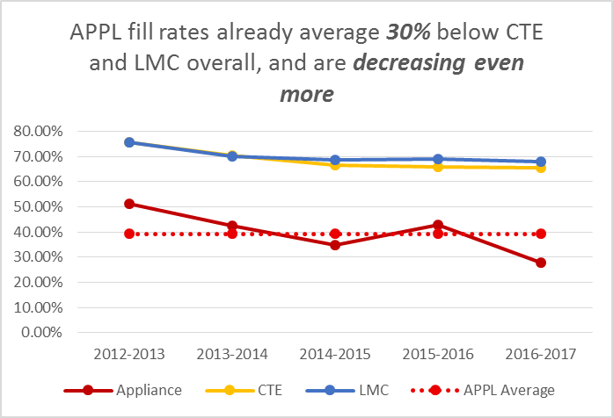

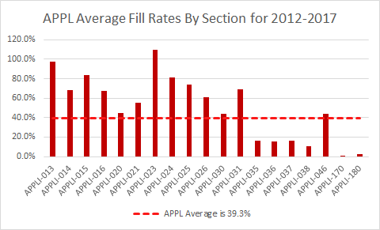

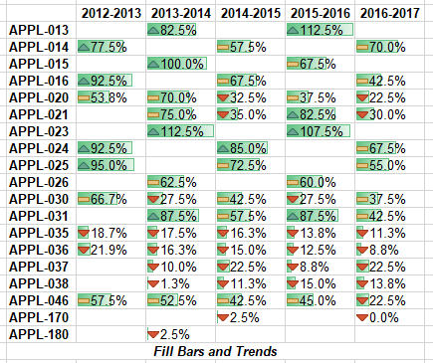

Historic and Current Degrees and Certificates Awarded

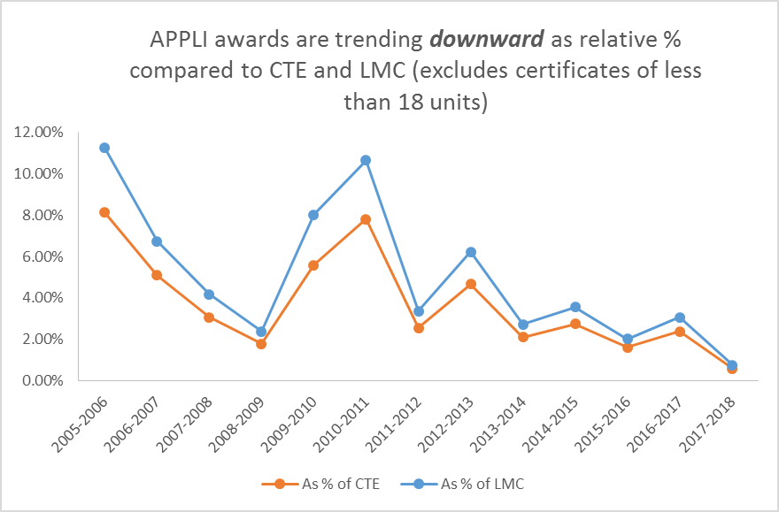

Decline in Programs Offering Appliance Technology Programs
Over the past twenty years, Appliance Repair Programs have declined steadily. According to the California Community Colleges Chancellor’s Office, six colleges offered a comprehensive Appliance Technician Program in 1992. Three of the six programs were offered by Contra Costa Community College District. In 2002, four programs existed with LMC and CCC offering a comprehensive program and the two other institutions only offering skill-builder type courses. By 2008, LMC was the only California Community College program offering any type of comprehensive and/or skill-builder courses. To date, only one other program exists in California. Hacienda La Puente Adult Education, located in Southern California, offers a two semester program in Major Appliance Service and Repair. (Exhibits 6 and 7)
The Bureau of Electronic and Appliance Repair, Home Furnishings and Thermal Insulation (BEARHFTI) is California’s regulatory agency under the Department of Consumer Affairs. The Bureau provides consumer protection by enforcing the provisions of the Electronic and Appliance Repair Law. Currently, the Bureau licenses businesses and not individuals, there are no formal education or experience requirements for licensure. According to BEARHFTI’s 2017 Sunset Report, “most electronic product and appliance manufacturers offer training to their authorized repair agents and certify the repair dealers and/or their technicians for their line of products. . . . As the businesses are licensed, and not their technicians, it is the business owner’s responsibility to ensure their employees are adequately trained to repair the products they service”. (Exhibit 8 and 9)
In minutes from BEARHFTI’s November 15, 2016 meeting, Bureau members discussed the two appliance programs currently offered in the State of California. At one time “12 community colleges offered appliance training but it is a challenging and expensive program for schools to maintain with a dwindling job market and the programs have been cut”.
Job Outlook for Appliance Technicians
Based on market research conducted by IBISWorld, Appliance Repair was identified as an industry that has remained in flux since the recession and is considered one of the riskiest industries in which to succeed. Factors contributing to their high risk are expected to keep declining over the next five years. Appliance Repair in the United States received an overall risk score of 7.17 Risk scores referenced were on a scale of one to nine, where one represents lowest risk and nine represents highest) with industry revenue expected to fall an annualized 1.5%.
According to Industry Insider, “Strong external competition has been forcing this industry into a decline over the past decade. The biggest threat is from appliance manufacturers and large retailers that offer warranties for repair services, which undercuts demand for industry services. Consumer preferences for reliable brand names, such as the Home Depot and Best Buy, tend to drive business away from independently owned specialty repair shops. In addition, technological advances are improving the lifespan of appliances, reducing the need for repairs. And as incomes rise in line with the improving economy, consumers will begin purchasing new appliances, which will further diminish repair demand. New technologies, such as built-in diagnostic tools, will allow consumers to fix minor problems on their own and go longer before requiring major repairs”. (Exhibit 1)
Additional labor market analysis by region shows a declining industry. The region, defined as Contra Costa, Solano and Alameda Counties, posted the following net changes for Home Appliance Repairers (SOC Code 49-9031) according to data analytics using EMSI modeling tool:
Table1
Year | Percentage of Change | Timeframe
2015 | -8.3% | 2013-2020
2016 | -10% | 2016-2020
2017 | -6% | 2016-2020

Data gathered September 14, 2018 using 0*Net online indicate a 4% decline nationwide and zero percent change for the forecasted period of 2016-2026.
Cost Analysis
Los Medanos College has continually supported the Appliance Technology Program. Faculty replacement of a 42 year veteran of the program occurred in fall 2016. The retiring faculty remained available/accessible through the transition and continues to teach part-time as a substitute when needed. In 2016, the Dean and Department Chair began working with the new faculty to examine the curriculum and revise the curriculum because course enrollments were low. The Workforce Development unit provided support by providing labor market information/data, and support for forming an effective advisory committee. Faculty from neighboring DVC were brought in to assist/advise the program, as well as the Deputy Sector Navigator (regional resource) from the Bay Area Community College Consortium. Lastly, the program has been supported through professional development and conference attendance at assist the faculty in making a relevant program. (Exhibit 15)
Cost Analysis:
 | 2013-14 | 2014-15 | 2015-16 | 2016-17 | 2017-18
Revenue
FTES | 317,046  (59.820 FTES) | 262,774  (49.580 FTES) | 266,007  (50.190 FTES) | 202,142  (38.14 FTES) | 147,340  (27.80 FTES)
Expense
Salary & Benefits | 166,179 | 178,108 | 258,746 | 116,888 | 121,910
Operating  Budget (Actual) | 15,239.46 | 17,482.97 | 11,696.02 | 8,977.56 | 12,103.85
 | 135,627.54 | 67,183.03 | <4,435.02> | 76,276.44 | 13,326.15

Recommendation to President’s Cabinet
It is important to note, however, that LMC lacks a robust process for formal program revitalization and/or program discontinuance. LMC is currently in the beginning stages of collaborating with the Academic Senate to design and document a formal process and policy that supports the existing 4CD Board policies. We anticipate that the process for developing and implementing a more formal process can be completed prior to the end of the Spring 2019 semester.
Board Policy 4008 states, “A review of program performance with the faculty members involved and the appropriate departments/divisions should take place before a program is designated as in trouble. Prior to the development on campus of a formal "program in trouble" recommendation, both the Academic Senate President and the United Faculty Vice President on campus should have direct discussions with the College President regarding why the program is in trouble.” A meeting with the United Faculty, Academic Senate President and President of LMC will be taking place in November 2018 to further discuss the issues surrounding the existing Appliance Repair Program.
Collaborative efforts between the Vocational Technical Department, Office of Instruction, and Strong Workforce unit have been taking place to explore options to develop a new HVAC program. Both industry and the labor market show a high demand for trained and skilled labor in this field. This information is noted in Programs Being Investigated section of this report.
Programs Being Investigated
New Instructional Programs at LMC go through a two-step approval process. The first is a proposal made to Academic Senate and our Shared Governance Council to indicate agreement that we support the development of a new degree or certificate. Once that approval is given, the second step is to formally have all the component courses and the degree or certificate approved by Curriculum Committee.
AD-T in Social Justice Studies, Chicano Studies, Phase I in Process
AA in American Sign Language, Phase I Completed
Teacher Pathways: LMC faculty are working with the Teacher Pathway Regional Joint Venture through the BACCC to address the shortage of teachers. Nationwide, the demand for teachers is 7% and slightly more for California. Focusing on STEM teachers, the initiative is to create a pipeline, including the associate degree for transfer, to matriculate LMC students to bachelor degree programs that support teacher training. Led by Dean Ryan Pedersen and expanding on earlier work from a STEM grant, LMC plans to launch the teacher pathway project in spring 2019.
Construction Technology: Local leaders over the past two years have asked LMC to pursue construction technology as new program for this area. The efforts to revitalize the northern water front, a tight housing market, recent natural disasters, and an industry that is still recovering the loss of workers from the economic recession of 2008 has led to an industry that does not have enough workers to fill available jobs. Data indicate the labor market for construction work is anticipated to grow 8.3% for this region over the next five years. LMC is positioning itself to provide needed workers to this industry, and to date, has engaged local employers, unions, cities, feeder school districts, and community based organizations to determine the best approach for meeting this need.
HVAC/Fabrication Technology/Industrial Maintenance: LMC has historically offered six core courses in HVAC; however, growth for this industry is more aligned with a multi-disciplinary track that encompasses heating and air conditioning, sheet metal workers, and environmental/industrial engineering technicians. Universal skills such as basic electrical wiring, welding, fabricating, machining and lathing are all in-demand skills across multiple industry sectors and no longer belong to one discipline or program. LMC’s approach is to leverage existing programs such as welding, HVAC and Electrical Instrumentation to create a suite of multidisciplinary courses that support skill development for students that seek jobs in these sectors. The labor market growth for these skilled professions is 12% for the bay region, and expanding existing programs leverages existing infrastructure (with additional courses and curriculum developed as needed) to meet this need. The concept of a “skill builder” academy is being discussed with faculty that provide quick on-ramping of these essential job skills.
Makerspace & Entrepreneurship: This faculty-led effort to create a space for craftsman, explorers and artisan entrepreneurs. This is a multidiscipline venture that is in the fact-finding stages. There is a large makerspace initiative statewide and championed by the state Chancellor’s Office, and regional investments of Strong Workforce Funds that have created a Regional Joint Venture with other BACCC colleges to explore details around makerspaces, including overall investments in personnel, equipment and facilities, as well as the sustainability of creating and maintaining a makerspace. The core principle of makerspaces are to provide essential job skills to a rapidly changing workforce. The faculty engaged in this project are also working with faculty that are pursing HVAC/Fabrication Technology/Industrial Maintenance to make sure that programmatic overlaps or synergies are realized. Exact data around the economic impact of makerspace is not yet realized, but the interest is here. Most recently, city of Brentwood is investigating the makerspace concept to support east county entrepreneurism.
Drone Technology: The Byron airport has been identified as a potential hub for un-manned aircraft “out of sight” flights. Contra Costa County is supporting a grant by the California State Departments of Technology and the FAA to designate Byron Airport for unmanned/out of sight flying site; furthermore, discussions have ensued with a company named Airmap to provide air traffic control services for unmanned aircraft in the region. LMC is in the discovery phase of this work, and is working with other regional colleges to determine appropriate program/discipline, curriculum, etc. It is unclear at this point what program or discipline this program may fall. Use of drones spans computer science, public safety, journalism, etc. This is a new and emerging field with initial estimates indicating an $82 billion dollar industry, 100,000 jobs, and the need for 150,000 commercial drone pilots nationwide. There are currently seven colleges in the Bay Area that have some type of drone program.
Community Education: In a response to citizen requests, LMC is pursuing community education to specifically meet the requests of adult learners and middle school youth. Modeling after DVC’s Emeritus program and College for Kids, LMC has identified a gap in services to provide enrichment programs to adult learners, and early program orientation and career exploration for youth. Adult learners have indicated their interest in political science, economics, computer literacy and similar topics in a short duration format of such as a two hour mini lecture. Youth interests, as we have learned through our Career Pathways work, are interested in graphic communication, web and game design, or courses designed to explore careers. LMC will continue to work closely and monitor the adult education offerings, as well as the community services programs, to ensure we are not duplicating efforts and are truly addressing gaps.

New Instructional Programs Proposal for being implemented (already investigated). Remember to complete the separate new program form.
AA-T in Political Science (4CD Approved, Fall 2018 submission to CCCCO)
AA-T in Philosophy (4CD Approved, Fall 2018 Submission to CCCCO)
AA in Humanities (4CD Approved, Fall 2018 Submission to CCCCO)

Programs to be Modified/Reduced (Include last program review date and/or reason for modification)
Programs to be Discontinued (Include reasons for being discontinued and status of faculty/staff involved)
DSPS Learning Skills Courses
Learning Skills courses, i.e., LRNSK 50, 70, 81, and 82, are offered at LMC as part of Counseling Department’s instructional activity. These courses will be discontinued, because they have not been able to consistently attract students at a sustainable productivity level. This downward trend is largely due to changes in English and Math course sequencing and the impact of Assembly Bill 705 which discourages remediation through standard curricular offerings. Data is presently being collected to inform the design of new courses.

Student Learning Outcomes (SLOs)
Narrative of Progress
Similar to past years, all (100%) Student Services Programs continue to work on SLO assessment projects. This can be reflected in the chart that is typically used in the educational programs report.
In terms of a narrative, Student Services Programs maintain the same five year cycle addressing course student learning outcomes (CSLO’s) as in instructional programs. Program student learning outcomes (PSLO’s) in Student Services are also assessed at least once within the same five year cycle.
The Student Learning Outcome (SLO) and Program Learning Outcome (PLO) assessment cycle takes place over a five-year timeline. Each of the course level SLOs are assigned to one of four possible cohorts. The final year of the cycle is reserved for the PLO assessment. During the 16-17 year, LMC determined we had approximately 90 courses that had not either 1) been assessed due to not being offered in alignment with the assigned cohort, or 2) that were deemed to be inactive, however, were still listed in the catalog. Courses that were not assessed have been placed into a new cohort in Cycle 2, in which 17-18 is the first year of cycle 2. The college is currently bringing all inactive courses through the curriculum committee to be formally deactivated and removed from the catalog.
In the PLSO assessment cycle, it is important to note that LMC changed its definition of “program” in the middle of the current five-year assessment cycle. Prior to this change, “programs” were being defined at the department level only. If a single department had four certificate programs, these were being counted as one single program as it related to assessment. LMC updated its definition to more accurately reflect the need for each program to have its own set of PLOs. All of LMC’s programs were assessed in the fifth year of the assessment cycle in 2016-17.
In 2017-2018, courses in cohort 1 began their assessment and reporting. In 2018-2019, courses in cohort 2 are beginning their assessment and reporting. All courses must be assessed in their cohort and the results from the assessment are to feed into the updating of the Course Outline of Record (COOR), which is brought before the Curriculum Committee at least once every five-year cycle.
The committee involved with assessment on campus, the Teaching and Learning Committee (TLC), has taken the lead on implementing improvements that were identified as needed in the Comprehensive Program Review (CPR) reports from 2017-2018. These include replacing the current assessment tool and word documents into a web-based solution from an external vendor. The District is moving forward and will have the solution in place by spring 2019, and LMC will start using it, hopefully, in fall 2019. This program will lead to new ways of doing assessment, most likely removing the need for SLO assessment reporting forms.

(data from AACJC report)
 | Percentage | Comments
% of programs with SLOs (ending with degree or certificate) | 100%
% of program SLOs with ongoing assessment | 100%
% of courses with SLOs | 100%
% of course SLOs with ongoing assessment | 70%
% of Student and Learning Support with SLOs | 100%
% of Student and Learning Support Services SLOs with ongoing assessment | 100%
% of administrative units with SLOs | NA | Not required for accreditation
% of administrative units with ongoing assessment | NA | Not required for accreditation
% of Institutional Outcomes | 100% | LMC uses the 5 General Education Learning Outcomes as the Institutional Learning Outcomes.
% of Institutional Outcomes with ongoing assessment | 100% | 4 out the 5 outcomes have on-going assessment. It has been determined that the 5th outcome is no longer applicable and the GE committee is taking steps to eliminate the outcome in 17-18.

Transfer Degrees (per SB 1440)
(Provide a brief description and identify the SB1440 degrees developed and approved to date)
At the conclusion of the 2017-18 academic year, LMC has available to students 23 AA/S-T degrees listed below.

Transfer Degree | Type | Year Approved
Social Justice Studies: LGBT Studies | AS-T | 2017-18
Social Justice Studies: African-American Studies | AA-T | 2017-18
Spanish | AA-T | 2016-17
Biology | AS-T | 2016-17
Chemistry | AS-T | 2016-17
Anthropology | AA-T | 2014-15
Art History | AA-T | 2014-15
Music | AA-T | 2014-15
Administration of Justice | AS-T | 2013-14
Computer Science | AS-T | 2013-14
English | AA-T | 2013-14
History | AA-T | 2013-14
Journalism | AA-T | 2013-14
Mathematics | AS-T | 2013-14
Studio Arts | AA-T | 2013-14
Communication Studies | AA-T | 2012-13
Business Administration | AS-T | 2012-13
Early Childhood Education | AS-T | 2012-13
Kinesiology | AA-T | 2012-13
Physics | AS-T | 2012-13
Psychology | AA-T | 2012-13
Sociology | AA-T | 2012-13
Theatre Arts | AA-T | 2012-13

AB 705 Implementation Status

Describe the current status of your preparation for meeting the AB 705 requirements as related to English, math, and ESL?
LMC is well prepared to meet AB 705 requirements in English, math and ESL. As one of the California Community Colleges that received a Basic Skills Transformation grant, we had already begun implementing a plan to ensure that most students would complete transfer level English and math in at most one year. All students will have direct access to transfer level courses in English and math by Fall 2019 at the latest. The ESL curriculum has been completely redesigned, and courses will be scheduled in a manner that makes it possible for students to complete transfer level English within 6 semesters or less, even if they begin with our new noncredit offerings.
Where is the college in developing co-requisites/concurrent support models for transfer-level courses?
Co-requisite support courses have been developed and are currently offered in English and math. In English, the co-requisite support course for transfer level Freshman Composition was offered beginning Fall 2017. In math, a co-requisite support course for Statistics has been offered for the last two and a half years. Beginning in Fall 2019, co-requisite support courses will also be offered for Applied Calculus and Precalculus.
Is the college planning to use the default placement rules put out by the state Chancellor’s Office? If not, please share the reasoning behind it and describe how the college has insured the best possible chance of students completing transfer-level math and English within a year.
Yes, LMC will use the default placement rules as defined by the state Chancellor’s Office.
Describe changes to the college course schedule offerings and the college shifting enrollments between transfer-level and pre-transfer courses? How does the Fall 2019 schedule compare with Fall 2017, in the ratio of pre-transfer and transfer-level courses?
We have not yet developed the Fall 2019 schedule, but there has already been a dramatic shift in both English and math in the ratio of transfer level to pre-transfer level courses. This shift had already begun in Fall 2017 due to our participation in the Basic Skills Transformation grant and the implementation of co-requisite support courses. In Fall 2016, we offered 36 sections of pre-transfer level English and 33 sections of transfer level Freshman Composition. In Fall 2017, we offered 10 sections of pre-transfer level and 52 sections of transfer level. In Spring 2019, we will offer 4 sections of pre-transfer level and 42 sections of transfer level Freshman Composition. (We offer fewer Freshman Composition courses in Spring and more sophomore level English transferrable courses in Spring.) Given this trend we can predict that less than 1% of English Composition courses will be pre-transfer level in Fall 2019.
In math, from Fa 17 to Fa 18, the ratio of transfer to pre-transfer courses has gone from 55% to 56%. While this is not much, a large portion of our changing over from pre-transfer to transfer Math offerings at LMC occurred much earlier than Fa 17. We used to have a much larger percentage of pre-transfer Math classes than transfer classes. In particular, by comparison in Fa 15 (prior to implementing our co-requisite support model), only 39% of our offered sections were transfer level. Additionally, in Fa 18, nine of the pre-transfer courses were support courses. If you do not count them, our transfer level course percentage would be 61%.
Is the college planning to use guided and/or self-placement? If so, please describe how.
Yes, LMC is planning to use guided self-placement. In English, we plan to revise our existing directed self-placement questions, with the default recommendation being transfer level Freshman Composition without a corequisite support course. Students will be given information about the corequisite support course and our one pre-transfer level course in writing, and through informational videos. In math, students will answer a series of non-Math content questions which will direct them both to the level of math (support or not) and the type of math, depending on which of the guided pathways they fall into based on their interest in a particular major.
What professional development has taken place and/or is planned to help faculty support students’ learning and success within transfer-level classes?
With the support of the Basic Skills Transformation grant, we have provided intensive training in both English and math to support faculty in successfully teaching transfer level classes, particularly in co-requisite support classes. Faculty leads in English and math have offered such training every semester since Spring 2016, including teaching communities, mentorships, workshops, flex activities, etc. For example, in math we have had a teaching community running for faculty who teach statistics along with the support course for the full two and a half years. We have created teaching facilitation notes, solutions manuals, activity packets, and organized online text materials and assessment. In the future our plan is to incorporate these materials directly into Canvas based on work done by a colleague at Cuyamaca Community College.

