LMC FACULTY GOVERNANCE SURVEY RESULTS (52 RESPONDENTS)
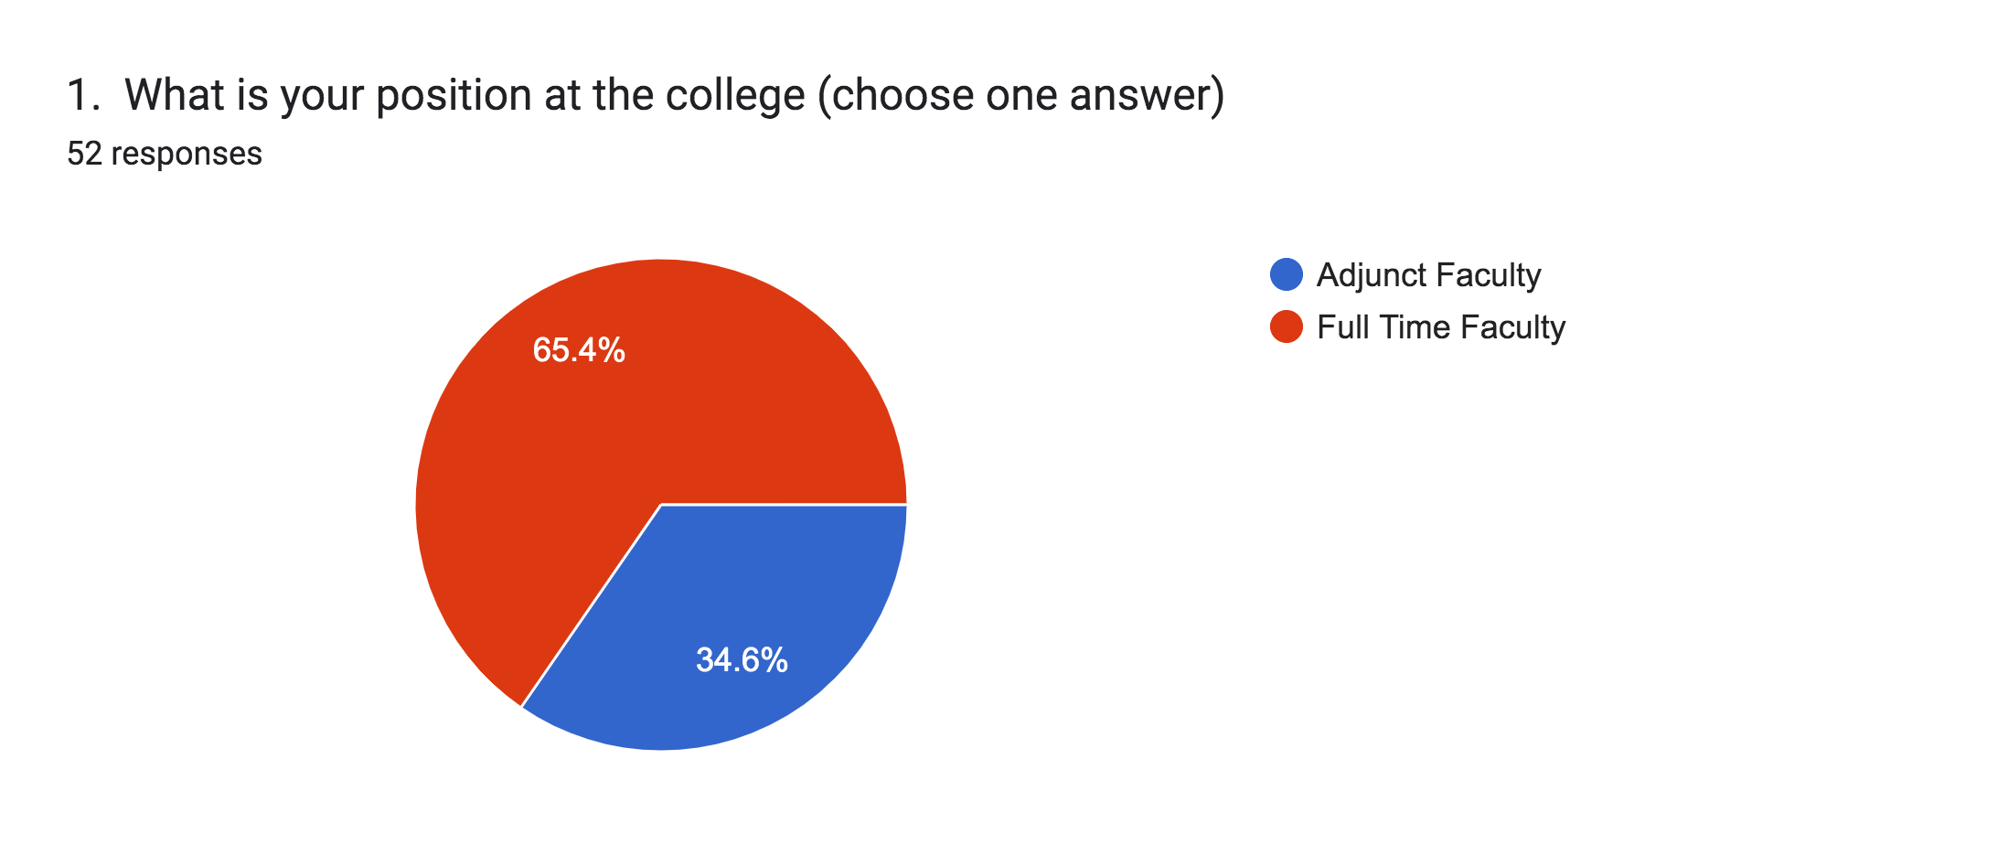
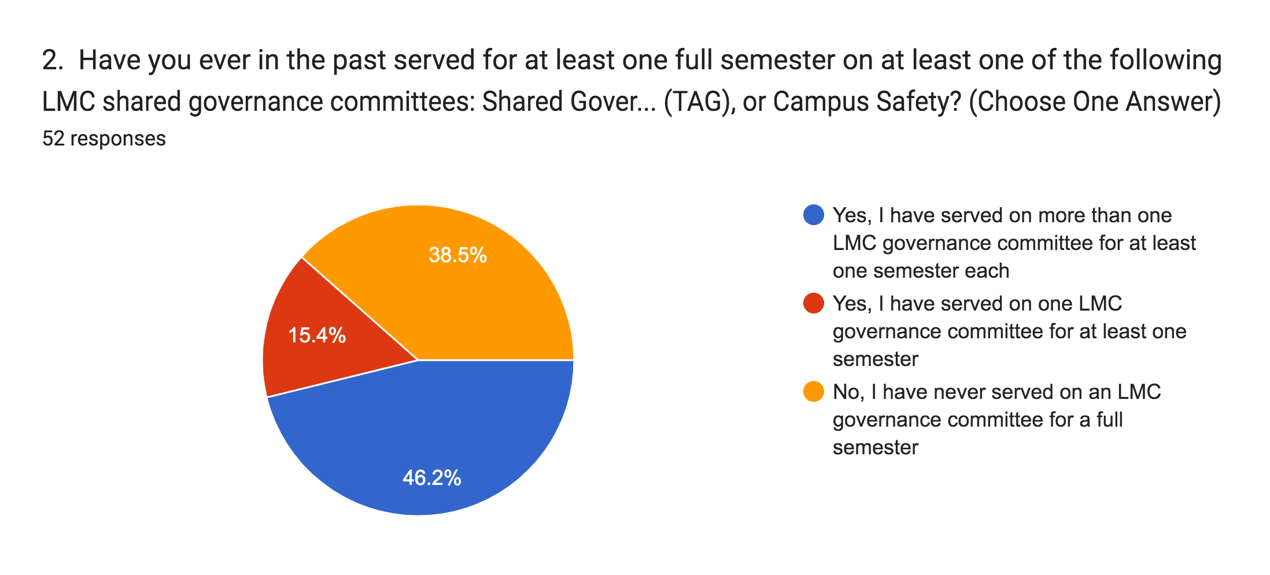
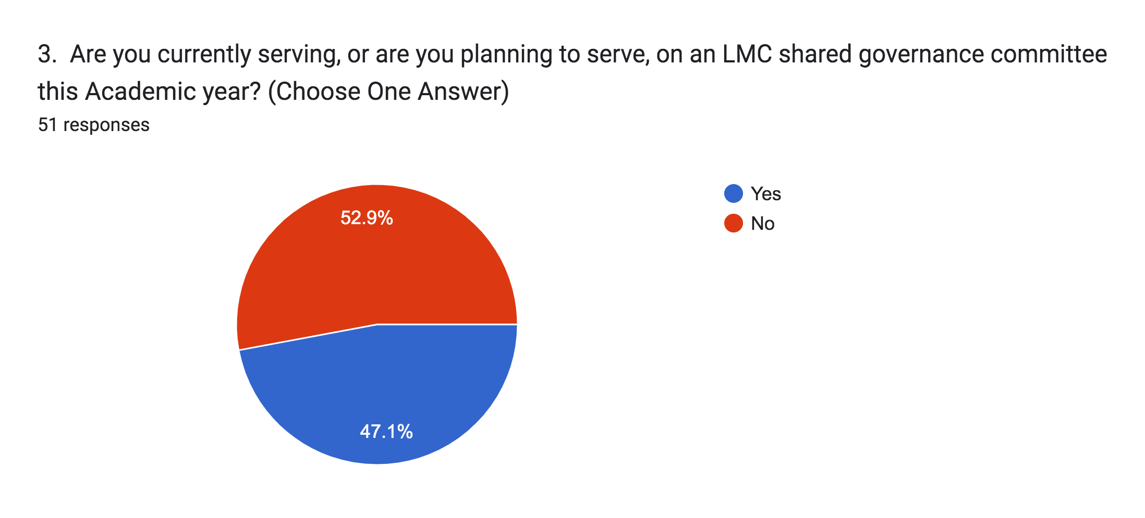
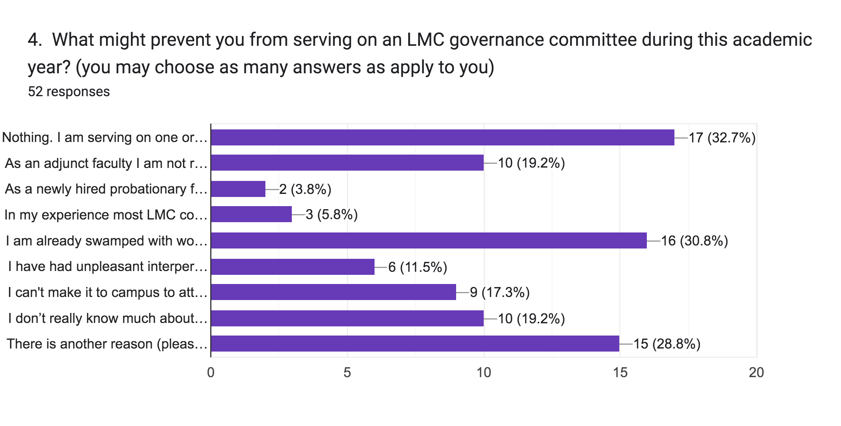
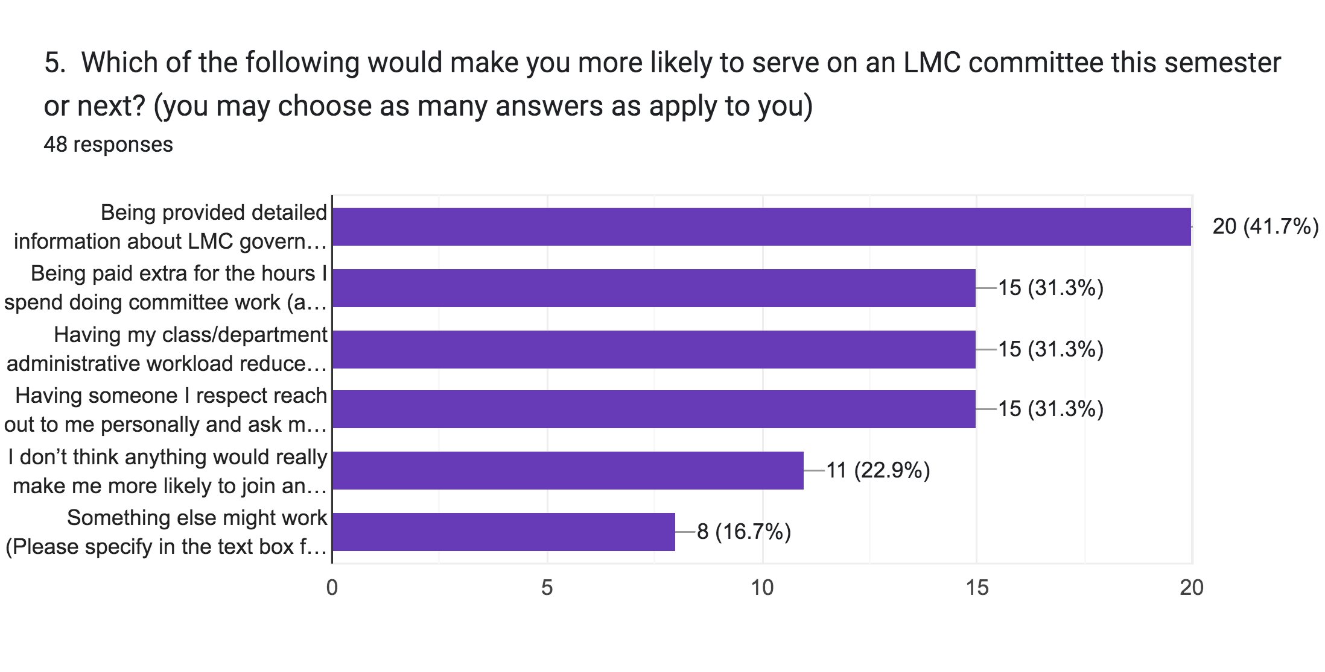
6. Please share any other thoughts you have in the space below about why you do not plan to participate in LMC shared governance this academic year, or what might motivate you to participate in the near future.

The largest barrier is that most committee meetings conflict with my teaching schedule.
Besides being swamped with work from teaching, evaluations, etc., I am personally taking a break from committee work to re-focus on in-person teaching after the pandemic and to give full attention to my students.

zoom attendance

I currently serve in another capacity and do not have the additional time to do unpaid committee work. The college doesn't seem to value the work done on non-governance committees/programs. This work is vital to the college/students/community and there's only so much bandwidth a person has when they are also teaching a full load. R/T for positions that have a significant amount of work for a faculty member (in terms of shared governance committees) is essential. Paying OAS isn't an incentive for most FT faculty when you factor in the amount of hours required. R/T is what allows FT faculty to be able to balance their teaching responsibilities (which is #1 in my opinion) with service to the college. I also think it's important to note that in the past faculty voice on some shared governance committees has felt devalued and candidly, disrespected. There were times where I would feel as though management already had their mind made up and was only placating the faculty voice. There have also been times where it feels as though management doesn't respect faculty time when it comes to scheduling work outside the meeting times. Just because faculty aren't in class teaching a specific time doesn't mean they are magically available. Especially during "crunch times" of the semester like the start, midterms and finals. I have been on committees where the deadlines where at the worst times for faculty to be active thus, silencing our voice because if we have to choose, most of us choose doing the work to serve our students first. Lastly, there's also been an issue with burnout. Historically, there's a small group of faculty doing all the things and large number of faculty not participating with no recourse. Should we be forced to participate? No. Should there be incentive to keep participating if you are a "joiner?" YES.

I work a full-time classified job.

Committee work is the same people saying the same things they have said for 30+ years. A few faculty manage to talk loudly enough and bully other faculty into getting their way. If the handful of faculty who dominate would just go away, I would think about coming back to committee work. But my experience has been that nothing really changes and nothing really matters when it comes to committee work. It is truly thankless.

For me, it has mostly been a scheduling issue. Many of the committees that I would have liked to join meet on days when I have labs. That has been my greatest obstacle. A secondary obstacle has been the formalities and lack of understanding of procedure for joining some committees. Thank you.

I have always enjoyed my leadership positions at LMC, Senate VP, Curriculum Committee Chair (twice), Assessment Chair, DE Chair multiple years, DE Committee 25 years, DE Coordinator(during the pandemic) District Committees (multiple), Brentwood Campus Coordinator, Department Chair (25 years), Currently I am CVC/OEI Course Reviewer at LMC. I recently had a death in my family and I am just trying to make sure my 4 fully online classes are successful this academic year. I help with a variety of community Latinx events and Flex sessions. I hope to return to my leadership roles once I am no longer Trustee to my parents' estate.. in 2024 I will have finished my family obligation to the estate. TY
Last year...retiring and reduce load this year.

I'd be interested in serving on the Academic Senate again or another committee if the opportunity presented itself, if I knew more of what was expected, if I were compensated, & if I thought my participation would make a difference! Knowing that the meeting day/time would fit my schedule or having a Zoom option would really help...The in-person Monday afternoons for the AS meetings is a bit of a deal breaker since, thanks to hybrid teaching, I've only needed to be on campus one day per week (but not on Mondays) for the past couple semesters, which has been great!

I think all committees need a reminder that as they begin every new year, they need to start with on-boarding for any new members. I’ve sat on many committees and felt like there was assumed knowledge, which is off-putting and doesn’t feel inclusive or establish a sense of “I belong here.”
I am grateful for the time and work you have put in for all of us. I will consider participating, but I would like to know more about what is involved. Being an adjunct, half the time I am still looking for and applying for part-time teaching positions. After the first semester of the pandemic I lost a class I had for some time so I am still trying to replace that. Again, thank you for your time and effort. I appreciate your service : )

My choice to not work in share governance is two fold. 1. I need to make room for historically disenfranchised voices. 2. These spaces lack safe boundaries and respect for the work and others. Instead they are disorganized, personally charged. From my observation it stems from a culture which diminishes the experience and expertise of the faculty, by allowing people to speak without research, data or experience on subjects.

Adjunct pay for meetings, committees, additional responsibilites is a hindrance and does not seem to be consistent accros departments or committees

New FT faculty...but as an adjunct here for the last 7-8 years, the lack of adjunct compensation for committee work was a hindrance

I plan to retire at the end of May 2024. I am already on four non-shared governance committees, and those are enough for me at this point.

It is no secret that moral in this campus is at an all time low, and the fact that management and the academic senate are oblivious to this problem, makes this problem that much worse. There is no accountability for the contractual responsibilities for faculty to serve in committees. It is extremely inequitable to have the same faculty members serve in various committees while other faculty members do not do any committee work. At some point you had faculty members such as Marie Arcidiacono, Edward Haven, Ryan Hiscocks, excited to participate and to be fully engaged in many LMC governance committees, however, the lack of leadership, low moral, lack of accountability, lack of transparency among other institutional defeats, have made many faculty members completely apathetic to any sort of engagement outside of their teaching duties. These, and many other problems, are constantly reported to management, yet nothing, absolutely nothing, ever gets done about it. I really hope that objectively speaking, you know why no one is interested in the position of Academic Senate President. In this survey, you will not find out anything that you didn't already knew. And at the end of the day, just like everything else at LMC, nothing will come out of this survey and no action will continue to be the norm.
I don't know what specifically could improve participation, but some type of positive (reward?) or negative (restriction?) consequence might be effective. Rewards for participating could be a stipend, end-of-semester celebration with committee members, flex credit, or some other "carrot". A negative consequence for non-participation could be a requirement to serve as lead of department assessments, completing extra flex, carrying out partial duties of their department chair, or some other "stick". Another "stick" could be posting a list of all faculty with their current and past participation; this list could be sorted such that "high participators" will be at the top of the list, and let it be know that faculty at the bottom of the list will be the first to be contacted regarding openings on committees. A further "stick" could be declaring faculty in violation of their contractual duties if they do not participate on committees for extended periods of time.
I would be happy to serve on a committee if it fits with my schedule, but I am reluctant to add standing meetings to my schedule because I am an adjunct at multiple schools, and scheduling is already difficult enough for me.

N/A

Serving needs to have some type of training from the get go, even if just a manual that explains the processes in place. You would get more traction for all the committees, if we got the woke politics out of school. We should focus on educating nor indoctrinating nor kowtowing to the far left. The vast majority of the public are moderate and we should be neutral.
I currently serve on two LMC shared governance committees, am teaching overload, and just don't have the bandwidth to serve on a third at this time. However, I would love to serve on Academic Senate in the future! I have served on Academic Senate in the past as well as TLC, and as I said I'm currently on 2 other committees. I hope more full-time faculty are able to serve on at least one shared governance committee.

I think that the obstacles to widespread faculty participation on committees are multiple. These are my observations: 1. Both faculty and students have clearly expressed they want a hybrid campus experience. So, any committee that is not brown act needs to be hy-flex to allow for inclusive participation. 2. The rhetoric now about coming "back" and reverting meetings and assemblies "back" in person with no remote option (non-brown act ones) feels patronizing and like taking us back to the 1990s. It feels like there is no recognition of the passion and commitment by faculty who work primarily remotely. 3. Some faculty sit on committees for extended periods of time, meaning those seats are never available. This does not encourage widespread and diverse participation and can cause alienation. Senate reps should have to be elected or re-elected every two years. 4. Reps do not share out committee information as they should, so people aren't aware of the urgency of what's happening..plus just don't feel represented as their input is never solicited by their rep. 5. Redundancy/inefficency: why do we need three reps on sgc for each constituency when the appropriate senates have already approved something? Shouldn't that approval just count? I've seen multiple instances of other faculty reps on SGC going against or altering a proposal that senate already approved, creating so much additional circulation of a proposal to be word-smithed or revised. 6. Confusion about the purpose of some things: what does a TLC rep even do? As far as I can see, really not much at all. And what that committee does as a whole is very confusing. 7. A feeling that all we talk about is plans, and more plans, and planning to plan... 8. Many faculty are teaching overload for financial reasons. 9. When we switched to block scheduling and the 16 week semester, we created much less time in a faculty member's day. (DVC for instance has a lot of meetings on Fridays. I don't want that, but there was a reason for it). 10. Burn out 11. Sometimes "shared governance" can feel like lip service...something will go through that process, seem like it is approved, then never happen or get altered in its implementation or not funded, etc. 13. An increase in the administrative work we all have to do, due to all kinds of things, but that sucks up time. 14. In the English department, our student load increased with AB705. We all teach more students now, and students who are new to college. We've been overwhelmed with that. 15. There's been so much change state wide: so many revisions to things, new things, etc. Faculty are constantly creating and revising curriculum to meet changing expectations. 16. There is no accountability mechanism for faculty who don't do their committee service.

As an adjuct faculty with other job commitments besides LMC, as much as I would morally like to help by joining a committee, I can't afford to financially without adequate compensation.
Thank you for creating and disseminating this survey out to faculty and for soliciting our feedback!

I am a remote adjunct professor but would love to learn more (and would be open to serving if can be done in a remote fashion). Thank you to all for their great work on committees - you all are very much appreciated!

I think reaching out personally helps, and that if we work together, the work will be less overwhelming.

Allowance for remote meetings.

Campus Shared Governance Committee Work to be implemented as a part of Faculty's "A Load" Schedule

