Los Medanos College
New Instructional Program Proposal – Phase 1
DRAFT 1-4-05; Revised October 2010

Date:10-12-2-243

Primary Contacts: Janice Townsend/Randi Osburn (faculty); Dennis Franco (dean)

Program Name: Associate of Science Degree Early Childhood Education: Site Supervisor

Mission/Goals
This new program offers both an Associate’s Degree of Science that meets the educational requirements for the Site Supervisor Permit on the California Commission on Teacher Credentialing Preschool Permit Matrix. This degree is designed to serve those students who want to work in the field of early childhood education and want to meet the requirements of Site Supervisor on the California Commission on Teacher Credentialing Preschool Permit Matrix.

Rationale
Currently we offer skills certificates, an AS-T Degree in ECE and a Certificate of Achievement aligned with the Permit Matrix. We are proposing that we offer two new AS Degrees and two new Certificate’s of Achievements that also align with the permit matrix. An Associate of Science Degree and Certificate of Achievement at the Master Teacher level and an Associate of Science Degree and Certificate of Achievement at the Site Supervisor level. This proposal is for the Associate of Science Degree in Early Childhood Education: Site Supervisor.

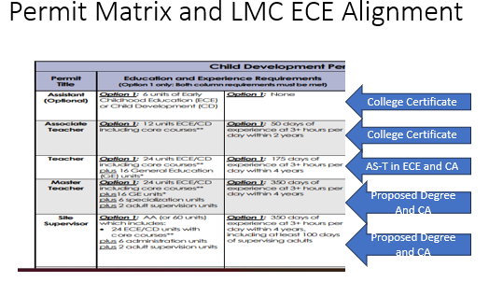

As the AS-T degree in ECE is now the foundation for the P-K to 3 Education Specialist Credential and 24 units of ECE are required to teach TK with a Multiple Subject Credential, it seems that the current CA and AS-T in ECE are geared for students who want to transfer and those who want to earn one of the two elementary teaching credentials.

Once students have worked in the early childhood field as a teacher the next step of advancement is to be a site supervisor. In order to be a site supervisor, students need to complete specific leadership and administration coursework. The coursework in this Early Childhood Education: Site Supervisor Associates of Science degree meets the early childhood education course requirements to earn the Site Supervisor Permit as well as the general education requirement.

Curriculum and Needs Assessment/Feasibility
List the proposed new courses for the program, including the title, number of units, and a brief course description.

None of the courses are new for this degree. We are using existing courses to meet the Site Supervisor level of the Commission on Teaching Credentialing Preschool Permit Matrix.

We do want to note that this is a stackable degree. Should someone want to earn the AS-T in ECE after completing the Associate of Science Degree in Early Childhood Education: Site Supervisor they would need to take 4 more general education courses based on the CALGETC requirements and one ECE course, ECE 90 Student Teaching Practicum in Early Childhood Education

List the course requirements for the major.
Required Courses:

UNITS | COURSE # | COURSE NAME
3 | ECE 001 | Principles & Practices of Teaching Young Children
3 | CHDEV/ECE 010 | Child Growth & Development
3 | CHDEV/ECE 020 | Child, Family &Community
3 | ECE 062 | Introduction to Curriculum
3 | *ECE 083 | Field Experience in an Early Childhood program
3 | CHDEV/ECE 050 | Teaching in a Diverse Society
3 | ECE 011 | Observation & Assessment
3 | ECE 065 | Health, Safety & Nutrition in Early Childhood Programs
2 | ECE 92 | Adult Supervision/Mentor Teacher

Complete 6 Administration Units:
UNITS | COURSE # | COURSE NAME
3 | ECE 95 | Administrations of Early Childhood Programs  ECE 96: Staff Development and Leadership in Early Childhood Programs
3 | ECE 96 | Staff Development and Leadership in Early Childhood Programs

Choose One 6-Unit Specializations:

Infant/Toddler Care and Education
UNITS | COURSE # | COURSE NAME
3 | ECE 40 | Infant/Toddler Development
3 | ECE 41 | Curriculum & Strategies for Infants/Toddlers

Infant/Toddler Care and Education
UNITS | COURSE # | COURSE NAME
3 | ECE 40 | Infant/Toddler Development
3 | ECE 41 | Curriculum & Strategies for Infants/Toddlers

Trauma Informed Practitioner
UNITS | COURSE # | COURSE NAME
3 | ECE 30 | Trauma Informed Practitioner: Foundations
3 | ECE 31 | Trauma Informed Practitioner: Practices and Strategies

Children With Special Needs Care and Education
UNITS | COURSE # | COURSE NAME
3 | ECE 55 | Introduction to Children with Special Needs
3 | ECE 57 | Curriculum & Strategies for Children with Special Needs

Curriculum in Early Childhood Education
UNITS | COURSE # | COURSE NAME
3 | ECE 34 | Creative Art and Movement for Young Children  ECE 35: Science and Math for Young Children
3 | ECE 35 | Science and Math for Young Children

List the proposed sequence of program-specific courses and the projected enrollment:

Fall-Year 1

ECE 1
ECE 10
Specialization course

Spring-Year 1

ECE 20
ECE 62
Specialization course

Summer Year 1

ECE 65

Fall-Year 2

ECE 11
ECE 50
ECE 95

Spring-Year 2

ECE 92
ECE 96

Projected number of students in the program*:
Fall-Year 1 40 Students Spring – Year 1 40 Students Summer- Year 1 40 Students
Fall-Year 2 40 Students; Spring – Year 2 40 Students

* Unduplicated total headcount in program-specific courses.

Enrollment projections are based on: [enrollments in experimental (900) courses to be included in the program; enrollments in similar programs in the college or nearby colleges; etc.]

Projected Annual FTES (to be completed by the Office of Instruction)

Year 1 ____________
Year 2 ____________

Do other colleges in the district or in neighboring districts offer a similar program? If so, provide the rationale for duplicating it at LMC.

Currently DVC offers the Master Teacher and Site Supervisor Certificate of Achievement. They do not offer the corresponding Associate Degrees. We want to offer the Associates of Science Degree as there are transfer opportunities to WASC Accredited Bachelor’s program that will accept students with the Early Childhood Education: Site Supervisor Associate Degree.

CCC does not have either of these degrees or certificates of achievement.

As this field has high need for early childhood educators that are qualified to work with young children it would be a benefit to California if all community colleges had this option.

For new CTE programs: provide labor market information and job market projections that support the establishment of this program. Sources for this information are provided in the Program and Course Approval Handbook (Chancellor’s Office). Also include the results of discussions with key local employers/potential advisory committee members.
This LMI data shows the job market and the need for early childhood educators.

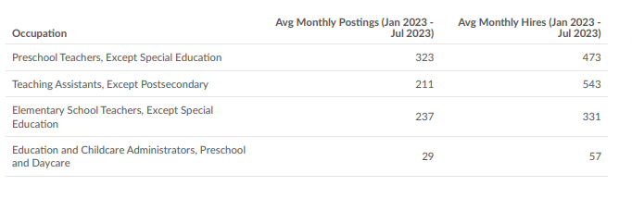
Early childhood programs are so short staffed that they can not open all of their classrooms. This is even happening at our own child study centers.

What other departments at the college could be affected by adding this program? Explain and include the results of preliminary discussions with the affected departments.

No other department will be affected. We have been offering these courses and now are packaging them into a degree and certificate of achievement.

Staffing
Describe the initial staffing needed for the program, including the approximate number of full time and part time faculty and classified staff.

We would work with the existing full-time and part-time faculty.

Will new hires be required in order to offer the program? If so, are the pools of full-time and/or part-time faculty expected to be sufficient? If we need to hire more faculty, the pool is sufficient.

How will the staffing needs change in years 2-4?

If this brings more students to the program, then we would work through the Box 2A process to document our need and request an additional full-time faculty. We have a strong part-time faculty pool.

Operating Budget
Outline the initial budget required to fund the program. Briefly explain any budget item as needed to make the purpose clear.

We will be putting in a SWP/Perkins proposal if these degrees are approved for advising and marketing materials. We want students to be clear on which degree or certificate of achievement is best for them and will need increased faculty advising for this. This is also a recommendation of our advisory committee. We see this project lasting for at least two years.

We have yet to map out this project, however we did have a one year advising project in the 2022/2023 school year and that project was funded for $18,000.

Facilities
Describe the facilities needed for the program in the first year (classrooms, labs, offices, other).

Current college facilities.

All of the ECE courses have online sections. This could be a fully online degree regarding the ECE coursework.

What additional facilities needs should be anticipated in subsequent years?
None.

Reviewed by:

__________________________ Senior Dean of Instruction

__________________________ Academic Senate President

__________________________ President

