Bay Miwok Mural
At Los Medanos College
Proposal by Eric Sanchez, Lindsay Litowitz, Robert Delgado, and Joan Riley

The Bay Miwok Mural will support the diversity of the LMC community, the greater Pittsburg area, and honor the land that our college sits on. Going beyond a plaque or statue, the mural will be an engaging art piece that cannot be missed. We will engage with native artists, and a representative from a tribe whose people inhabited the land LMC is built on, by hosting a speaker who will inspire our community.
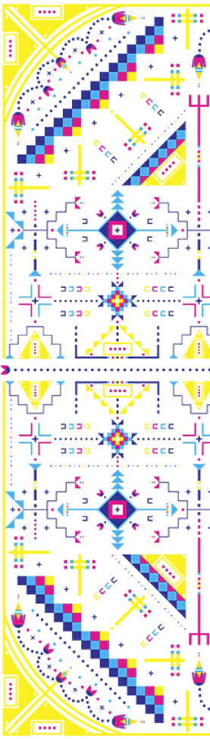 | Plan for Fall 2024 Semester  - Speaker & Workshop  - How to approach the design process for another culture's design language  - Bay Miwok representative to advise on culturally significant designs and  - Design Competition  - In conjunction with Eric’s Fall 2024 2D Design Course & open to LMC community  - Jury Selection of Design  - Paint on Panels  - Student stipend  - Installation – December 9-20, 2024  - 3-5 days  - Unveiling at All College Day January 2025  Jury Selection (Spring 2024)  - Bay Miwok Tribe member  - 2 Students from LMCAS  - 2 Managers  - President’s Cabinet  - President’s Council  - 2 Classified Professionals from Classified Senate  - 2 Faculty Members from Academic Senate  Shared Governance Requests (Spring 2024)  - LMCAS, Classified Senate, & Academic Senate vote on location  - Select jury members  Funded by the 4CD Equal Employment Opportunity Grant

