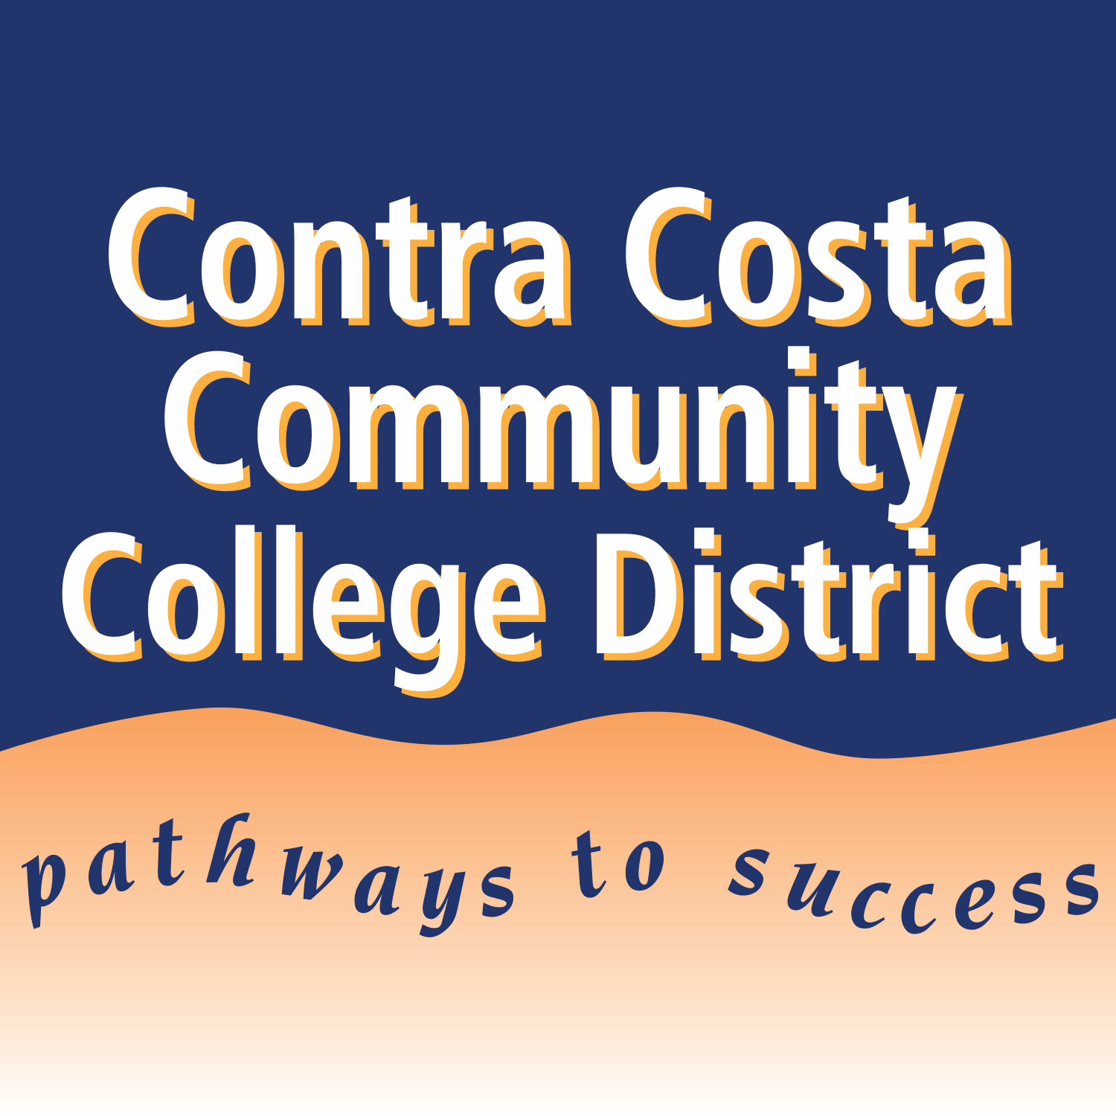

District-Wide AI Taskforce, Approved 12/2024

Guidance: 4CD Artificial Intelligence Acceptable Use

Contra Costa Community College District recognizes the impact of Generative AI tools within a student's educational experience and encourages critical digital literacy, responsible use, and acknowledgment of ethical implications.

Individual course instructors set their own policies on the use of generative AI tools in their courses, including allowing or disallowing some or all uses of such tools. These parameters of use should be clearly communicated to students in course syllabi. Students who are unsure of course policies regarding generative AI tools should ask their instructors for clarification.

In general, use of AI tools must adhere to existing academic integrity policies. Without a clear syllabus statement from a course instructor, or in a situation that might not be clearly covered by such a statement, use of generative AI without clear attribution and/or using AI tools to complete an assignment or exam without explicit permission to do so can constitute plagiarism and/or cheating, as defined in the Contra Costa Community College District Student Code of Conduct ([Student Services Procedure 3027](https://www.4cd.edu/gb/policies-procedures/student/S3027.pdf)). Students should cite or acknowledge the use of generative AI and should clarify policies regarding the use of AI with their course instructor when in doubt.