Los Medanos College
New Instructional Program Proposal – Phase 1
DRAFT 1-4-05; Revised October 2010

Date:10-12-2-243

Primary Contacts: Janice Townsend/Randi Osburn (faculty); Dennis Franco (dean)

Program Name: Certificate of Achievement: Master Teacher

Mission/Goals
This new program offers a Certificate of Achievement that meets the early childhood education educational requirements for the Master Teacher Permit on the California Commission on Teacher Credentialing Preschool Permit Matrix. This certificate of achievement is designed to serve those students who want to work in the field of early childhood education and are working towards becoming a Master Teacher on the California Commission on Teacher Credentialing Preschool Permit Matrix.

Rationale
Currently we offer skills certificates, an AS-T Degree in ECE and a Certificate of Achievement aligned with the Permit Matrix. We are proposing that we offer two new AS Degrees and two new Certificate’s of Achievements that also align with the permit matrix. An Associate of Science Degree and Certificate of Achievement at the Master Teacher level and an Associate of Science Degree and Certificate of Achievement at the Site Supervisor level. This proposal is for the Certificate of Achievement in Early Childhood Education: Master Teacher.

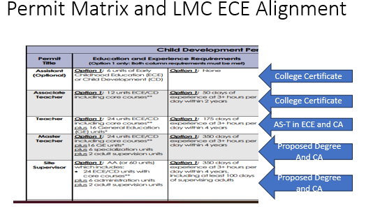

As the AS-T degree in ECE is now the foundation for the P-K to 3 Education Specialist Credential and 24 units of ECE are required to teach TK with a Multiple Subject Credential, it seems that the current CA and AS-T in ECE are geared for students who want to transfer and those who want to earn one of the two elementary teaching credentials.

For those people working in early childhood programs and employers of those people, we are hearing that they need more early childhood education coursework. By aligning to the California Commission of Teacher Credentialing Permit Matrix at the Master Teacher level this will benefit those employers who require this permit. And the employers feel l that the early childhood education workforce will be able to meet better meet the needs of children if they have more early child coursework within the Certificate of Achievement. This is for a number of reasons:

There are more children who have experienced trauma and the early childhood educators don’t have the skills to work with them.
- There are more children diagnosed with special needs and the early childhood educators don’t have the skills to work with them.
- As the 4-year old’s are now in TK, more of early childhood programs and expanding their infant and toddler programs and early childhood educators don’t have the required infant toddler coursework to work with those children.

We have heard from employers and their employees in early childhood programs that they need more early childhood education courses in the above-mentioned areas. This proposal is in direct response to that feedback and at our advisory committee meeting it was voted to move forward with this certificate of achievement.

Curriculum and Needs Assessment/Feasibility
List the proposed new courses for the program, including the title, number of units, and a brief course description.

None of the courses are new for this Certificate of Achievement. We are using existing courses to meet the Master Teacher level of the Commission on Teaching Credentialing Preschool Permit Matrix.

We do want to note that this is a stackable certificate to earning the Early Childhood Education: Master Teacher Associates of Science Degree. Should someone want to earn Associate of Science Degree in Early Childhood Education: Master Teacher they would need to take the 6 required general education courses and 5 elective units.

List the course requirements for the major.

Required Courses:

UNITS | COURSE # | COURSE NAME
3 | ECE 001 | Principles & Practices of Teaching Young Children
3 | CHDEV/ECE 010 | Child Growth & Development
3 | CHDEV/ECE 020 | Child, Family &Community
3 | ECE 062 | Introduction to Curriculum
3 | CHDEV/ECE 050 | Teaching in a Diverse Society
3 | ECE 011 | Observation & Assessment
3 | ECE 065 | Health, Safety & Nutrition in Early Childhood Programs
2 | ECE 92 | Adult Supervision/Mentor Teacher

Choose Two 6-Unit Specializations:

Infant/Toddler Care and Education
UNITS | COURSE # | COURSE NAME
3 | ECE 40 | Infant/Toddler Development
3 | ECE 41 | Curriculum & Strategies for Infants/Toddlers

Trauma Informed Practitioner
UNITS | COURSE # | COURSE NAME
3 | ECE 30 | Trauma Informed Practitioner: Foundations
3 | ECE 31 | Trauma Informed Practitioner: Practices and Strategies

Children With Special Needs Care and Education
UNITS | COURSE # | COURSE NAME
3 | ECE 55 | Introduction to Children with Special Needs
3 | ECE 57 | Curriculum & Strategies for Children With Special Needs

Curriculum in Early Childhood Education
UNITS | COURSE # | COURSE NAME
3 | ECE 34 | Creative Art and Movement for Young Children  ECE 35: Science and Math for Young Children
3 | ECE 35 | Science and Math for Young Children

List the proposed sequence of program-specific courses and the projected enrollment:

Fall-Year 1

ECE 1
ECE 10
Specialization course

Spring-Year 1

ECE 20
ECE 62
Specialization course

Summer Year 1

ECE 65

Fall-Year 2

ECE 11
ECE 50
Specialization Course

Spring-Year 2

ECE 92
Specialization Course

Projected number of students in the program*:

Fall-Year 1 40 Students Spring – Year 1 40 Students Summer- Year 1 40 Students
Fall-Year 2 40 Students; Spring – Year 2 40 Students

* Unduplicated total headcount in program-specific courses.

Enrollment projections are based on: [enrollments in experimental (900) courses to be included in the program; enrollments in similar programs in the college or nearby colleges; etc.]

Projected Annual FTES (to be completed by the Office of Instruction)

Year 1 ____________
Year 2 ____________

Do other colleges in the district or in neighboring districts offer a similar program? If so, provide the rationale for duplicating it at LMC.

Currently DVC offers the master teacher and site supervisor certificate of achievement. They do not offer the corresponding associate’s degree.

CCC does not have either of these degrees or certificates of achievement.

As this field has high need for early childhood educators that are qualified to work with young children it would be a benefit to California if all community colleges had this option.

For new CTE programs: provide labor market information and job market projections that support the establishment of this program. Sources for this information are provided in the Program and Course Approval Handbook (Chancellor’s Office). Also include the results of discussions with key local employers/potential advisory committee members.
This LMI data shows the job market and the need for early childhood educators.

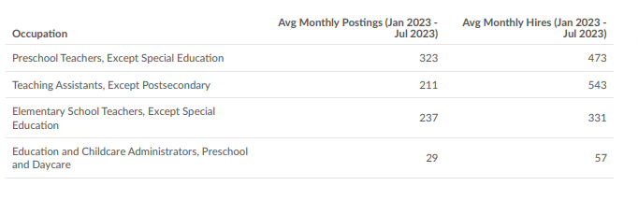
What other departments at the college could be affected by adding this program? Explain and include the results of preliminary discussions with the affected departments.

No other department will be affected. We have been offering these courses and now are packaging them into a degree.

Staffing
Describe the initial staffing needed for the program, including the approximate number of full time and part time faculty and classified staff.

We would work with the existing full-time and part-time faculty.

Will new hires be required in order to offer the program? If so, are the pools of full time and/or part time faculty expected to be sufficient? If we need to hire more faculty, the pool is sufficient.

How will the staffing needs change in years 2-4?

If this brings more students to the program then we would work through the Box 2A process to document our need and request an additional full time faculty. We have a strong part-time faculty pool.

Operating Budget
Outline the initial budget required to fund the program. Briefly explain any budget item as needed to make the purpose clear.

We will be putting in a SWP/Perkins proposal if these degrees are approved for advising and marketing materials. We want students to be clear on which degree or certificate of achievement is best for them and will need increased faculty advising for this. This is also a recommendation of our advisory committee. We see this project going on for two years.

We have yet to map out this project however we did have a one year advising project in the 2022/2023 school year and that project was funded for $18,000.

Facilities
Describe the facilities needed for the program in the first year (classrooms, labs, offices, other).

Current college facilities. All of the ECE courses have online sections. This could be a fully online certificate of achievement.

What additional facilities needs should be anticipated in subsequent years?
None.

Reviewed by:

__________________________ Senior Dean of Instruction

__________________________ Academic Senate President

__________________________ President

