Academic Senate Co-President Drop-in Hour – MA-130

Hola LMC Communidad,

I wanted to let LMC employees know that I am hosting an academic senate president drop-in hour for anyone that would like o meet with one of the senate co-presidents about matters on your mind—you're also always welcome to just drop by for a quick hello and visit! This is an oportunidad to get your voices heard and to continually build our LMC community through frequent communications with each other.

Drop-in hours will be every Friday for 1 hour at the senate office, MA- 130 (Math Building) starting tomorrow, Friday, February 23rd, 2024. There will be no drop-in hour during spring recess and my conference travel dates. The ones I know for sure that I am not available are Friday, March 29th, and Friday, April 26th. I will have a sign posted if I am not hosting my drop-in hour that week. I will continue these Friday drop-in times until May 3rd, 2024.

If you cannot attend F2F, I will have my Zoom up and running for the hour (information included below).

**Academic Senate President Drop-In Hour**

Every Friday from 10am-11am in MA-130 or by ZOOM

I hope to see some of you on a Friday Drop-In Hour!

In solidarity,

Adrianna

Topic: Academic Senate President Drop-In Hour

Join Zoom Meeting

[https://4cd.zoom.us/j/2850738670](https://nam10.safelinks.protection.outlook.com/?url=https%3A%2F%2F4cd.zoom.us%2Fj%2F2850738670&data=05%7C02%7CADuldulao%40losmedanos.edu%7Ca57b07515a1b468a970808dc33f0c6f8%7Cc354694acce5489fb2a3a2a9d26e0c3f%7C0%7C0%7C638442357949001137%7CUnknown%7CTWFpbGZsb3d8eyJWIjoiMC4wLjAwMDAiLCJQIjoiV2luMzIiLCJBTiI6Ik1haWwiLCJXVCI6Mn0%3D%7C0%7C%7C%7C&sdata=Tgs4dsWVmJ0FEMxlOYqs8Y0Wy7BUNs9TCE8KgZR%2Fe%2BQ%3D&reserved=0)

Meeting ID: 285 073 8670

One tap mobile

+16694449171,,2850738670# US

+16699006833,,2850738670# US (San Jose)

Dial by your location

• +1 669 900 6833 US (San Jose)

• +1 346 248 7799 US (Houston)

• +1 719 359 4580 US

• +1 253 215 8782 US (Tacoma)

• +1 305 224 1968 US

• +1 312 626 6799 US (Chicago)

• +1 386 347 5053 US

• +1 929 205 6099 US (New York)

• +1 301 715 8592 US (Washington DC)

Find your local number: [https://4cd.zoom.us/u/kcORO5XhHi](https://nam10.safelinks.protection.outlook.com/?url=https%3A%2F%2F4cd.zoom.us%2Fu%2FkcORO5XhHi&data=05%7C02%7CADuldulao%40losmedanos.edu%7Ca57b07515a1b468a970808dc33f0c6f8%7Cc354694acce5489fb2a3a2a9d26e0c3f%7C0%7C0%7C638442357949010365%7CUnknown%7CTWFpbGZsb3d8eyJWIjoiMC4wLjAwMDAiLCJQIjoiV2luMzIiLCJBTiI6Ik1haWwiLCJXVCI6Mn0%3D%7C0%7C%7C%7C&sdata=Dyb0DJkuCHTHPzkpQp%2BgyIQu3ZtBh2IoYw%2Bqi5Lh2Xg%3D&reserved=0)

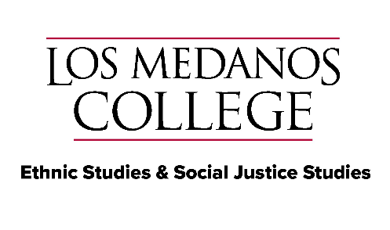“People have to be true to themselves while simultaneously holding one unshakable conviction ―*I am willing to struggle against all forms of racism until the day I die.*”  
― Cornel West

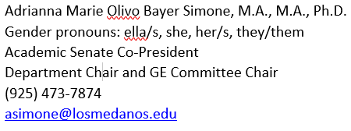

Adrianna Marie Olivo Bayer Simone, M.A., M.A