Academic ESL
The Los Medanos College Academic ESL for Educational and Professional Advancement Program is a for-credit (Credit) program within the LMC ESL Department that serves and supports non-native English-speaking students who are ready to make the commitment to working to acquire intermediate and advanced academic language proficiencies and competencies.
Our Academic ESL Program supports these students’ college and career advancement by intentionally infusing two key components into our second language acquisition-oriented program student learning outcomes (PSLOs): 1) the LMC Institutional/General Education student learning outcomes, which exist and function to prepare students to succeed in general and career education courses as well as students’ chosen major coursework, and 2) the thinking dispositions (i.e., the Habits of Mind) that research has shown most significantly support student success, and which are equivalent to the highly valued “soft skills” that industry and employers have called upon higher education to help students attain to prepare them for the world of work.
Additionally, our instruction takes an appreciative, strengths-based approach to teaching our multilingual immigrant, refugee, and international student populations by valuing the rich diversity they bring to our college classrooms, respecting their language learning goals as additive and commendable, and empowering them toward academic and career engagement and success.
We strive to offer the intermediate and advanced Academic ESL courses according to their three-course certificate-based packages during the sixteen-week fall and spring semesters. The courses are designed in an integrated manner; for optimal language learning and progress, students who are committed to advancing and transitioning into general, career, and college major coursework should take all three courses as a package.
At the Pittsburg Campus, the three ESL-085 courses and the three ESL-095 courses are offered on a rotating basis during the fall and spring semesters according to the following schedule:
Morning/Day Academic ESL classes are currently scheduled as follows |  |  |  | Afternoon/Evening Academic ESL classes are currently scheduled as follows
 | Class 1 | Class 2 | Class 3 |  | Class 4 | Class 5 | Class 6
Tuesday and Thursday | 8:45-10:50 | 11:10-1:15 |  | Tuesday and Thursday | 3:20-5:25 | 5:45-8:15
Wednesday |  |  | 9:35-12:45* according to room availability | Wednesday |  |  | 4:15-7:25
For students’ convenience, each semester, the college posts a searchable schedule of available classes on the Course Schedule Search page: https://webapps.4cd.edu/apps/CourseScheduleSearch/Default.aspx
By registering and enrolling in any General ESL or Academic ESL course, the LMC ESL Department expects that each student understands, and both can and will COMMIT to the following:
- attend EACH and EVERY class session from the start-date to the end-date of the given session or semester
- come FULLY prepared with textbooks, materials, and completed homework, and for tests
- come ON TIME according to the start-time listed and stay until the end-time listed
- ASK QUESTIONS and strive to understand answers about anything that is not clear and/or that you do not understand
- RESPECT and FOLLOW the instructor of the class, the class syllabus and all class policies and guidelines, and the LMC Student Code of Conduct
- work to become increasingly aware of, understand, practice, and apply the 16 HABITS OF MIND as you are supported to do so by your teacher during class and specific activities, exercises, and assignments, and as other learning situations warrant
- MAKE APPOINTMENTS with the class professor during her/his Students’ Hours (also known as Office Hours) or at another time pre-arranged time to discuss any classroom, instructional, or course problems, issues, and/or complaints (Please note, such items will not, should not, and cannot be addressed and discussed during class time, and it is a student’s responsibility to follow the guidelines and procedures stated here and as put forth on the Help with Difficulties You May Encounter at LMC page.)
Below are the course schedule descriptions of for the Academic ESL courses. The full course outlines of record (COORs) for each of these courses, which provide detailed information about each course, can be found here: https://www.losmedanos.edu/catalog/coor/ESL.aspx

Academic ESL Engage and Exit Stages Course Schedule Descriptions
(drop down listing)
INTERMEDIATE = ENGAGE
ESL-085G – Intermediate Grammar for College and Career Communication
Communicate confidently and correctly in English-speaking college and work settings. Understand and engage with academic and career texts, lectures, and your fellow students and professors at an intermediated level of English. Enhance your understanding of and ability to use intermediate English grammar structures to strengthen your reading ability and your oral and written communication. ESL-085G will help you do all of this. Take it with ESL-085WR and ESL-085SL to increase your overall language development and potential for college success. Successfully complete all three of these intermediate-level courses, and then apply for the Intermediate English for College and Career Success Skills Certificate.
ESL-085SL – Intermediate Oral Communication for the College Classroom and Beyond
Understand and prepare for the oral communication opportunities and challenges of U.S. college classrooms in this intermediate level course for multilingual English language learners. Sharpen your listening abilities and visual sensitivities as you listen to, watch, and analyze lectures and presentations on a range of college subjects and career-bound topics. Learn and practice effective note-taking strategies and improve your comprehension. Develop interactive speaking and listening skills to help you engage fully and confidently in a variety of college oral communication settings and situations. Take ESL-085SL! Take it with ESL-085G and ESL-085WRV to increase your language development. Successfully complete all three of these intermediate-level courses, and then apply for the Intermediate English for College and Career Success Skills Certificate.
ESL-085WRV – Intermediate College Writing, Reading, and Dispositional Thinking
In this intermediate course for multilingual English language learners, you will build a strong academic vocabulary base and develop critical reading, dispositional thinking, and college writing skills that will prepare you to engage and succeed in the U.S. college classroom. You will build an ability to understand and use college and career-bound vocabulary and expressions, and you will learn skills and strategies to critically analyze, understand, discuss, and academically write about stimulating social, cultural, and global issues, events, and concepts in English. You will develop intermediate-level English grammar and syntax skills, master academic paragraph writing, and gain a solid understanding of the North American academic essay. Complete this course, ESL-085G, and ESL- 085SL and apply for the Intermediate English for College and Career Success Skills Certificate.

ADVANCED = EXIT
ESL-095G – Advanced Grammar for College and Career Communication
Communicate accurately and confidently in English-speaking college and career environments. Understand and engage with academic and career texts, lectures, and your fellow students and professors in English. Enhance your understanding of and ability to use advanced English grammar structures to strengthen your oral and written communication. ESL-095G will help you do all of this. Take it with ESL-095WR and ESL-095SL to increase your language development and college success. Successfully complete all three of these advanced-level courses, and then apply for the Advanced English for Academic and Professional Advancement Skills Certificate.
ESL-095SL – Advanced Speech Communication for Academic and Professional Pursuits
Improve your college, career, and personal speaking and listening abilities in this advanced level speech communication course for multilingual English language learners. Learn and develop verbal, and nonverbal communication skills and strategies that will help you become a more confident and effective public speaker and active and critical listener. Use your developing understanding of certain interpersonal and intercultural communication ideas and techniques toward helping you interact in relationships. Get help and practice performing presentations, interviews, and debates. Take ESL-095SL and help yourself succeed in reaching your college and career goals! Complete this course, ESL-095G, and ESL-095WRV and apply for the Advanced English for Academic and Professional Advancement Skills Certificate.
ESL-095WRV – Advanced Academic Writing, Reading, and Dispositional Thinking
In this advanced level course for multilingual English language learners, you will increase your academic vocabulary base, enhance your critical reading, dispositional thinking, and university writing abilities, and ultimately advance your potential to succeed in English 100 and other U.S. college classrooms. You will improve your ability to understand and use academic and professional vocabulary and expressions, and you will sharpen your skills and strategies to critically analyze, understand, discuss, and academically write about stimulating social, cultural, ethical, and global issues, events, and concepts in English. You will also improve your understanding and use of advanced-level English grammar and syntax as you gain mastery of North American academic paragraph and essay writing. Complete this course, ESL-095G, and ESL-095SL and apply for the Advanced English for Academic and Professional Advancement Skills Certificate.

HIGH-ADVANCED = TRANSITION
ESL-100G – English Grammar Support for Advanced Multilingual Students
Communicate accurately and confidently in English-speaking college and career environments. Understand and engage with academic and career texts, lectures, and your fellow students and professors in English. Enhance your understanding of and ability to use English grammar structures at a high- advanced level of English proficiency to strengthen your reading and your oral and written communication. ESL-100G will help you do all of this. Take it with ENGL-100S or ENGL-100, or with the advanced level ESL courses ESL- 095WR and ESL-095SL to support your academic writing, reading, and critical thinking and your overall success in college-level coursework.

Academic ESL Engage and Exit Stages Required Textbooks
The following is the list of REQUIRED textbooks that each student is responsible for purchasing and bringing to each class session beginning from day one of instruction.
Without exception, each student MUST have their own course textbook or the listed required printed course material. This includes the online course access code that accompanies the main textbook for each of the intermediate and advanced courses listed here. It is expected that all students who enroll in one of these courses understand this requirement and will do what they need to do to procure or access the financial costs associated with purchasing the textbooks.
Students can choose to purchase their textbooks through the LMC Bookstore - currently located in the College Complex, Level 3, and soon to move to the new Student Union Building, Level 1 - or via an online source such as Amazon. When purchasing the textbooks via an online source, students MUST MAKE CERTAIN to use the appropriate ISBN (International Standard Book Number) listed for each book in the chart below. Textbook information will also be provided on every course syllabus that students will receive on the first day of instruction.
Course | Textbook Titles and ISBNs | Image | Approximate Cost  w/out taxes | Required Books
 |  |  |  | Sem  ___ | Sem  ___ | Sem  ___ | Sem  ___
ESL-085SL | 21st Century Communication 3: Listening, Speaking, and Critical Thinking  ISBN:  9781337275828 | 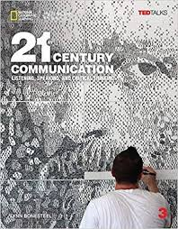 | $40.00-71.00
ESL-085G | Focus on Grammar 3 Student Book with MyEnglishLab, 5e  ISBN:  9780133854886 | 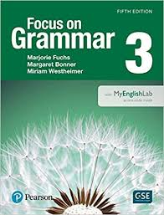 | $40.00-78.00
ESL-085WRV | Longman Academic Writing Series 3: Writing Skills for College  ISBN:  9780134663326  Enrique’s Journey: The Story of a Boy’s Dangerous Odyssey to Reunite with his Mother  ISBN:  9780812971781  Girl in Translation  ISBN:  9781594485152 | 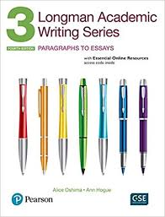  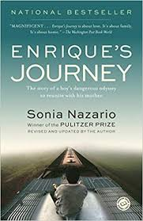  OR  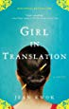 | $30.00-55.00  $10.00-17.00
ESL-095SL | Zero Textbook Cost (ZTC) | Students will print materials | ZTC
ESL-095G | Focus on Grammar 4 Student Book with MyEnglishLab, 5e  ISBN:  9780134119991 | 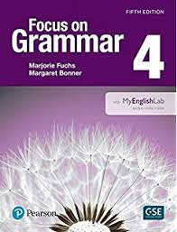 | $40.00-78.00
ESL-095WRV | Elements of Success4  Student Book with Essential Online Practice  ISBN:  9780194028295  Reaching Out  ISBN:  9780547250304  Outliers: The Story of Success  ISBN:  978-0-316-01793-0 | 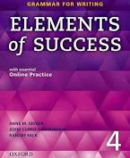  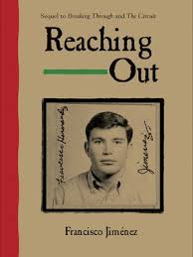  AND  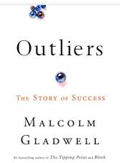 | $25.00-66.00  $10.00-17.00  $10.00-17.00

