CANVAS: QUICK START
Logging In:  - Go to losmedanos.instructure.com  (or through the link on the InSite portal)  - Use your Insite ID & password  - Login troubles?  - Call Admissions & Records:  (925) 473-7500 | 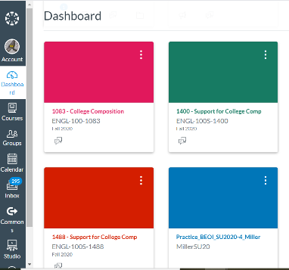  Finding Your Courses:  - This is your dashboard  - If you don’t see your course cards, click on the book icon, “Courses” on the left-hand side  - Click on the link “All Courses”  - Press the “star” icon to make sure your courses appear on your dashboard  - Note: Your courses may not appear until the first day of class.
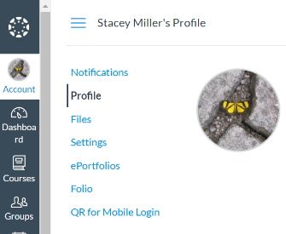  Setting Your Profile:  - Click on “Account” then “Profile” from your dashboard  - Click on “Edit Profile” to add a bio (optional)  - Move your mouse over your image to make the pencil appear. Upload a student-friendly & professional looking image (optional, but nice!) | Checking Your Settings:  - From “Profile” click on “Settings”  - Your default email will be your @insite.4cd.edu  - You can add “ways to contact”  - Add alternate email addresses: choose the email you look at regularly  - Add other contacts including your cell phone if you want!
Creating Notifications:  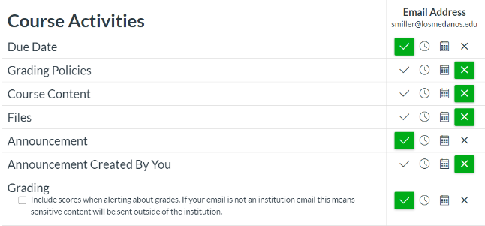  - You can create notifications to alert you of due dates, announcements, and grades for all of your courses. This is recommended!  - From “Account” choose “Settings” and then click on “Notifications” on the left-hand side  - For each of the items, adjust the frequency of the alert so that it best fits your needs  - We recommend setting: Due Dates, Announcements, and Grades | Using Canvas Student Guides:  - Consider watching the “Canvas Overview for Students” video for a quick overview  - Use the “Canvas Student Guides” to access a ton of extra resources  - Here’s a curated list of info we think you’ll find most helpful:  - View my grades  - View announcements  - Upload a file for an assignment  - View assignment feedback  - Use calendar  - Embed an image in a discussion  CANVAS 24/7 STUDENT HELPLINE:  (844) 303-5586

