**Los Medanos College**

**Distance Education Strategic Plan 2009**

**Spring 2014 Update**

**Presented by the Distance Education Strategic Planning Task Force**

**February 2010**

**2013 - 2014 Los Medanos College Distance Education Committee**

**Clayton Smith ____________________________________________**

Faculty, Computer Science, Distance Education Co-chair

**Kimberly Wentworth** **____________________________________________**

Faculty, Library, Distance Education Co-chair

**Kevin Horan ____________________________________________**

Vice President

**Michael Becker** **____________________________________________**

Information Technology & Services Manager

**Eloine Chapman** **____________________________________________**

Marketing

**Rickie Hall** **____________________________________________**

Admissions & Records

**Laurie Huffman** **____________________________________________**

Faculty, World Languages

**Kirsten Martin** **____________________________________________**

Faculty, Registered Nursing

**Mary Oleson** **____________________________________________**

College Advancement

**Christine Park** **____________________________________________**

Faculty, Library

**Penny Wilkins** **____________________________________________**

Faculty, Business

**Debbie Wilson** _____________________________________________________

Faculty, Travel

**Current Status**

|  |  |  |  |  |  |  |
| --- | --- | --- | --- | --- | --- | --- |
|  | Spring 2014 | | Summer 2014 | | Fall 2014 | |
|  | Hybrid | Online | Hybrid | Online | Hybrid | Online |
| CCC |  |  |  |  |  |  |
| DVC |  |  |  |  |  |  |
| LMC | 30 | 34 | 5 | 23 |  |  |

The college is not offering a substantial number of courses online, but the retention and success rates for the classes offered is high both at LMC and across the District.

**LMC Completion and Success Fall 2013**

|  |  |  |  |  |
| --- | --- | --- | --- | --- |
| **COMPLETION** | **ALL STUDENTS** | | **LATINOS** | |
| LMC | STATE | LMC | STATE |
| Online | 81% | 83% | 81% | 53% |
| Face-to-Face | 87% | 87% | 85% | 87% |

|  |  |  |  |  |
| --- | --- | --- | --- | --- |
| **SUCCESS RATE** | **ALL STUDENTS** | | **LATINOS** | |
| LMC | STATE | LMC | STATE |
| Online | 62% | 60% | 66% | 55% |
| Face-to-Face | 71% | 69% | 70% | 67% |

**District wide Persistence**

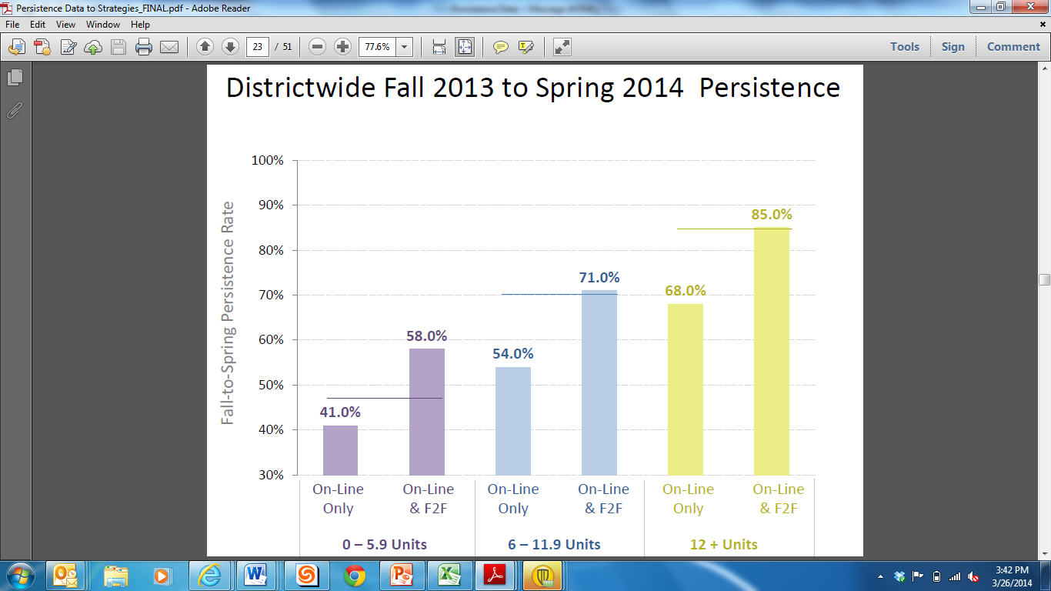

Major factors currently affecting distance education at Los Medanos College include:

* The adoption of the District shared learning management system (LMS), Desire2Learn (D2L) has led to the formation of Learning Management System Work Group (LMSWG) the District DE Council which is the vehicle for regular district-wide dialog.
* The State is in the process of creating an Online Education Initiative (OEI) which will lead to increased competition between the community colleges.
* Instructors will need to be certified to teach classes in OEI.
* The Chancellor has set a goal of a District online degree.

**Updated S.W.O.T Analysis**

**Strengths**

* District wide learning management system
* Formation of District Distance Education Council (DDEC)
* Creation of District website for Desire2Learn training and online teaching support

**Weaknesses**

* Changes to LMC’s culture are needed to embrace fully online courses and programs
* Lack of coordinated oversight or strategic planning in regard to campus-wide computer labs or technology resources from an instruction perspective
* The Distance Education Committee (DEC) has trouble getting representation from constituents in multiple academic areas
* No consistency within the course management system (Desire2Learn) for instructional design.
* Lack of support for instructional design for distance education courses and educational technology
* Lack of permanent administrative support for Desire2Learn

**Opportunities**

* New pathways to degrees and certificates
* LMC Distance Education Courses will be easily available to community college students across the entire state through the Online Education Initiative
* @One is developing new, shorter Online Teaching Instructor Certification

**Threats**

* Competition from other community colleges whose online course offerings will be easily available to our students through the CA Community Colleges Online Education Initiative.
* Continued demands on infrastructure necessitated by increasing technology needs of students and faculty

**Action Items to begin Fall 2014**

1. LMC’s administration makes a commitment to support DE by funding the Technology Training and Development Coordinator position and making Distance Education Committee Chair release time permanent.
2. The District administration makes a commitment to support DE by continue to fund the development of the D2L Training/Online Teaching Community website.
3. LMC DE Committee approves new Distance Education Supplement form to COOR.
4. LMC participates in fusing LMC’s Strategic plan with a District DE strategic Plan
5. LMC DE Charter, LMC Distance Education Supplement Form, LMC DE Strategic Plan, District DE Strategic Plan are all approved by LMC Senate, Shared Governance Council, Curriculum Committee, General Education Committee.
6. District DE Council & LMC DE Committee adopts district wide certification process to teach online for OEI.
7. DDEC and VP of Instruction meet with Sr. Dean, Research and Planning to use data to understand which classes are “bottlenecks,” most effective district-wide plan for an online degree, use data determine which classes will be most successful online.
8. DE Committee advises Technology Training and Development Coordinator in the creation of instructional design best practice standards for online classes.
9. District DE Council writes sample departmental bylaws with regards to DE
   1. How classes are selected to be taught online
   2. How instructors are approved to teach online
   3. How courses are reviewed for quality
10. VP of Instruction and academic deans work with DE Chair to inform department chairs and faculty of new DE goals and progress towards these goals.