Learn how to download your Zoom meeting recordings, where to store your recording files, and how to share recordings on Canvas and other platforms.

4CD Zoom Recording Cloud Storage

Update: Our district’s Zoom cloud storage limit is 1.43 TB for all account users. In order to stay within our storage limit, District IT will delete Zoom cloud recordings on July 1, 2021. Review your meeting recordings and download the recording files that you want to save before June 30, 2021. See the 4CD Guidance on Zoom Storage memo from May 12, 2021 for background information on the storage limit issue and how to manage your Zoom recordings.

Download Meeting Recordings: Zoom Account Option

Login to https://4cd.zoom.us

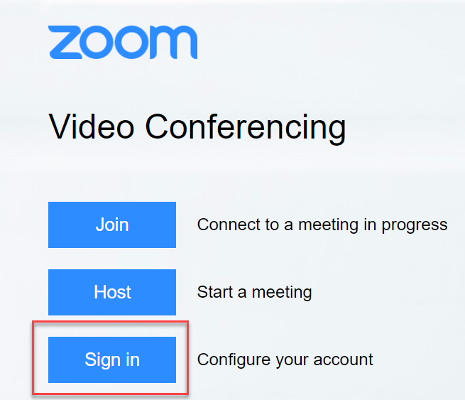

Select Recordings from the navigation menu.
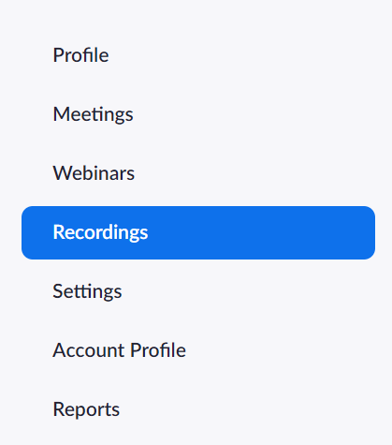

You will see a list of cloud recordings on your account. You can filter your recordings by date range, host, meeting ID, topic, or keyword.

To download all recording files (full meeting recording, audio, audio transcript, chat if applicable), select More [1] and Download [2].

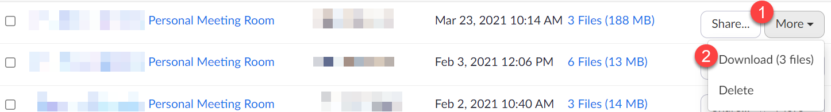

The recording files will be in your downloads folder with a name based on the date/time the recording was made in GMT. The video file is the .mp4 file (e.g., GMT20210427-141742_Recording_640x360.mp4 = recording made April 27th, 2021, at 14:17 GMT). Consider renaming the files to a more descriptive name soon after downloading.
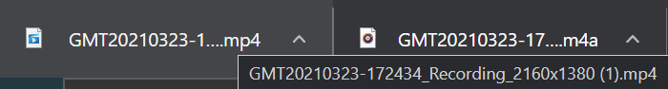

To download specific recording files, select the Meeting Topic link or the Files link.

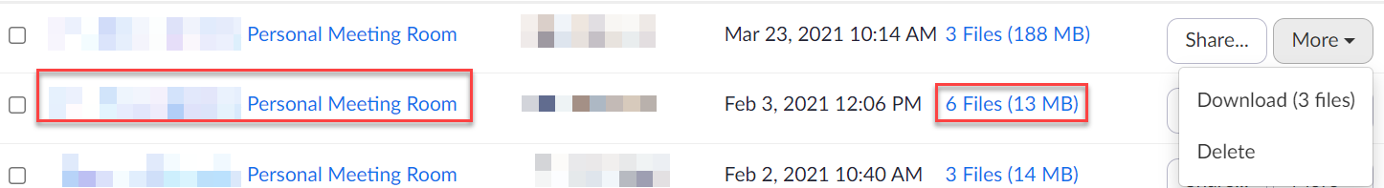

Hover your cursor over the file you want to download, and select the Download icon.
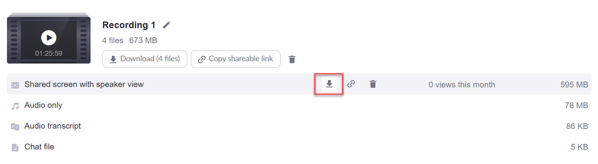

If you clicked Stop Recording and Start Recording during your meeting, the recording will be saved in multiple segments.
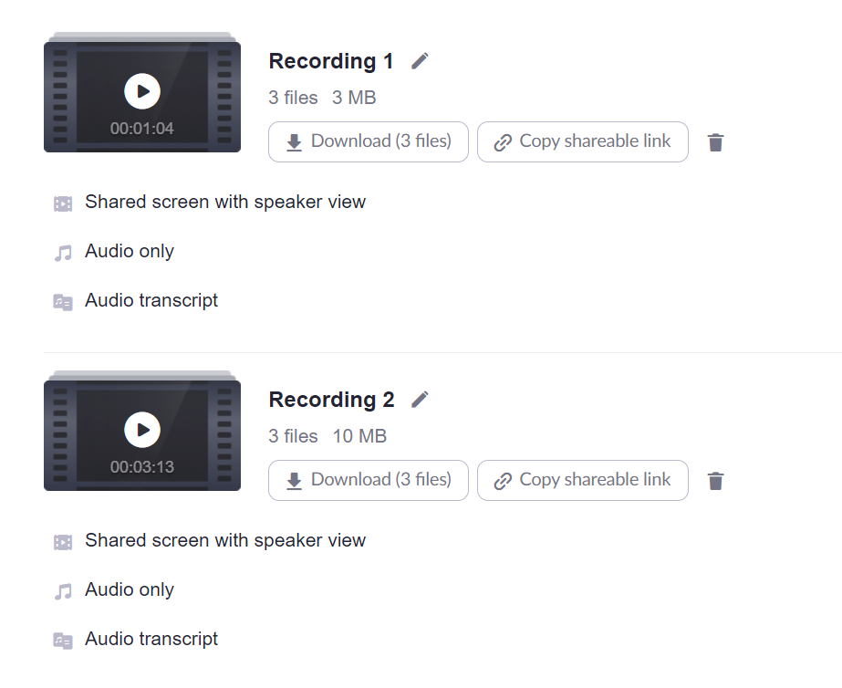

Download TechConnect Zoom Recordings from Canvas

Another way to download your Zoom meeting recordings is through TechConnect (if applicable).

Log in to Canvas at https://4cd.instructure.com.

Access one of your courses from your Dashboard or Course list.

Select TechConnect from the Course Navigation.



On the TechConnect Zoom page, select the Cloud Recordings tab [1], and then select either the Meeting Title [2] or the Files [3].

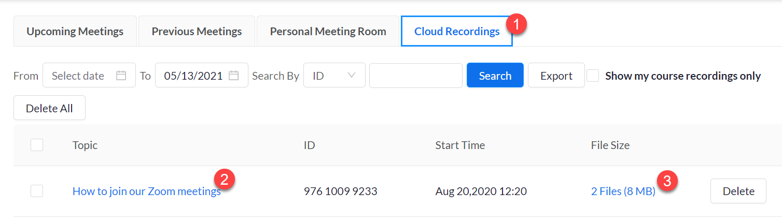

On Course Recordings, select the Download link for the recording file you want to save.
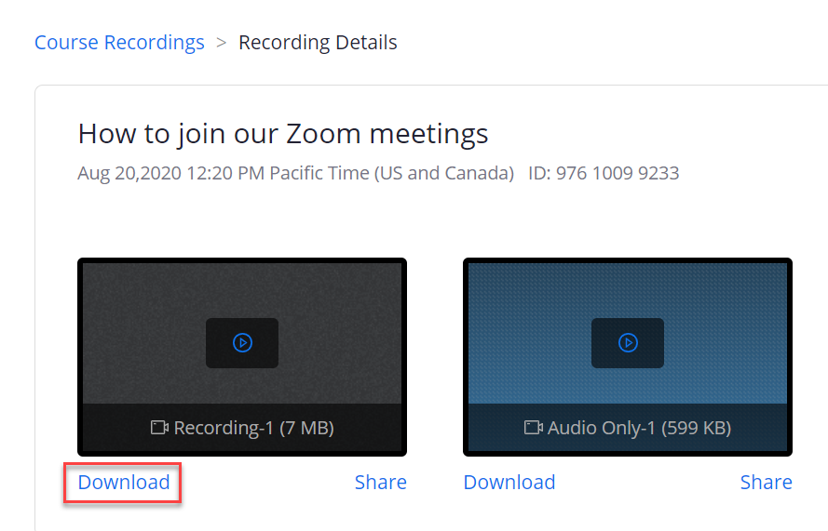

Storing and Sharing Zoom Recordings

There are a number of storage options for your video recordings.

- OneDrive: All 4CD employees have access to 1TB of cloud storage in our OneDrive accounts. Use OneDrive to upload media and create share links for others to view.

- TechConnect Cloud/3C Media Solutions: funded by the California Community Colleges Chancellor’s Office, 3C Media Solutions offers free media storage to all California Community College employees to upload and share video files. LMC’s Canvas account includes a 3C Media integration to make it easy to embed your 3C Media uploads in your Canvas course.

- Canvas Studio: Record, upload, organize, and share videos within or outside of Canvas. Studio has the added benefit of allowing for discussion overlays or video quizzing! It also allows you to see which of your students viewed your video - and for how long - when embedding in Canvas.

- YouTube: uploading and sharing videos via a personal YouTube account. (It is particularly important to be mindful of FERPA with this public platform.) YouTube offers auto-captioning and the ability to upload and edit your own captions.

