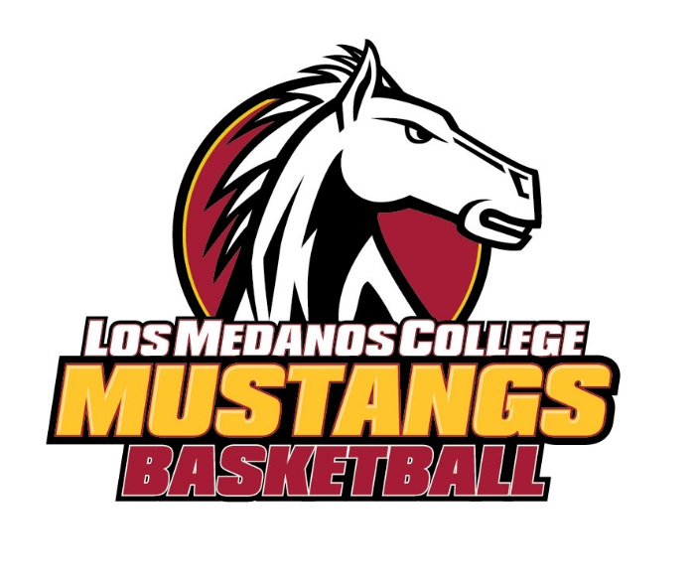
LOS MEDANOS COLLEGE
2022-23
Women’s Basketball Schedule
DAY  Thursday | DATE  October 13 | OPPONENT  Cosumnes River Coll. (scrim) | LOCATION  LMC | TIME  6:00pm
Friday | October 28 | Coll. of San Mateo(scrim) | San Mateo | 3:00pm
Tuesday  Wednesday | November 8  November 9 | Gavilan College  Lassen College | Gavilan  LMC | 4:00pm  5:00pm
Wednesday  Fri -Sun  Thursday  Tuesday  Thursday | November 16  December 2-4  December 8  December 13  December 15 | Ohlone College  Storm Tournament  Monterey Peninsula College  Mission College  College of the Siskyous | LMC  Napa Valley  Monterey  LMC  LMC | 5:00pm  TBA  5:00pm  5:00pm  5:00pm
Friday  Monday | December 16  December 19 | Hartnell College  Las Positas College | LMC  LMC | 5:00pm  5:00pm
Wednesday | December 21 | *Contra Costa College | LMC | 3:00pm
Thursday | December 29 | Shasta College | LMC | 1:00pm
Tuesday | January 3 | *Napa Valley College | Napa | 7:30pm
Thursday | January 5 | *Laney College | LMC | 7:30pm
Saturday | January 7 | *College of Marin | Kentfield | 3:00pm
Tuesday | January 10 | *Mendocino College | LMC | 7:30pm
Thursday | January 12 | *Merritt College | LMC | 7:30pm
Saturday | January 14 | *Yuba College | Yuba | 3:00pm
Wednesday | January 18 | *Solano College | LMC | 7:30pm
Friday | January 20 | *Contra Costa College | San Pablo | 7:30pm
Friday | January 27 | *Napa Valley College | LMC | 7:30pm
Wednesday | February 1 | *Laney College | Oakland | 5:30pm
Friday | February 3 | *College of Marin | LMC | 7:30pm
Wednesday | February 8 | *Mendocino College | Ukiah | 7:30pm
Friday | February 10 | *Merritt College | Oakland | 7:30pm
Wednesday  Friday | February 15  February 17 | *Yuba College  *Solano College | LMC  Fairfield | 7:30pm  7:30pm

* Indicates conference games

President: Bob Kratochvil (925) 473-7301
Athletic Director: Richard Villegas (925) 473-7605
Head Coach: Richard Villegas (925) 473-7605
Athletic Trainer: Brian Powelson (925) 473-7615
Equipment Coordinator: John McDermott (925) 473-7616
Mascot: Mustang
Colors: Cardinal & Gold

Los Medanos College * 2700 E. Leland Road * Pittsburg, CA 94565 * (925)439-2181

