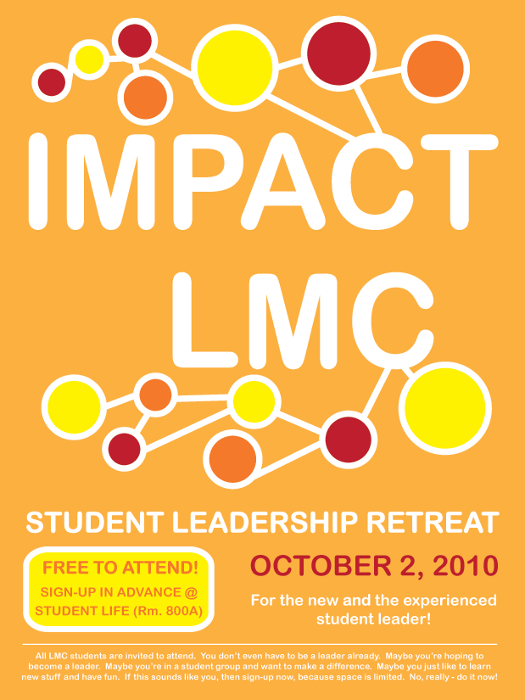
LMC Student Leadership Retreat
Saturday, October 2nd

Join a group of LMC student leaders for this full day retreat!
This program is free for LMC students, however space is limited and you must sign-up in advance.

All LMC Students are eligible to attend.
DEADLINE to register is THURSDAY, September 23rd at 5PM.

QUICK FACTS

What: LMC Student Leadership Retreat
When: Saturday, October 2, 2010; 9am-4pm
Where: LMC Community Room (Library Building)
Plus: Breakfast, Lunch, and all retreat materials will be provided.
More Info: Student Life Office or visit www.losmedanos.edu/studentlife

WHAT IS IT?

The LMC Fall Student Leadership Retreat is an annual student leadership retreat on the LMC campus. Through workshops, speakers, and activities, students gain insight into their personal leadership styles, meet and connect with other LMC student leaders, and gain essential tools to be leaders in their clubs, organizations, and programs.

= = = = = = = = = = = = = = = = = = = = = = = = = = = = = = = = = = = = = = = = = = = =

REGISTRATION FORM

Fill out this registration form completely and turn it in to the Student Life Office- Room 800A (x3266).

STUDENT INFORMATION:

Name: _______ Student ID #: ____
Address: ____________________ _______ ____
E-mail:_______________________________________ Phone: ________________________

PROGRAM INVOLVEMENT: Please identify any of the programs and/or clubs that you are a part of:
LMCAS Honors ACE MESA TPLC Umoja Puente AVID Student Ambassadors
Student Club(s): _________________________________________________________

My signature certifies that I am a currently registered student of Los Medanos College. I understand that the full cost for this retreat is being paid for by the college. By signing this agreement, I agree that I will participate in this event.
If I am unable to participate, I will let the Student Life Office know prior to September 29th.

Student Signature Date

