S-STEM NSF Program
Qualification and Probation Protocol
LOS MEDANOS COLLEGE
Updated August 2, 2015

Below is the detailed disqualification and probation strategy that will be followed by the STEM Scholars Program at Los Medanos College to keep track of the STEM scholars’ achievement and commitment to the program.
Disqualification from the program:
For any scholar, if any of the following occurs, the scholar will be automatically disqualified from the program:
- Scholar’s STEM GPA < 3.0 or cumulative GPA < 2.7.
- Scholar drops a class and is enrolled less than 12 units (not full-time status).
- Scholar changes majors to a non-STEM major.
- Scholar no longer has financial needs.
Extreme circumstances, such as illness or family death, which would lead to any of the above situations, will be considered on a case-by-case basis before a final decision is made by the director of the STEM Scholars Program. Documentations verifying the circumstance will be required to review such cases.
The GPAs as well as the academic status of all scholars will be reviewed at the beginning of every semester for the previous semester. In case a scholar is disqualified from the program, the program’s director will draft an official “Letter of Disqualification” and mail it to the student at the address on record (see Appendix A for Letter of Disqualification – Template). The letter will also be sent via email to the disqualified student. A disqualified student dismissed from the program has the right to re-apply to the program again and go through the application process as a new applicant.

Probation Status:
A STEM scholar at LMC will be placed on probation status if any of the STEM Scholar Standards classified below are not met. The degree of the probation status is determined according to the tiers below. The end-of-semester activity report that each scholar must submit to the STEM Scholars office will be reviewed to monitor the scholars’ progress on meeting the standards.
Tier I:
A scholar will be placed on Tier I Probation if any of the following applies:
- Missing ONE field trip to a transfer university (in a semester).
- Missing any ONE of the three supplemental activities (see list in Appendix B).
- Missing 2 meetings with the assigned mentor.
- Missing a meeting with a STEM counselor in a semester.
.A scholar placed on Tier I Probation will receive a letter informing the student s/he has been placed on Tier I Probation and informing the scholar of what needs to be done on their part to remove the probationary status (see Appendix C for Letter of Probation Status – Template).
In order to remove the Tier I probationary status, the scholar will have to make up all missed activities within the semester following the semester when the activities were missed and submit a “Probation Status Removal Form” to the program’s director (see Appendix D). This is in addition to all other standards/activities required for the current semester. If a scholar who is on Tier I probationary status fails to make up the missed activities within the allowed time window, s/he will automatically be placed on Tier II Probation. Once on Tier II probation, the scholar will not receive any scholarship funds until the Tier I probationary status is removed and a “Probation Status Removal Form” is submitted.
Tier II:
A scholar will be placed on Tier II Probation if any of the following applies:
- Miss the TWO field trips to a transfer university.
- Miss TWO or THREE of the three supplemental activities (see list in Appendix B).
- Miss 1/2 of the meetings with the assigned mentor.
- Scholar did not complete the 1-unit MESA seminar course in their first year.
A scholar placed on Tier II Probation will receive a letter informing the student s/he has been placed on Tier II Probation and informing the scholar of what needs to be done on their part to remove the probationary status (see Appendix C for Letter of Probation Status – Template).
Scholars placed on Tier II probation will have all their current and future scholarship funds placed on hold and not disbursed until the scholar’s status is restored to “normal.”
In order to remove the Tier II probationary status and restore status to “normal,” the scholar will have to make up all missed activities semester following the semester when the activities were missed and submit a “Probation Status Removal Form” to the program’s director (see Appendix D). This includes any activity missed by a scholar placed on Tier II probation after being on Tier I probationary status. In addition to making up all missed standards/activities, a scholar on Tier II probationary status will still have to fulfill all other standards/activities required for the current semester.
If a scholar who is on Tier II probationary status fails to make up the missed activities within the allowed time window, s/he will be disqualified from the program with a notice (see Appendix A).
Following the removal of either a Tier I or Tier II probationary status, the scholar’s status will be restored to “normal.” However, if the same scholar is placed on any probationary status for a second time, s/he will be dismissed from the program with a notice (see Appendix A). Disqualified students dismissed from the program have the right to re-apply to the program again and go through the application process as new applicants.
Students who fail to submit the End-of-Semester Standards Report will immediately be placed on Tier II Probation and notified.
A summary of this disqualification and probation policy for STEM Scholars Program is summarized in the Disqualification and Probation Chart shown in Appendix E.
Funds Disbursement Dates:
Funds are to be disbursed TWICE a semester.
Appendix A
Letter of Disqualification - Template

[DATE]
Dear [STUDENT NAME HERE],

This letter is to inform you that you have been disqualified from the STEM Scholarship Program at Los Medanos College because you did not fulfill the following main requirement(s):
Enroll in 12 units
Maintain an overall minimum GPA of 2.7
Maintain a STEM minimum GPA of 3.0
Maintain a STEM major
Enroll in the Counseling 33 MESA class within the last academic year
Continue to demonstrate financial need
Please be advised that you can re-apply to the program in the future as a new applicant. You also have the right to appeal this disqualification decision by submitting a letter of appeal, with supporting documents, to the S-STEM office. If you think this letter was sent to you by mistake, please contact our office.

Sincerely,

S-STEM Scholarship Program Coordinator

Appendix B
List of Supplemental Standards/Activities
Every scholar is required to satisfy at least three different of the following standards by the end of each semester:
- Attend 3 Academic Excellence Workshops.
- Attend a MESA speaker series.
- Be an on campus STEM tutor.
- Become a STEM ambassador.
- Join a club or professional STEM association.
- Participate in an internship or research project.
- Attend a STEM conference.
- Visit a local STEM industry.
- Attend a college fair.
- Organize a MESA Town Hall Meeting
- Other pre-approved activity. (Subject to submission by student prior to the event/activity and approval by the coordinator)

Appendix C
Letter of Probation Status - Template
[DATE]
Dear [STUDENT NAME HERE],
This letter is to inform you that you have been placed on STEM Scholar Tier I Probationary Status because you did not fulfill the following requirement(s):
Attend 2 required meetings with your mentor
Participate in one of the three supplemental program activities
Attend one of required field trips to a STEM transfer university
Meet with a STEM counselor (per semester)
In order to remove the Tier I Probationary Status, you must make-up the missing requirement(s) indicated above and submit, to the S-STEM office, the enclosed Probation Status Removal Form by [INSERT DEADLINE HERE] or you will be placed on Tier II Probation and all your future funds will be placed on hold. If you continue to miss the required STEM scholar standards, you will be disqualified from the program.
Please contact our office with any questions or to discuss this matter further. If you think this letter was sent to you by mistake, please contact our office.
Sincerely,
S-STEM Scholarship Program Coordinator

[DATE]

Dear [STUDENT NAME HERE],
This letter is to inform you that you have been placed on STEM Scholar Tier II Probationary Status because you did not fulfill the following requirement(s):
Attend 1/2 required meetings with your mentor
Participate in two of or the three supplemental program activities
Attend the two required field trips to a STEM transfer university
Complete the 1-unit MESA seminar course in their first year.

As a result of being placed on Tier II Probationary Status, all your future scholarship funds will be placed on hold. In order to remove the Tier II Probationary Status and receive your funds, you must make-up the missing requirement(s) indicated above and submit, to the S-STEM office, the enclosed Probation Status Removal Form by [INSERT DEADLINE HERE]. Failure to complete the missed activities in the next semester will result in disqualification.
Please contact our office with any questions or to discuss this matter further. If you think this letter was sent to you by mistake, please contact our office.

Sincerely,
S-STEM Scholarship Program Coordinator

Appendix D
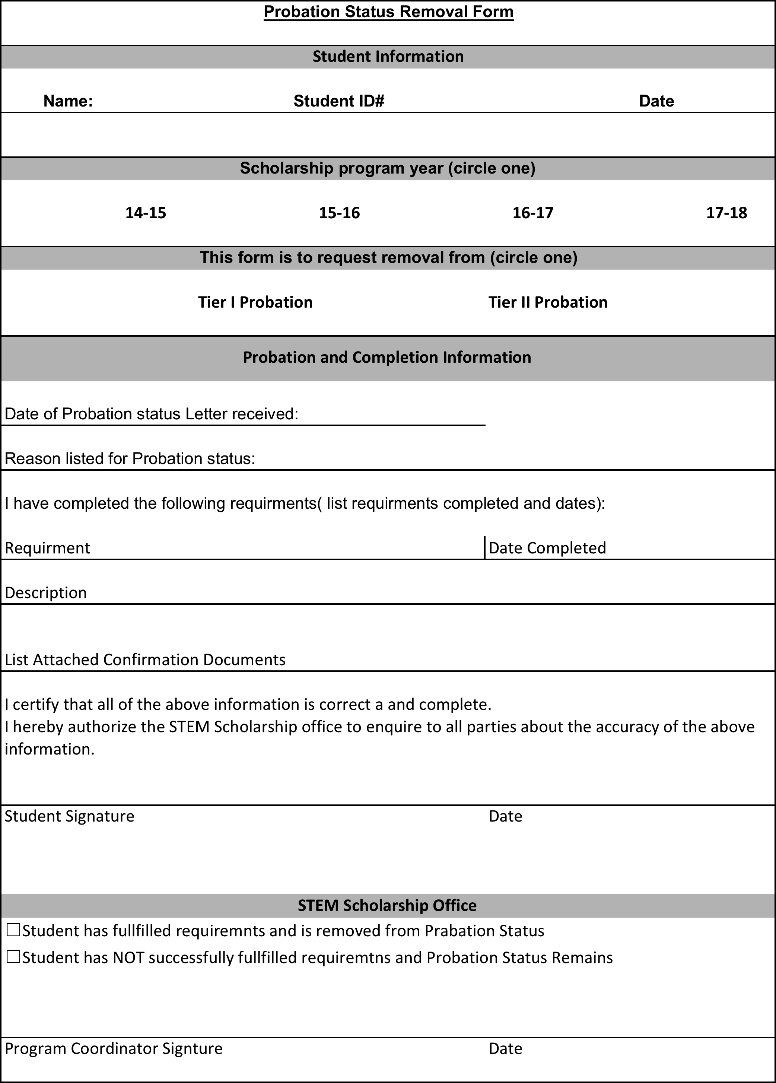

Appendix E
Disqualification and Probation Chart

