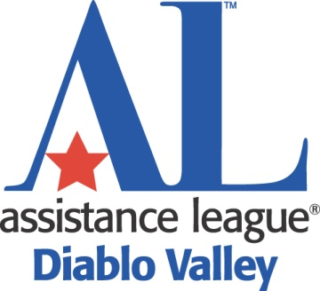

COMMUNITY COLLEGE STUDENTS
SCHOLARSHIPS AWARDED UP TO $4,000

REQUIREMENTS FOR APPLICATION

- Current full-time community college student transferring in Fall 2017, as a junior, to a four-year college or university

- Resident of Contra Costa County, California

- Financial need

- Minimum GPA of 3.0

- Academic achievements, school activities, community involvement, employment, special circumstances

- Complete application received on or before April 3, 2017

- Not a chapter member, relative of a chapter members, nor an employee of Assistance League of Diablo Valley

DEADLINE: MONDAY, APRIL 3, 2017

To obtain a Community College application packet, contact your Scholarship Office
or log on to diablovalley.assistanceleague.org, click on Teacher Support and Scholarship Applications, and then select Community College Student Application Packet.

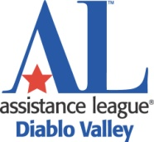
COMMUNITY COLLEGE SCHOLARSHIP APPLICATION
GUIDELINES & PROCEDURES

Assistance League of Diablo Valley is offering scholarships to full-time students currently attending a Contra Costa County community college who will be transferring, as a junior, to a four-year college or university. Scholarships will be awarded in two equal payments, half for the first term and half for the second term.
All application information is confidential and will not be shared with anyone outside the selection committee.

In order to be considered, application must contain the following:

- A complete application form

- An official transcript of grades. The transcript must contain the seal of the school and signature of the registrar or other designated school official. Copies displaying the seal and signature will be accepted.

- A personal statement from the applicant. This statement can include information concerning academic and personal accomplishments, career goals, financial need, family situation and obligations, special circumstances, work experience, obstacles overcome, school activities, community service, etc. All information will remain confidential.

- Two letters of recommendation:
(1) One from an individual associated with the college (faculty member, advisor, etc.)
(2) One from an individual NOT associated with the college (employer, coach, community member, church leader, etc.).
Letters of recommendation should be submitted in sealed envelopes with
the initials of the signer over the sealed point of the flap and submitted
with the application in ONE packet.

Mail or hand-deliver completed application, including all required documentation, to:

Chairman, Community College Scholarships

Assistance League of Diablo Valley
2711 Buena Vista Avenue
Walnut Creek, CA 94597

Application packet must be RECEIVED no later than APRIL 3, 2017

- Faxed or e-mailed applications or transcripts will not be accepted.

- Do not use staples or make two-sided copies of application documents.

- Retain copies of all materials submitted. They will not be returned.

- Scholarship recipients will be notified by May 1, 2017.
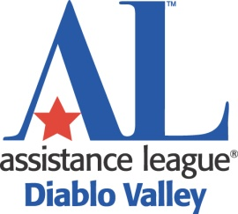

GUIDELINES & PROCEDURES - Page 2

Evaluation Considerations and Procedures

- Application
Evaluators will consider academic accomplishments, financial need, community involvement, job and school activities, special considerations, recommendations, and the content, quality and clarity of the personal statement.

- Two Recommendations
One recommendation must come from an individual associated with the college.
One recommendation must come from an individual NOT associated with the college.
Both recommendations must be included in the application packet.

- Personal interviews
All semi-finalists will be interviewed by the Scholarship Committee. At that time, applicants must fully disclose all other financial aid, including scholarships, grants, tuition waivers, etc., for which they have applied or received. Nondisclosure could result in forfeiture.

Evaluation of all applications and selection of recipients will be done by
members of Assistance League of Diablo Valley's Scholarships Committee.
All information provided by the applicant will remain confidential.

-------------------------------------------------------

Conditions for Retaining the Scholarship

- Must maintain a minimum 2.8 GPA during the period of this scholarship.

- Must maintain full-time student status during the period of this scholarship, completing
a minimum of 12 units each term.

Failure to maintain the minimum GPA or required units
will result in forfeiture of the second-term payment.

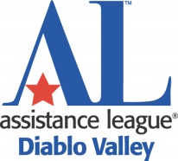

2017 COMMUNITY COLLEGE

SCHOLARSHIP APPLICATION

Deadline: Monday, April 3, 2017

PERSONAL INFORMATION Please print or type. Do not use pencil.

Name ____________________________________________________ Male___ Female___
First Last

Email ____________________________________ Phone No. _________________________

Current Address _______________________________________________________________ Number and Street/Apt. No. City, State and Zip Code

Current Community College ______________________________________________________

Who will be responsible for your college expenses? ___________________________________

If applicable, list any dependents: _________________________________________________

FAMILY INFORMATION - If a Dependent

Father's Name _________________________ Mother's name _________________________

Address ______________________________ Address ______________________________
Number and Street Number and Street

____________________________________ ______________________________________
City, State and Zip Code City, State and Zip Code

Father's Phone _________________________ Mother's Phone ________________________

Father's Employer ______________________ Mother's Employer ______________________

Estimated annual family contribution toward education expenses ________________________

Annual family Income, after taxes: ________________________________________________

If applicable, list the ages of any siblings or other dependents: ___________________________

_____________________________________________________________________________

Page 1 of 4
COLLEGE INFORMATION List colleges to which you are applying.
Name of College | Estimated  Annual Tuition | Estimated Annual Room & Board | I have applied | I have been accepted

FINANCIAL INFORMATION Give your best budget estimates for the 2017-18 year.

ESTIMATED RESOURCES | Amounts | ESTIMATED ANNUAL EXPENSES | Amounts
*Pell Grant |  | Tuition and fees
*Cal Grant |  | Books and supplies
Expected Summer Earnings |  | Room and board  (Rent, utilities, food)
Expected School-Year Earnings |  | Transportation
Personal Savings |  | Child Care Costs, if any
Family Support |  | Clothing
Scholarships/Financial Aid Received (Not including loans) Please list: |  | Miscellaneous  (Cell phone, entertainment, etc.)
Scholarships/Financial Aid Applied For (Not including loans)
Please list:

TOTAL: |  | TOTAL:
*If received, please include your FAFSA's "Student Aid Report."

Additional Financial Comments: ___________________________________________________

_____________________________________________________________________________

_____________________________________________________________________________

Page 2 of 4
ADDITIONAL INFORMATION
List your school activities, community involvement and employment below.

SCHOOL ACTIVITIES | Dates of Involvement | Average Hours  Per Month

COMMUNITY INVOLVEMENT | Dates of Involvement | Average Hours  Per Month

EMPLOYERS | Dates of Employment | Average Hours  Per Week

Page 3 of 4

What is your anticipated field of study? _____________________________________________

What are your occupational goals? _________________________________________________

_____________________________________________________________________________

Where did you learn about this Assistance League scholarship? __________________________

_____________________________________________________________________________

School Advisor’s signature is required as verification that applicant is in good
standing and will graduate.

Advisor’s/Faculty Member’s Name:________________________________________

Phone: ___________________________________________

Email: _____________________________________________

_______________________________________________ Date:________________
School Official's Signature

Applicant must sign below.

I certify that all information in this application is true and complete.
I understand that information contained in my application is confidential and will be read and reviewed only by members of the Assistance League of Diablo Valley Scholarships Committee.

________________________________________________________
Applicant’s Signature

Date:_______________________

Page 4 of 4

