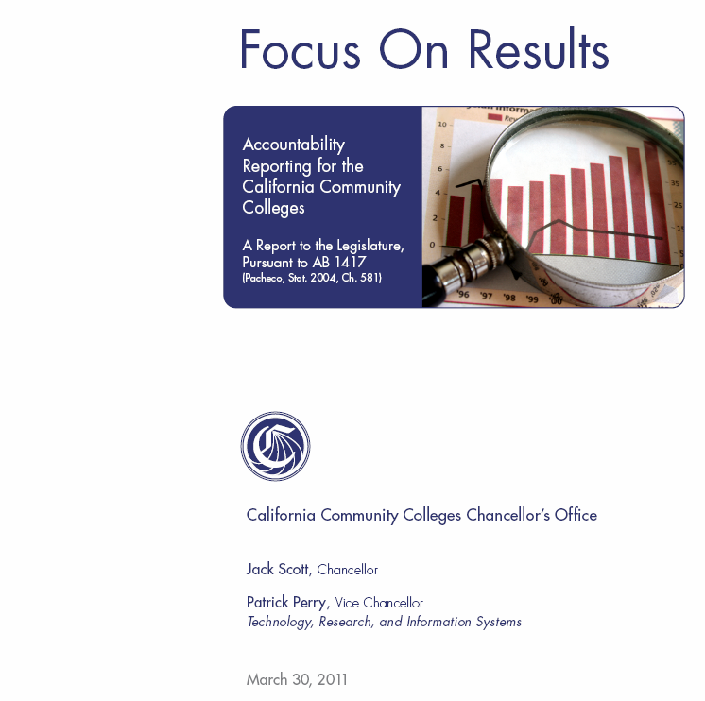

ARCC 2011 Report:

An Introduction to the College Level Indicators

The Accountability Reporting for the Community Colleges (ARCC) framework specifies that community college performance data should be aggregated, analyzed, and reported at two levels: the individual college level (college level indicators) and across the community college system (system-wide indicators). The following section of the 2011 ARCC report presents results for the performance indicators chosen for college level accountability reporting. Colleges and schools of
continuing education are organized alphabetically (by college name). However, colleges that have “College of the…” in their titles will be found under “C.” Results for each college are presented in Tables 1.1 to 1.11. The methodology for performance indicators and college profile demographics is found in Appendix B. Tables 1.1 to 1.11 are organized under three main categories: College Performance Indicators, College Profiles, and College Peer Groups. As in the previous year, we extracted demographic data for the college profiles from the Chancellor’s Office Data Mart. Therefore, the labels for Table 1.10 match the Data Mart’s labels. College Performance Indicators are further categorized as Degree/Certificate/Transfer, Vocational/Occupational/Workforce Development, and Pre-Collegiate Improvement (Basic Skills, ESL, and Career Development and College Preparation). The tables present the following data for each college:

1. Student Progress and Achievement Rate

2. Percent of Students Who Earned at Least 30 Units

3. Persistence Rate

4. Annual Successful Course Completion Rate for Credit Vocational Courses

5. Annual Successful Course Completion Rate for Credit Basic Skills Courses

6. Improvement Rates for Credit ESL Courses

7. Improvement Rates for Credit Basic Skills Courses

8. Career Development and College Preparation Progress and Achievement Rate

9. College profile summaries, (e.g., headcounts, percentages of student enrollments by various demographics) obtained from the CCCCO Data Mart.

10. Summary of the college’s peer groups for each indicator

This college level section includes data for each of the colleges in the system at the time of this report, although data for some earlier time periods may be missing for the newer colleges. Most of the college level tables include data for the most recent academic years; however, the time periods may differ for a few of the indicators. Thus, it is important to note the years specified in the titles or column headings for the tables. Because analysts of state level policy often need to know how the entire system has performed on specific indicators, we report the total system rates on the ARCC college level indicators in the table below.

College Level Performance Indicator State Rate

1. Student Progress & Achievement (2004‐05 to 2009‐10) 53.6%

2. Completed 30 or More Units (2004‐05 to 2009‐10) 72.8%

3. Fall to Fall Persistence (Fall 2008 to Fall 2009) 67.6%

4. Vocational Course Completion (2009–10) 77.0%

5. Basic Skills Course Completion (2009‐10) 61.4%

6. ESL Course Improvement (2007‐08 to 2009‐10) 54.6%

7. Basic Skills Course Improvement (2007‐08 to 2009‐10) 58.6%

The rates in this table use the total number of students in the state that qualified for a specific cohort as the denominator. The numerator likewise uses the total number of outcomes in the state. Analysts should avoid using the rates in this table to evaluate the performance of an individual college because these overall rates ignore the local contexts that differentiate the community colleges. Evaluation of individual college performance should focus upon the college level information that appears on the separate pages that follow. On those pages, Tables 1.1 to 1.11 for each college explicitly enable analysts to evaluate a college in an equitable manner.

A Note About The Career Development and College Preparation Progress and Achievement Rate (CDCP)

The Career Development and College Preparation Progress and Achievement Rate (Table
1.6) was added to the ARCC report in 2008 as a result of legislation (SB 361, Scott,
Chapter 631, Statutes of 2006) that increased funding for specific noncredit courses (see
Appendix F).

As of this report, we have partial or complete CDCP data for 37 community colleges/schools of continuing education. See Appendix B for a description of the methodology used to obtain data and calculate progress rates for the CDCP indicator and a list of the colleges with CDCP data available for this report. Given that the CDCP data collection is still in its early stages, there will be no peer
grouping for this indicator in the 2011 ARCC. However, colleges with CDCP funding should consider CDCP performance when they prepare their self-assessments for the final ARCC report.
Adding the CDCP Progress and Achievement Rate to the ARCC report also meant adding CDCP performance data and demographic data for schools of continuing education (e.g., Marin Community Education, San Francisco Continuing Education, San Diego Continuing Education, etc.). Because they do not offer programs measured by the other ARCC indicators, Tables 1.1 through 1.5 and Table 1.11 are marked with “NA” (Not Applicable) for schools of continuing education. We have included demographic data for these schools, where available, in Tables 1.7 through 1.10.

A Note About Peer Groups in the 2011 ARCC Report

The 2011 ARCC report uses the same peer groups identified for the 2009 and 2010 ARCC reports. That is, unlike the first three ARCC reports, the 2011 report has omitted the cluster analysis step that used the most recent data available to identify and cluster new peer institutions for each performance indicator. The Chancellor’s Office has decided to stabilize the peer groups by continuing to forego new peer group formation for this year’s ARCC report. Table 1.11 in the 2011 ARCC report retains the peer groups identified for the 2010 report. However, the data in columns 3 through 6 of Table
1.11 have been updated to reflect the most recent performance data for the members of each peer group. The peer group comparison for basic skills improvement, as shown in the 2011
ARCC report, appears with the following special warning. The Chancellor’s Office notes that the peer groups for this performance indicator will probably change substantially the next time that the Chancellor’s Office calculates the peer groupings, and college administrators presenting to their trustees may choose to note the tentative nature of the peer group comparison for basic skills improvement in the 2011 ARCC report.

A complete explanation of this year’s strategy can be found in the Introduction to Appendix A.

