- Go to the InSite Website and click on “Reports-Districtwide”
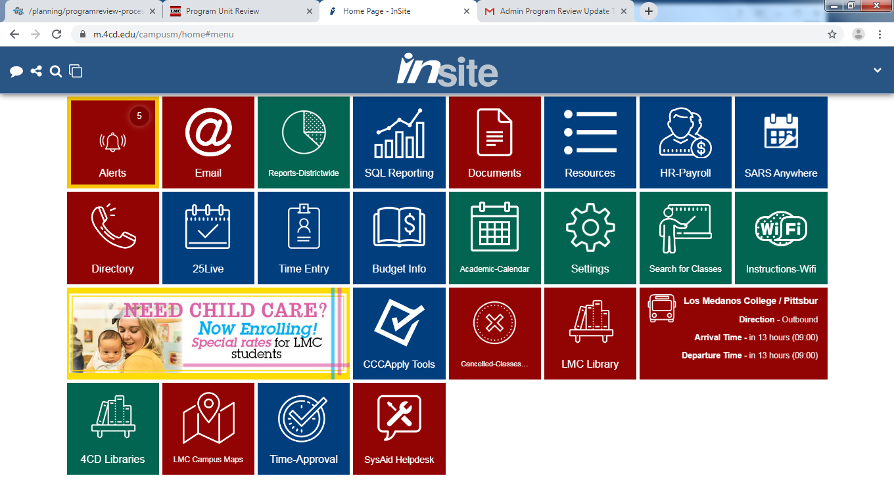

- Click on “Enrollment & Productivity Reporting”
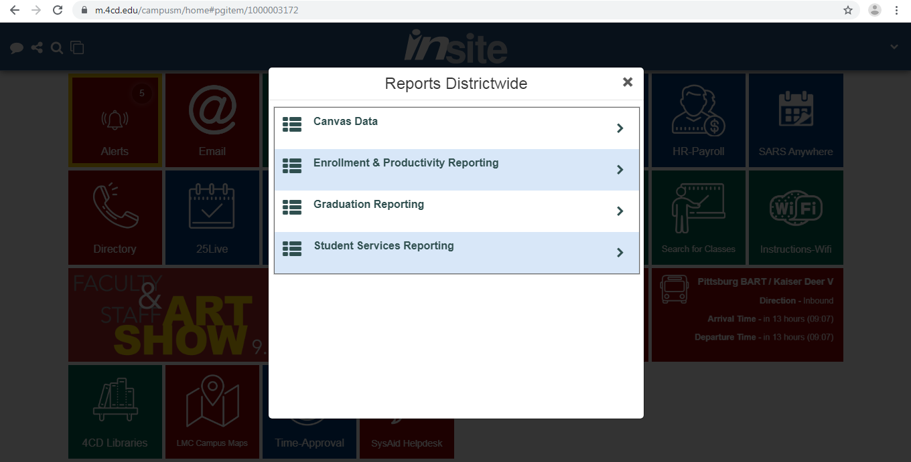

- Click on “Enrollment & Productivity By Specified Date”
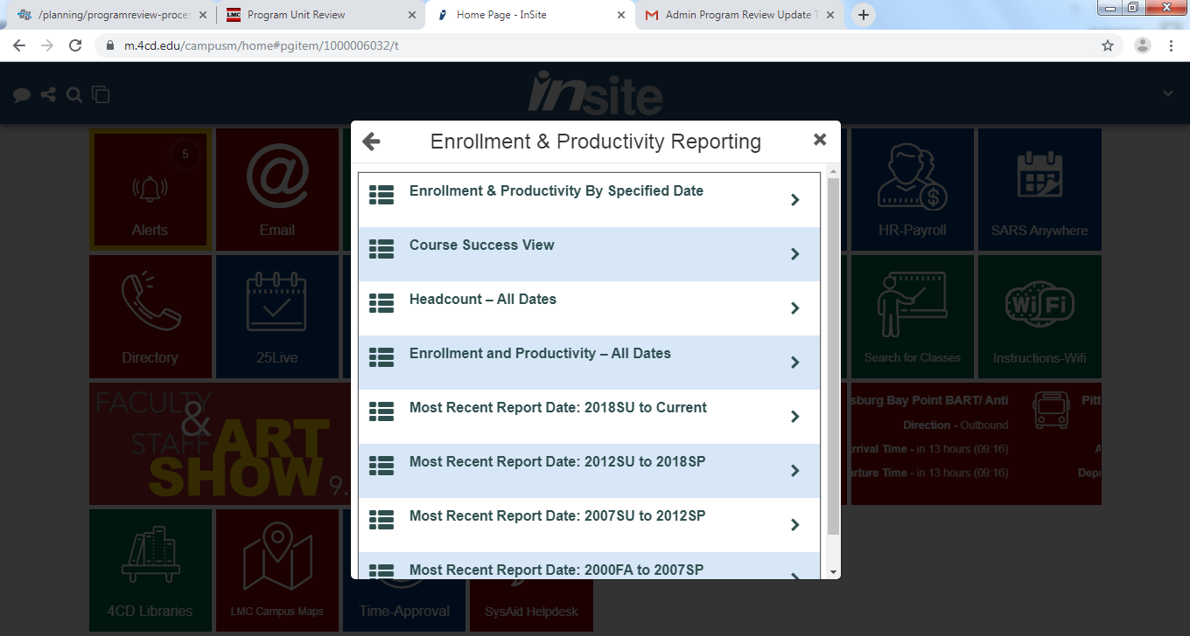

- It will take you to this new webpage.
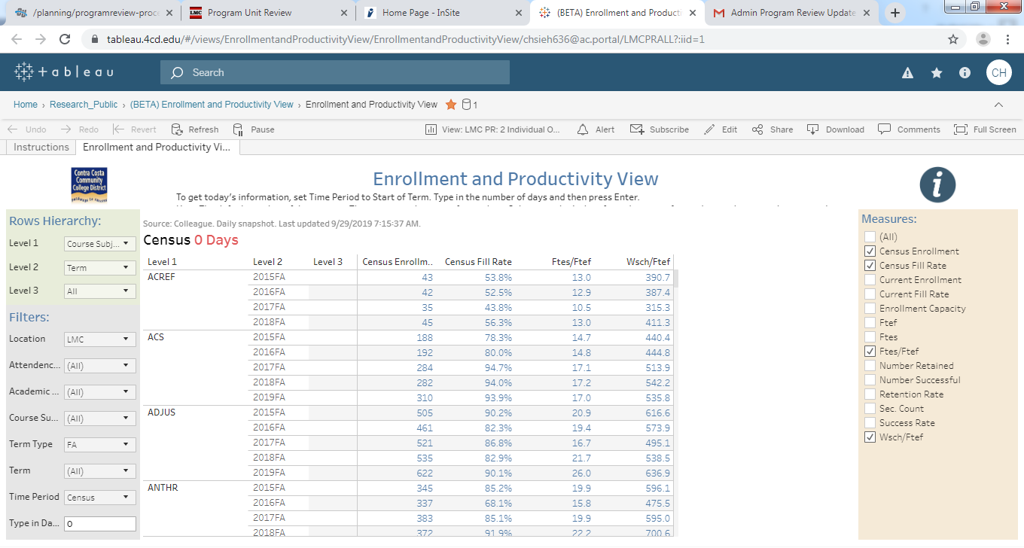

- On the new page, click on “View: LMC PR: 2 Individual Overall”
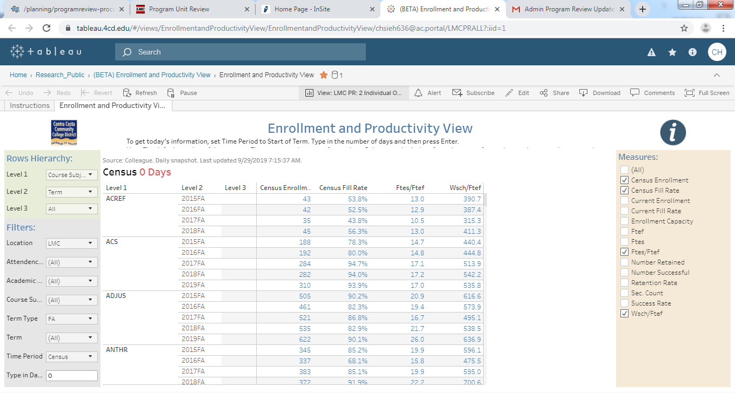

- Scroll down and click on the program you would like to view.
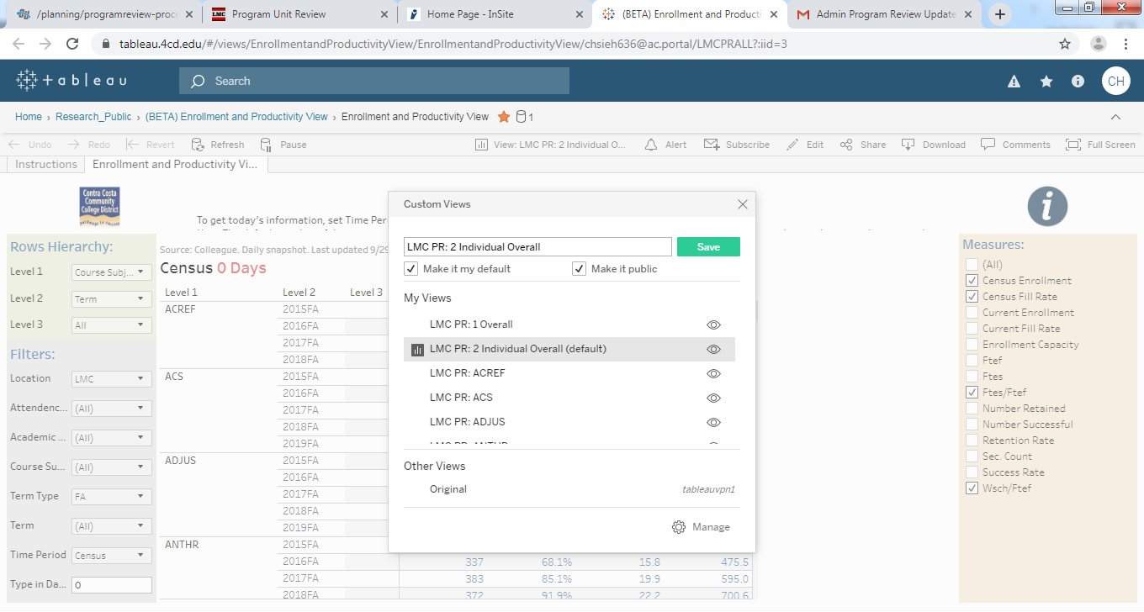

- Example:
