* Go to the InSite Website and click on **“Reports-Districtwide”**

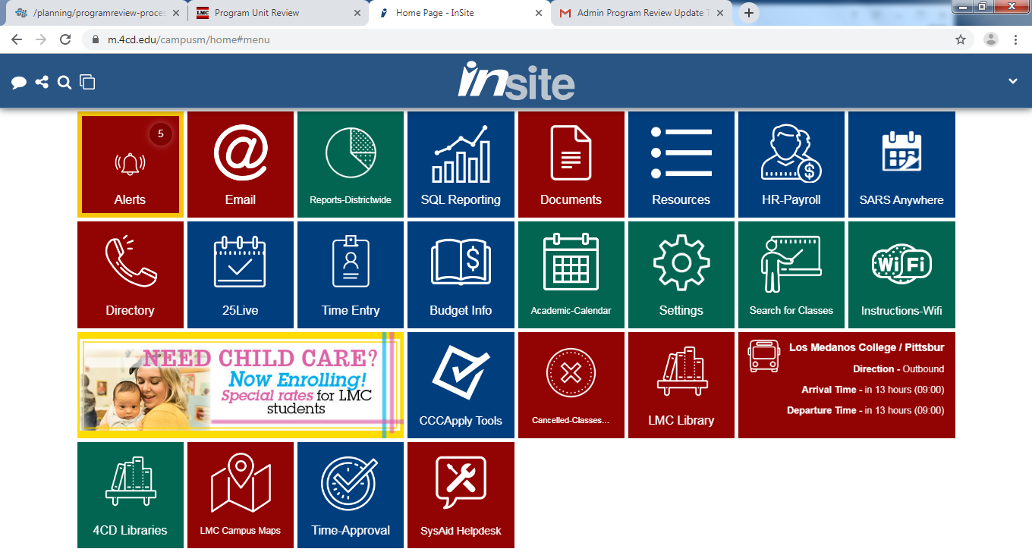

* Click on **“Enrollment & Productivity Reporting”**

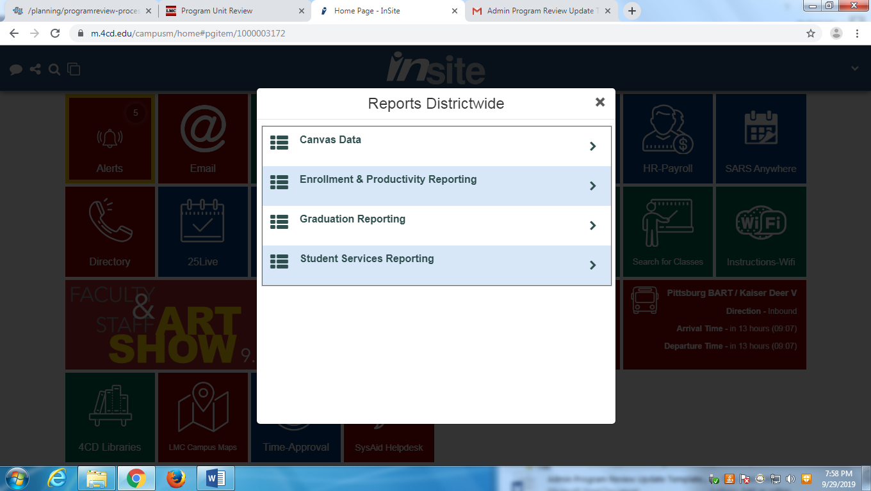

* Click on **“Course Success View”**

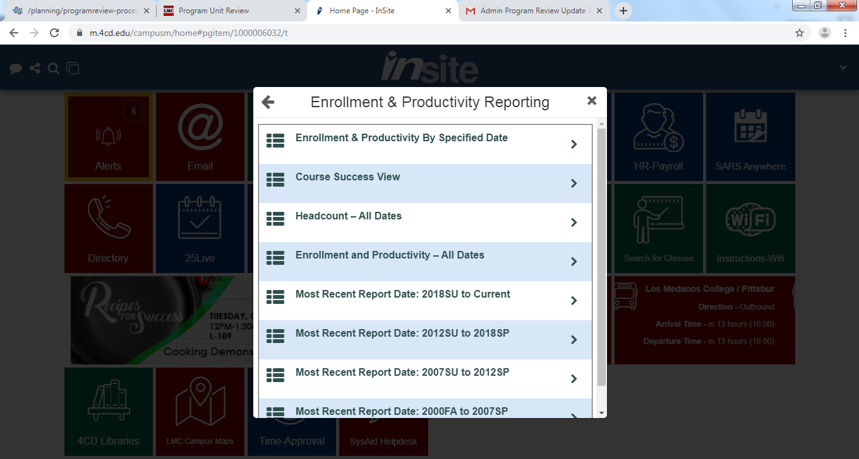

* It will take you to this new webpage.

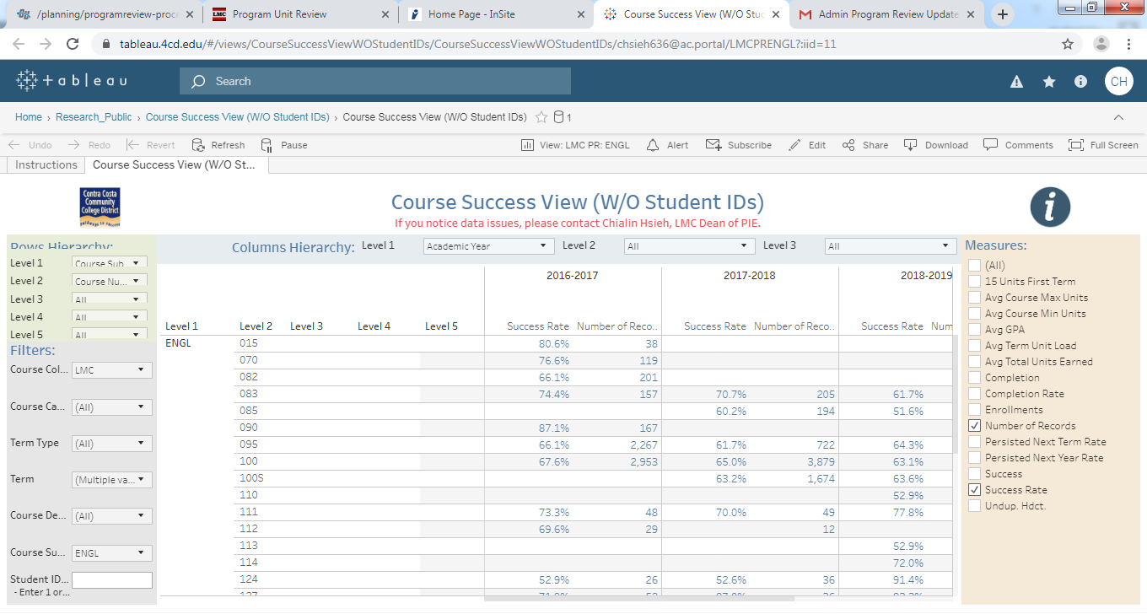

* Click on **“View: LMC PR”**



* Scroll down and click on the program you would like to view.

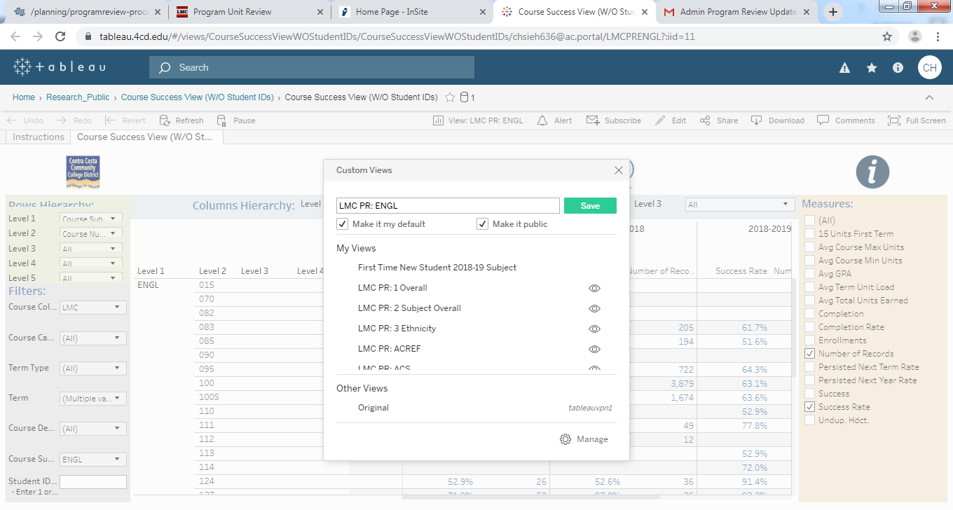

* Example:

