Desire2Learn Email
The “email” feature of Desire2Learn is not a true email account. It is a messaging system within D2L, very similar to the message feature in Facebook. If you want your students to get the emails you send them in Desire2Learn in their LMC email accounts (or any outside email account), the students must each set this up in their D2L accounts. Here are the instructions:
- Click on Account Settings.
- Click the Email tab.
- Look under the heading, Forwarding Options.
- Check the box that states, “Forward incoming messages to an alternate email account.”
- Type in the LMC email account.
- Click Save and Close.
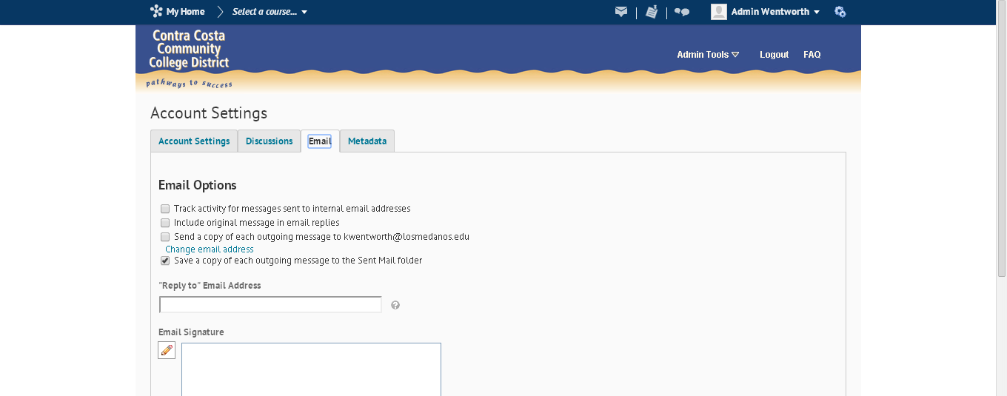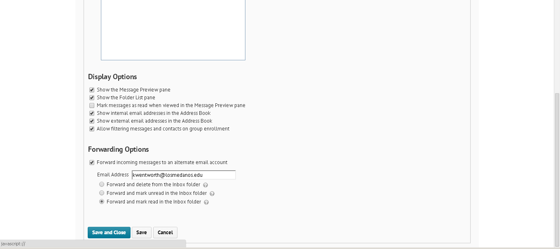
Once students read D2L email in their LMC InSite mail or any other outside email account, they must go back into Desire2Learn to respond. If students do reply to a D2L forward notification email in an outside email account, there is no email server at that reply address, and the message bounces back as undeliverable.

