D2L Learning Community: How to Promote a Product Feature Request
- Go to: https://community.desire2learn.com/
- Click: Sign Up.
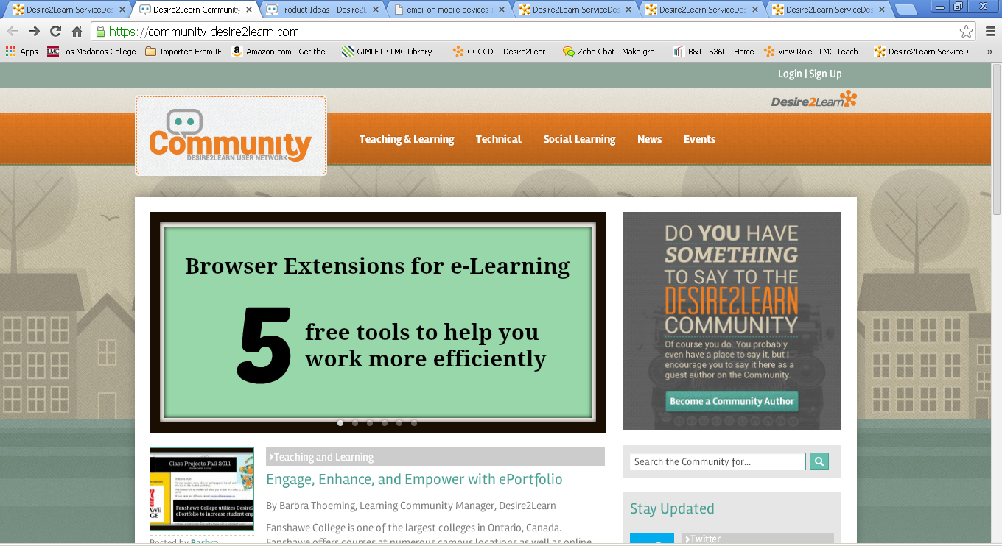
- Once you have signed, Log In.
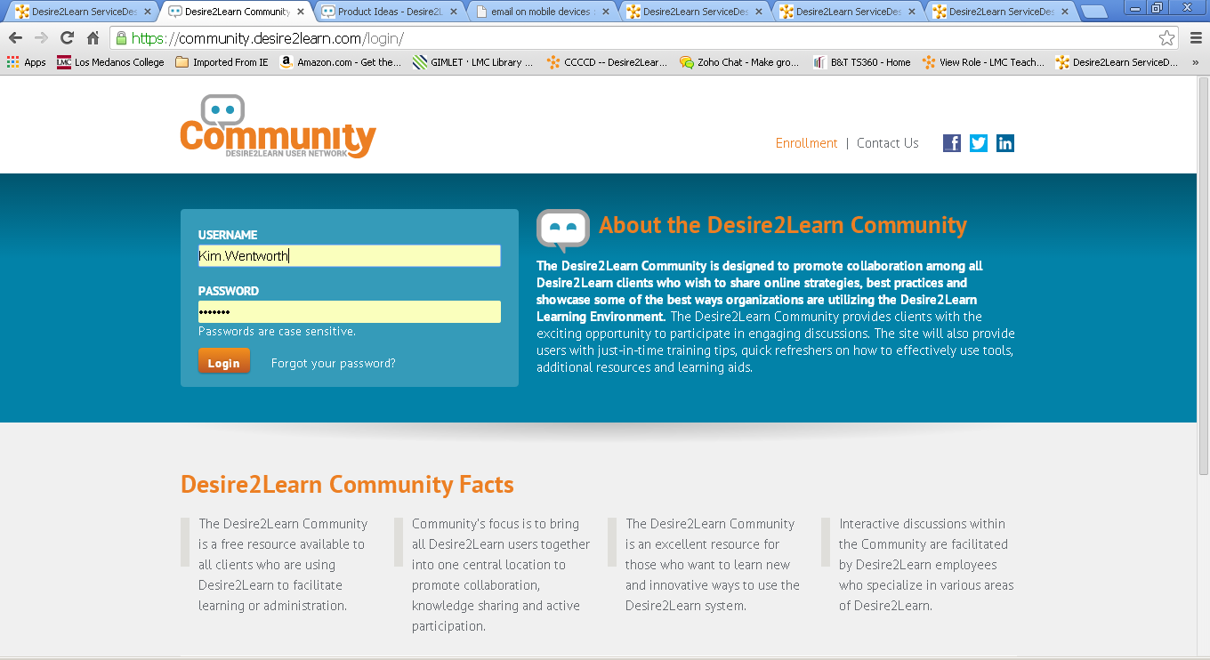

- Click on Product Ideas.
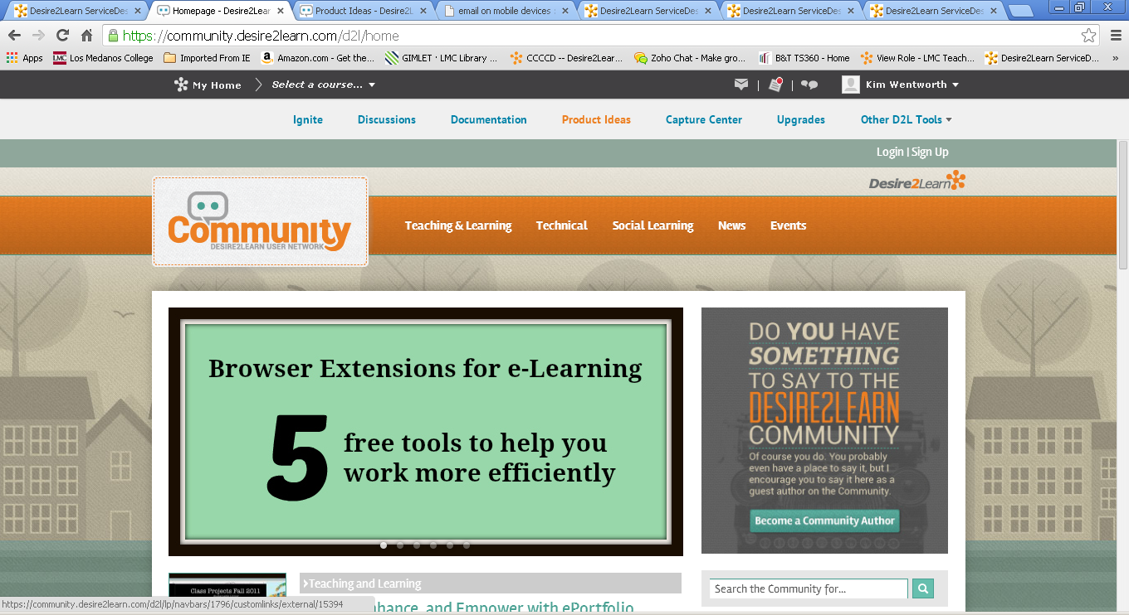
- Enter search terms “Email Mobile app.”
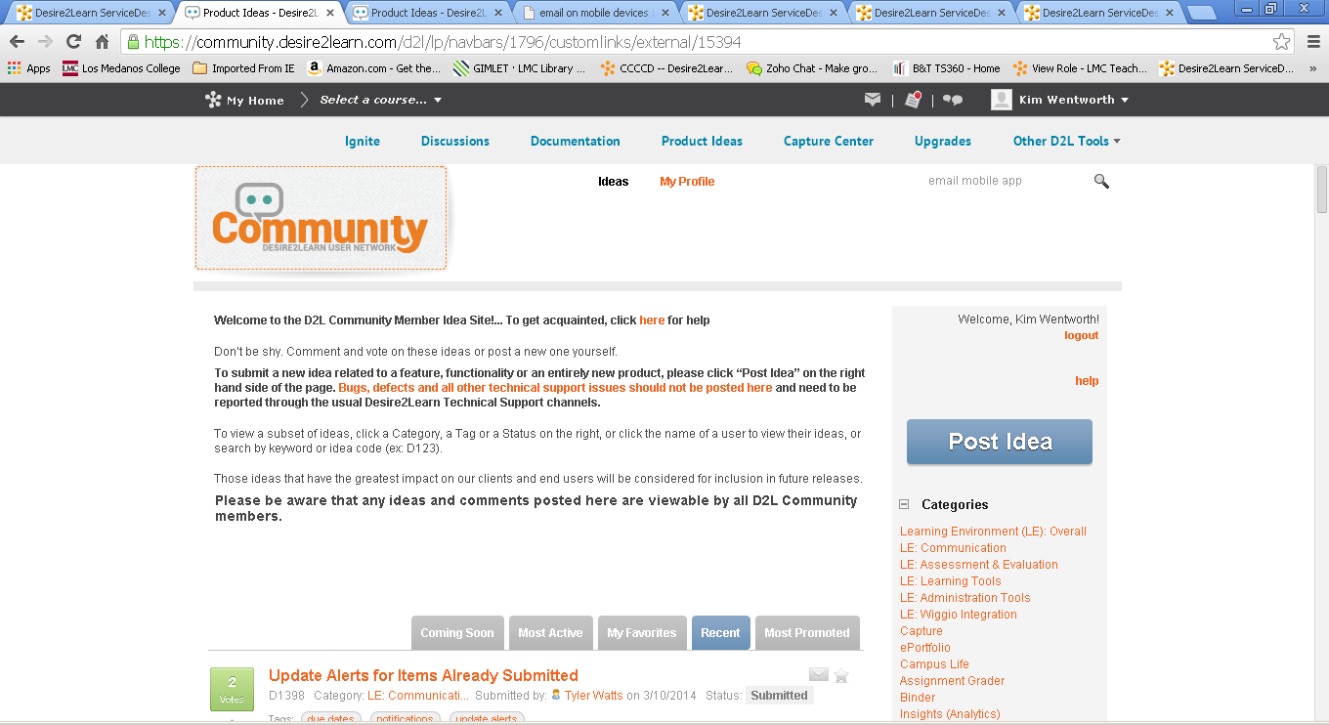

- Click on the first search result in the list.
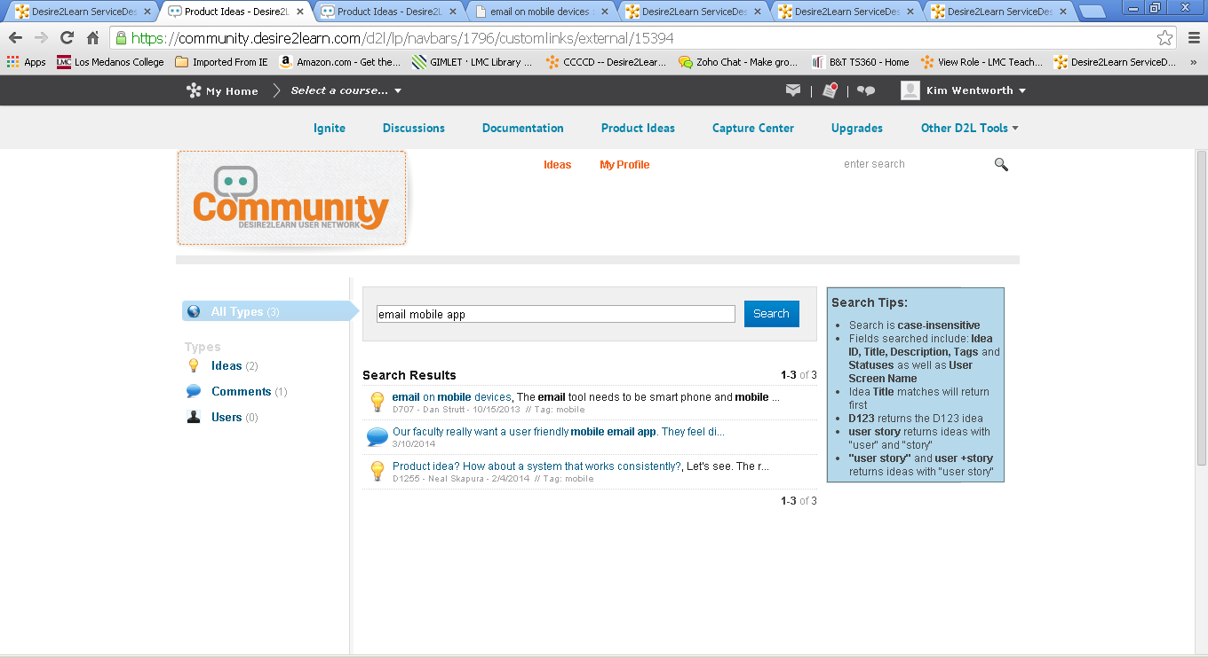
- Vote to promote this idea and leave comments.
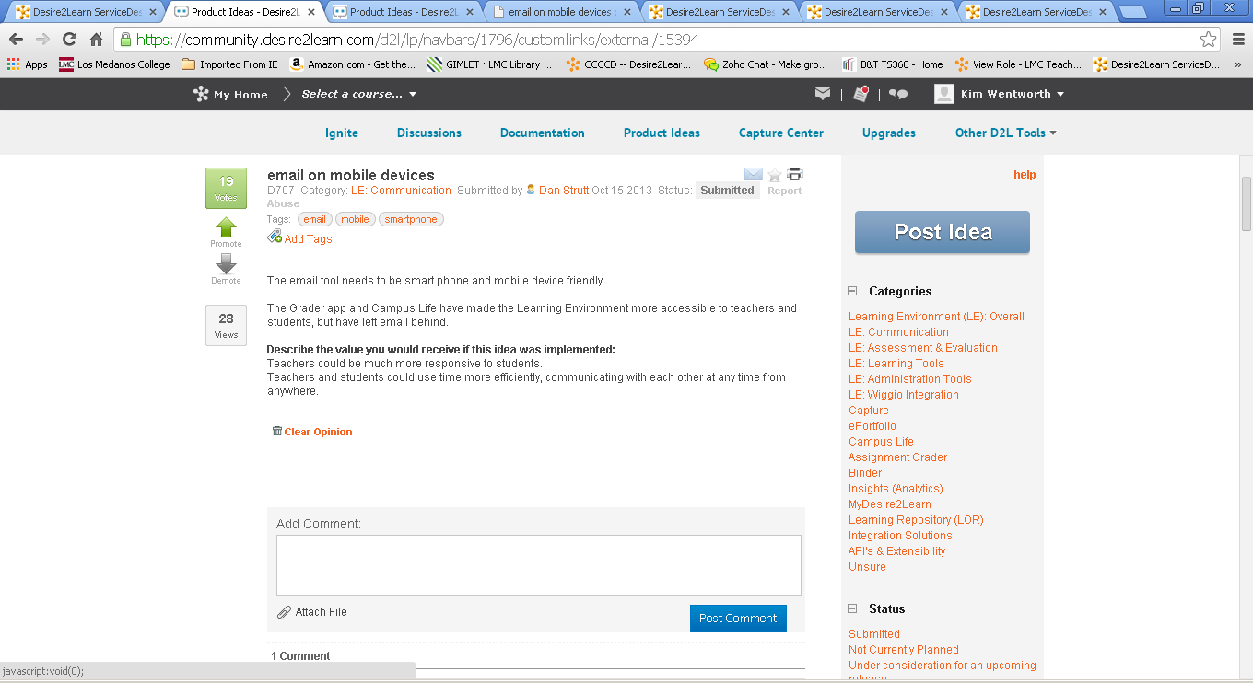
- Explore the site for additional product feature requests that you’d like to promote or write your own new ones.
- That’s all!

