Microsoft Office 2007 Installation Instructions

Introduction

The Los Medanos College IT department will be implementing a campus-wide roll out of Microsoft Office 2007(henceforth referred to as O2K7). The process of installing O2K7 is automated but does require a special login that will be provided to your manager, department chair or program lead. The following is a detailed guide to the steps involved in installing O2K7 on networked PCs used by LMC staff.

Steps:

1). When you are ready, press log off from your usual network account. At the next login screen (shown in the picture below), please provide the O2K7 installation [Username] and [Password] that were given to your manager/chair/lead.

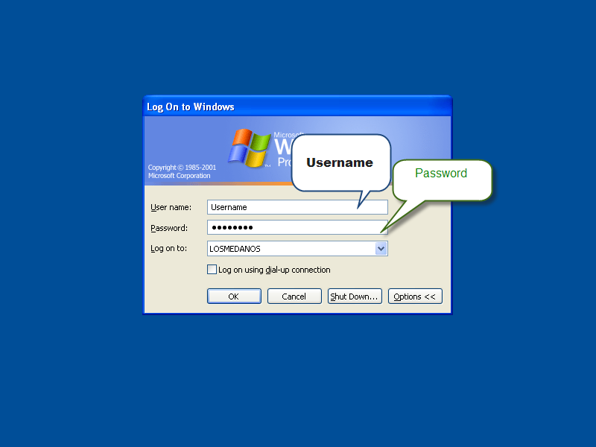

2). Once you login with the O2K7 installation username and password, the installation process will start on its own, beginning with the screen shown below.

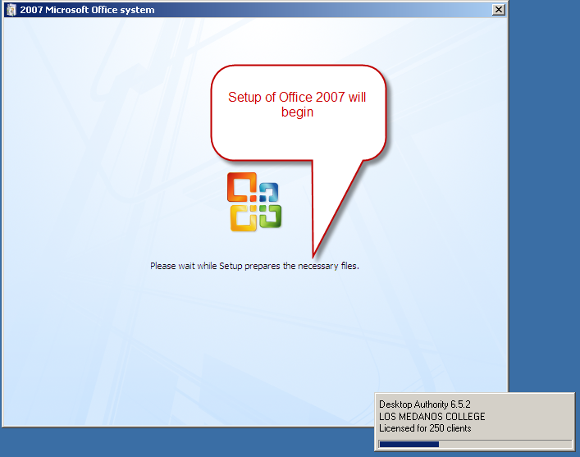

3).The duration of time needed for the installation to complete will be approximately 30-45 minutes. Upon completion of O2K7, the computer will reboot and come back to the login screen shown below.

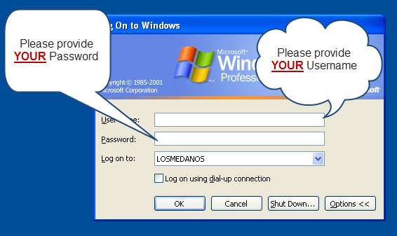

4).At this time, please provide YOUR login credentials (your LMC network username and password). Once your login credentials have been provided, the installation will have been completed.
4a). At this point, please click on [START], choose [PROGRAMS], then [MICROSOFT OFFICE] finally, scroll down and launch
Microsoft Word 2007. (shown in the screen below)
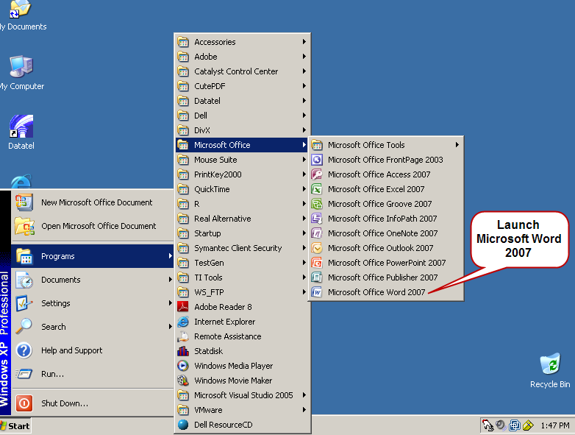

5).After launching Microsoft Word 2007, there will be a screen popup that will ask for your Name and Initials. This will be populated for you. Click OK.
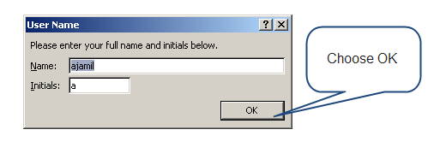

6). As soon as you click OK, the “Welcome to the 2007 Microsoft Office system” will appear. The first box will be chosen for you. Please click OK.
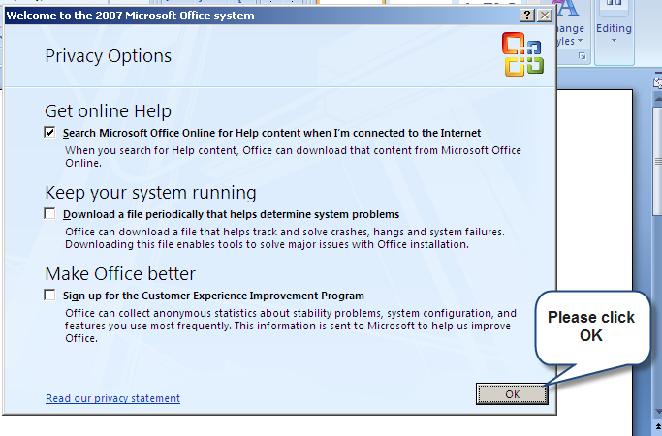
*IMPORTANT: DO NOT CHECK THE OTHER TWO BOXES!!!*

7).You have now completed the installation of O2K7.

8).Upon opening O2K7 Outlook, you will be prompted with the following popup screen shown below. Please check the box and click OK.

9). Now you will be able to use all the features of O2K7
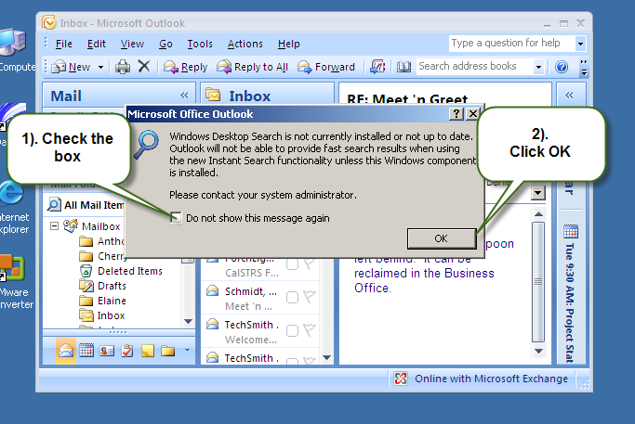

Tip:

Please call extension 3767 if you encounter any issues during this installation. A technician is on standby to assist you!

