All media equipment delivery and setup requests must be made via the Media Equipment Request Tool (10.39.9.14/eventscheduler/) from any computer on campus.

Important:
- Chrome or Firefox are the recommended browsers
- The current version of Firefox (35.0) may not work on Macs
- Internet Explorer is not recommended
- Accessible on campus only
- Login: When the login prompt appears, login with your InSite/WebAdvisor credentials.
Read the information and policies located on the landing page. 7-days advance notice required. 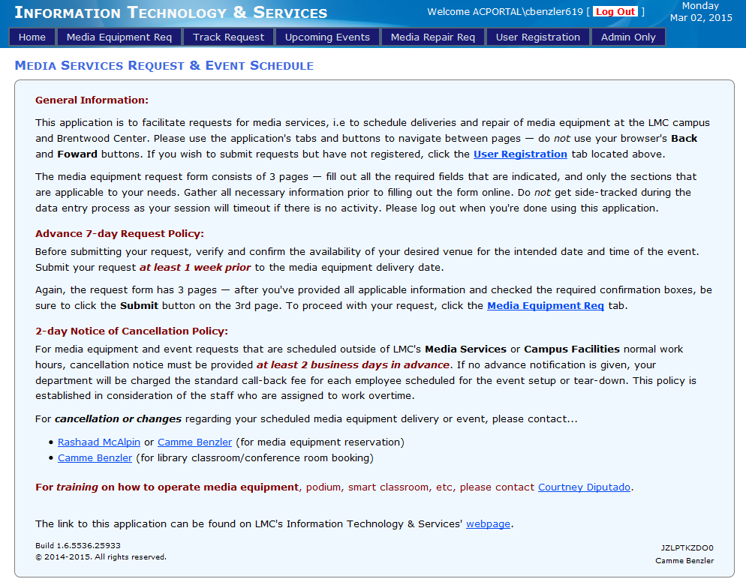
Be sure if you have not registered, that you click the “User Registration” tab. 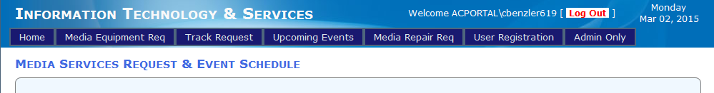
Fill in your registration information. Without registering you cannot use the submission form. 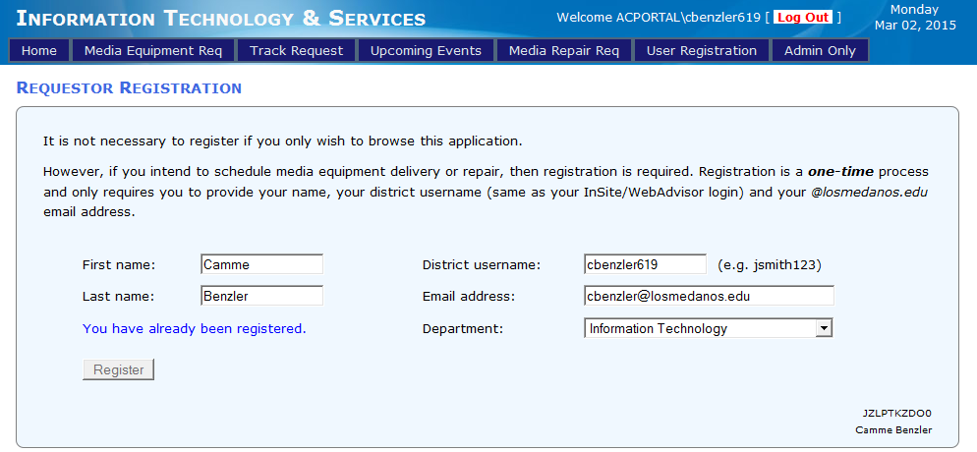
For training on how to operate media equipment, podium, smart classroom, etc., please contact Courtney Diputado.

