Why All Humanists Should Go to Prison
By Alex Tipei September 25, 2016
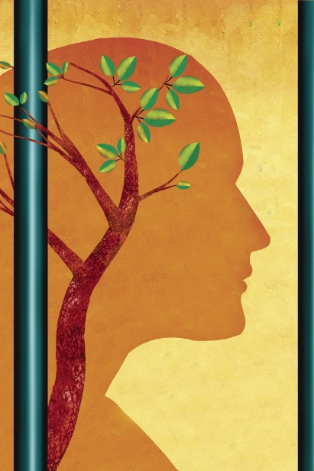
Michael Morgenstern for The Chronicle
Passing through the sally port at Indiana Women’s Prison for the first time, someone comforted me: "Once you’re inside, it looks just like a junior college."
"An institution is an institution," I quipped without realizing how often I would say those words over the next year.
During that period, I volunteered as an instructor in the prison. My students took a master’s-level theory and methods course designed to advance their own research on the facility, which is the oldest women’s penal institution in the United States. I got involved with the program because it offered me an opportunity to teach my own graduate course and to use my decade of training as a historian to give back.
I hadn’t anticipated, however, that working with student-prisoners would help me rethink questions concerning technology and pedagogy or the notion of a crisis in the humanities. Yet the material limitations of the prison classroom, its diverse student population, and its dramatic impact on recidivism rates offered me a singular lens to examine these issues.
Teaching at Indiana Women’s Prison persuaded me that humanities scholars would do well to go to prison — not because volunteering in these institutions is the "right thing" to do (it is), but because, as individual instructors and members of an academic corps, we have much to learn by participating in such programs.
Universities have transformed lecture halls into collaborative learning studios lined with wired workstations and plasma screens, spent heaps of tuition dollars updating internet portals, and organized countless workshops on how to integrate these resources into course syllabi. Articles, advertisements for training sessions, and calls for papers on innovative pedagogies (or the use of technology for instructional purposes) jam academics’ mailboxes.
In my own college teaching, I have employed PowerPoint to give lectures, YouTube videos to illustrate ideas, and images from Google Maps to create a sense of place in my classes. When I heard colleagues describe assignments requiring students to post ideas for paper topics on Pinterest or to edit Wikipedia pages, I wondered if my courses might benefit from their experiments.
At the prison, however, technology-driven pedagogy wasn’t an option. I had to eliminate the technologies I already relied on, rather than introduce new ones. I began to question why I had used specific tools in the first place. Had I depended on lecture slides to help my students follow along? Or were they there to keep me on point? Did videos add to the course content or simply fill up discussion time? If they did augment the material, were there other ways to arrive at the same place — means that refrained from directing everyone’s attention to a screen rather than to one another?
Stripped of the gadgets that adorn the 21st-century lecture hall, I zeroed in on writing compelling talks and provoking lively debates. I thought more about what I put in and left out of lectures — about what information my students, deprived of internet access or a research library, needed to contextualize a text, an argument, or an assignment.
I began to re-evaluate the costs associated with a technology-driven model of education. Hardware, software, and training programs all eat into institutional budgets. Moreover, many of us have been primed to think that unless our lesson plans feature a digital component, students will lose interest. Consequently, college instructors collectively exert a great deal of energy creating interactive classroom experiences and exercises featuring technology.
This energy could be spent engaging more deeply with sources and students. Volunteering in the prison pushed me to reassess how universities and instructors allocate their time and money. It reminded me that constructing an assignment that uses social media should function as a supplement to, not a replacement for, lecture and discussion. Working at the prison let me redefine innovative pedagogy as thinking creatively about materials and means to provoke student engagement with ideas, texts, and one another — goals that did not require screens, fiber-optic cables, or clickers.
In my low-tech classroom, I taught an extraordinarily diverse group in terms of socioeconomic background, ethnicity, race, and gender identity. Though the college population has grown increasingly variegated, an irony of over-incarceration is that the prison has become the true American melting pot. The prison not only showed me how judiciously we need to think about approaches to teaching, but also the value of traditional methods — including the formation of well-rounded individuals through the liberal arts — for educating an array of people.
Proponents of the liberal arts don’t assert that students receive career-specific training, as they might in vocational or STEM programs. Rather, humanities education develops skills pertinent to life’s professional and personal challenges.
Humanities courses also positively impact prisoners. For instance, among alumni of the liberal-arts-driven Bard Prison Initiative, the recidivism rate is less than 2 percent. This statistic calls out for further research on liberal-arts education in prisons. It also suggests that as they learn about history, literature, and philosophy, students in and outside of prison cultivate tools that let them succeed. In other words, the prison teaches us that there is no humanities crisis — we simply fail to assert the utility of the liberal arts.
In retrospect, perhaps I should have been less surprised that teaching in a prison led me to reconsider the role of technology in the classroom and the value of the humanities. An institution is an institution; and academic and penal institutions face similar problems. They are the subject of debates on budgets, privatization, and the applicability of the business model in running these facilities.
The value of these institutions as a public good and their raison d’être has been called into question: Can prisons function as sites of reform? And do the liberal arts prepare students for the real world?
Discussions surrounding prisons and universities point to a disconnect between these establishments’ traditional (and possibly idealized) missions and the place they occupy in American society. We educate a growing number of undergraduate students, but to what end? And at what personal and social cost? We incarcerate legions of men and women, but how much economic and human capital are we squandering in the process? And how could we better rehabilitate inmates?
Teaching at Indiana Women’s Prison let me think about these institutions and issues together. Unplugging in the prison classroom presented an opportunity to reassess not only how I used technology in my teaching, but also how university budgets are prioritized. Working with a diverse group of nontraditional students reminded me that changing demographics do not equate to a mandate to overhaul the humanities. Rather it points to a need to consider the unexpected ways liberal-arts education positively impacts diverse individuals and to learn to articulate those benefits more clearly.
In doing so, we humanists can confront attacks on our disciplines and challenge the very notion of a crisis of the humanities. In short, by reaching beyond the ivory tower to engage directly with prison-education programs, humanists can at once help reimagine the prison as a space of reform and reaffirm the humanities as a relevant mode of learning.
Alex Tipei recently completed her doctorate in history at Indiana University at Bloomington.

