'The Great Shame of Our Profession'
How the humanities survive on exploitation
By Kevin Birmingham February 12, 2017
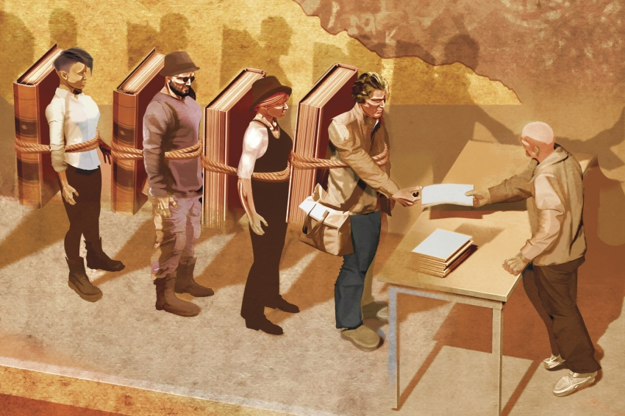
Illustration by Pierre Fortin for The Chronicle Review

A talk the author gave in Iowa City in October on winning the Truman Capote Award for his book, The Most Dangerous Book: The Battle for James Joyce’s Ulysses (Penguin, 2014), reprinted with permission.
If it’s worth coining a term for the sort of work that a few other scholars and I are doing, we might call it "Narrative Historicism." Narrative Historicism is like any other historicism in that it assumes a text’s significance is not immanent but rather radiates outward from the author to the author’s family, influences, preoccupations, and further outward to friends and allies, editors and publishers, and still further outward to cultural habits and biases, to legal, political, and economic institutions. Historicists think all of these ghosts are hovering nearby whenever a reader picks up a book.
Historicism imposes order upon chaos. It finds patterns in the boggling immensity of the past. What fascinates the historicist is how a book ripples out across the wide surface of a culture, how literary intentions end up serving unforeseen interests, how meanings get warped, how people may grow rich or suffer, how what was an expression of freedom now becomes a trap, how what was virtuous now becomes immoral.
Narrative Historicism uses storytelling as its method of imposing order. It inverts the standard critical structure. Rather than embedding stories in an argument, it embeds arguments in a story. The narrative asserts relevance, identifies influence, and qualifies importance. It draws out nuances of personality, of moments in time, of settings and disputes and gestures. Criticism is not distant. Literary history accumulates from a litany of intimacies, from the small, day-to-day experiences of men and women of letters. Recreating those experiences is as crucial as forming arguments about them. In fact, it doubles as an argument about them. Narrative details serve critical purposes. The size and style of James Joyce’s notebooks are important. It matters not just that Ezra Pound was one of Joyce’s early allies but that he was the sort of child who would ask Santa Claus for a battle-ax and a globe. It matters not just that Sylvia Beach dared to publish Ulysses but that she was so supremely kind and yielding, almost to a fault.
We can, of course, apply these methods to literary criticism itself. How it is produced, funded, and disseminated shapes its content. Writing on a laptop differs from writing on a typewriter or with a pen and paper. The difference between a trade press and an academic press matters. It matters that literary critics almost always work under the auspices of universities. It matters that criticism receives the support of fellowships, grants, and awards.
If you are a tenured (or tenure-track) faculty member, you are both the instrument and the direct beneficiary of exploitation.
This award was created in memory of Newton Arvin, an English professor at Smith College who was charged with lewdness and possession of obscenity after officers from the Massachusetts "pornography unit" ransacked his apartment in 1960. Arvin’s real crime was that the sexually explicit material he owned was homosexual. During the investigation, Arvin apparently named two untenured faculty members at Smith who also possessed allegedly obscene material. The courts ultimately overturned the professors’ convictions, but Smith College suspended Arvin from teaching and cut his salary in half. He died in 1963. The two untenured faculty members were fired, and Smith has never apologized.
This award for literary criticism acknowledges an injustice perpetrated by a profession that failed to live up to its own values. There is some satisfaction in knowing that, decades after these men suffered under obscenity law, this year’s award in Arvin’s memory honors the history of James Joyce’s struggles against the very same censorship regime.
I accept the Truman Capote Award in this spirit of justice. I would be remiss, therefore, if I did not address another injustice tarnishing the literary critical profession. I am, so far as I can tell, the first adjunct faculty member to receive this award. To be sure, I have one of the best non-ladder positions available. My paychecks cover my bills. I have health insurance. I can work full time. I know by the end of June if my appointment is renewed for the fall. And yet I am one of over one million non-tenure-track instructors working on a temporary or contingent basis and whose position offers no possibility of tenure. To be contingent means not to know if you’ll be teaching next semester or if your class will be canceled days before it starts. Most adjuncts receive less than three weeks’ notice of an appointment. They rarely receive benefits and have virtually no say in university governance.
Yet to talk about adjuncts is to talk about the centerpiece of higher education. Tenured faculty represent only 17 percent of college instructors. Part-time adjuncts are now the majority of the professoriate and its fastest-growing segment. From 1975 to 2011, the number of part-time adjuncts quadrupled. And the so-called part-time designation is misleading because most of them are piecing together teaching jobs at multiple institutions simultaneously. A 2014 congressional report suggests that 89 percent of adjuncts work at more than one institution; 13 percent work at four or more. The need for several appointments becomes obvious when we realize how little any one of them pays. In 2013, The Chronicle began collecting data on salary and benefits from adjuncts across the country. An English-department adjunct at Berkeley, for example, received $6,500 to teach a full-semester course. It’s easy to lose sight of all the people struggling beneath the data points. $7,000 at Duke. $6,000 at Columbia. $5,950 at the University of Iowa.
These are the high numbers. According to the 2014 congressional report, adjuncts’ median pay per course is $2,700. An annual report by the American Association of University Professors indicated that last year "the average part-time faculty member earned $16,718" from a single employer. Other studies have similar findings. Thirty-one percent of part-time faculty members live near or below the poverty line. Twenty-five percent receive public assistance, like Medicaid or food stamps. One English-department adjunct who responded to the survey said that she sold her plasma on Tuesdays and Thursdays to pay for her daughter’s day care. Another woman stated that she taught four classes a year for less than $10,000. She wrote, "I am currently pregnant with my first child. … I will receive NO time off for the birth or recovery. It is necessary I continue until the end of the semester in May in order to get paid, something I drastically need. The only recourse I have is to revert to an online classroom […] and do work while in the hospital and upon my return home." Sixty-one percent of adjunct faculty are women.
You have asked me to speak to you today about literary criticism, and so we might note that the conditions ravaging our profession are also ravaging our work. The privilege of tenure used to confer academic freedom through job security. By now, decades of adjunctification have made the professoriate fearful, insular, and conformist. According to the AAUP, adjunct faculty are about half as likely to undertake risky research projects, and the timidity moves up the ladder. "Professionalization" means retrofitting your research so that it accommodates the critical fads that will make you marginally more employable. It means cutting and adding chapters so that feathers remain unruffled. Junior faculty play it safe — conceptually, politically, and formally — because they write for job and tenure committees rather than for readers. Publications serve careers before they serve culture.
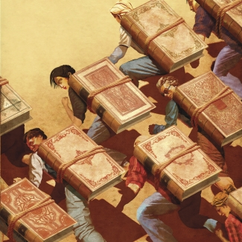

If my book deserves recognition, then we must also recognize that no young scholar with any sense would be foolish enough to write it. Graduate students must tailor their research projects to a fickle job market, and a book like mine simply doesn’t fit. Few academic presses publish narrative literary history, and what’s worse is that my book is a microhistory — it chronicles the publication of just one novel. The job market’s clearest demand is that a candidate must demonstrate breadth in research, especially if he or she works in a traditional field. This year, for example, there are only eight tenure-track jobs seeking a scholar of British modernism. And yet even this tally is too generous, because all eight of those departments are looking for someone whose expertise covers two or more centuries of British literature.
The message is clear: Stick to the old dissertation formula — six chapters about six authors. The most foolish mistake is addressing an audience beyond the academy. Publishing with Penguin or Random House should be a wonderful opportunity for a young scholar. Yet for most hiring committees, a trade book is merely one that did not undergo peer review. It’s extracurricular. My book exists because I was willing to give up a tenure-track job to write it.
We cannot blame this professional anemia on scarce funding. The largest adjunct-faculty increases have taken place during periods of economic growth, and high university endowments do not diminish adjunctification. Harvard has steadily increased its adjunct faculty over the past four decades, and its endowment is $35.7 billion. This is larger than the GDP of a majority of the world’s countries.
The truth is that teaching is a diminishing priority in universities. Years of AAUP reports indicate that budgets for instruction are proportionally shrinking. Universities now devote less than one-third of their expenditures to instruction. Meanwhile, administrative positions have increased at more than 10 times the rate of tenured faculty positions. Sports and amenities are much more fun.
Last year the University of New Hampshire made news when one of its librarians, Robert Morin, who had saved almost 50 years of paychecks, left $4 million to the university upon his death. UNH spent $1 million of the librarian’s gift on a 30-by-50-foot high-definition scoreboard for the new, $25-million football stadium. The university defended its decision by stating that the donation had been used for "our highest priorities and emerging opportunities." Adjuncts in the English department there reportedly receive $3,000 per class. They already knew they weren’t a high priority.
And why should they be? Amid competing budgetary pressures, classroom instruction is the easiest expense to cut. And part-time employees aren’t just cheap; they also provide curricular flexibility. Unpredictable course enrollments encourage administrators to find faculty who can be hired and fired just as unpredictably. Adjuncts help departments offer an ever-changing menu of courses.
But the problem goes deeper than administration as well. It’s systemic. The key feature of adjunctification is a form of labor-market polarization. The desirability of elite faculty positions doesn’t just correlate with worsening adjunct conditions; it helps create the worsening conditions. The prospect of intellectual freedom, job security, and a life devoted to literature, combined with the urge to recoup a doctoral degree’s investment of time, gives young scholars a strong incentive to continue pursuing tenure-track jobs while selling their plasma on Tuesdays and Thursdays.
This incentive generates a labor surplus that depresses wages. Yet academia is uniquely culpable. Unlike the typical labor surplus created by demographic shifts or technological changes, the humanities almost unilaterally controls its own labor market. New faculty come from a pool of candidates that the academy itself creates, and that pool is overflowing. According to the most recent MLA jobs report, there were only 361 assistant professor tenure-track job openings in all fields of English literature in 2014-15. The number of Ph.D. recipients in English that year was 1,183. Many rejected candidates return to the job market year after year and compound the surplus.
It gets worse. From 2008 to 2014, tenure-track English-department jobs declined 43 percent. This year there are, by my count, only 173 entry-level tenure-track job openings — fewer than half of the opportunities just two years ago. If history is any guide, there will be about nine times as many new Ph.D.s this year as there are jobs. One might think that the years-long plunge in employment would compel doctoral programs to reduce their numbers of candidates, but the opposite is happening. From the Great Recession to 2014, U.S. universities awarded 10 percent more English Ph.D.s. In the humanities as a whole, doctorates are up 12 percent.
Why? Why are professional humanists so indifferent to these people? Why do our nation’s English departments consistently accept several times as many graduate students as their bespoke job market can sustain? English departments are the only employers demanding the credentials that English doctoral programs produce. So why do we invite young scholars to spend an average of nearly 10 years grading papers, teaching classes, writing dissertations, and training for jobs that don’t actually exist? English departments do this because graduate students are the most important element of the academy’s polarized labor market. They confer departmental prestige. They justify the continuation of tenure lines, and they guarantee a labor surplus that provides the cheap, flexible labor that universities want.
The abysmal conditions of adjuncts are not the inevitable byproducts of an economy with limited space for literature. They are intentional. Universities rely upon a revolving door of new Ph.D.s who work temporarily for unsustainable wages before giving up and being replaced by next year’s surplus doctorates. Adjuncts now do most university teaching and grading at a fraction of the price, so that the ladder faculty have the time and resources to write. We take the love that young people have for literature and use it to support the research of a tiny elite.
All of this is to say that the profession of literary criticism depends upon exploitation. Even this formulation is too soothingly vague, so let us be more direct: If you are a tenured (or tenure-track) faculty member teaching in a humanities department with Ph.D. candidates, you are both the instrument and the direct beneficiary of exploitation. Your roles as teacher, adviser, and committee member generate, cultivate, and exploit young people’s devotion to literature. This is the great shame of our profession. We tell our students to study literature because it will make them better human beings, that in our classrooms they will learn empathy and wisdom, thoughtfulness and understanding. And yet the institutions supporting literary criticism are callous and morally incoherent.
No one, of course, signed up for this. You wanted to teach Milton and Toni Morrison. You wanted to change the way we understand novels and plays. You agree that the current state of affairs is awful. You have written all about the patriarchy and racism and poverty and the subaltern. You call administrators "neoliberals," and that feels good. You have little job-market chats with incoming grad students. It makes you sad the way local decisions ripple out across the wide surface of a culture, how literary intentions end up serving unforeseen interests, how people may grow rich or suffer, how what was an expression of freedom now becomes a trap, how what was virtuous now becomes immoral.
I sometimes wonder when the ripples widened out beyond what I had imagined. Recently, I sat next to two professors at the plenary session of a graduate-student conference. The students had been presenting their research all weekend, and now they were listening to us. "What is your advice?" a student asked. "Get your hands dirty," one of the professors said. "Throw yourself into your work. Don’t be afraid." He is a good person. He is an important scholar and an inspiring teacher. He immigrated to the United States decades ago and threw himself into his love for literature. He worked his way up, as we say, published several books, received tenure, won fellowships and awards, and now, in 2016, he was offering advice about bravery to graduate students surviving on $10,000 a year. This is the carefully dressed underclass of his department, the people who, when he wasn’t looking — because he didn’t go to yesterday’s luncheon — furtively filled their tote bags with leftover fruit and potato chips.
How did we become like this? What does the narrative historicism of this profession look like? It looks like the bright 21-year-old peeking into office hours seeking advice about grad school and your wanting to help. It looks like the papers stacked on the wobbly cafe table of the adjunct who doesn’t have an office. It looks like the miles ticking away on her shabby car’s odometer. It looks like the hiring-committee member who, by the time you’ve given your job talk, still has not bothered to read your application’s cover letter. It is coming to terms with the appalling fact that you have spent the better part of the last decade applying for a seat at this table, trying to convince committees in hotel suites that you would be a more effective member of this particular team. It is the painful recognition that it never fully outraged you until the jobs didn’t work out.
It is the grad student about to make her first foray into the job market who nods in agreement about all of this in a crowded restaurant on a cold night in Madison, Wisconsin, and who replies over her tepid coffee that she will have a better chance of changing the system from within. It is suddenly seeing yourself 10 years ago. It is remembering how powerful the word "system" made us grad students feel, how it tricked us into imagining locations and targets, pillars we could smash, wires we could cut. It is arriving at the proper sense of wonder at the atmosphere we once called "the system." It is being told over the phone that you have won an award and finally getting that metaphor ("the system"), finally grasping, after all these years, that change is more cunning than we were prepared for, that change is as gentle as the snow falling faintly onto the surface of the lake outside while we wait for the server to bring the bill.
You have asked me to speak to you today about literary criticism. This is what literary criticism feels like.
Kevin Birmingham is an instructor in the Harvard College Writing Program.
A version of this article appeared in the February 17, 2017 issue.

