2012-2017 Midway Report

Contents
TLC Membership 1
Assessment Update 1
ISLO versus GE SLO Discussion 2
Institution-Set Standards 2
Assessment of Assessment 3
Assessment of Assessment Addendum 4
Concluding Remarks 13
LMC Course Assessment By The Numbers Addendum 14
Membership Addendum 15

TLC Membership
Since TLC’s inception, LMC has undergone an entirely new management team and a management reorganization. One outcome is that all representative committees had to adjust their membership. Including the chair, there are 19 required members for the TLC. Only the Academic Senate (22 possible members) is larger. Most other major committees on campus (i.e. SGC, GE, BSC) have less than 10 required members. Assuming full TLC membership, quorum requires 9 attendees. Over the years, we have often struggled to maintain quorum. The TLC has discussed the possible redundancy of requiring both a faculty member and a manager for the following four divisions: liberal arts; math and sciences; CTE and social sciences; student services. We have decided to keep this aspect of membership “as is”, but we will add a Membership Addendum reflecting the change in management.

Assessment Update
Please see Summary of Assessment, Fall 2014 and the LMC Course Assessment By The Numbers Addendum for an analysis of CSLO, PSLO and GE SLO assessment. LMC now employs the Program/Unit Review Submission Tool (PRST, http://www.losmedanos.edu/planning/programreview.asp) for all assessment-related activities.

GE SLO Update
In 2012(?), the TLC voted to remove four of the five ISLOs, keeping only the GE SLOs. The GE Committee has since assessed 3 of the five GE SLOs and is currently working to assess the final two by the end of the five year cycle, in summer 2017. The committee is discussing improving the GE SLOs to (1) include Information Literacy and (2) reposition the interdisciplinary SLO as a core GE component of GE courses versus an SLO.

TLC and GE are interested in data-driven solutions and thus have inquired from our District Research Office, “What percent of LMC students have ever taken a GE course?” The report may be found on the GE Resources website, http://www.losmedanos.edu/intra-out/ge/resources.asp.

As of 9-29-14, 6389 current LMC students enrolled on or before the 2012-13 academic year. 82% of these students have taken a GE course. This gives evidence that a strong majority of LMC students, who have persisted for more than one year, experience GE SLOs. Further investigation is warranted, especially concerning the numbers of GE courses taken and the types of courses taken by persisting LMC students who take little to no GE courses.

Institution-Set Standards
According to a memo from ACCJC, “The U.S. Department of Education issued several new regulations for institutions and accreditors that became effective July 1, 2010, 2011 and 2012.” These regulations created the Institution-Set Standards for Satisfactory Performance of Student Success. Accreditation is now requiring Program-Set Standards that should be reviewed regularly. TLC has decided that the deans will review the standards with their respective department chairs and, once every five years, the standards will be formally reviewed during Program Review Evaluation.

Assessment of Assessment
The Faculty Survey on Assessment, administered during the spring of 2015, satisfies both the assessment rubric of the Accrediting Commission for Community and Junior Colleges — under the category of Sustainable Continuous Quality Improvement, which calls for the “evaluation of student learning outcomes processes” — and the LMC Shared Governance Council charge to
“evaluate the effectiveness of the TLC.”
The 12-question survey was completed by 81 individuals: 36 full-time faculty (on average, 17 years teaching at the college level), 30 adjunct faculty (12 years), 10 classified (16 years) staff and 5 managers (24 years). The Assessment of Assessment Addendum details the findings.

Next Steps
- Begin discussing creating complementary ISLOs to create more inclusion of non-academic department/programs and awareness around GE SLO/ISLO assessment.
- Create a series of PSLO professional development activities focused on departments/programs. Share opportunities concerning the three assessment-related faculty leadership positions.
- Connect with NEXUS to urge participation with the goal of eventual leadership within assessment-related faculty leadership positions.

- There is strong interest in leadership, with very strong interest right now for the CSLO/PSLO coordinator position. There needs to be a process for creating a list of “who’s next” for these positions.
- Assessment takes 6 hours. This suggests that paying adjuncts 3 hours per class is not adequate.
- Focused PD on discovering what works and what doesn’t, emphasizing the ability to measure learning. Time/space may be given for departments/programs to collaborate.
- Orientations on the 5-year integrated model of assessment (emphasizing PSLO and GE SLO assessment) and sharing/exploring best practices on effective assessment (emphasizing CSLO assessment).
- More institutional time given to assessment (i.e. Mondays, FLEX) and reduce the data entry component of assessment.

Assessment of Assessment Addendum
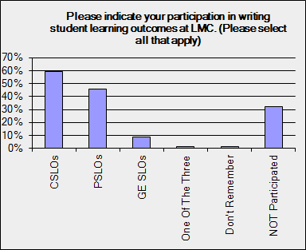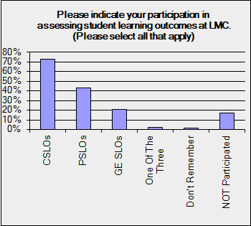

Remarks
A majority of those surveyed indicated participation in writing and/or assessing CSLOs. These data were not disaggregated by position within the college, which creates a bias that actually increases the percentages. A sizeable amount of those surveyed also participated in assessing and/or writing PSLOs and very few people assessed and/or wrote GE SLOs.

Next Steps
The GE Committee is currently discussing how to support greater involvement in assessing GE SLOs.

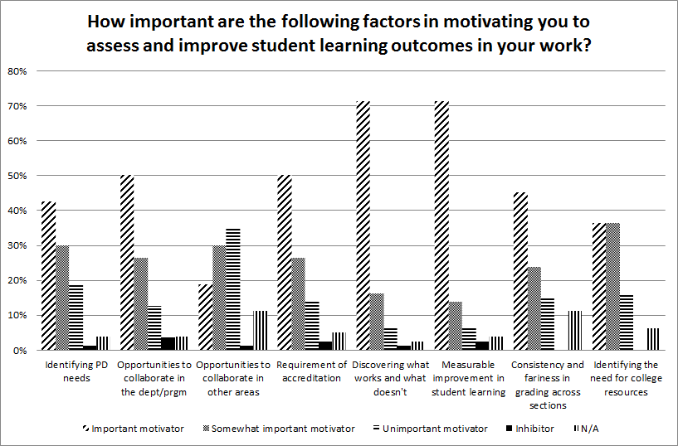

Remarks
The TLC wished to determine important motivating factors regarding assessing and improving SLOs. The clear motivators (~70%) were “Discovering what works and what doesn’t work“ and “Measurable improvement in student learning”. This is great news because this is precisely what SLOs are supposed to motivate. It is also exciting because these motivate closing the loop through changing curriculum, pedagogy or otherwise restricting the learning experience.

Those surveyed showed a need (~50%) for collaboration within their department but not for collaborating across areas. Coupling this with some need (~40%) for assessment-related professional development, there is an opportunity for TLC leadership to provide department/program specific professional development opportunities. Serendipitously, LMC is about to enter year 5, where departments/programs assess the Program-Level SLOs, or PSLOs. Since those surveyed are motived (50%) by accreditation requirements and PSLO assessment is required by accreditation, there is an opportunity for the TLC to assist the CSLO Coordinator in developing PSLO-related professional development. These data suggest that such an experience be closely related to the classroom or learning environment, for “student learning” and “what works” are more motivational than consistency across sections or “collaboration across areas.
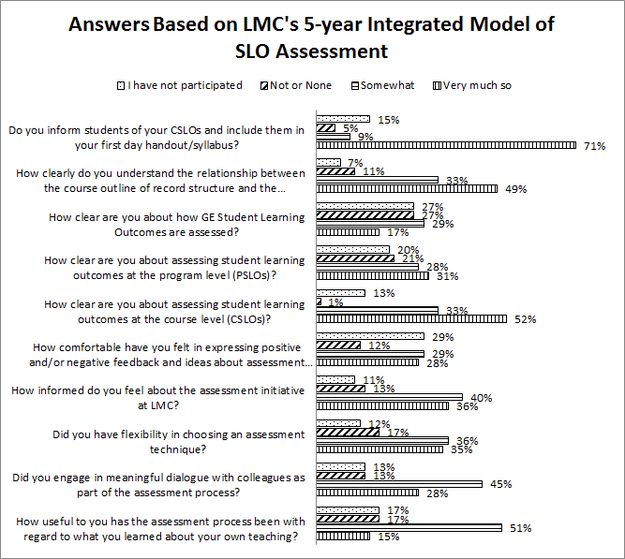

Remarks
This question offered the most challenges to the TLC. It appears that those surveyed have a strong, basic grasp of assessment, with respect to CSLOs. However, there are many areas for improvement.
- There is a need for increased understanding of assessment at the PSLO and GE SLO level.
- There is a need for being more informed around the assessment initiative.
- Approximately one third of respondents felt they had great flexibility in choosing an assessment technique. Approximately one third felt they had some flexibility and one third felt they had no flexibility.
- There is opportunity for increasing meaningful dialogue around assessment.
- Although in the previous question respondents were clearly motivated by “what works and what doesn’t”, after answering (largely negatively) to the last few sub-questions in this question, respondents reported that they did NOT learn much about their own teaching.

Synthesizing this information, there is an opportunity for strong professional development around PSLOs and GE SLOs. There is evidence to focus on PSLOs. We suggest offering a series professional development activities focused on creating a collaborative environment around understanding, enacting and creating meaning from PSLO assessment.

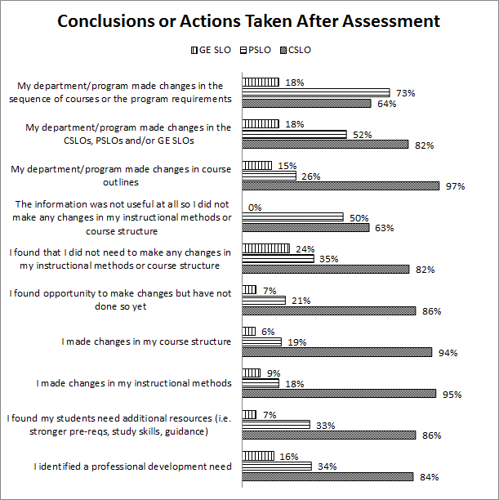

Remarks
It would have been helpful to place the numbers next to the percentages. Questions 4-6 seemingly contradict the other question’s answers. However, given the fact that 26 respondents did not participate in writing SLOs and 14 did not participate in assessing SLOs, it makes sense that there were 8-17 people who did not answer questions 4-6 favorably. In future surveys, perhaps the TLC should first ask the excluding question, “Have you ever assessed and/or written an SLO before?” If yes, proceed. If no, then there would be additional follow-up questions ascertaining the reasons they have not (new hire, their position doesn’t have associated SLOs, etc).

If we assume that questions 4-6 largely were not answered by respondents who had written/assessed SLOs, then the remaining responses give more evidence that survey respondents successfully close the loop with respect to CSLO assessment. However, the poor responses with respect to PSLOs and GE SLOs suggest that (1) professional development assessment activities focus on PSLOs and (2) the TLC should revisit adding ISLOs that complement GE SLOs.

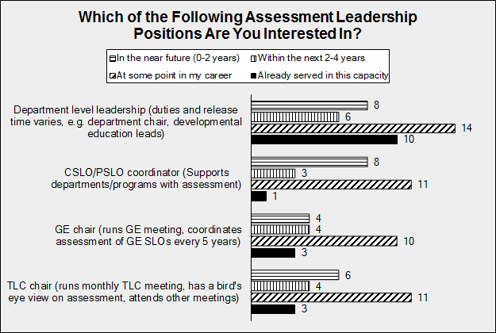

Clearly respondents are involved in department level leadership. Great! However, there is decreasingly less interest the CSLO/PSLO Coordinator position, followed by TLC chair, then by GE chair. As one TLC member put it, “How do we turn ‘At some point in my career’ into ‘in the near future’”? The TLC proposes a multi-prong approach:
- Offer amazing professional development concerning assessing PSLOs and throughout the series discuss the three positions
- Meet with every full-time faculty member and discuss which year would be of interest to her/him regarding assessment leadership
- Continue employing a series of stop-gap measures for the next 1-2 years until (2) begins to take over
These positions offer high levels of support. It provides a perfect springboard for faculty interested in future leadership roles. Currently, CCCCD offers NEXUS. Should this continue, it would be advantageous for the TLC to become strongly involved with NEXUS. First year tenure-track hires could observe committees. Interested second year tenure-track hires could serve on a committee. 3rd-5th year hires could serve in a leadership role for 2 years. This process would help ensure that new faculty have a bird’s eye view of LMC with respect to assessment.

Professional Development Needs

This was an open-ended question, of which 57 of the 81 responders chose to answer. Of particular note was the average amount of time required to assess a class. For small sections of classes, respondents suggested 6 hours was reasonable. This is twice the current 3 hours of pay that adjunct professors receive.

When followed up with what type of professional development is needed, several individuals wished to learn more about the assessment process and how to build and use effective assessment tools. Others focused on needing more time and reducing the data entry aspect of assessment.

These data suggest increasing the adjunct faculty stipend to 6 hours, especially if they are assessing more than their own section. It also suggests workshops on the assessment process and on assessment itself. These ideas can be woven into the previously mentioned professional development on PSLOs. Data entry into PRST is fairly minimal, so perhaps with more workshops on assessment, faculty, administrators and staff will develop ways that are less data-entry-intensive.

Equity

In the past, the TLC has not focused on equity in assessment. With new SEP funding, the TLC is excited to bring an equity lens toward assessment. Leading the effort, PSLO/CSLO Coordinator Briana McCarthy invited Dr. Ben-Zeev to speak on Stereotype Threat at an LMC FLEX professional development opportunity in Spring 2016. GE Coordinator Cindy McCarthy is facilitating a GE committee discussion on how to be inclusive and to raise awareness of equity issues in assessing its diversity GE SLO. Professional Learning Coordinator and TLC committee member Paula Gunder suggested several workshops related to equity and assessment.

Concluding Remarks

The TLC Midway Report serves to track the TLC’s progress toward its original goals. In 2012, LMC needed to institutionalize its new, streamlined assessment process. Our midway report concludes that we are on track. Within the next two years, we are on course to:
- Complete our first cycle using the new assessment model
- Greatly improve our rate of classes assessed (from 55.7% in 10 years to an estimated 60-80% in 5 years)
- Update nearly 100% of our COORs

Our ultimate goals are to:
- Continue to update and refine our 5-year assessment model
- Ensure strong understanding and participation in CSLO, PSLO and GE SLO (and possibly ISLO) assessment-related activities
- Update 100% of our COORs within every 5-year assessment cycle
- Assess 100% of LMC’s CSLOs, PSLOs and GE SLOs (and possibly ISLOs)
- Increase the number of hours in compensation for adjunct professors who participate in assessment
- Have a successful and satisfying process for filling assessment-related full-time faculty leadership roles

LMC Course Assessment Data By The Numbers Addendum

This report is a first draft template for use with the CSLO Coordinator’s annual update. For the next few years, we envision the Overview to remain largely unchanged. It serves as a reminder of the challenging work involved in collecting all of the data into one location, as well as provides milestones in assessment. Assessment Cycle 0 officially ended in Spring 2012 and thus the data point of 55.7% will also most likely remain unchanged. We do suggest leaving it in subsequent reports, to serve as a reference point. Namely, it took 10 years for LMC to assess the CSLOs in 55.7% of its courses.
We also envision the descriptions for every data point to remain largely unchanged. Every year, the CSLO Coordinator will update the data within the current cycle, and leave the remaining cycles in the report as an archive for easy reference. For example, Assessment Cycle 0 will remain unchanged but in in Assessment Cycle 1, we expect the “current courses assessed to date in Cycle 1 to increase, and thus to increase the percent of courses assessed at the CSLO level.
As this is a first draft template, there may be additions, changes or eliminations. The TLC’s latest suggestion is to add “updated COORs” to each section. The goal, however, is for this document to be readable and to serve as a guiding signal with respect to CSLO assessment.
In looking at our data, 100% of LMC’s courses could have been assessed from Cohort 1, but only 66% were actually assessed. Cohort 2 ended last Fall 2014 and 56.4% of its courses are overdue for assessment. Cohorts 3 and 4 are still “in process”, although 65.8% of courses in Cohort 3 are not assessed and will be considered overdue by Fall 2015. Of note are the 91 LMC courses that do not currently belong to a cohort and thus cannot be counted as assessed.
In analyzing our data, we are behind in Cohort 1 and most likely behind in Cohort 2. We also must assign cohorts to all of the new courses. However, it is unlikely that all of these courses will be assessed in Cohort 1 due to the logistics of how new courses are placed into cohorts. It is worth mentioning, though, that, compared with LMC’s previous attempt to assess CSLOs, we are improving. Using our new model, we assessed 34.1% of our courses at the CSLO level in 3 years, compared to our previous model which took 10 years to assess 55.7% of our courses at the CSLO level. Thus, although there is room for improvement, we are improving.
In conclusion, management and the TLC have a strong plan to decrease the numbers of overdue courses that need to be assessed at the CSLO level. An Excel file now exists which catalogues every course, the data it was last assessed, and the date the COOR was updated. The Deans will work with department chairs to plan how the overdue courses can be assessed by the end of Cycle 1. An interesting feature of our new model is year 5 does not have a cohort. Thus although departments will focus on assessing their PSLOs during year 5, they also have one more year to assess overdue courses before the cycle resets. Finally, of the 91 new courses currently not in a cohort, the plan is to place them 1-2 cohorts ahead of the current cohort. For example, a course approved in Fall 2015, during Cycle 1’s cohort 4, will be placed in Cycle 2’s cohort 1 or 2. This of course means that it will not be assessed in Cycle 1 and thus will be removed from the total number of courses LMC assesses in that cycle. These plans afford LMC 1.5 years to assess 100% of courses assessed at the CSLO level by the end of Cycle 1.

Membership Addendum
Chair
CSLO Assessment Coordinator
General Education Program Assessment Coordinator
Development Education/ESL, faculty lead/designee
(appointed by DE/ESL committee)
Student Services, faculty lead/designee
(appointed by Student Services faculty)
Library and Learning Services, faculty/lead or designee
(appointed by LLS faculty)
Department Chair representative, CTE
(Voted by CTE Department Chairs)
Department Chair representative, Liberal Arts
(appointed by LAS Department Chairs)
Department Chair representative, Math and Sciences
(appointed by LAS Department Chairs)
Part-time faculty at large
(appointed by AS/compensated at NI rate with TLC friends)
Curriculum Committee, Chair/designee
(appointed by Curriculum Committee)
Professional Development Advisory Committee, Chair/designee
(appointed by PDAC)
Planning Committee, chair/designee
(appointed by Planning Committee)
Distance Education, Chair/Designee
(appointed by Distance Education Committee)
Student Representative
(appointed by Associated Students of LMC)
Senior Dean, Student Services
Dean of Career Technical Education & Social Science
Dean of Liberal Arts
Dean of Math & Sciences

