State funding cuts routinely hurt certain colleges more than others
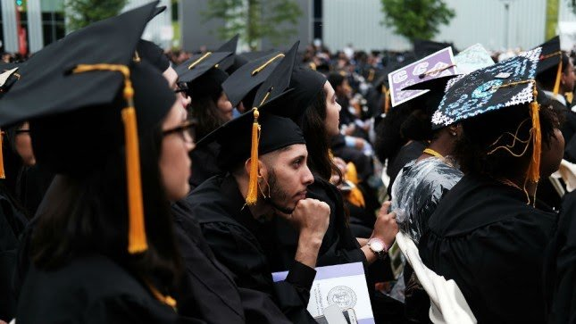

By William C. Boland and Marybeth Gasman, opinion contributors Tweet Share Email
The National Association of State Budget Officers (NASBO) forecasts slow growth in state revenues across the U.S. through 2018. The prediction for further drought in state funding does not bode well for public colleges and universities - especially those already receiving less funding, including minority-serving institutions (MSIs).
The Center on Budget and Policy Priorities (CBPP) reports that public higher education nationally received $10 billion less in fiscal year 2016 than before the recession. Forty-six states provided less funding per student than before the recession, with many by more than 30 percent less.
And while many states have increased funding slightly, it is not by an amount sufficient to offset rising tuition and falling family median income.
Some policymakers and analysts argue that colleges and universities must get with the austere times and rein in reckless spending. While researchers have explored instances where larger research and state flagship universities could tighten their belts (or redistribute expenditures), the majority of public postsecondary education consists of regional four-year and two-year colleges.
These are the schools enrolling a substantial portion of all college students, including the majority of low-income, first-generation and minority students.
These are the schools receiving the least amount of state funding.
The state appropriations process is complex and varies wildly between states and within sectors of public higher education. A state government or higher education coordinating or governing board allocates funding according to institutional enrollment and prior-year enrollments and funding in most states. More than 30 states employ some form of distributing funding contingent on outcome measures, but the percentage of which varies considerably, with Ohio and Tennessee awarding all funding based on outcomes.
Yet not all state funding to public institutions is created equal. Research universities and state flagship institutions receive the lion's share of funding. Smaller regional public four-year colleges and community colleges - a rapidly growing portion of which are MSIs - get much less.
As a recent PBS report demonstrated, this contributes to a disparity that hurts these institutions. Anthony Carnevale, director of the Georgetown University Center on Education and the Workforce, acknowledges in the PBS report that states fund the higher education institutions most in need the least.
Public MSIs tend to be community colleges and less-selective public four-year colleges. As of 2015, there were 248 two-year institutions eligible for federal MSI designation. This accounts for nearly half of all MSIs and 22 percent of all community colleges.
That state funding to public higher education is distributed unequally is rarely questioned. On its face, this makes sense. Why should New Jersey allocate the same sum to a public four-year flagship such as Rutgers University as the smaller Hispanic-serving institution Montclair State University?
The selectivity of these institutions and the types of students both tend to serve shows that the schools enrolling a higher number of low-income students and students of color are precisely those served more by institutions like Montclair State. And it's such institutions that do not receive a comparably large amount of funding to serve the students that higher education most needs to enroll if states are to meet future workforce and economic needs.
Current state funding structures perpetuate those who already have access, resources and privilege.
The California public higher education system reveals the stark differences in state allocations per sector. California is renowned for providing among the highest amounts of state allocations to its public institutions. Yet not all of the system's three segments receive the same level of funding.
The California Legislative Analyst's Office reports that the University of California (UC) system's total funding ($28 billion) was over three times the California Community Colleges (CCC) system's total funding ($9.2 billion) in 2015-2016. The CCC (1.2 million full-time equivalent students) serves over 10 times as many students as the UC (254,000 full-time equivalent students).
But California isn't alone. Let's look at three states with many public historically black colleges and universities (HBCUs): Louisiana, Mississippi and North Carolina.
Louisiana has been particularly egregious in cutting funding to its public postsecondary education systems. The Louisiana State University system received 25 percent less appropriations in 2012-2013 than in 2007-2008. Its public four-year HBCUs fared worse during that timeframe.
Southern A&M University felt the sharpest cut, with a 45 percent decline. Grambling State University's state appropriation was 36 percent lower in 2012-2013 compared to 2007-2008, and Southern University at New Orleans received 35 percent less funding during the same span of time.
Neighboring public four-year HBCUs in Mississippi have not fared much better. Alcorn State University experienced a 32 percent decline in state funding between 2007-2008 and 2012-2013. Funding to Jackson State University decreased by 26 percent. Mississippi Valley State University received 25 percent less during this timeframe.
While North Carolina provides a higher amount of funding to its public four-year HBCUs compared to most other states, per full-time equivalent (FTE) funding reveals much about the disparities between HBCUs and non-HBCUs.
For example, Winston-Salem State University received $10,618 per FTE in 2012-2013, an amount far less than the funding per FTE that the University of North Carolina, Chapel Hill ($17,992) and North Carolina State University ($15,558) received that academic year.
The consequences of state disinvestment are plain to see. The Institute for Research on Higher Education in the Graduate School of Education at the University of Pennsylvania found that overall declining state support for public higher education contributes to the increasing college affordability problem in the U.S. Institutions have increased the price of higher education to backfill the loss of state funding.
By passing on the cost of higher education to students and families, a higher percentage of family income for all socioeconomic strata is required to foot the bill of enrollment. This fact is obvious to many. However, not as easy to see are the consequences for institutions such as MSIs, which are routinely asked to do more with less each year.
To take our eyes off this looming crisis is irresponsible and demonstrates a lack of care and concern for those students who need the greatest amount of support.
Marybeth Gasman is professor of higher education at the University of Pennsylvania and director of the Penn Center for Minority Serving Institutions. William Casey Boland is a research assistant at the Penn Center for Minority Serving Institutions.
The views of contributors are their own and not the views of The Hill.

